Being a Systems Thinker Activity

20 minutes

Learning Objective(s): Participants will…
Become familiar with the concept of systems thinking and explain how developing habits of systems thinking when practicing management tactics in homes, lawns, gardens and landscapes can support environmental stewardship and a sustainable community.

Supplies:
Handouts:  - Scrap paper  - Writing utensils | 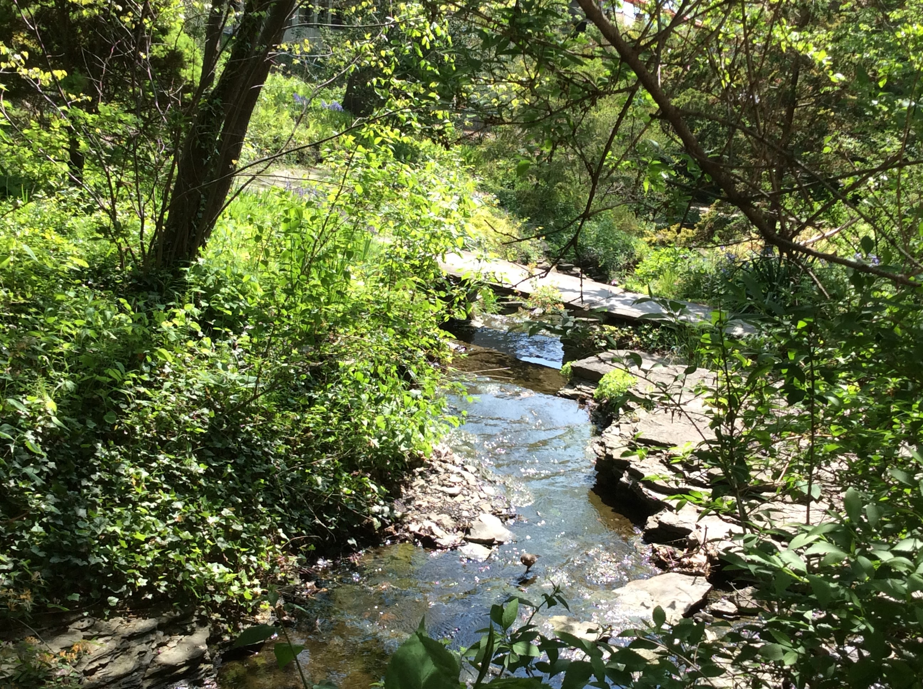
Materials:
- Handout Being a Systems Thinker
Instructions:
What exactly do we see when we look at a forest? We see trees, certainly, as well as other plants, soil, water, birds, animals and often much more. If we placed some trees, soil, a pool of water, and squirrels and chipmunks together, however, we clearly would not have a forest. A forest is the complexity of relationships among these elements and other connected systems such as weather, climate, and human settlements.

The systems thinking approach aims to understand the complexity of the world in terms of relationships, connectedness, and context. By observing relationships and the impacts of changes on those relationships, can we recognize and analyze the interconnections within the whole versus among its isolated parts. With this observation, we start to develop a comprehensive picture that different parts of a system are so interconnected that if we alter one part of a system it will change other parts. This allows us to ask the important questions that will help us better understand the system. For example, what happens to the soil as plants reach maturity, and eventually die? What happens to the plants and animals as soil health and water quality change?

Inspire Understanding with Discussion
Practice systems thinking and discover how elements in your garden are linked to other elements and systems.

Call to mind some part of your garden with which you are very familiar (a tree, a group of plants, a compost pile, a sitting area, a pond). Reflect on and record your answers to questions such as:
- What is it made of?
- Where has it come from?
- Who made it?

Then consider more searching questions like:
- What needs does it fulfill?
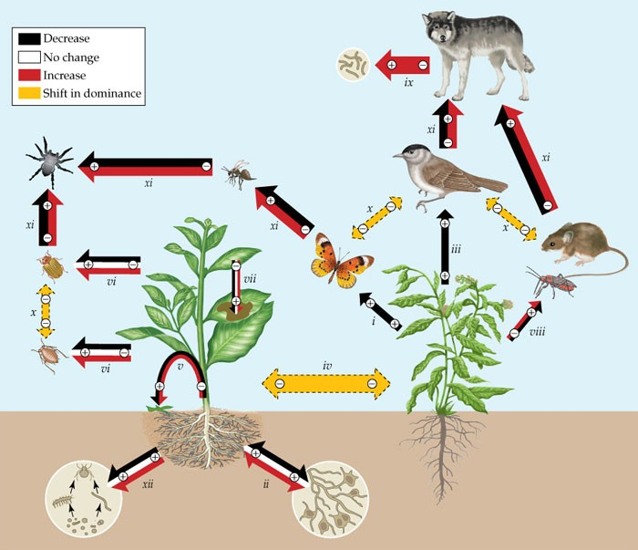
- Is it necessary?

- What will happen to it in the future?
- Could it be redesigned to have a smaller environmental footprint?

Begin to identify connections between your responses and produce a web-like diagram.

Return to the whole group and some might volunteer to share their initial exploration with others and collectively additional connections might be uncovered. This activity can extend almost indefinitely depending on the enthusiasm of the groups and can lead groups well outside the garden system to economic, social and ecological systems.

References:
Habits of a System Thinker from https://www.watersfoundation.or /
L. Booth Sweeney 12 Habits of Mind http://www.lindaboothsweeney.net/thinking/habits

Gardening in a Warming World: A Climate Smart Gardening Course Book, 2018. http://climatechange.cornell.edu/gardening

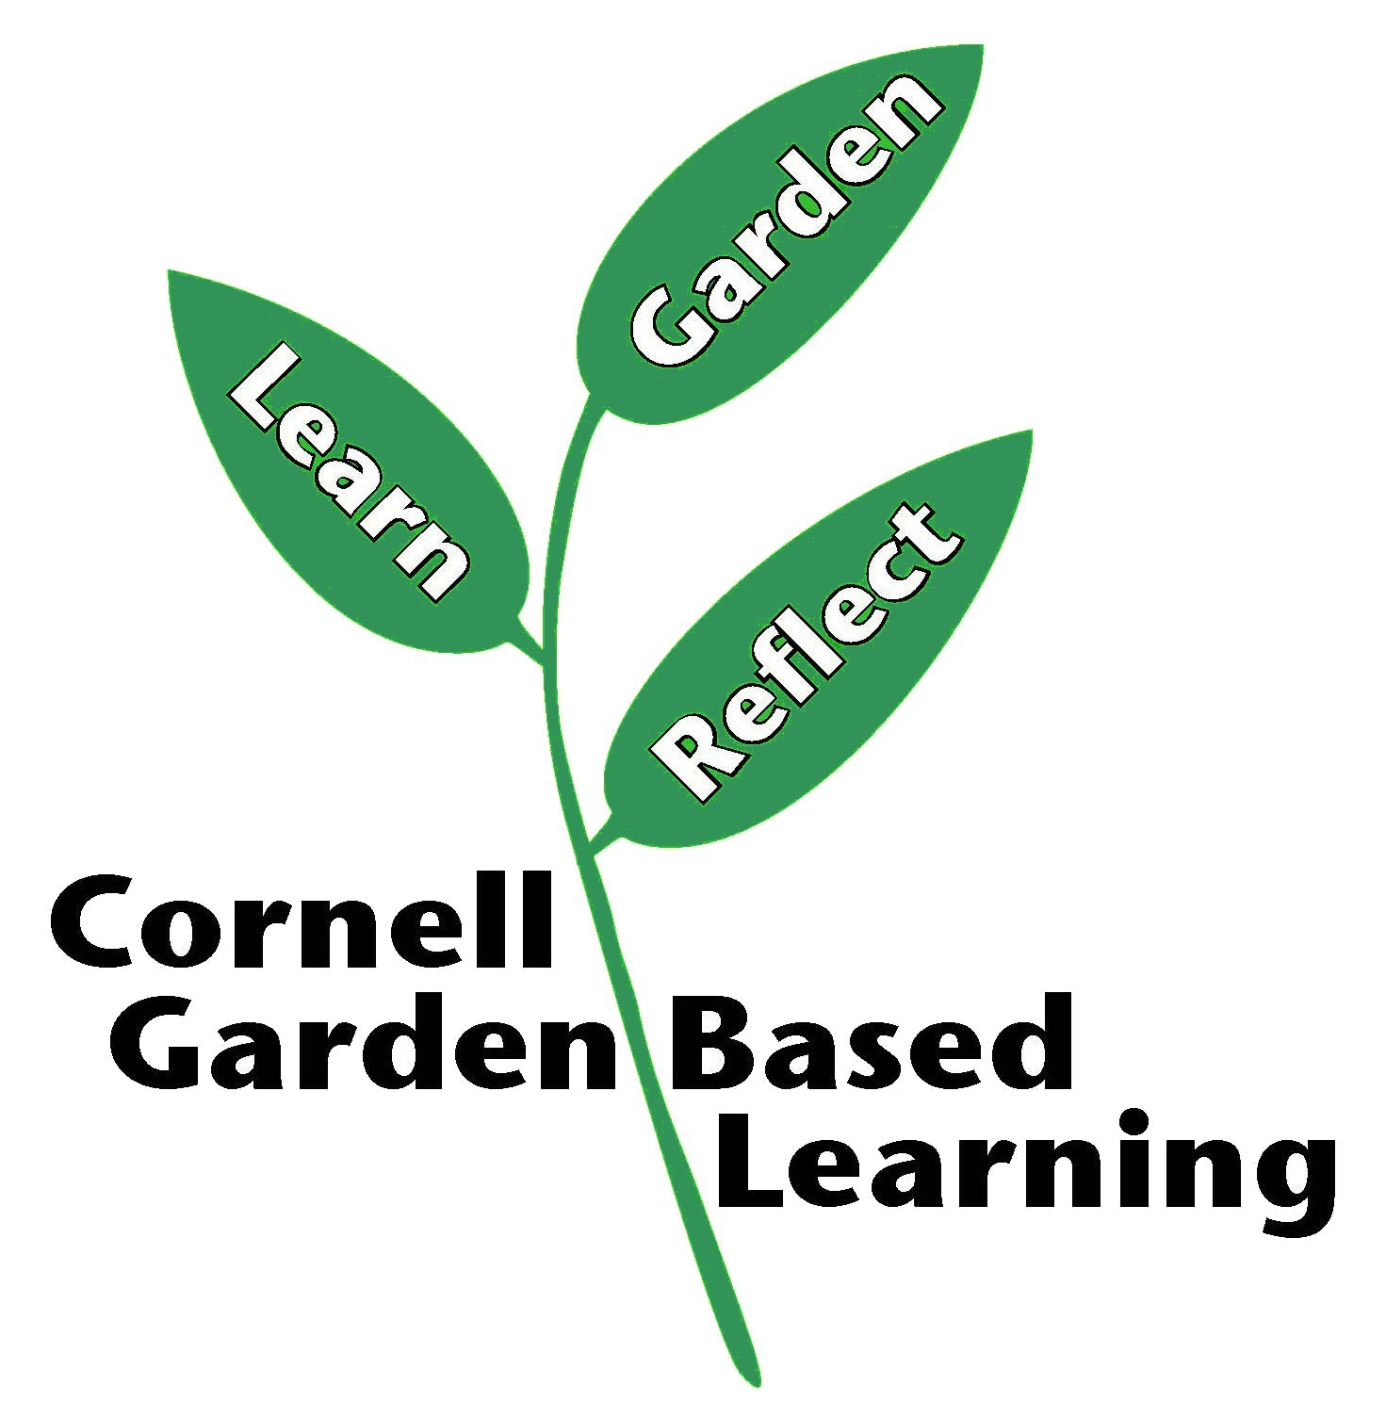

Published: April 2019
Author: Lori Brewer
Reviewer: Fiona Doherty

