Lawns and Plant Ecosystems Services
Knowledge Check KEY
In the GBL Learning Library - Core Preparation Sessions
this is Section 3.3 in Module 3: Ornamental Plants and Ecosystems Services

1. Name and briefly describe the 4 categories of ecosystems services.
(From pre-work reading, The Basics of Ecosystem Services)

Supporting Services
Ecosystems themselves could not be sustained without the consistency of underlying natural processes, such as photosynthesis, biomass production, formation of atmospheric oxygen, nutrient cycling, the creation of soils and the water cycle. These processes allow the Earth to sustain basic life forms, let alone whole ecosystems and people. Provisional, regulating and cultural services would not exist without these supports.
Provisioning Services
A provisioning service is any type of benefit to people that can be extracted from nature and are inclusive of many products we use in daily living like food, fresh water and medicines. National Gardening Association 2013 report notes that 42 million households are growing food at home or in a community garden.
Regulating Services
Ecosystems provide many of the basic services that make life possible for people. A regulating service is the benefit provided by ecosystem processes that moderate natural phenomena including reducing storm water flow, with their normal loads of sediment and pollutants, to coastal waters or rivers. Rain gardens are versatile features that aim to mimic natural hydrology by collecting and absorbing runoff from rooftops, sidewalks, and streets.
Cultural Services
Cultural service are non-material benefits that contribute to the development and advancement of local, national and global cultures. The would include recreation, creativity born from interactions with nature (music, art, architecture), and the building of knowledge and the spreading of ideas. As we interact and alter nature, the natural world has in turn altered us.
2. Name one or more easy cultural practices that can improve lawn appearance and health.
(From http://turf.cals.cornell.edu/lawn/lawn-care-the-easiest-steps-to-an-attractive-environmental-asset/four-steps-to-success/make-adjustments/)
- Keep the mower blade sharp
- Mow Grass Higher
- Mulch Grass Clippings and Leaves
- Patch Weak /Bare Spots
4. What is an example of a strategy, using vegetation, to reduce energy consumption during the summer? (From the pre-work Landscape for Life reading, pg. 89)
- Shade A/C Units
- Shade windows that receive direct sunlight
- Shade walls and parts of the roof that receive a lot of sunlight
- Shade dark colored driveways or patios

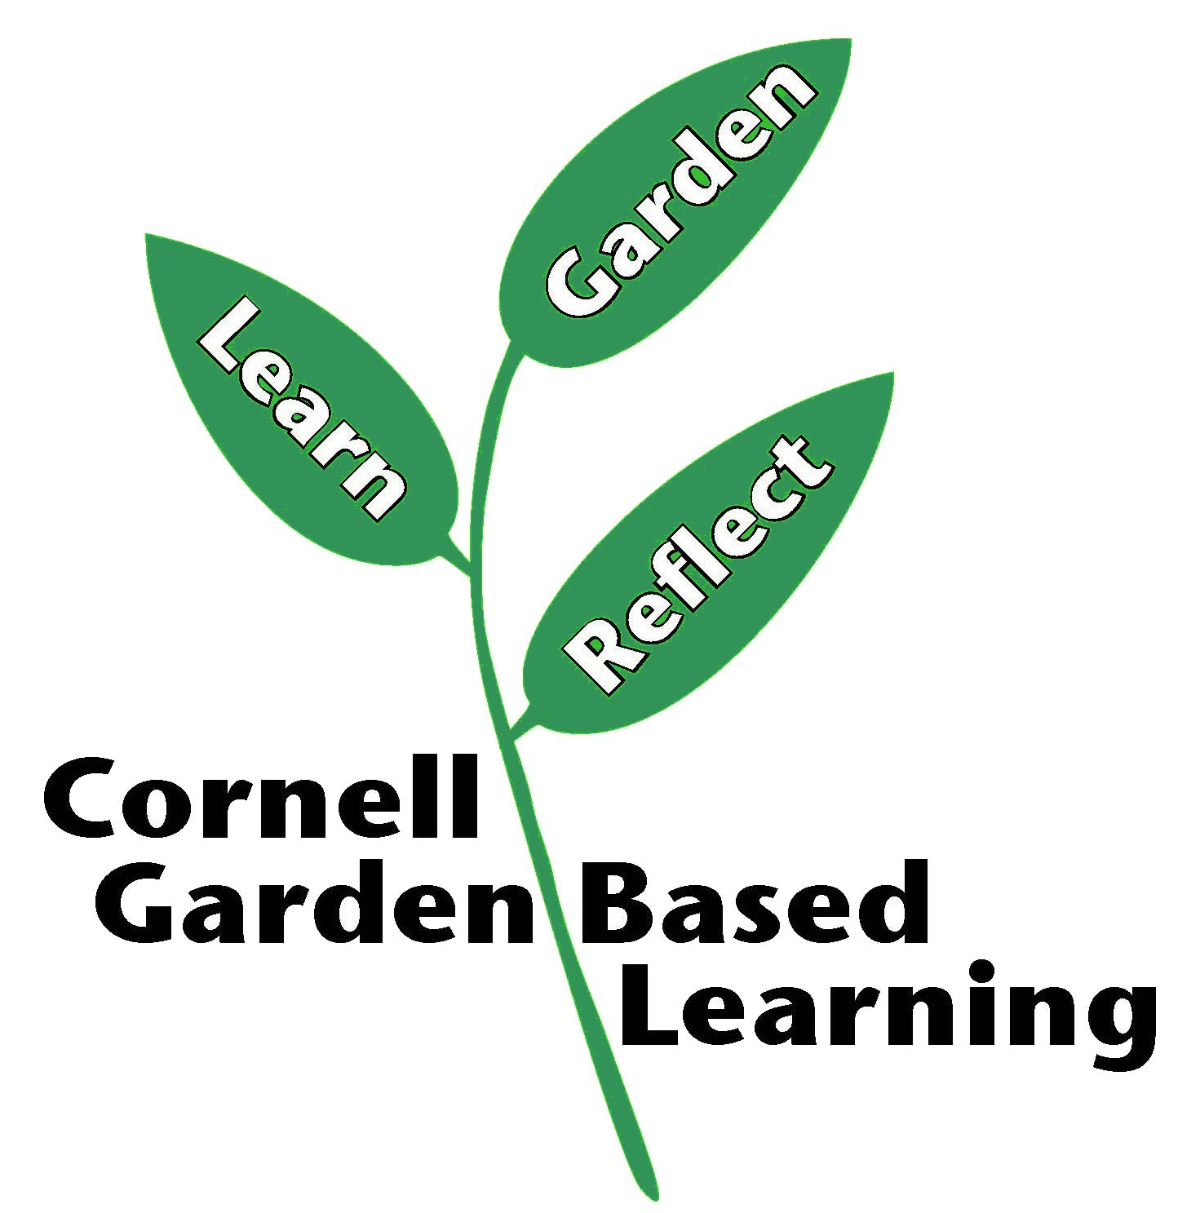
Date Published/Updated: April 2019
Reviewer(s): Fiona Doherty

