Action Project Planning Worksheet with Due Dates
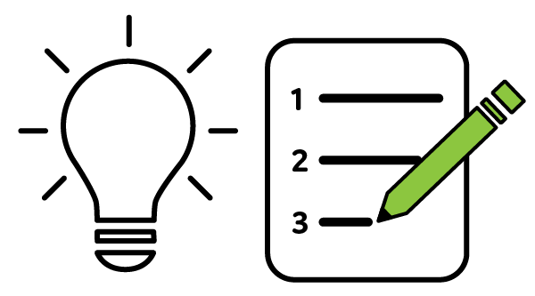
Time: 30 minutes

Leaning Objective:
Identify the steps you will take to complete an action project.

What is an action project?
An action project provides an opportunity for you to practice sharing garden educational information with your peers to enhance your learning, skills, and confidence. Your project should be a manageable, effective, and rewarding experience that builds on your strengths and interest as well as the learning activities and materials from the volunteer preparation sessions. You may work on an action project individually, with a partner, or in a small group.

What are examples of action projects?
You will develop a tangible product of your choice. Look to your program coordinator for guidance as you identify a gardening related topic that is important to you, you wish to learn more about, and connects with the local program goals. Depending on program needs as well as your skills and interests, you may wish to update or create a:

- Short video
- Presentation
- Infographic
- Display
- Hands-on activity
- Article or blog
- Fact sheet
- Project plan for group or school garden-based learning project
- Another educational product

Action Project Overview
Use the steps detailed in this worksheet to guide the development of your action project. Record specific due dates of each benchmark/assignments in timeline. As you progress through the steps and the volunteer preparation sessions you may find you wish to adjust what you initially set out to do. An iterative process is encouraged and be sure to communicate to your coordinator any significant changes.
- Propose Project and Identify Your Team
- Assess Needs
- Design Objectives
- Develop Delivery Strategies
- Implement Design
- Program Evaluation/Feedback
- Dry Run and Discussion
- Project Showcase
- Self-Review
- Follow-Up/Next Steps
Timeline Action Project

Step | Activity/Assignment | Due Date* | Done?
1 | Propose Project and Identify Your Team
2 | Assess Needs
3 | Design Objectives
4 | Develop Delivery Strategies
5 | Implement Design
6 | Program Evaluation/Feedback
7 | Dry Run and Discussion
8 | Project Showcase
9 | Self-Review
10 | Follow-Up/Next Steps

*On due date, be prepared to informally share and discuss with peers what you produced for the activity/assignment. It is an opportunity to gather feedback as well as discuss questions and challenges. On the Project Showcase date, the sharing and feedback will be more formal.

Additional notes:
1. Propose Project and Identify Your Team

Your name:

Will you be presenting (check one)?
- Individually
- With a partner or in a group (please list names)

Project topic, concept, or plan:
This is a rough idea as you will work out details in future steps. Please talk to coordinator if you need to adjust your idea after getting started on next couple of steps.

What method of delivery/format do you anticipate for your project?
Please talk to coordinator if you need to adjust your idea.

- short video
- presentation
- infographic
- display
- hands-on activity
- article or blog
- factsheet
- project plan for group or school garden-based learning project
- another educational product (please specify)

2. Assess Needs

“Need” is described as a gap between real and ideal (or normal) conditions. An issue is particularly ripe for educational programming when there is a “gap between real and ideal that is both acknowledged by community values and potentially amenable to change.”
From: Reviere, R.,(1996). Needs Assessment: A creative and practical guide for social scientists.

Using your answers to the questions below, clearly articulate in a short paragraph a rational for your educational effort that includes the who and why. Focus on a basic project that is well-thought-out rather than a lofty one that may overwhelm you.

Who is the audience, what are their characteristics and what are their needs? What makes this audience unique?

Needs Assessment may include reviewing existing data and documentation, reaching out to stakeholders and potential stakeholders, and seeking expert advice. What tools will you use to assess the audience’s needs? What needs have you identified?

How do you think your educational project fits the CCE mission? Is it on target with the local program plan of work?
3. Design Objectives

You may wish to review:
- Constructing Learning Objectives posted on TechSmith’s SCREENCAST.COM Service
(5-minute video) http://www.screencast.com/t/31O8Yjxu

Focus on identifying 1-to-3 clear and concise learning objectives. What will the audience be expected to learn by engaging with your educational product?

How are the learning objectives consistent with community needs? How are the learning objectives connected to our CCE mission and the local program plan of work?
4. Develop Delivery Strategies

You may wish to review:
- The Basic Principles of Adult Learning Lecture.
What delivery methods have you used in the past? What worked well and what didn’t? What new methods are you curious to try? If you haven’t had much experience with delivery methods, talk with other Master Gardener Volunteers who have and ask them about their experiences.

What ways are most effective for your audience? In what ways will you deliver the information? What challenges do you face?

What are the resources you need and plan to use to complete your project? (This might be people, resources, software, etc.)

Aim to organize your to-do list into a timeline with target completion dates to keep your educational product development moving forward at a manageable pace for your life.

5. Implement Design

You may wish to review:
- Worksheet Facilitating Adult Learning from Introduction session.
- Facilitating Learning with the Adult Brain in Mind: A Conceptual and Practical Guide by Kathleen Taylor, Catherine Marienau (March 2016) http://www.wiley.com/WileyCDA/WileyTitle/productCd-1118711459.html
- Unlocking the Magic of Facilitation: 11 Key Concepts You Didn't Know You Didn't Know by Sam Killermann and Meg Bolger
What will you need to do to be well prepared? What are your resources and materials?

How will you make the information relevant to your audience and how will you keep them engaged and ready to learn?

What additional logistics might need consideration prior to presenting to ensure your success?

6. Program Evaluation/Feedback

Ideally, evaluation begins before program development starts. Though for many educators, the idea of measuring the effects of your program is so daunting it never begins.

Consider and respond to these key questions:

- Who is this evaluation for?

- What do you want to know, and why? After receiving and interpreting results, will you alter your strategy?

- What’s do‐able, really?

How has your feedback been gathered for education sessions you have participated in? Pre-and or Post-surveys? Group or individual interviews?

Understand from your local program coordinator what data they need you to gather and submit to them for the reporting they must complete about volunteer efforts and impacts.
Does your educator have examples to share or specific ones that every educational session uses?

7. Dry Run and Discussion

Complete this table and a draft of your action project’s educational product. You will share your draft with a small group of peers. Peers will complete the Peer Review Feedback Form for other group members and can engage in further discussions to address challenges or questions that will inform how adjustments can be made that will improve reaching the target audience and achieving learning objectives.
WHO:
Name the target audience
WHY:
The situation (need)
Learning Objectives | Learning Strategy (name the specific approach to be used)
Peer Review Feedback Form

What worked well?
What could be modified?
What could be added? Removed?

8. Project Showcase

You will model how you would engage your desired target audience with your action project’s educational product. You will be allotted a specific amount of time which may not be sufficient to model your entire product. Consider providing an overview or a segment you could complete in a limited time frame. Peers will complete the Peer Review Feedback Form (page 10).

Note additional details your coordinator has shared about how project showcase will run and share your specific needs associated with your presentation with your coordinator.

9. Self-Review

What happened with your presentation?

What was your response to what happened? How do you make sense of it?

What might you do differently next time?

Throughout your action project development, what was your greatest area of growth? Where do you continue to have room for growth?

What surprised you most about the development process? Is there a different approach you might take?

What adjustments do you believe are needed to finalize your educational product for your target audience? What additional items do you wish to discuss with your coordinator regarding your educational product specifically and more generally how to enhance your learning, skills, and confidence?
10. Follow-Up/Next Steps

Work with your coordinator to arrange a time to share your action project materials as well as discuss your peer review feedback and self-review.

Date: _____________ Location: __________________

Guidance on Source Evaluation and Documentation

Cornell University LibGuides:
Evaluating Information:
http://guides.library.cornell.edu/c.php?g=543699&p=4433818
HORT 1175: Storying the Foodshed: Evaluating Credibility:
http://guides.library.cornell.edu/c.php?g=32487&p=204540
Critically Analyzing Information Sources: Critical Appraisal and Analysis:
http://guides.library.cornell.edu/criticallyanalyzing
A Guide to Finding Visual Resources:
http://guides.library.cornell.edu/findimages

Cornell University Library, Portal for Cornell Cooperative Extension:
http://guides.library.cornell.edu/cce_portal

The C.R.A.P. Test in action: Websites from Portland State University Library (5-minute video) https://www.youtube.com/watch?v=lhwB4zQD4XA

We are suggesting the American Psychological Association (APA) citation and format style. It is less critical that you get it exactly correct, it is most critical that you note from where you gathered your information and images as others will apply the C.R.A.P. Test to your educational materials.

For example:
Contributors' names (Last edited date). Title of resource. Retrieved from http://Web address for OWL resource

Paiz, J., Angeli, E., Wagner, J., Lawrick, E., Moore, K., Anderson, M., Keck, R. (2010, May 5). General format. Retrieved from http://owl.english.purdue.edu/owl/resource/560/01/

More details on APA style can be found in many locations like Purdue Online Writing Lab:
https://owl.purdue.edu/owl/research_and_citation/using_research/citation_style_chart.html

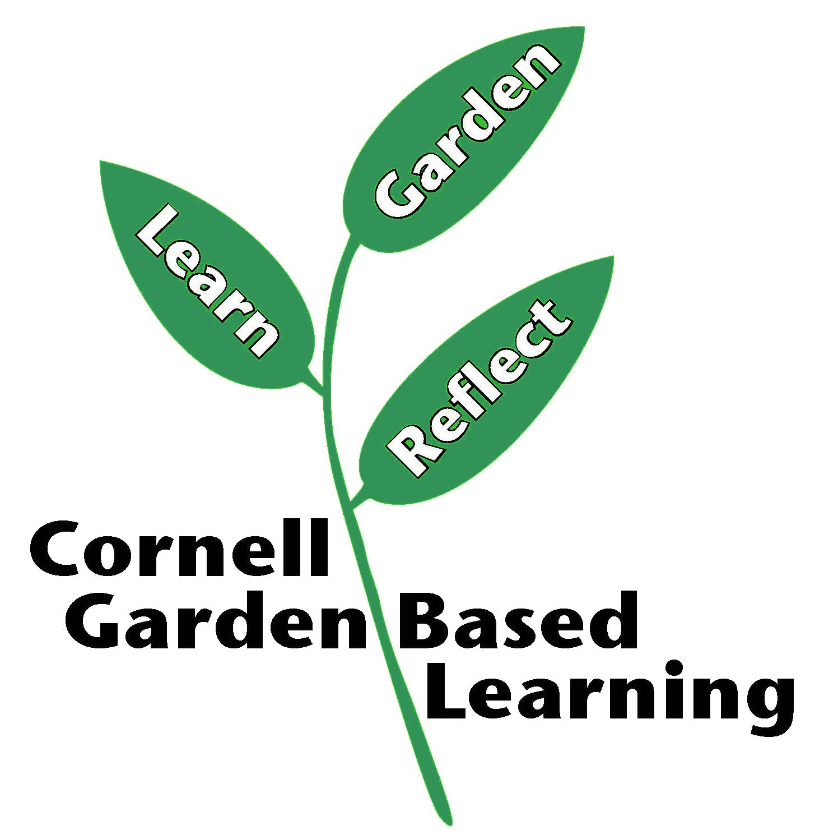
Published: April 2019
Author: Fiona Doherty and Lori Brewer
Reviewers: Donna Alese Cooke, Michelle Podolec

