Reading and Understanding a Soil Test Activity KEY
15 Minutes
Learning Objective:
- Participants will practice reading a soil test report to gather information about the soil nutrient status of a site.
Note: This activity is focused on reading a soil test report and gathering additional information, not focused on providing solutions to the community member.
Supplies:
Handouts:
- Sample Soil Analysis Report Form D-1 NY Report for each participant
Materials:
Instructions:
Interpreting a soil test can be overwhelming. There is a lot of information and you don’t want to miss a bit of it. This activity will help you practice reading a soil test.
Read the sample soil test report form and answer the questions below. If you wish to go further you could review other soil test reports and answer the same questions.
1. What does the test tell you about the:
- Soil pH?
A: 7.0 (Neutral)
- Organic Matter?
A: 12.2% (Very High)
- Phosphorous?
A: 66.4 lbs/acre (considered to be in the ‘Very High’ range)
- Potassium?
A: 428.7 lbs/acre (considered to be in the ‘Very High’ range)
- Soil contaminants?
A: Soil contaminants are not measured on this type of soil test.
2. Imagine that a community member brings you these soil test results, what conversation would you have with them? What questions would you ask?
A: Ask them questions about their landscape and previous soil management practices. Many of their nutrient levels are high, as is their percent of organic matter.
- Tell me something about the soil you have. (Texture, drainage, pH, etc)
- What do you hope to accomplish?
- Have you been adding fertilizer? If so, how much? How do you do it?
- Have you been amending with mulch, compost, manure, etc.? What materials are you adding?
- What about watering? Do you water? If so, how?
- What observations have you made based on plant health and plant history?
- What do you think the problem is? What might be contributing to it?
3. Where could the community member go to learn more?
A
- Cornell Soil Health: http://soilhealth.cals.cornell.edu/soil-health-manual-series/
- Healthy Soils, Healthy Communities: http://blogs.cornell.edu/healthysoils/

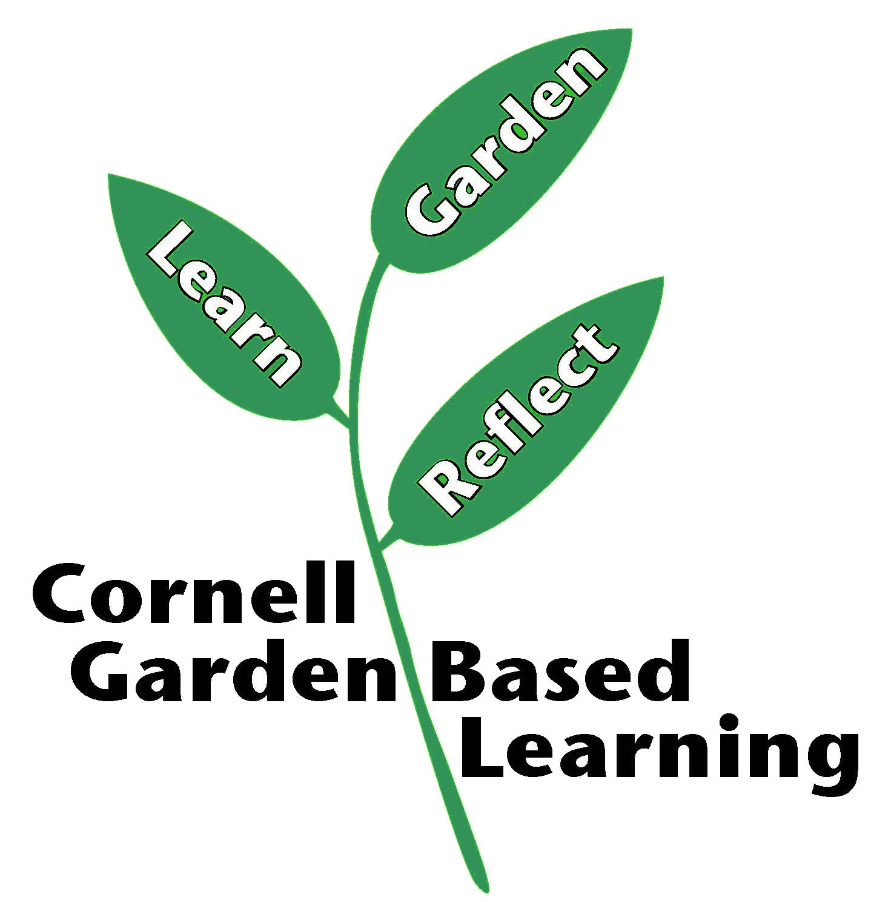
References: Soil Analysis Report Form D-1 NY Report, http://dairyone.com/analytical-services/agronomy-services/soil-testing/
Date Published/Updated: April 2019
Contributors: Fiona Doherty and Jonathan Russell-Anelli
Reviewer(s): Michelle Podolec

