Soil Amendments and Fertilizers
Knowledge Check KEY
In the GB Learning Library - Core Preparation Sessions
this is Section 5.2 in Module 5: Management Strategies
1. Name a few reasons why a gardener might use a cover crop.
- Suppressing weeds
- Protecting soil from rain or runoff
- Adding active organic matter to soil
- Improving soil aggregate stability
- Reducing surface crusting
- Breaking hardpan
- Fixing nitrogen
- Scavenging soil nitrogen
- Suppressing soil diseases and pests
(From Soil Amendments and Fertilizers presentation)
2. Using the online cover crop tool for vegetable growers, http://covercrops.cals.cornell.edu/index.php, provide a recommendation for a cover crop that can help minimize winter soil erosion.

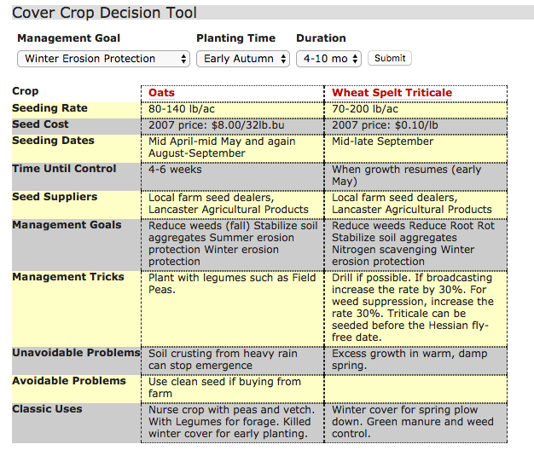

3. What valuable information can a soil test provide about a specific site?
The soil pH, organic matter and availability of nutrients such as potassium and phosphorus. This valuable information will help a gardener determine if they need to make adjustments to meet the needs of their desired plants.
Some soil tests can also provide valuable information on soil contaminants. (From Soil Amendments and Fertilizers presentation)
4. Why add organic matter to existing soil? What are some sources of organic matter?
The person has had the soil tested and the report states the soil is deficient.
Organic matter is added to the soil to improve soil properties by increasing the water and nutrient holding capacity, improving aeration and drainage, feeding microorganisms and providing some nutrients.
Common organic matter sources include composted manure, peat moss, plant-based compost and plant and animal by-products. Cover crops
(From Getting the Most out of Your Vegetable Garden Soil Test Report and Soil Amendments and Fertilizers presentation)
6. On the following label, what do the numbers 2-4-1 indicate?
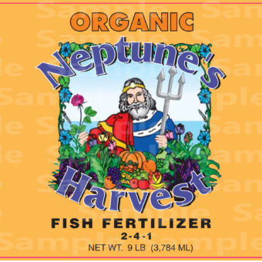
https://goo.gl/images/FMbw1D
The first number indicates the percent of nitrogen (N), the second number is the percent of phosphate (P2O5) a source of phosphorus, and the third number is the percent of potash (K2O) a source of potassium. They are simply referred to as N-P-K. (From Soil Amendments and Fertilizers presentation)
7. How many ounces of Nitrogen are in a 20-pound bag with the following label?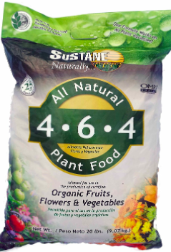
https://goo.gl/images/Tetu8T
A 20-pound bag of 4-6-4 contains 0.8 pounds (12.8 ounces) of Nitrogen, 1.2 pounds (19.2 ounces) of P2O5 a source of phosphorus, and 0.8 pounds (12.8 ounces) of potash (K2O) a source of potassium. The rest of the material is made up of other inert material, such as sand or clay granules to help spread the fertilizer. (From Reading and Understanding Fertilizer Labels activity)

Published: April 2019
Author: Lori Brewer
Reviewer: Fiona Doherty, Michelle Podolec

