Gardening in a Warming World
Knowledge Check KEY
In the GB Learning Library - Core Preparation Sessions
this is Section 5.4 in Module 5: Management Strategies
1. Identify how weather and climate are not the same.
(From page 8 in Gardening in a Warming World: A Climate Smart Gardening Course Book found at http://climatechange.cornell.edu/gardening/)
Weather is the state of the atmosphere at a specific time and place. It is the short-term variations of the atmosphere (from minutes to weeks). Weather is often referred to in terms of brightness, cloudiness, humidity, precipitation, temperature, visibility, and wind. Meteorology is the study of the atmosphere and weather of the lower atmosphere (below 50 miles) often focused on weather prediction and analysis.
Climate is the prevalent long-term weather conditions in a particular place. Generally, climate is considered the weather in a place over a period of 30+ years. Climatic elements include precipitation, temperature, humidity, sunshine and wind velocity, and phenomena such as fog, frost and snow.
2. The carbon budget is the amount of carbon released into the atmosphere by both natural sources, such as decaying plants, or anthropogenic (human-caused) sources, such as the burning of coal and oil minus the amount of carbon absorbed by the ocean, growing green plants, and other carbon sinks. True or False
(From page 10 in Gardening in a Warming World: A Climate Smart Gardening Course Book found at http://climatechange.cornell.edu/gardening/)
3. Describe what it means to adapt to climate change and mitigate climate change? Provide examples of such actions in the area of gardening.
(From page 19 in Gardening in a Warming World: A Climate Smart Gardening Course Book found at http://climatechange.cornell.edu/gardening/)
Actions to mitigate climate change are those activities which reduce emissions to stabilize the levels of heat-trapping gases in the atmosphere. Actions to adapt to climate change are those help us adjust to actual and expected impacts. There a numerous examples you could provide including gardeners who cut down the need for gaspowered mowers and fossil-fuel based fertilizers by replacing high maintenance lawns with alternatives mitigate the causes of climate change by reducing greenhouse gas emissions. Gardeners who include a more diverse mix of plants in gardens including plants tolerant to drought or typically grown in higher zone are employing adaptive strategies.
4. What will you do differently in the management of your lawns, gardens or landscapes to mitigate climate change? Adapt to climate change?
There a numerous possibilities. See best practices pages 20 to 28 in Gardening in a Warming World: A Climate Smart Gardening Course Book found at http://climatechange.cornell.edu/gardening/

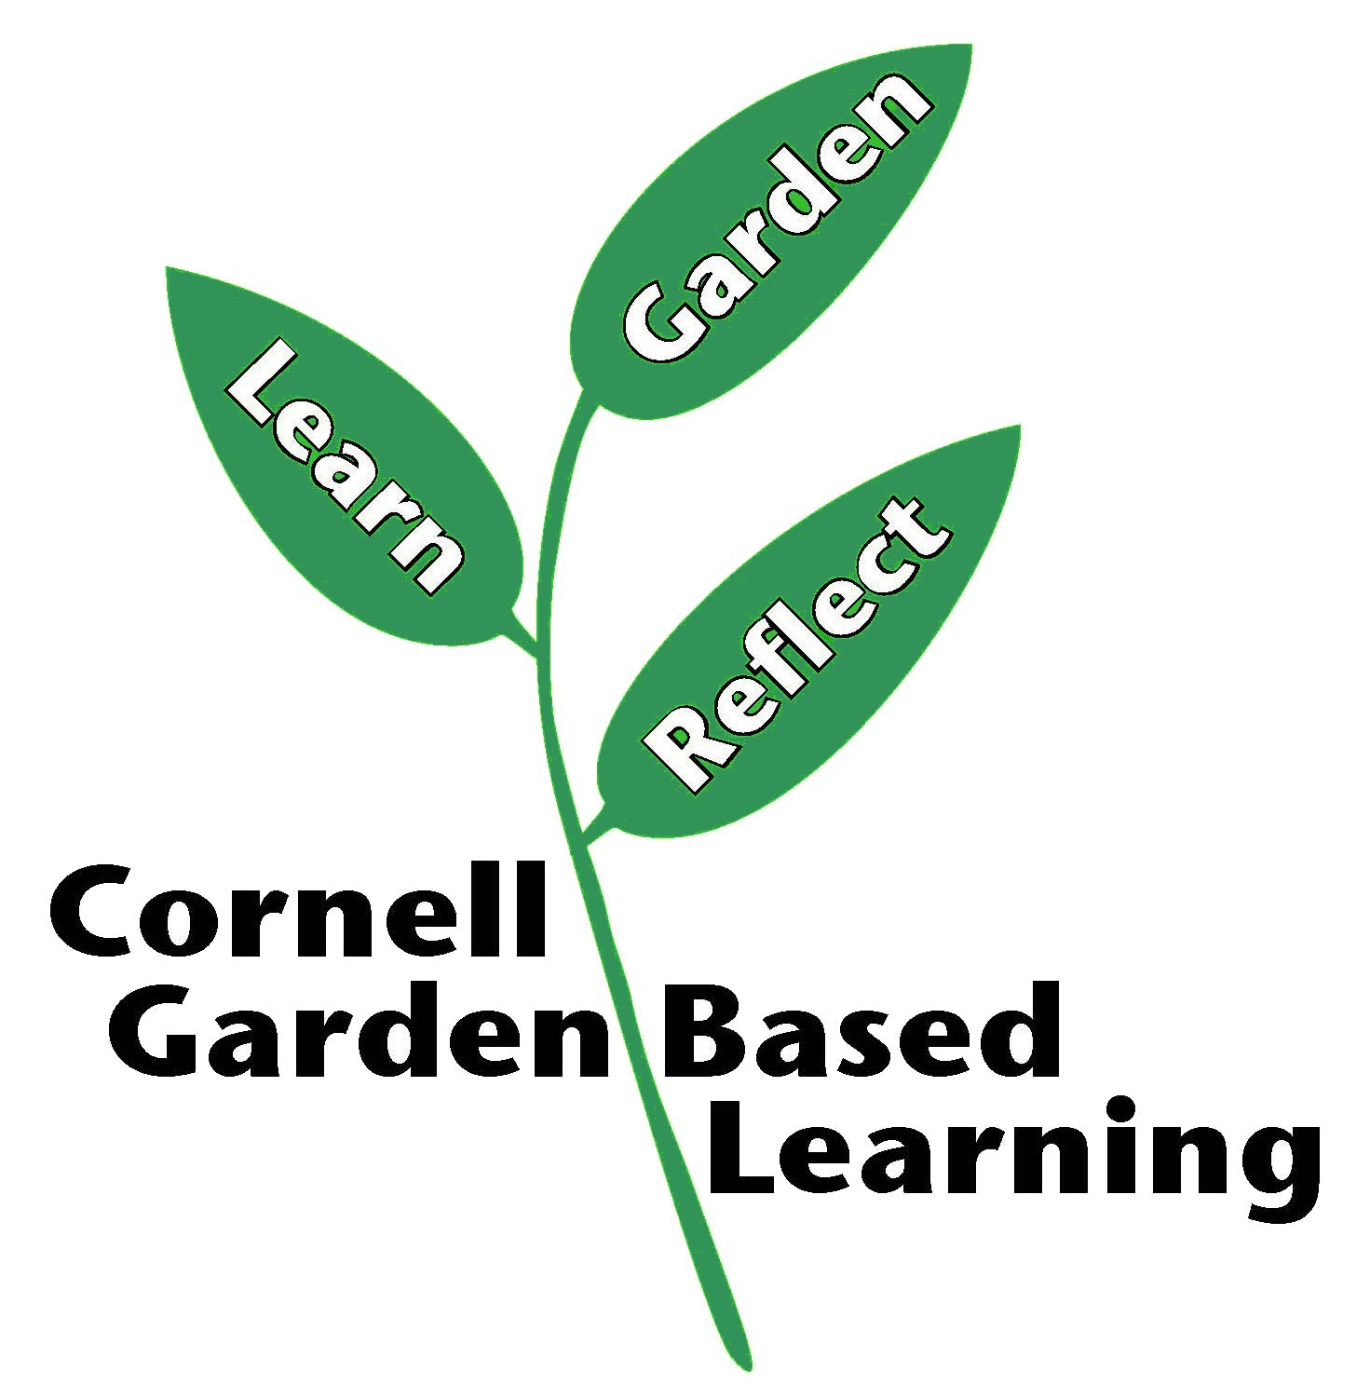
Date Published: April 2019
Author: Lori Brewer
Reviewer(s): Fiona Doherty

