Gardening in a Warming World
Knowledge Check
In the GB Learning Library - Core Preparation Sessions
this is Section 5.4 in Module 5: Management Strategies
1. Identify how weather and climate are not the same.

2. The carbon budget is the amount of carbon released into the atmosphere by both natural sources, such as decaying plants, or anthropogenic (human-caused) sources, such as the burning of coal and oil minus the amount of carbon absorbed by the ocean, growing green plants, and other carbon sinks. True or False?

3. Describe what it means to adapt to climate change and mitigate climate change? Provide examples of such actions in the area of gardening.

4. What will you do differently in the management of your lawns, gardens or landscapes to mitigate climate change? Adapt to climate change?

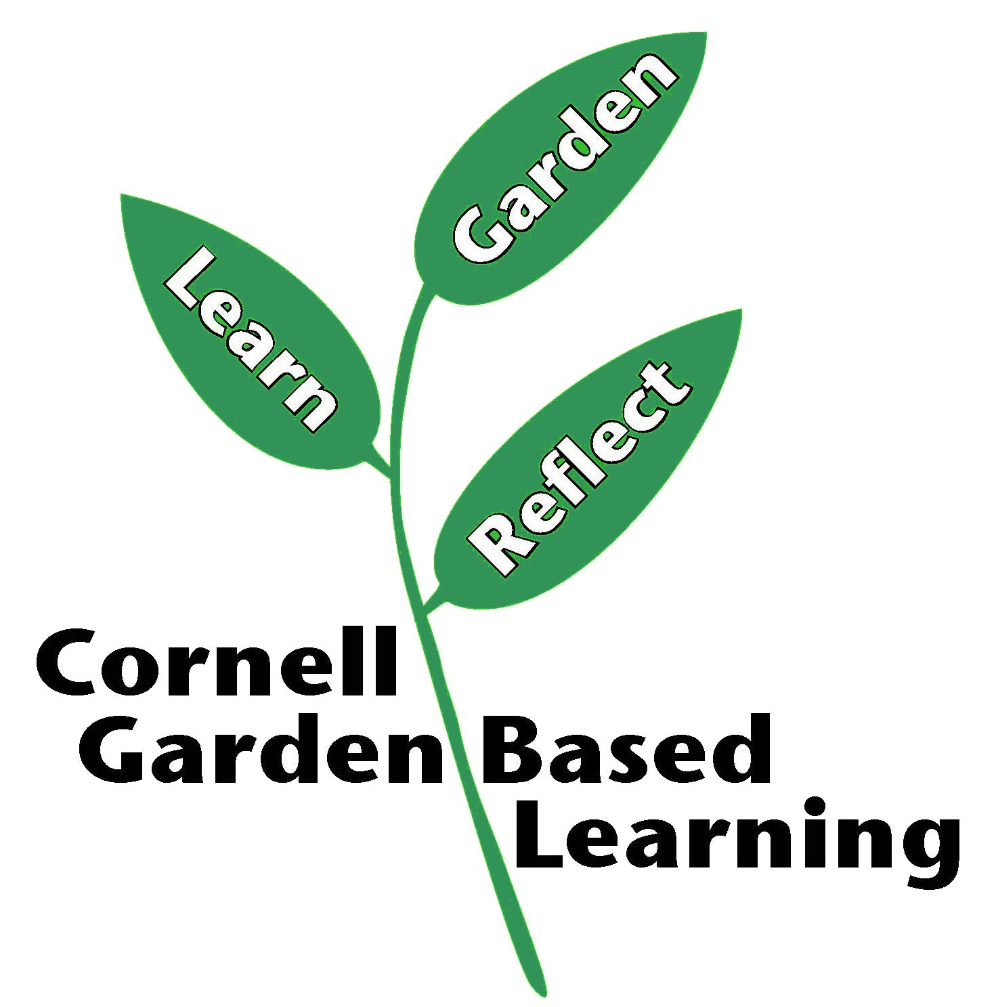
Date Published: April 2019
Author: Lori Brewer
Reviewer(s): Fiona Doherty

