Problem Solving: Pests in the Home and Garden Knowledge Check KEY
In the GBL Learning Library - Core Preparation Sessions
this is Section 4.3b in Module 4: Problem Solving

NOTE: Answers will vary depending on the participant’s selected wildlife. Look for well-formed answers sourced from the Cornell publications listed below.

To answer these questions, refer to the readings, videos, resources on wildlife in this section and the Cornell Publications at http://wildlifecontrol.info/publications/cornell-publications/ and Penn State publications found at: http://wildlifecontrol.info/publications/penn-state-publications/

- Name the top three nuisance wildlife that disrupt the ecology of your garden, and the damage (if any) that they do to your plants and garden site. How did you determine which animal did what damage (observation, evidence of habitats, etc.)?

- Give an example of a cultural method you can use to control any damage due to each animal. Provide the source where you found this method of control.

- Describe the steps you will take to address your wildlife issues, and how this will improve the ecology of your garden and landscape.

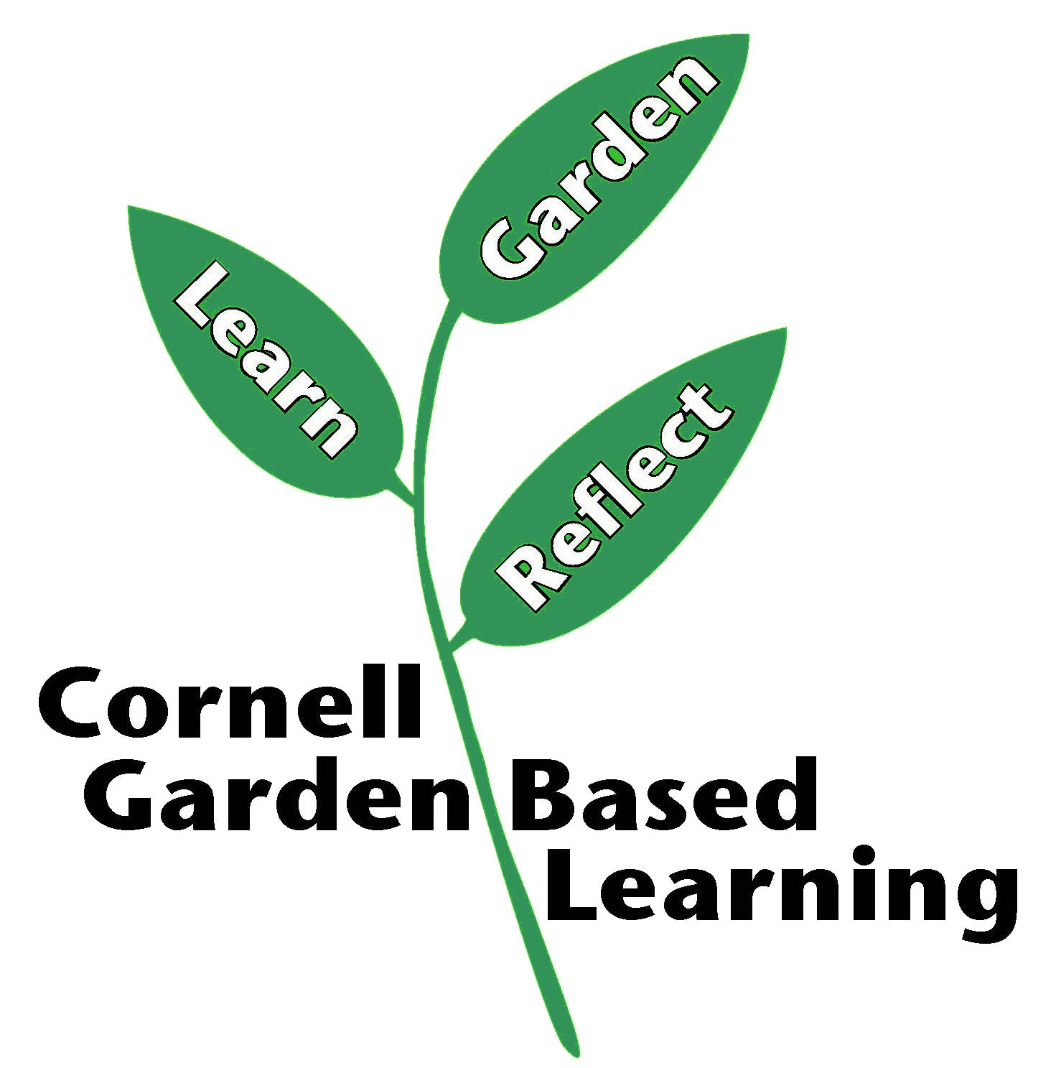
References: Cornell Wildlife Control Info http://wildlifecontrol.info
Penn State Publications http://wildlifecontrol.info/publications/penn-state-publications/
Published: April 2019
Author: Donna Alese Cooke
Reviewer: Fiona Doherty

