Integrated Pest Management (IPM)
Knowledge Check
In the GB Learning Library - Core Preparation Sessions
this is Section 4.1 in Module 4: Problem Solving

- Integrated pest management (IPM) is integrated because it rarely relies on just one tactic; it brings together a range of biological, organic, cultural, mechanical, and chemical options for management of pests such as insects, weeds, fungi, bacteria, viruses, wildlife and more. True or False?

- Name and briefly describe the seven IPM steps.

1.

2.

3.

4.

5.

6.

7.

3. What are three methods of pest prevention?
1.

2.

3.

4. What is an IPM threshold?

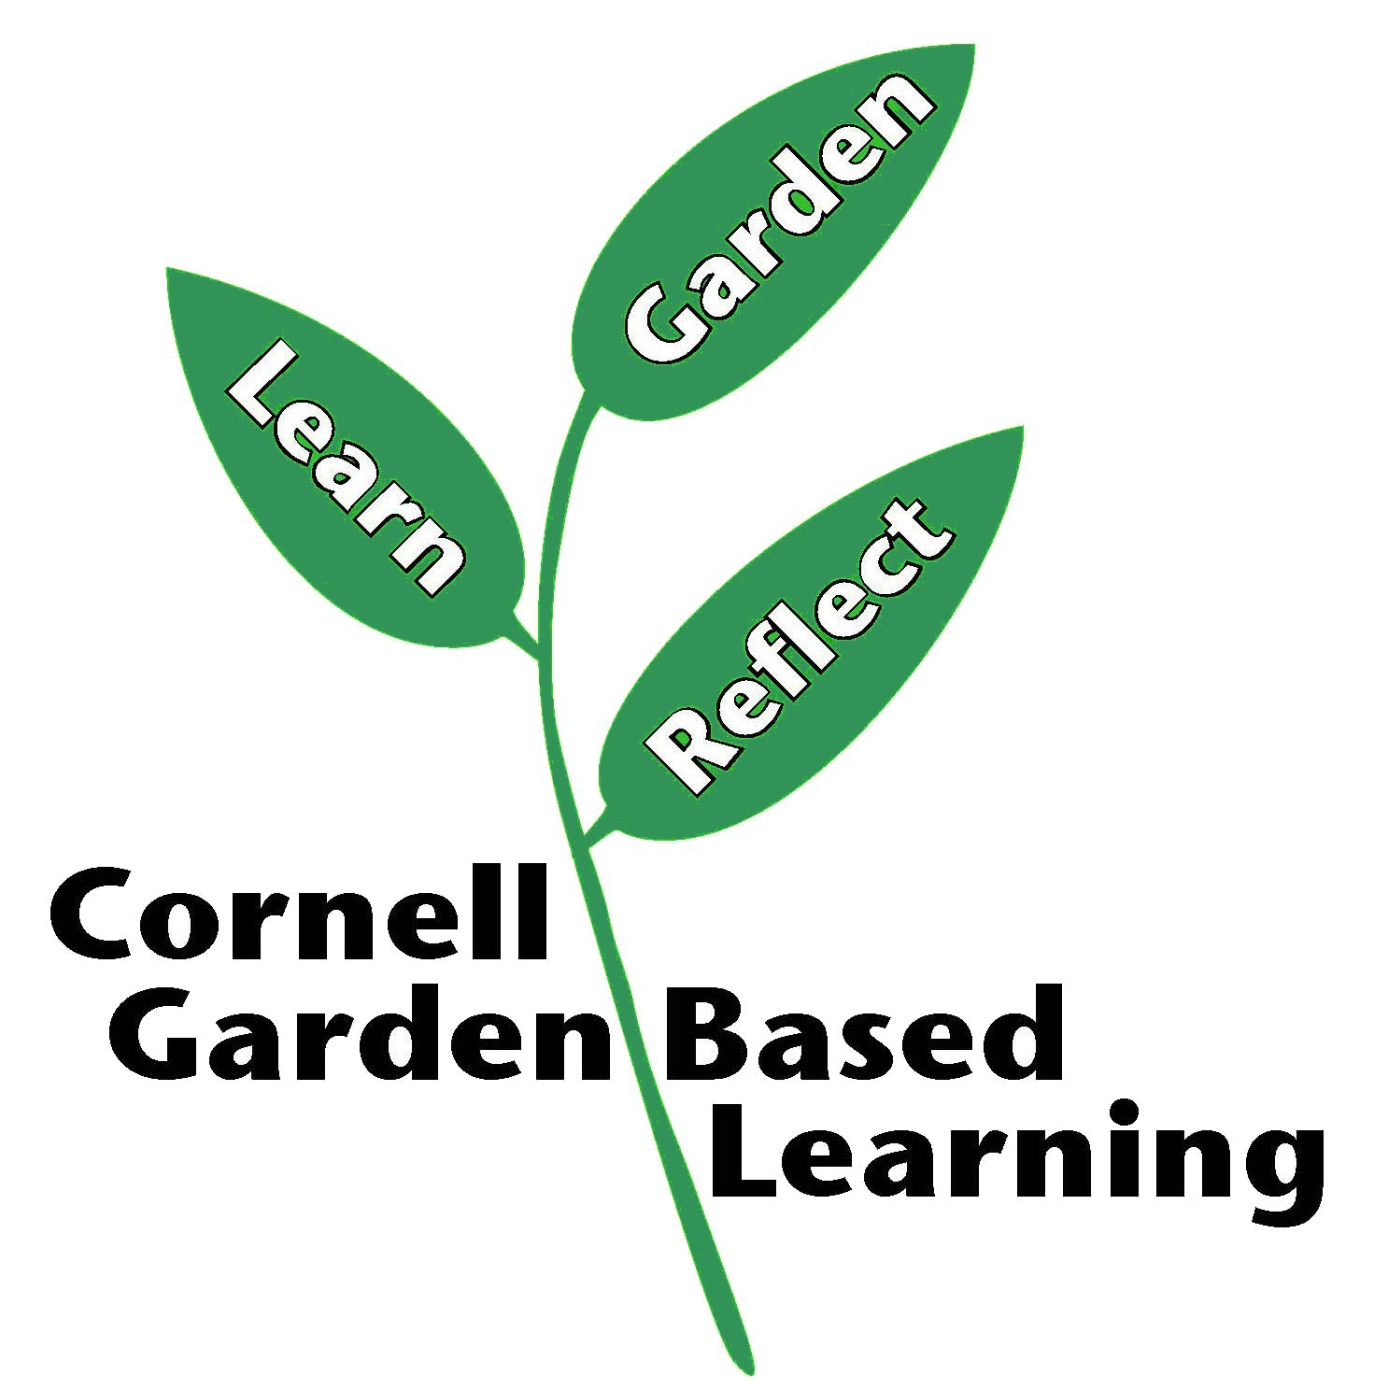

Date Published: April 2019
Contributor(s): Fiona Doherty
Reviewer(s): Annie Christian-Reuter

