Herbaceous Plants
Knowledge Check KEY
In the GBL Learning Library - Core Preparation Sessions
this is Section 3.2 in Module 3: Plant Ecosystems Services

1. What distinguishes the following herbaceous plants: perennials, biennials and annuals. Provide an example of each. (From the in-class Herbaceous Plant Activity)

Annual: completes life cycle in one year such as Zinnia: http://www.gardening.cornell.edu/homegardening/scene7e05.html

Biennial: completes life cycle in two years. First season growth results in a small rosette of leaves near the soil surface. During the second season's growth stem elongation, flowering and seed formation occur followed by the entire plant's death. Such as Foxglove: http://www.gardening.cornell.edu/homegardening/scenec1a6.html

Perennial: life cycle extends three or more years such as Bleeding Heart http://www.gardening.cornell.edu/homegardening/scene9f1f.html

More examples at http://www.gardening.cornell.edu/homegardening/scenee139.html

2. How do you plant and care for a bulb?
(From the in-class Herbaceous Plant Activity)

The general rule of thumb for planting spring bulbs is to plant two to three times as deep as the bulbs as tall. This means most large bulbs like tulips or daffodils will be planted about 6 inches deep while smaller bulbs will be planted 3-4 inches deep. The depth of planting should be measured from the surface level of the soil to the shoulder of the bulb. And plant roots down and stem up (root side is flatter, step side is pointy).

Periodic fertilizing and lifting to split bulbs will keep them blooming.

3. Once plants are planted, what are three fundamentals of basic landscape maintenance?
(From the Herbaceous Plants Presentation)
- Water ~1” a week
- Weeding~ are you growing what you want, where you want it?
- Trimming~ removing spent blooms, keeping vigorous growers in check, harvesting herbs/fruits/flowers
- Propagation~ splitting/dividing, seed saving, cuttings

4. What is a weed? What is the most important thing to remember about weeding?
(From the Herbaceous Plants Presentation)
A weed is any plant growing where you do not want it to be growing. This includes plants that may be wandering off to where you do not want them.

When weeding it is important to get the whole weed (leaves and roots).

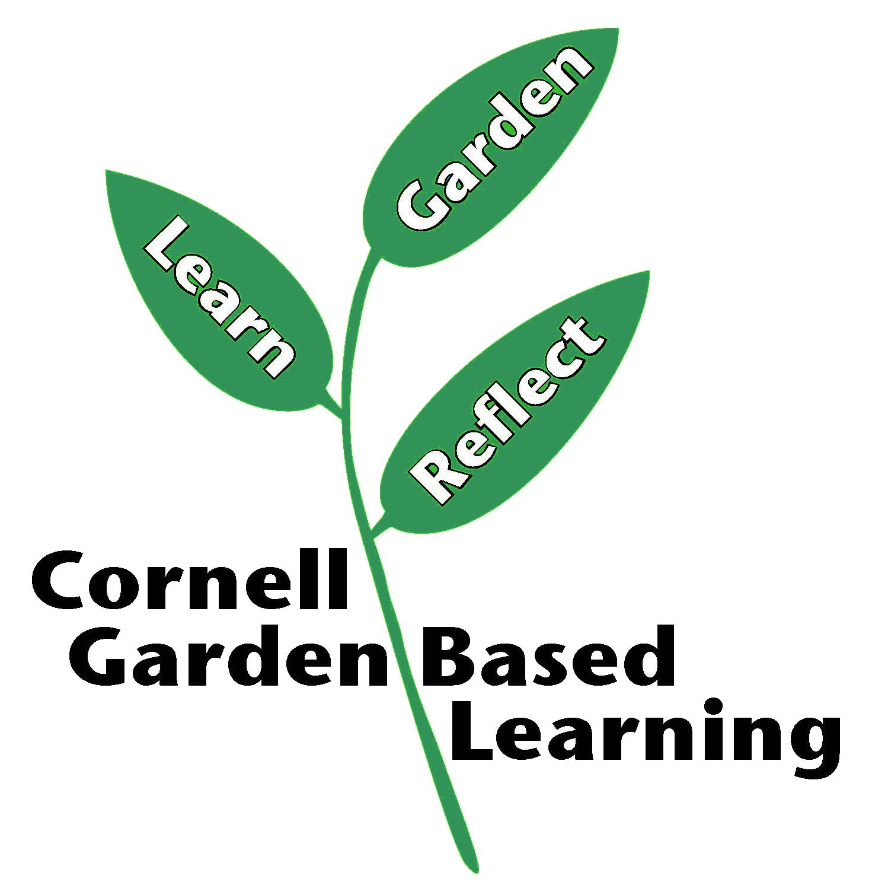
Date Published/Updated: April 2019
Author(s)/Contributor(s): Michelle Podolec
Reviewer(s): Fiona Doherty

