Woody Plants
Knowledge Check
In the GBL Learning Library - Core Preparation Sessions
this is Section 3.1 in Module 3: Plant Ecosystem Services

1. What are the challenges that can surface when trying to embrace both the “Right Plant, Right Place” approach and the goal to select native woody plant species?

2. Visit the Cornell University’s Woody Plant Database to help you answer the next three questions http://woodyplants.cals.cornell.edu.
A. What is the scientific name for Spicebush? What pH does Spicebush prefer?

B. What is the common name for Quercus acutissima? Describe Quercus acutissima moisture tolerance.

C. What evergreen shrub can tolerate acid to alkaline soil and salt spray?

3. In what three forms are trees and shrubs typically purchased?

4. Why is building a volcano of mulch around a tree not good for the tree?

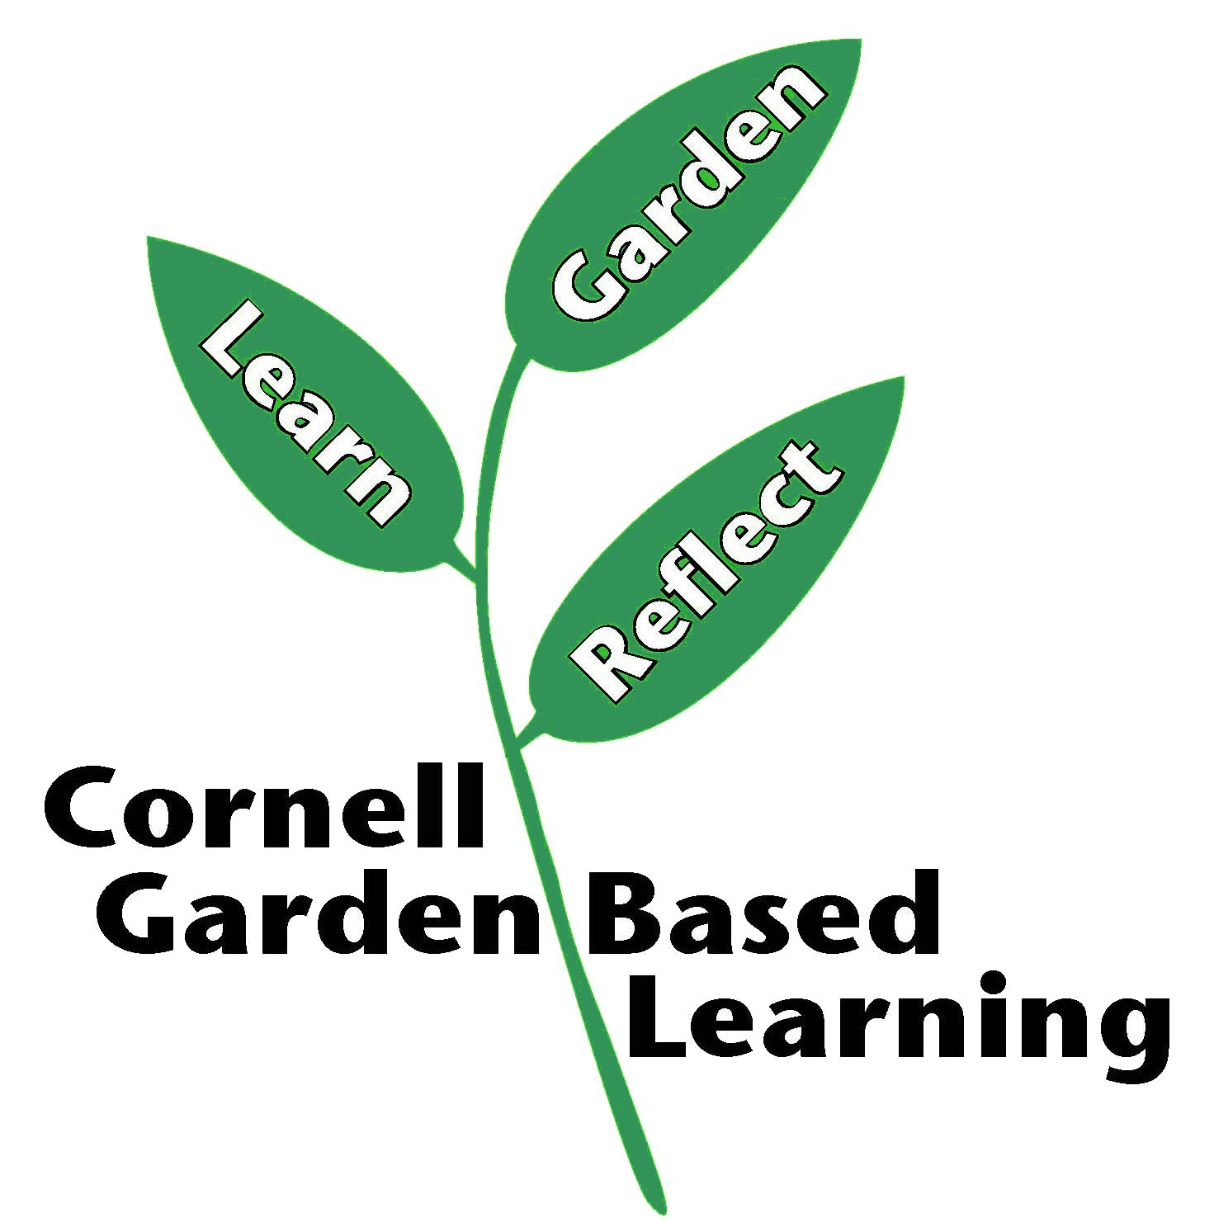
Published: April 2019
Compiled by: Lori Brewer
Reviewer: Donna Alese Cooke, Michelle Podolec, Fiona Doherty, Nina Bassuk

