Community Engagement
Knowledge Check
In the Learning Library - Core Preparation Sessions
this is Section 2 in Module 0: Introduction

- Identify one or more characteristics of an effective member of a peer-learning network.

Responses may vary; trust, personal readiness, flexibility, an understanding of the viewpoints of others. (See post-work reading Qualities of an Active Contributor to a Peer Learning Network)

- Reflect on one major takeaway you got from the community engagement video discussions or the facilitation scenarios. What is important to remember when working in community?
Responses will vary. Look for key themes from community engagement videos and key points of learning that came from facilitation scenarios.

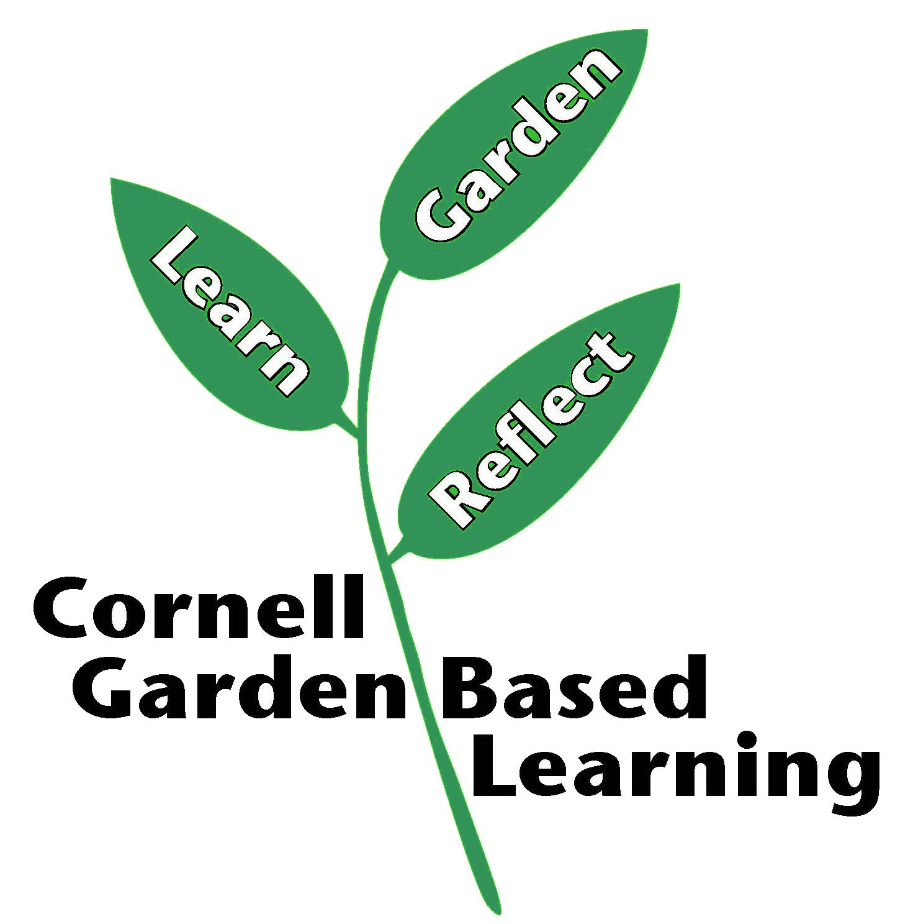

Date Published: April 2019
Author: Fiona Doherty
Reviewer(s): Marcia Eames-Sheavly, Michelle Podolec, Lori Brewer

