Your Identity Pie Chart Worksheet

Time: 15 to 30 minutes
Learning Objective: Reflect on your identity.

Instructions:

Consider and jot down:
- Who are you?
- What are the things that make up who you are?

Create:
- A pie chart identifying characteristics that have some importance to your self-concept.
- Indicate the approximate importance of each characteristic by the size of the slice of pie that you assign to it.
An example of an identity pie chart

Reflect:
- How might elements of your identity impact your role as a peer educator? And your contributions to a peer learning network?

Adapted from Developing competency to manage diversity: Readings, cases and activities; © 1997 by Taylor Cox, Jr., & Ruby L. Beale, Berrett-Koehler Publishers, Inc., San Francisco, CA. http://www.sagepub.com/upm-data/5000_Powell_Chapter_1.pdf

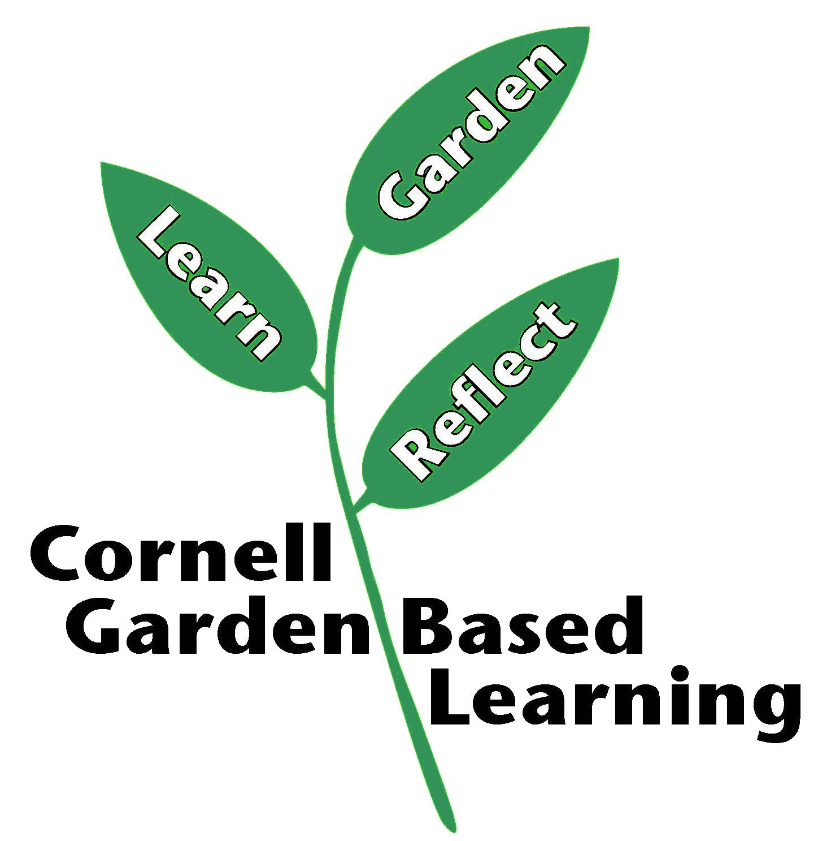
Date Published: April 2019
Author: Lori Brewer
Reviewer: Michelle Podolec

