Problem Solving: Pests of Food Crops and Ornamental Plants Knowledge Check KEY

In the GBL Learning Library - Core Preparation Sessions

this is Section 4.3a in Module 4: Problem Solving

- What are the ABCD’s of submitting samples to the Plant Disease and Insect Diagnostic Labs, for accurate and timely results? (From Test Don’t Guess Brochure: Cornell University Plant Disease Diagnostic Clinic)

Ask questions prior to submitting a sample
- Review this brochure, refer to our websites or call ahead to determine what type of material should be included in the sample
- Check with staff to determine if holidays may interfere with the receipt of samples

Be observant
- look around the area of concern
- note characteristics of the damage
- stand back and consider the big picture, then note
the damage to the entire site, on individual plants and on individual plant parts

Collect a quality, representative sample
- Gather material with a broad range of symptoms including early to late stages of symptom expression
- collect material prior to any pesticide applications

Details should be provided with the sample material
- Fill out the submission form carefully and completely
- Describe the situation with details about when it first occurred, the plant(s) affected and level of damage
- include the location and date of collection
- Always include all your contact information so the diagnostician can contact you with questions and provide you with answers efficiently shipping of material for analysis

- What are best methods and tips for shipping materials for analysis?
(From Test Don’t Guess Brochure: Cornell University Plant Disease Diagnostic Clinic)
• Send material using the fastest means possible
• Ship early in the week to avoid your sample spending the weekend in a post office or warehouse
• If you can’t send material immediately, keep it refrigerated until you can

- Dead plant samples are as good as live samples for proper diagnosis. True or False
Select specimens that display a range of symptoms. Try to include plants that show early examples of the problem and those with increasing levels of damage. Do not include what appears to be dead material; this material may no longer include the primary source of the problem. (From Test Don’t Guess Brochure: Cornell University Plant Disease Diagnostic Clinic)
- Avoid using railroad ties, telephone poles, pressure-treated wood and some painted wood, because they contain chemicals that can get into vegetable garden soil. True or False
Avoid treated wood, railroad ties, telephone poles, pressure-treated wood and some painted wood contain chemicals that can get into soil. (From What Gardeners Can Do: 10 Best Practices for Healthy Gardening from http://cwmi.css.cornell.edu/healthysoils.htm)

- What are the steps to help guide your observations and fact collection when making conclusions for vegetable and fruit problems?
(From Plant Diagnostics: What is “wrong” with my plant?)
- Know what is normal to determine if a ‘REAL’ problem exists.
- Check for symptoms. Symptoms can be categorized as:
  - Underdevelopment of tissues or organs.
  - Overdevelopment of tissues or organs.
  - Necrosis or death of plant parts.
  - Alteration of normal appearance. Examples include mosaic patterns of light and dark
- Check for signs.
- Ask lots of questions.
- Final Diagnosis

Laboratory Tests
Refer to local county Diagnostic Labs and Cornell Resources:
Insect Diagnostic Laboratory - http://idl.entomology.cornell.edu/
Plant Disease Diagnostic Clinic - http://plantclinic.cornell.edu/
Cornell soil test guidance - http://cwmi.css.cornell.edu/GuidanceSoilTesting.pdf

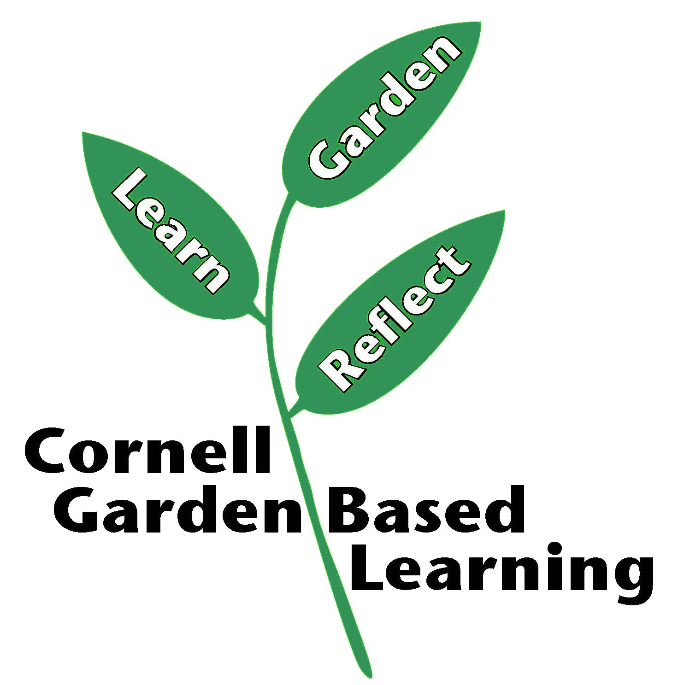

Date Published: April 2019
Author: Donna Alese Cooke
Reviewer: Fiona Doherty

