Fruit Gardening
Knowledge Check KEY
In the GBL Learning Library - Core Preparation Sessions
this is Section 2.2 in Module 2: Food Gardening
All responses from Cornell Guide to Growing Fruit at Home https://ecommons.cornell.edu/bitstream/handle/1813/67/Cornell_Guide_to_Growing_Fruit.pdf?sequence=2&isAllowed=y
1. What is critical to consider before a gardener plants a fruit crop?
(From page 1 in Cornell Guide to Growing Fruit at Home)
Consider site selection, soil preparation, and planting plans. Before you order plants, you also need to learn about their pollination needs, their winter hardiness, and how susceptible a crop is to pests.
Most tree fruits will not bear fruit right away. They require a large commitment to pruning, pest management and care. A gardener needs to be sure he/she is ready to devote the time to the planting and maintenance of the tree fruits before he/she starts. Mistakes made in selection, soil preparation and planting are extremely hard to remedy due to the years of growth required before the trees come into bearing fruit.
2. Name several keys to success for growing fruit trees in the garden.
(From page 14 in Cornell Guide to Growing Fruit at Home)
- Choose cultivars that are hardy in your area. Dwarf cultivars bear fruit earlier than standard trees and are easier to manage in home plantings.
- Except for peaches (which are self-fruitful), plant at least two different cultivars for good pollination.
- Start with nursery grown one- or two-year old bare-root plants. Older plants are more difficult to train.
- Choose a site with good air circulation and air drainage (the air moves down and off site such as on a slope) that is not vulnerable to late spring frosts.
- Plant trees in early spring as soon as the soil has warmed and drained. Begin preparing soil (adjusting pH and adding organic matter) and controlling weeds a year before planting.
- Mulch with bark or wood chips to provide a grass-free zone within 2 feet of each tree.
- Stake dwarf and semi-dwarf trees, and commit to timely pruning and fruit thinning.
- Protect trees from deer, rodents, and other pests and diseases.
3. Name several keys to success for growing grape vines in the garden.
(From page 43 in Cornell Guide to Growing Fruit at Home)
- Choose disease-resistant cultivars that are hardy for your site.
- Make sure your site gets full sun and has good air circulation.
- Prune vines annually during the dormant season, removing up to 90% of new growth.
4. Name several keys to success for growing strawberries in the garden.
(From page 54 in Cornell Guide to Growing Fruit at Home)
- Choose a site with full sun, good drainage, and a pH between 5.5 and 7.0.
- Begin improving the soil the year before planting, especially if the pH needs adjusting.
- Plant in early spring in soil where no strawberries, brambles, or crops in the tomato family (including potatoes, peppers, and eggplants) have grown for several years.
- Strawberries are shallow rooted. Keep plants well-watered, especially just after planting.
- Do a good job of early weed control during the establishment year to prevent problems later. If using the matted-row system, pluck flowers the first year to encourage runners to fill out a 12- to 15-inch-wide strip, but don’t let plants get too crowded.
5. Name several keys to success for growing brambles (raspberries and blackberries) in the garden. (From page 65 in Cornell Guide to Growing Fruit at Home)
- Choose a sunny site with well-drained soil. Brambles need lots of moisture, but they will not tolerate soggy soil.
- Do not plant brambles in a site where strawberries or plants in the tomato family (including potatoes, peppers, and eggplants) have been grown.
- Prepare the soil at least a year before planting, particularly if pH and nutrient levels need to be adjusted. Get weeds under control before planting.
- Trellis the plants for easier management and harvesting and to keep the fruit from coming in contact with the ground and rotting.
- Be prepared for annual or even twice-a-year pruning. With most types of brambles, you’ll need to thin the plants to get a good harvest of high-quality fruit.
6. Name several keys to success for growing blueberries in the garden.
(From page 77 in Cornell Guide to Growing Fruit at Home)
- Your soil must be acidic, with a pH of less than 5.0.
- Test the soil and start reducing its pH at least a year before planting. If the pH is more than 7.0, it may be too difficult to reduce pH. Consider growing something else instead.
- Choose a sunny site and avoid frost pockets.
- Plants require at least a 140-day frost-free growing season.
- Blueberry plants prefer a moist but well-drained soil but will tolerate a wide range of soils (as long as the pH is less than 5.0).
- Plants are sensitive to moisture stress, especially the first few years after transplanting.
7. Name several keys to success for growing ribes (gooseberries and currants) in the garden.
(From page 84 in Cornell Guide to Growing Fruit at Home)
- Unlike most other fruits, currants and gooseberries grow well in partial shade.
- They prefer cool, moist locations on a north slope or the northern side of a building, for example.
- Choose a site with good air circulation to avoid powdery mildew, a disease that commonly plagues Ribes.
- Currants and gooseberries prefer rich soil with a high water-holding capacity.
- To prepare your site, incorporate organic matter well ahead of planting, particularly if you have light, sandy soil.
- Ribes are heavy nitrogen feeders. Mulches high in nitrogen, such as grass clippings, are ideal. If you use high carbon mulches, such as straw, you may need to apply extra nitrogen fertilizer.
- Prune annually to remove four-year-old canes. Mature plants should have about eight bearing canes.
References: Cornell Guide to Growing Fruit at Home, https://ecommons.cornell.edu/bitstream/handle/1813/67/Cornell_Guide_to_Growing_Fruit.pdf?sequence=2&isAllowed=y

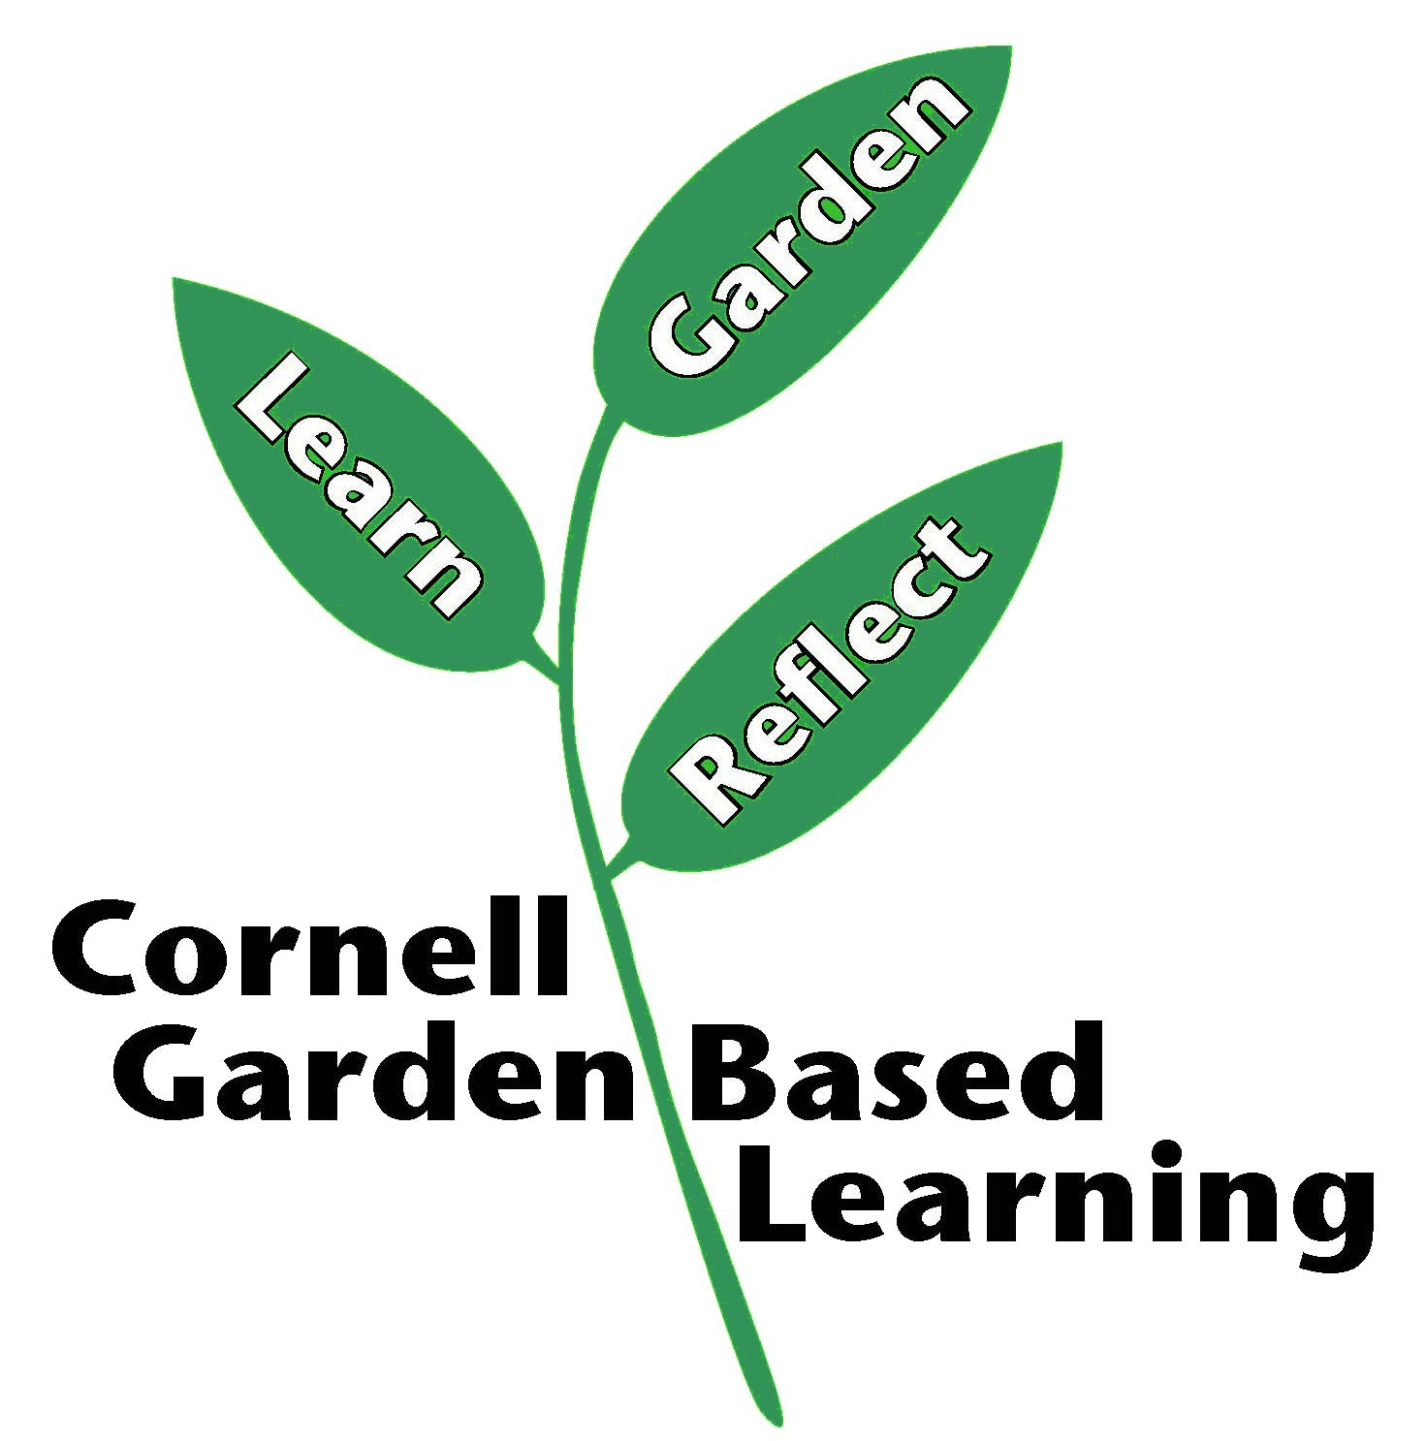
Published: April 2019
Compiled by: Fiona Doherty
Reviewed by: Donna Alese Cooke, Michelle Podolec, Russell Welser

