Facilitating Adult Learning
As a Master Gardener Volunteer peer educator, you will have the chance to facilitate adult learning. This involves engaging active participants in their own learning, as well as encouraging self-reflection and other conditions that enable them to learn.
Facilitation is different from a more didactic and ‘teachy’ style of classroom learning (which somewhat sadly, has likely been the primary foundation of your own learning!) Malcolm Knowles identified several practices that seem to embody effective facilitation….
- Establish a climate conducive to learning.
- Involve learners to formulate their own learning outcomes.
- Encourage learning to identify and use a variety of resources to accomplish these outcomes.
- Help adult learners implement, evaluate and reflect on their learning.
Knowles, Malcolm. 1980. The Modern Practice of Adult Education: from Pedagogy to Andragogy. River Grove, IL: Follett.

A number of other thought leaders have described foundations of facilitating adult learning. One of these foundations is emotional intelligence: the ability to recognize and understand our own emotions (self-awareness) and the emotions of others (social awareness) and then to use this ability to guide our behavior (self-management) and manage our relationships (relationship management). What might this actually look like in the context of facilitating adult learning? An emotionally intelligent leader is easy to relate to and creates an atmosphere in which participants feel comfortable and listened to (even when she has her own workload to manage.) Her door is open, so to speak, she listens carefully, asks good questions, and her participants feel that she understands their learning needs. At the same time, she has clear boundaries, prioritizes her own self-care, and is not a door mat!
Goleman, Daniel. 1995. Emotional Intelligence: Why it can matter more than IQ. NY: Bantam.

In facilitation, self-direction is critical. Self-directed learning is often appreciated as a journey in addition to a destination, taking place not in isolation, rather, in connections with others as resources and fellow sojourners. The capacity for self-directed learning varies among us and can be developed. As Cheryl Lowry said, facilitating self-directed learning means inspiring learners to view knowledge and truth as contextual, to see value frameworks as cultural constructs, to appreciate that they can act on their world individually or collectively to transform it. You’ll want to consider and be sensitive to such things as…
- Use multiple modalities – not just didactic teaching – to achieve objectives.
- Attend to, notice, tweak and generally manage the learning experience with participants’ needs in mind.
- Fostering partnerships.
- Help participants stay focused on the overarching goals and outcomes, and periodically revisit goals to stay on track.

Lowry, Cheryl. 1989. Supporting and Facilitating Self-Directed Learning. Columbus, OH: ERIC Clearinghouse on Adult, Career, and Vocational Education.

Although there are many foundations of adult learning and facilitation, we’ll name one more – transformative learning. Transformation is fundamentally about being open to possibilities and perspectives by critically reflecting on one’s lived experience. This is vital since it generates new insights and signals a change in how we see and make sense of the world. It brings about more aligned, sustainable and synergistic behavioral patterns and actions. Facilitating community-based experiences can be transformational for facilitators, participants and partners. Because these relationships are collaborative and all of us are learning, we can make changes we have never considered before, too!
Mezirow, J. and Associates. 1990. Fostering Critical Reflection in Adulthood: A Guide to Transformative and Emancipatory Learning. San Francisco: Jossey-Bass.

Reflection on your experiences with facilitation…
Recall a time in which you facilitated someone else’s learning. (Alternatively, consider a time in which you witnessed someone who facilitated learning in a particularly vivid way).
Describe this experience.

What did you do? What did the learner do?

When you think about your efforts and what you aimed to do, what factors affected/contributed to the success of the experience? (On the other hand, if it was a ‘train wreck’ that you learned from, what contributed to its derailment…?)

If anything, what might you do differently next time?

What metaphor best describes how this whole experience felt for you?

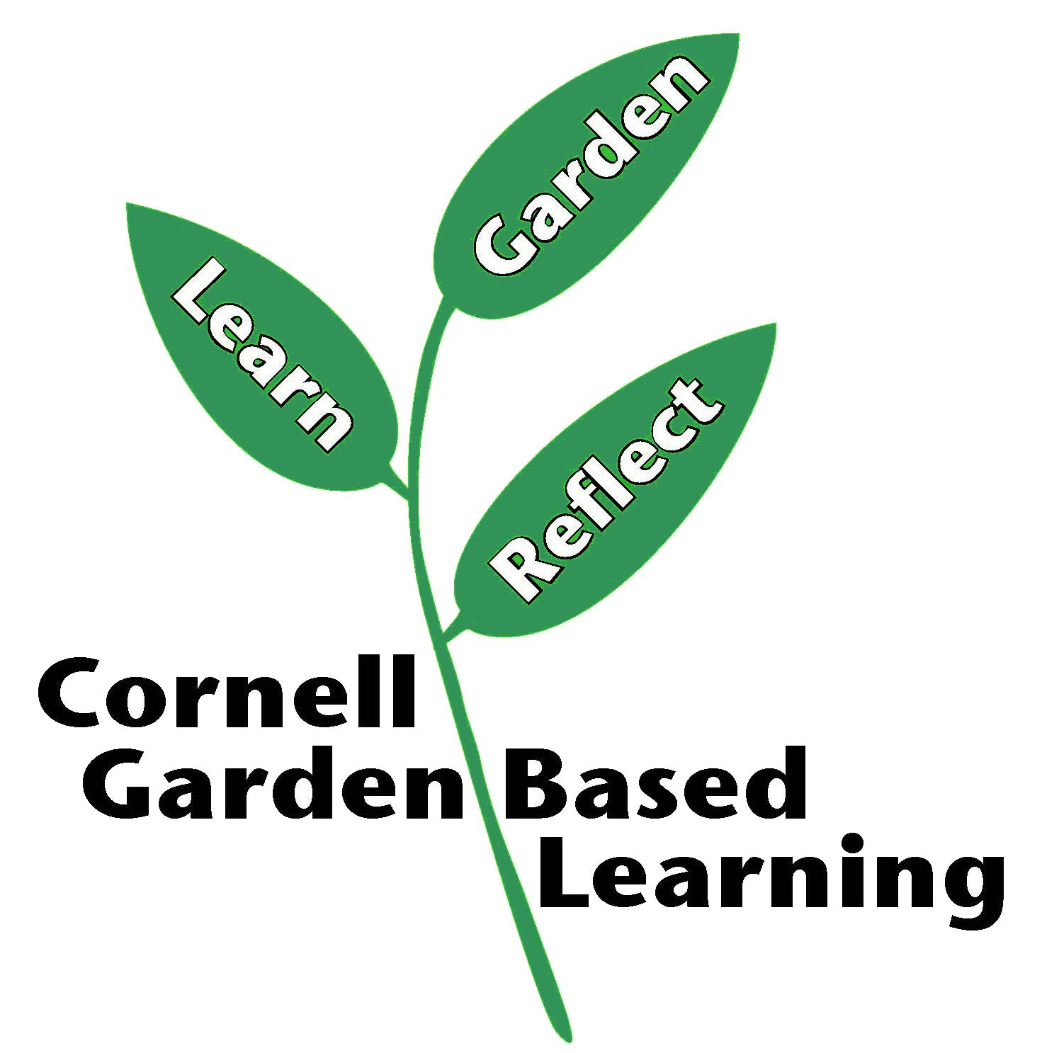

Adapted from Marcia Eames-Sheavly’s Facilitating Adult Learning for Cornell University’s Seed to Supper course
Published: September 2020

