Engaging Low-Literacy Audiences
Participant Guide

According to The New England Journal of Medicine, 12 percent of U.S. adults are estimated to have below basic “document literacy,” meaning they lack the ability to read and understand documents and labels. Low-literacy audiences may face many overwhelming challenges: poverty, unemployment, food insecurity, and the deep shame that undergirds these issues. It is difficult for this demographic to find accessible resources, including horticulture and IPM education. As our program increasingly meets the needs of low-income gardeners, we are learning that this marginalized community lacks even the most basic resources to properly participate in food gardening projects. Furthermore, without being able to read and understand documents, labels, directions and the basics of ecological gardening, it is highly likely they carry out improper horticultural product practices which could be detrimental to our environment – and to themselves and their families.
By actively participating in this session, you will:
- Identify the definition of low-literacy along with other common factors that may inhibit an individual’s reading comprehension.
- Understand the impacts of being low-literacy.
- Reflect on common assumptions surrounding low-literacy audiences.
- Practice adapting language into plain language.
- Practice testing the readability of materials.
- Reflect on how these new skills will impact your work as a MGV.
Before Session

READ:
- Guidelines for Best Practices: How Do We Reach Low-Literacy Audiences? (pdf, 74 pages)
WATCH:
- Readability Test Using Microsoft Word video (1.5 minutes)

DO:
- Find a factsheet or other educational resource that you’ve previously used or one that you find to be interesting. Bring it to class.
- Go to page 12 of the Guidelines for Best Practices, read the statements in Table 4 and reflect on the following questions:
  - Have you made any of the assumptions? How have they impacted your engagement with community members?

THINK:
- In addition to reading level, what are some factors that may impact an individual’s reading comprehension?

Opening and Introduction
- Facilitator reviews housekeeping, ground rules, learning objectives, and class flow.
Reconnect
- Partner up to discuss the question listed under the pre-work THINK prompt.
Public Engagement Brainstorm
- Follow the Public Engagement Brainstorm activity handout.
Plain Language Activity
- Follow the Plain Language activity handout.
Conclusions
- Facilitator leads group reflection on key take home points and any lingering questions.
Program Feedback
- Share your insight to help us improve the program, report results, & plan for the future.
Knowledge Check
- Assess what you now know. Be motived and empowered to share your knowledge with your peers and to learn more.
After Session

DO:
- Practice testing the readability of different resources using the Microsoft Word readability tool or another tool covered in the Guidelines for Best Practices.
EXPLORE:
- Visit the Department of Agriculture website (https://www.usda.gov/), which received an A- for plain language, and compare it to the Department Housing and Urban Development (https://www.hud.gov/), which received a D for plain language. What differences do you see?

REFLECT:
- What happened?
- What was my response to what happen? How do I make sense of it?
- How does it relate to other things I know?
- What can I conclude?
- What might I do differently next time?

LEARN MORE:
- National Assessment of Adult Literacy, https://nces.ed.gov/naal/literacytypes.asp
- State and County Estimates of Low Literacy, https://nces.ed.gov/naal/estimates/StateEstimates.aspx
- https://www.plainlanguage.gov/law/
- How to write low literacy materials from Journal of Extension, https://www.joe.org/joe/2001february/tt2.php
- What is science literacy, http://www.literacynet.org/science/scientificliteracy.html
- Disparities in science literacy from Science Magazine, http://science.sciencemag.org/content/360/6391/861
- What is post literate society, https://www.youtube.com/watch?v=ffyfHCEtGtA

Looking for Cornell people and resources? Don’t google, try the Cornell web search: http://www.cornell.edu/search/index.cfm

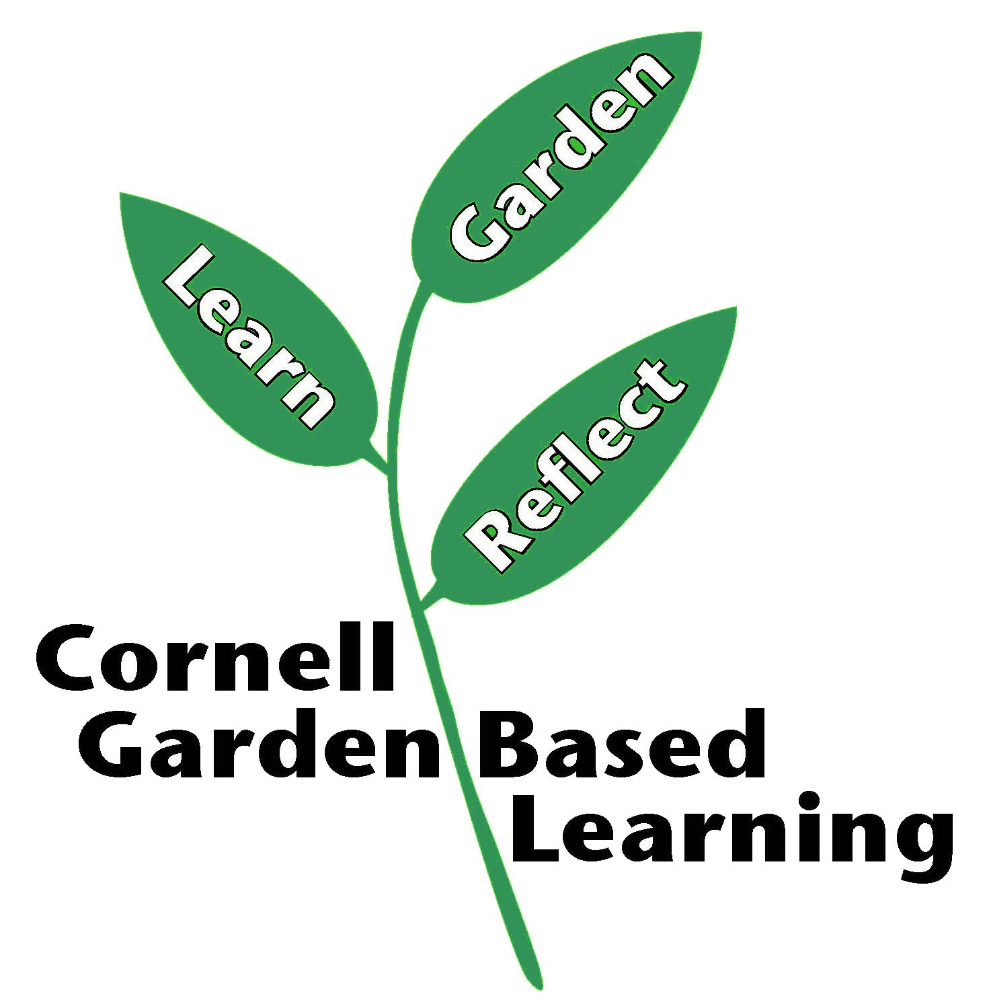

Date Published: April 2019

