WHO:  Participants | Individuals preparing for Master Gardener Volunteer role.
WHY:  The Situation | According to The New England Journal of Medicine, 12 percent of U.S. adults are estimated to have below basic “document literacy,” meaning they lack the ability to read and understand documents and labels. Low-literacy audiences may face many overwhelming challenges: poverty, unemployment, food insecurity, and the deep shame that undergirds these issues. It is difficult for this demographic to find accessible resources, including horticulture and IPM education. As our program increasingly meets the needs of low-income gardeners, we are learning that this marginalized community lacks even the most basic resources to properly participate in food gardening projects. Furthermore, without being able to read and understand documents, labels, directions and the basics of ecological gardening, it is highly likely they carry out improper horticultural product practices which could be detrimental to our environment – and to themselves and their families. (Marcus, 2006)
WHEN:  Timing | 1 hours: 55 minutes of session time & 5 minutes for a break.
WHERE:  Space | Classroom setting with seats and tables arranged in a circle or in clusters conducive to discussion and participation.
Learning Objectives* | Learning Strategy (name specific approach to be used)
- Identify the definition of low-literacy along with other common factors that may inhibit an individual’s reading comprehension. | Pre-work THINK prompt and in-class discussion
- Understand the impacts of being low-literacy. | Pre-work reading, Guidelines for Best Practices: How Do We Reach Low-Literacy Audiences?
- Reflect on common assumptions surrounding low-literacy audiences. | Pre-work reflection
- Practice adapting language into plain language. | Plain Language Activity
- Practice testing the readability of materials. | Pre-work video and post-work prompt
- Reflect on how these new skills will impact their work as a MGV. | Plain Language Activity, Public Engagement Brainstorm Activity
*These learning objectives match those in Participant Guide & Presentation.

Before Session

Total time for preparation will vary; minimally 2 hours.

Consider adult learning theory and strategies for implementation

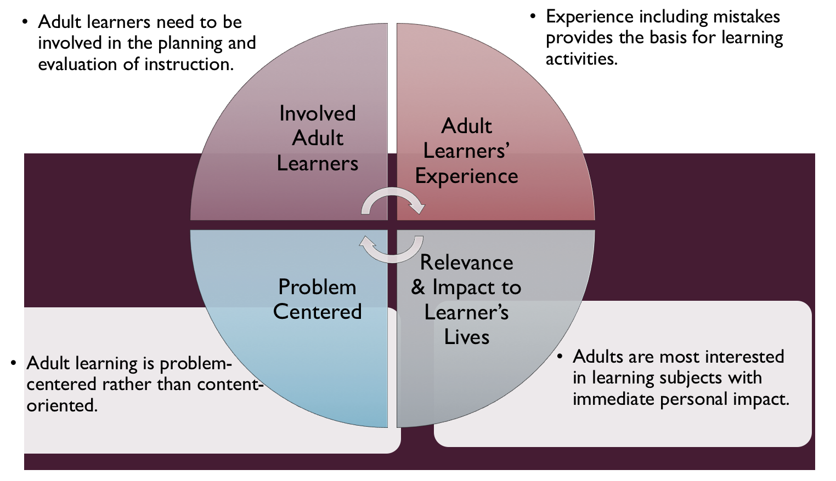
Figure credit: C. J. Carmichael adapted from M. S. Knowles and R.E. Mayer
Additionally, adult learners:
- Are experts of their lived experience.
- Come with their own motivations and goals.
- Need a safe and trusting learning environment.
- Know or will come up with 85% of the information you are planning to share.
- Remember 30% of what they hear and see, 50% of a demonstration, 70% of what they simulate, and 90% when they do the real thing.

Facilitated dialogue allows the classroom to become a conversation. Such discussion offers a way for students to explore supposedly settled questions and develop a fuller appreciation for the complexity of our knowledge. Model and encourage participants to ask open-ended questions that don’t seek yes/no answers or have right wrong answers. This will help create a safe and trustworthy learning environment that helps participants reflect on information and make it personally relevant. The ground rules for engagement from the Intro Session in the Learning Library- Core Preparation can be re-introduced if discussions lead to difficult and emotional conversations.

Review (time will vary; minimally 1 to 2 hours)
Go to the online Learning Library– Advanced Preparation and review the resources available in the section Engaging Low-Literacy Audiences including:
- FAQs
- Facilitator Guide
- Participant Guide
- Knowledge Check
- Print Materials for Before Session Pre-Work and Hands-on Activities

Gather materials and supplies (1 hour)
Gather post-it notes and print handouts for the Public Engagement Brainstorm Activity.
Gather highlighters and laptops (optional), print handouts for the Plain Language Activity.

Communicate with participants before session (1 hour)
Ideally at least 2 weeks in advance of this session provide participants with the Participant Guide found in the Learning Library- Advanced Preparation. This document details what participants must do before the session. Review the document to determine if you need to supply any material in advance and to confirm the links are still good. Time to complete this pre-work will vary depending on the participant’s background and interest. We estimate most participants should allocate 3 to 5 hours.

Program Evaluation/Feedback (1 hour)
See section below.

Session Flow and Delivery

Total time for session is 1 hour: 55 minutes of task time & 5 minutes for a break.

As participants settle in, ask them to complete a review activity that you’ve prepared or selected from the review bank OR go over pre-work with others around them.

Session Tasks
Task 1: Opening and Introduction (5 minutes)
Welcome everyone, review housekeeping, ground rules, learning objectives, and class flow.

Task 2: Reconnect (5 minutes)
Ask participants pair up to discuss the question under THINK in their Participant Guide.

Task 3: Public Engagement Brainstorm Activity (20 minutes)
Follow the activity handout.
5 Minute BREAK

Task 4: Plain Language Activity (15 minutes)
Provide participants with the Plain Language Activity handout. Ask them to complete Steps 1-3 independently and then pair up with a partner to discuss Step 4.

Task 5: Conclusion (5 minutes)

Ask participants to reflect on key take home points from today and any lingering questions.
Direct participants’ attention to the items listed under After Session in their Participant Guide.

Task 6: Program Evaluation/Feedback (5 minutes)
Provide participants with an avenue to give feedback and data for your program evaluation including reporting. See section below on Program Evaluation/Feedback.

Task 7: Participant Evaluation/Knowledge Check (part of participant’s After Session work)
Provide an avenue for participants to assess what they know. See section below on Participant Evaluation/Knowledge Check.

After Session

Total time for follow-up will vary; minimally 2 hours.

Communicate with participants after session (1 hour)
Follow-up on unanswered content questions that emerged during session as needed as well as provide feedback on the knowledge check.

Consider Program Evaluation/Feedback (1 hour)
Summarize the feedback and data you received from participants for your program reporting and or future planning needs. See section below on Program Evaluation/Feedback.

Session Materials and Supplies
General Materials List
Facilitator notes Markers Index cards Pens
Highlighters Flip chart paper Name tags Feedback Forms
Post-it® notes Masking tape Computer/Internet/Projector

Materials by Task
Before Session Tasks
- Materials found in MGV Learning Library:
  - Advanced Topic, Engaging Low-Literacy Audiences session
  - Evaluation Toolkit
Task 1 - Opening and Introduction
- Participant Guide
- Facilitator Guide
Task 2 - Reconnect
- Participant Guide
- Flip chart paper and markers for group discussion notes
Task 3 – Public Engagement Brainstorm Activity
- Activity handouts
- Post-it notes, enough to have 5-10 per participant
- Blank wall
Task 4 – Plain Language Activity
- Activity handouts
- Participants should bring a fact sheet or other written educational resource with them
- Highlighters
- Pens/pencils
- Laptops (optional)
Task 6 – Conclusion
- Participant Guide
- Flip chart paper and markers for group discussion notes
Task 7 – Program Evaluation/Feedback
- Your evaluation/feedback materials
Task 8 – Participant Evaluation/Knowledge Check
- Materials for participants to assess what they know around this topic such as Knowledge Check from MGV Learning Library
For After Session
- Feedback from participants
- Reporting forms
- Knowledge Check Key from MGV Learning Library

Optional Activities

Frequently Asked Questions (FAQs)
With the input of county and campus-based experts, we have compiled a list of top FAQs for each topic areas and placed it with the other session resources in the MGV Learning Library. Though not an exhaustive list, it should provide an opportunity for discussion and exploration of resources related to the topic. Integrate the FAQs in a way that makes sense for your local program. The FAQs could be used to prompt discussions within your group or they could be adapted into a scavenger hunt where individuals sift through reliable resources to find correct answers. Feel free to add or subtract questions and resources in the answers to meet your program's needs and address emerging issues.

Participant Evaluation/Knowledge Check

Adult learners enjoy getting feedback on what they have learned. In the MGV Learning Library, you will find the Knowledge Check handouts for each session. You may ask participants to answer the questions at home on their own or in small groups discussions. The Knowledge Check KEY can be used to allow participants to self-check or for the educator to grade and provide feedback. You may wish to identify more engaging ways to self‐test what they have learned as it motivates and empowers them to be more accountable for their learning.

Program Evaluation/Feedback

Time for creating and implementing a program evaluation plan will vary; minimally 1 hour.

Ideally, evaluation begins before the program starts. Though for many educators, the idea of measuring the effects of your program is so daunting it never begins. With this in mind, we provide an Evaluation Toolkit in the MGV Learning Library. Our aim is to offer tools you can use, even while you’re on the run. Check it out as you consider these key questions:
- Who is this evaluation for?
- What do you want to know, and why?
- What’s do‐able, really?

Other key resources will be your local county program plan of work which likely aligns with CCE Programmatic Plans: http://www2.cce.cornell.edu/plans/Pages/FY-2016-CCE-Programmatic-Plans.aspx

Find on CCE staff website under the Organizational Development and Planning Unit a Program Reporting module: http://staff.cce.cornell.edu/orgdev/Pages/reporting.aspx

References

For Adult Learning Theory references see those listed in Learning Libraryin Module 6: Facilitating Learning Section 6.1 Adult Learning and Community Engagement.

Conrath Doak, C. (1996). Teaching Patients with Low-Literacy Skills. Philadelphia: J.B. Lippincott.

Marcus, E. N. (2006). The silent epidemic - The health effects of illiteracy. New England Journal of Medicine, 355(4), 339-341. https://doi.org/10.1056/NEJMp058328

The Plain Writing Act, (2010). What is Plain Language? Retrieved from https://www.plainlanguage.gov/about/definitions/

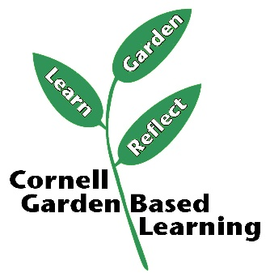

Date Published: April 2019

Facilitator’s Notes

List quotes and behavior change you noticed, especially those that may be included in your necessary reporting, success story, or for future program improvement:
List Participant Commitments that you will need to follow up on:
Changes and Adaptations to Session:

