Youth Development
Participant Guide
Gardening enhances the quality of life in numerous ways: providing fresh food, exercise and health benefits, opportunities for multi-generational and life-long learning, creating pleasing landscapes and improved environment, and bringing people together.
Garden-based learning programs result in increased nutrition along with environmental awareness, higher learning achievements, and increased life skills for our students. They are also an effective and engaging way to integrate curricula and meet learning standards, giving young people the chance to develop a wide range of academic and social skills.
Garden experiences foster ecological literacy and stewardship skills, enhancing an awareness of the link between plants in the landscape and our clothing, food, shelter, and well-being. They also provide children and youth with the time and space to explore the natural world–something that can occur rarely in today’s era of indoor living.
By actively participating in Youth Development, you will:
- Recognize the benefits of positive youth development and identify how to incorporate meaningful opportunities for youth engagement in garden-based learning (GBL) settings.
- Discuss some challenges, fears and expectations regarding youth engagement in the garden setting.
- Understand the steps to planning a successful garden project.
- Practice innovative garden-based activities and discuss how they could be adapted to fit various settings.
- Research school and youth garden projects in your community.
Before Session
DO:
- Research school and youth garden projects in your community.
- Take 10-15 minutes to look at the NYS 4-H website About and Mission, Vision, Values pages https://nys4-h.org/what-is-4h/, https://nys4-h.org/nys-mission-mission-values/
THINK:
What are the benefits of engaging youth in garden-based learning (GBL)? What are some challenges?
Opening and Introduction
- Facilitator reviews housekeeping, ground rules, learning objectives, and class flow.
Reconnect
- Partner up to discuss the question listed under the pre-work THINK prompt on page 1.
Gallery Walk Activity
- Walk around the room and add your thoughts to each of the prompts on the flipchart paper.
Benefits of Garden-Based Learning
- Listen to a lecture about Garden-Based Learning
Positive Youth Development and Effective Youth Engagement Activity
- Break into small groups and look over the Positive Youth Development Walk Around worksheet and Hart’s Ladder of Participation worksheet.
Planning a successful youth garden project activity
- Participate in this group activity to come up with key elements for a successful youth garden project. This includes the use of the CGBL logic model.
Garden-based learning curriculum for youth
- Practice garden-based learning activities; discuss curriculum sources and other aspects of garden based-learning.
Conclusions
- Facilitator leads group reflection on key take home points and any lingering questions.
  - What did you find most interesting or surprising about youth engagement? Do you have any lingering questions?
Program Feedback
- Share your insight to help us improve the program, report results, & plan for the future.
Knowledge Check
- Assess what you now know. Be motivated and empowered to share your knowledge with your peers and to learn more.
After Session
REFLECT:
- What happened?
- What was my response to what happen? How do I make sense of it?
- How does it relate to other things I know?
- What can I conclude?
- What might I do differently next time?

PRACTICE:
- Take 10-15 minutes to journal in response to the following prompt: Think back to an experience you had as a youth that incorporated elements of positive youth development and effective youth engagement. What did that feel like? What steps might you take to include that same feeling for youth you engage? Many of the same theories apply to adult engagement; how might you include feelings of belonging, power, mastery and generosity into an adult program?

LEARN MORE:
- Sowing the Seeds of Success, http://gardening.cals.cornell.edu/program-tools/ a web resource designed to walk you through the organizational aspects of a gardening program.
- Cornell Garden-Based Learning: Activities, evaluation toolkit, benefits and research: http://gardening.cals.cornell.edu/
- Junior Master Gardener Program: http://jmgkids.us/
- Act for Youth: Positive Youth Development 101 Manual: http://www.actforyouth.net/youth_development/professionals/manual.cfm
- Life Lab: School Garden Resources: http://www.lifelab.org/for-educators/schoolgardens/
- Effective Outdoor Management, http://www.lifelab.org/wp-content/uploads/2003/04/OutdoorClassroomManagement2.pdf (pdf)
- The Food Project: http://thefoodproject.org/activities/sustainable-agriculture-curriculum

Campus Links:
- NYS Ag in the Classroom: https://www.agclassroom.org/ny/
- Cornell Garden-Based Learning: http://gardening.cals.cornell.edu/
- 4-H Youth Development: https://nys4-h.org/

Looking for Cornell people and resources? Don’t google, try the Cornell web search: http://www.cornell.edu/search/index.cfm
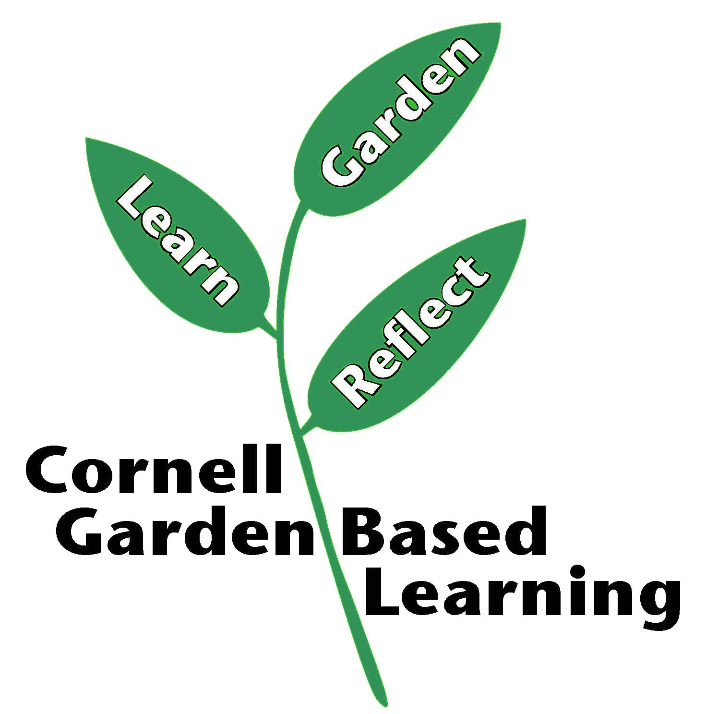
Date Published/Updated: April 2019

