WHO:  Participants | Individuals preparing for Master Gardener Volunteer role.
WHY:  The Situation | The demographics and needs of NYS youth and families have changed dramatically in recent decades as have the structure of the economy and resulting workforce needs. New York State has approximately 3.1 million youth, approximately 6% of the total youth population in the United States. New York is one of nine states that together account for more than 50% of the nation’s total youth population. The 4-H program must find ways to maintain its historically strong programs, volunteers and local funding support, while expanding the reach of 4-H in urban and suburban communities. The NYS 4-H YD program exists to connect youth to hands-on learning opportunities that help them grow into competent, caring, contributing members of society. Positive youth development through experiential learning is the foundation of 4-H programming. (Sourced from CCE Statewide Plan of Work)
WHEN:  Timing | 2.5 hours/135 minutes of session time & 15 minutes for a break.
WHERE:  Space | Classroom setting with seats and tables arranged in a circle or in clusters conducive to discussion and participation.
Learning Objectives* | Learning Strategy (name specific approach to be used)
Recognize the benefits of positive youth development and identify how to incorporate meaningful opportunities for youth engagement in garden-based learning (GBL) settings. | Benefits of GBL, Positive Youth Development worksheet, Hart’s Ladder of Participation worksheet
Discuss some challenges, fears and expectations regarding youth engagement in the garden setting. | Gallery Walk activity and discussion
Understand the steps to planning a successful garden project. | CGBL Logic Model, planning discussion
Practice innovative garden-based activities and discuss how they could be adapted to fit various settings. | Practice and discuss a variety of youth-focused activities
Research school and youth garden projects in their community. | Research existing local projects and discuss findings with a partner
*These learning objectives match those in Participant Guide & Presentation.
Before Session
Total time for preparation will vary; minimally 8 hours.
Consider adult learning theory and strategies for implementation
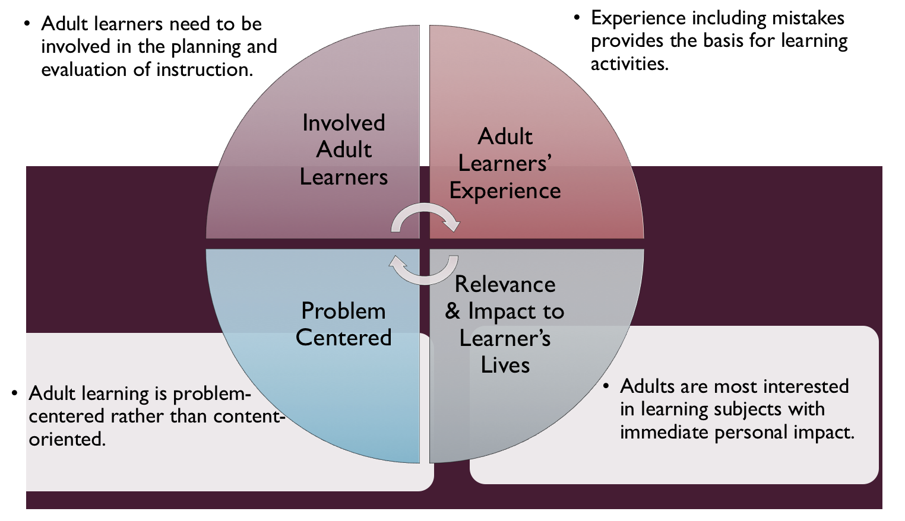

Figure credit: C. J. Carmichael adapted from M. S. Knowles and R.E. Mayer
Additionally, adult learners:
- Are experts of their lived experience.
- Come with their own motivations and goals.
- Need a safe and trusting learning environment.
- Know or will come up with 85% of the information you are planning to share.
- Remember 30% of what they hear and see, 50% of a demonstration, 70% of what they simulate, and 90% when they do the real thing.
Facilitated dialogue allows the classroom to become a conversation. Such discussion offers a way for students to explore supposedly settled questions and develop a fuller appreciation for the complexity of our knowledge. Model and encourage participants to ask open-ended questions that don’t seek yes/no answers or have right/wrong answers. This will help create a safe and trustworthy learning environment that helps participants reflect on information and make it personally relevant. The Ground Rules for Engagement from the Toolkit section in the GB Learning Library - Core Preparation can be re-introduced if discussions lead to difficult and emotional conversations.
Review (time will vary; minimally 4 to 6 hours)
Go to the online GB Learning Library - Core Preparation and review the resources available in the section Youth Development including:
- Session Slides and Facilitator Notes
- FAQs
- Facilitator Guide
- Participant Guide
- Knowledge Check
- Print Materials for Before Session Pre-Work and Hands-on Activities
Gather materials and supplies (2 plus hours)
- Positive Youth Development Walk Around*
- Hart’s Ladder of Participation Worksheet*
- CGBL Logic Model*
- Activities to practice, choose one or two activities from the list below or model a different youth engagement activity of your own choosing:
  - Group Bingo*
  - Mapping Your Favorite Meal
  - Conveyer Belt
  - Where Do You Land
  - Nutrition Superheroes
Communicate with participants before session (1 hour)
Ideally at least 2 weeks in advance of this session provide participants with the Participant Guide found in the GB Learning Library - Core Preparation. This document details what participants must do before the session. Review the document to determine if you need to supply any material in advance and to confirm the links are still good. Time to complete this pre-work will vary depending on the participant’s background and interest. We estimate most participants should allocate 3 to 5 hours.
Program Evaluation/Feedback (1 hour)
See section below.
Session Flow and Delivery
Total time for session is 2.5 hours - 135 minutes of task time & 15 minutes for a break.
Session Tasks
Task 1: Opening and Introduction (5 minutes)
Welcome everyone, review housekeeping, ground rules, learning objectives, and class flow.
Task 2: Reconnect (10 minutes) Feel free to share local/regional youth gardening programs that aren’t mentioned during the large group discussion. Ask participants to pair up and discuss the question under THINK in their Participant Guide.
Task 3: Gallery Walk activity (20 Minutes)
Gallery Walk Activity, see session presentation
Gallery Walk Discussion, session presentation

Task 4: Benefits of Garden-Based Learning (15 Minutes)
See session presentation or pre-recorded video in the Learning Library.
Task 5: Positive Youth Development and Effective Youth Engagement (20 Minutes)
Positive Youth Development Walk Around and Hart’s Ladder of Participation.
Introduce the two resources:
- In the case of most youth garden programs, youth make the decision to participate (or not to participate). A successful youth garden project will include each of these four elements: generosity, power, mastery and belonging.
- Research has shown that gardening interest is more strongly correlated with decision-making than garden activity. With that in mind, how might we more effectively engage young people?
  - Feel free to give specific examples from your local programs that demonstrate positive youth development and youth engagement
Handout and break into small groups to discuss.
- How might they include generosity, power, mastery and belonging into a youth garden program or activity?
- What are their thoughts, reactions or reflections based on Hart’s Ladder of Participation?
- Why are these tools important?
- How might both tools be applied to programs?

15 Minute BREAK
Task 6: Planning a successful youth garden project (35 minutes)
- Post-it activity (15 Minutes)
  - What are some key steps to planning a successful youth garden project? In a small group, write your thoughts on the post-its, one thought per post-it.
- Discuss post-its and add additional ideas (10 Minutes)
  - Some additional elements you may add include (see The Top 5 Things to Consider When Planning Your School Garden Program):
    - Start small
    - Partnerships are key
    - The importance of inclusion and communication
    - Effective youth engagement
    - Fundraising
    - Optional: Designing for children, see session presentation
- Logic Model (10 Minutes)
Key Term: A logic model is a simple work tool to assist you in planning, organizing and assessing your garden project goals, activities, partners and more. The visual diagram is priceless for planning effectively. The words within each box can even be modified to suit various planning needs.
  - Introduce the tool, discuss it and have them tuck it away for future use.
    - Often in our programs, we focus mostly on the activities. Giving thought to other program development areas can help ensure the success of a program.
    - Have you used logic models before?
    - Do you have any observations or questions on this particular template?
Task 7: Garden-based learning curriculum for youth (15 Minutes)
Model youth activities and discuss how they might be adapted.
- Choose one or two activities from the list below or model a different activity of your own choosing:
  - Group Bingo
  - Mapping Your Favorite Meal
  - Conveyer Belt
  - Where Do You Land
  - Nutrition Superheroes
Task 8: Conclusion (10 minutes)

Ask participants to reflect on key take home points from today and any lingering questions.
Direct participants’ attention to the items listed under After Session in their Participant Guide.
Task 9: Program Evaluation/Feedback (5 minutes)
Provide participants with an avenue to give feedback and data for your program evaluation and reporting. See section below on Program Evaluation/Feedback.
Task 10: Participant Evaluation/Knowledge Check (part of participant’s After Session work)
Provide an avenue for participants to assess what they know. See section below on Participant Evaluation/Knowledge Check.
After Session
Total time for follow-up will vary; minimally 2 hours.
Communicate with participants after session (1 hour)
Follow-up on unanswered content questions that emerged during the session and provide feedback on the knowledge check.
Consider Program Evaluation/Feedback (1 hour)
Summarize the feedback and data you received from participants for your program reporting and or future planning needs. See section below on Program Evaluation/Feedback.
Session Materials and Supplies
General Materials List
Facilitator notes, Markers, Index cards, Pens, Highlighters, Flip chart paper, Name tags, Feedback Forms, Post-it® notes, Masking tape, Computer/Internet/Projector
Materials by Task
Before Session Tasks
- Materials found in GB Learning Library:
  - Module 6: Starting and Sustaining Learning Gardens, Section 6.2 Youth Development
  - Evaluation Toolkit
Task 1 - Opening and Introduction
- Participant Guide
- Youth Engagement Session Presentation
Task 2 - Reconnect
- Participant Guide
- Flip chart paper and markers for group discussion notes
Task 3 – Gallery Walk Hands-on Activity
- Flipchart paper with prompts, markers.
Task 4 - Youth Engagement Session Presentation: Benefits of GBL slides or pre-recorded video in the Learning Library.
Task 5 - Positive Youth Development Walk Around and Hart’s Ladder of Participation Worksheets
Task 6 - Post-its, CGBL Logic Model
Task 7 - Youth Activities to practice and discuss: Your choice of Group bingo, Conveyer Belt, Where Do You Land, Map Your Favorite Meal, Nutrition Superheroes or another garden-based learning activity for youth.
Task 8 – Conclusion
- Participant Guide
- Flip chart paper and markers for group discussion notes
Task 9 – Program Evaluation/Feedback
- Your evaluation/feedback materials
Task 10 – Participant Evaluation/Knowledge Check
- Materials for participants to assess what they know around this topic such as Knowledge Check from GB Learning Library
For After Session
- Feedback from participants
- Reporting forms
- Knowledge Check Key from GB Learning Library

Optional Activities
Frequently Asked Questions (FAQs)
With the input of county and campus-based experts, we have compiled a list of top FAQs for each topic areas and placed it with the other session resources in the GB Learning Library. Though not an exhaustive list, it should provide an opportunity for discussion and exploration of resources related to the topic. Integrate the FAQs in a way that makes sense for your local program. The FAQs could be used to prompt discussions within your group or they could be adapted into a scavenger hunt where individuals sift through reliable resources to find correct answers. Feel free to add or subtract questions and resources in the answers to meet your program's needs and address emerging issues.
Participant Evaluation/Knowledge Check
Adult learners enjoy getting feedback on what they have learned. In the GB Learning Library, you will find the Knowledge Check handouts for each session. You may ask participants to answer the questions at home on their own or in small groups discussions. The Knowledge Check KEY can be used for participants to self-check or for the educator to grade and provide feedback. You may wish to identify more engaging ways for participants to self‐test what they have learned as it motivates and empowers them to be more accountable for their learning.
Program Evaluation/Feedback
Time for creating and implementing a program evaluation plan will vary; minimally 1 hour.
Ideally, evaluation begins before the program starts. Though for many educators, the idea of measuring the effects of your program is so daunting it never begins. With this in mind, we provide an Evaluation Toolkit in the GB Learning Library. Our aim is to offer tools you can use, even while you’re on the run. Check it out as you consider these key questions:
- Who is this evaluation for?
- What do you want to know, and why?
- What’s do‐able, really?
Other key resources will be your local county program plan of work which likely aligns with CCE Programmatic Plans: http://www2.cce.cornell.edu/plans/Pages/FY-2016-CCE-Programmatic-Plans.aspx
Find on CCE staff website under the Organizational Development and Planning Unit a Program Reporting module: http://staff.cce.cornell.edu/orgdev/Pages/reporting.aspx
References
For Adult Learning Theory references see those listed in the GB Learning Library in Module 6: Facilitating Learning Section 6.1 Adult Learning and Community Engagement.
- Cornell Garden-Based Learning program. Accessed March 12, 2019 from http://gardening.cals.cornell.edu/
- New York State 4-H. Accessed March 12, 2019 from https://nys4-h.org/nys-mission-mission-values/
- Junior Master Gardener. Accessed March 12, 2019 from http://jmgkids.us/
- The Food Project. Sustainable Agriculture curriculum. Accessed March 12, 2019 from http://thefoodproject.org/activities/sustainable-agriculture-curriculum
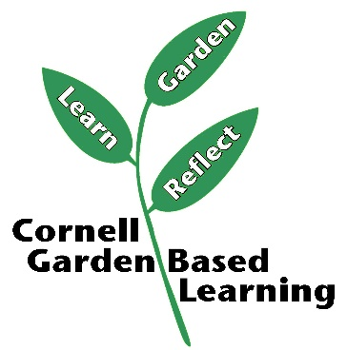
Date Published: April 2019

Facilitator’s Notes

List quotes and behavior change you noticed, especially those that may be included in your necessary reporting, success story, or for future program improvement:
List Participant Commitments that you will need to follow up on:
Changes and Adaptations to Session:

