Group Gardens and New York State Seed to Supper
Participant Guide

Food security is an identified focus area for the Master Gardener Volunteer program Mission and Vision. Nearly 1 million residents of upstate New York live in poverty, while the New York City metropolitan area has a 17% poverty rate. New York State ranked among the top 20 states with the worst food hardship, according to the Food Research and Action Center (FRAC), with 3 million New Yorkers relying on food assistance, 1 million being children. In response to these issues, NYS Seed to Supper (S2S) is a comprehensive beginning gardening experience focused on low budget strategies with community development and relationship building at its core. It gives novice gardeners the tools they need to connect with others in community, grow in confidence, and successfully grow a portion of their own food on a limited budget.

By actively participating in Group Gardens and New York State Seed to Supper, you will:
- Understand the basics of engaging with Community Organizations that run Group Gardens
- Define the Master Gardener Volunteer role in supporting Group Gardens and Seed to Supper.
- Prepare for the Seed to Supper program for interested Master Gardener Volunteers.

Before Session

Please review the following resources as supplements to the presentation.

READ:
- Liberated Roots - Review to become familiar with issues related to privilege and culturally responsive practices when engaging diverse groups in gardening.
Article From: Teaching Tolerance, Issue 58, Spring 2018, pg. 19 https://www.tolerance.org/sites/default/files/2018-01/Teaching-Tolerance-magazine-58.pdf (pdf)
- Top 5 Things to Know about Community Gardens (pdf available in Moodle course)
- The Complexities of Poverty and Hunger in New York State -Poverty and hunger in New York State is a complex issue – not one that can be introduced in just a page or two! As such, our aim with this brief overview is to begin to frame this multifaceted, challenging matter, particularly for those educators who may not have entered into this arena before, and to offer some questions for sincere reflection prior to embarking on the Seed to Supper journey (pdf available in Moodle course)
- The Seed to Supper Program and Its Effect on Low-Income Beginning Gardeners in Oregon - Review this Journal of Extension Article to understand the potential benefits of Seed to Supper from its origins in Oregon, such as program participants reducing their grocery bills as a result of growing their own food and eating more fruits and vegetables than usual during the growing season:
From Journal of Extension, June 2017, Volume 55: https://www.joe.org/joe/2017june/pdf/JOE_v55_3iw6.pdf

- Core Competencies for Seed to Supper Facilitators - Working with vulnerable populations requires a unique set of competencies – those skills, knowledge and abilities, as well as the “inner ground” necessary for working in community. Review this planning sheet to reflect on how you can build a robust team of facilitators as you build your NYS Seed to Supper program. (pdf available in Moodle course)
- NYS Seed to Supper Program: Roles and Responsibilities - Review the Garden Educator role that Master Gardener Volunteers may fill in this overview of the communities and relationships at the core of the NYS Seed to Supper (S2S) program (pdf available in Moodle course)

WATCH:
- Introduction: Seed to Supper - An overview of the program elements: https://youtu.be/6n8F8yB74uE
- Chimamanda Ngozi Adichie: The Danger of a Single Story

DO:
- One to several days before class get familiar with some of the activities surrounding cultural sensitivity in the garden:
  - Vegetable Matching Activity: https://cornell.box.com/s/qp5euxu67xai1lcq4hdydaan3wyt2e3d
  - Insensitive Statements:
https://cornell.box.com/s/mwbp9s76etw9muujzrzveekj7s4cfddu

THINK:
- What new ideas did you learn about when thinking through working with Group Gardens and Seed to Supper, and issues related to community tolerance and privilege? Where do you need support in your gardening outreach?

Opening and Introduction
- Facilitator reviews housekeeping, ground rules, learning objectives, and class flow.
Reconnect
- Partner up to discuss the question listed under the pre-work THINK prompt on page 2
Community Gardens
- Listen to presentation.
Why Engage Group Gardens? Activity Discussion
- Engage in small group activity and whole group discussion. Having use of tablets, laptops, or smartphones is needed for this activity.
- Review the two pre-work readings in the context of group gardens and give examples of equitable engagement verses equality in garden education.
Group Garden Insensitive Statements Activity
- Facilitator leads participants through group activity.
New York State Seed to Supper
- Participants listen to presentation and reflect on partnership organizations to engage in Seed to Supper.
Conclusions
- Facilitator leads group reflection on key take home points and any lingering questions.
Program Feedback
- Share your insight to help us improve the program, report results, & plan for the future.
Knowledge Check
- Assess what you now know. Be motivated and empowered to share your knowledge with your peers and to learn more.
After Session

REFLECT:
- What happened?
- What was my response to what happen? How do I make sense of it?
- How does it relate to other things I know?
- What can I conclude?
- What might I do differently next time?

PRACTICE:
- Practicing equity, diversity and inclusion in relation to food security and gardening takes practice and dedication. Here are a few resources to support you as you take your knowledge to the next step:
  - The American Community Gardening Association has professional development events related to engaging with Community Gardens: https://www.communitygarden.org/resources
  - Teaching Tolerance has educational tools and self-guided professional development on: Race & Ethnicity, Religion, Ability, Class, Immigration, Gender & Sexuality. https://www.tolerance.org/professional-development
  - North American Association for Environmental Education has Environmental Justice Resources to practice using inclusivity frameworks: https://naaee.org/eepro/resources/environmental-justice-resources
  - Free Civic Ecology Courses - Urban Environmental Education Approaches: https://civicecology.org/course-uee/

LEARN MORE:
  - A Free Seed to Supper Manual from Oregon Food Bank (pdf)
  - Multiple Social Identity Profile Overview (pdf)
  - The Complexity of Identity: "Who Am I?" (pdf)
  - The Culture of Power (Paul Kivel) (pdf)
  - The Increasingly Diverse United States of America (Washington Post) (url)

Campus Links:
- Cornell's Civic Ecology Lab: https://www.civicecology.org/
- Cornell Garden-Based Learning - Planning and Organizing: http://gardening.cals.cornell.edu/program-tools/planning-organizing/
- Cornell’s Diversity and Inclusion Homepage: https://diversity.cornell.edu/
- Cornell LibGuides - Local and Regional Food Systems: http://guides.library.cornell.edu/local_food/cornell/
- The Program on Applied Demographics (PAD) brings skills in demographics, economics, statistics, data gathering and data analysis together to provide a variety of organizations with data, information and advice:
https://pad.human.cornell.edu/

Looking for Cornell people and resources? Don’t google, try the Cornell web search: http://www.cornell.edu/search/index.cfm
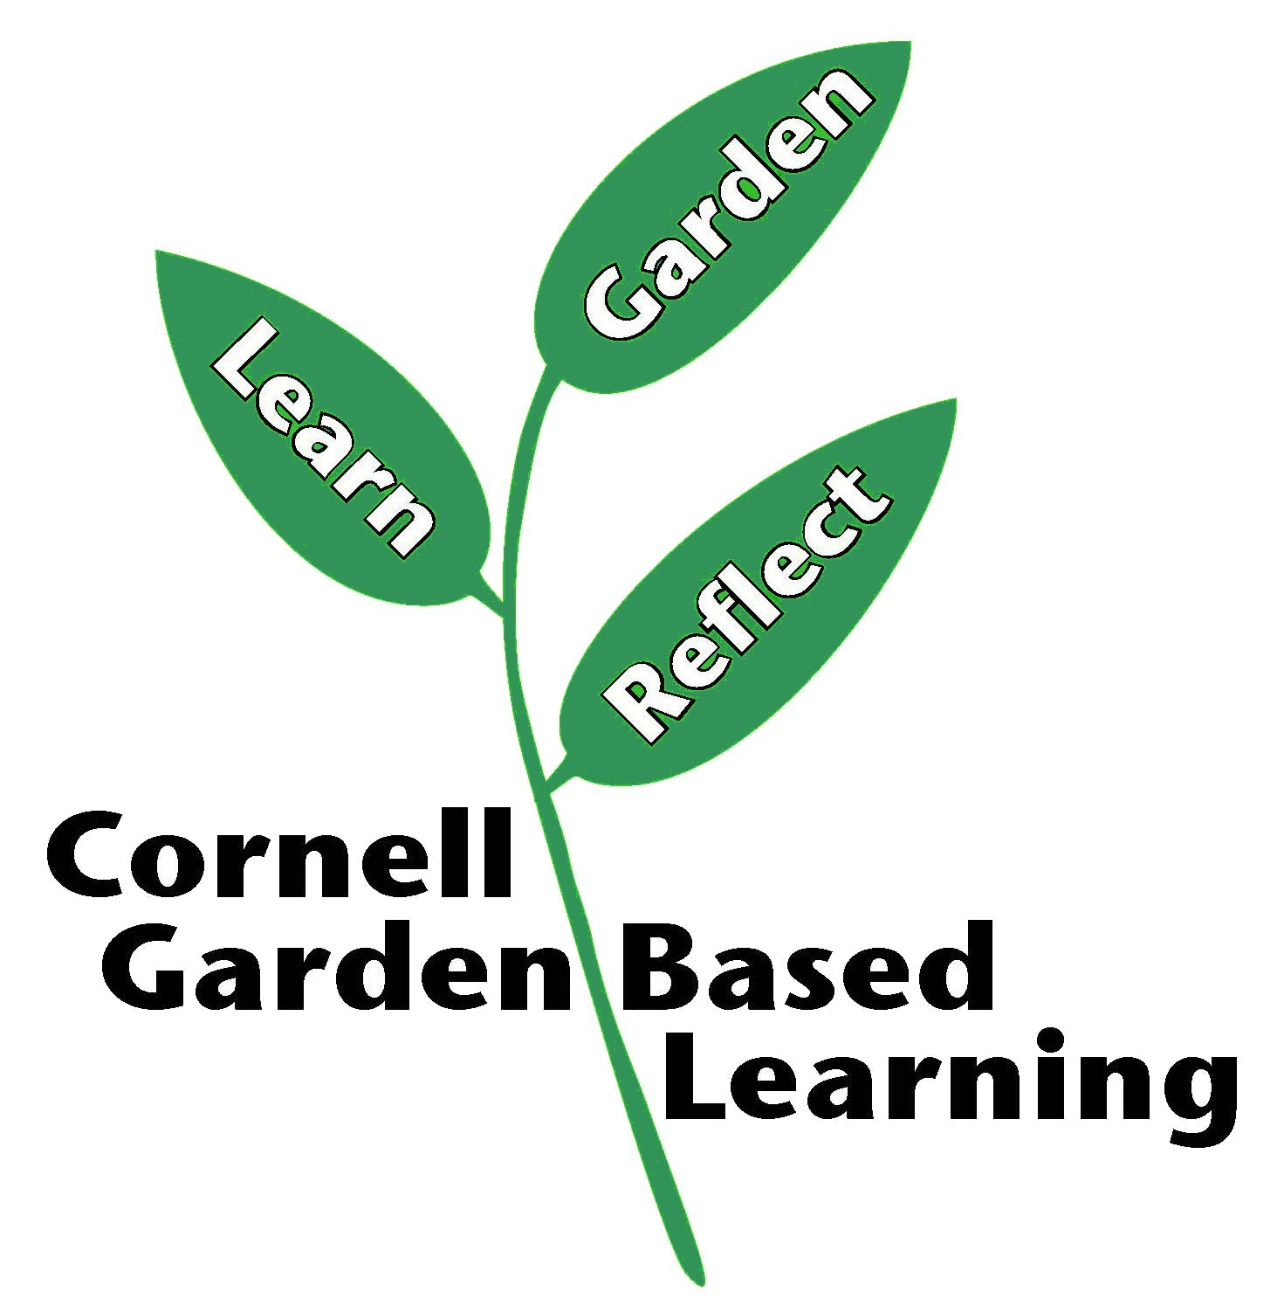
Date Published/Updated: 1/24/2020
Ashley Miller Helmholdt

