WHO:  Participants | Individuals preparing for Master Gardener Volunteer role and Seed to Supper Garden Educator role.
WHY:  The Situation | Food security is an identified focus area for the Master Gardener Volunteer program Mission and Vision. Nearly 1 million residents of upstate New York live in poverty , while the New York City metropolitan area has a 17% poverty rate. New York State ranked among the top 20 states with the worst food hardship, according to the Food Research and Action Center (FRAC), with 3 million New Yorkers rely on food assistance, 1 million being children.
WHEN:  Timing | 1 hour. 55 minutes of session time & 5 minutes for a break.
WHERE:  Space | Classroom setting with seats and tables arranged in a circle or in clusters conducive to discussion and participation.
Learning Objectives* | Learning Strategy (name specific approach to be used)
Understand the basics of engaging with Community Organizations that run Group Gardens | Read the Liberated Roots and the "Why Engage Group Gardens" discussion following the Community Gardens Lecture. Practice equitable engagement with the Insensitive Statements and Vegetable Matching Hands-on Activities.
Define the Master Gardener Volunteer role in supporting Group Gardens and Seed to Supper. | Review the Core Competencies of Seed to Supper Facilitators handout, Seed to Supper Roles and Responsibilities handout.
Prepare for the Seed to Supper program for interested Master Gardener Volunteers. | Research and discuss potential partnerships for Seed to Supper. Review videos and poverty data and materials.
*These learning objectives match those in Participant Guide & Presentation.

Before Session
Total time for preparation will vary; minimally 4 hours.
Consider adult learning theory and strategies for implementation
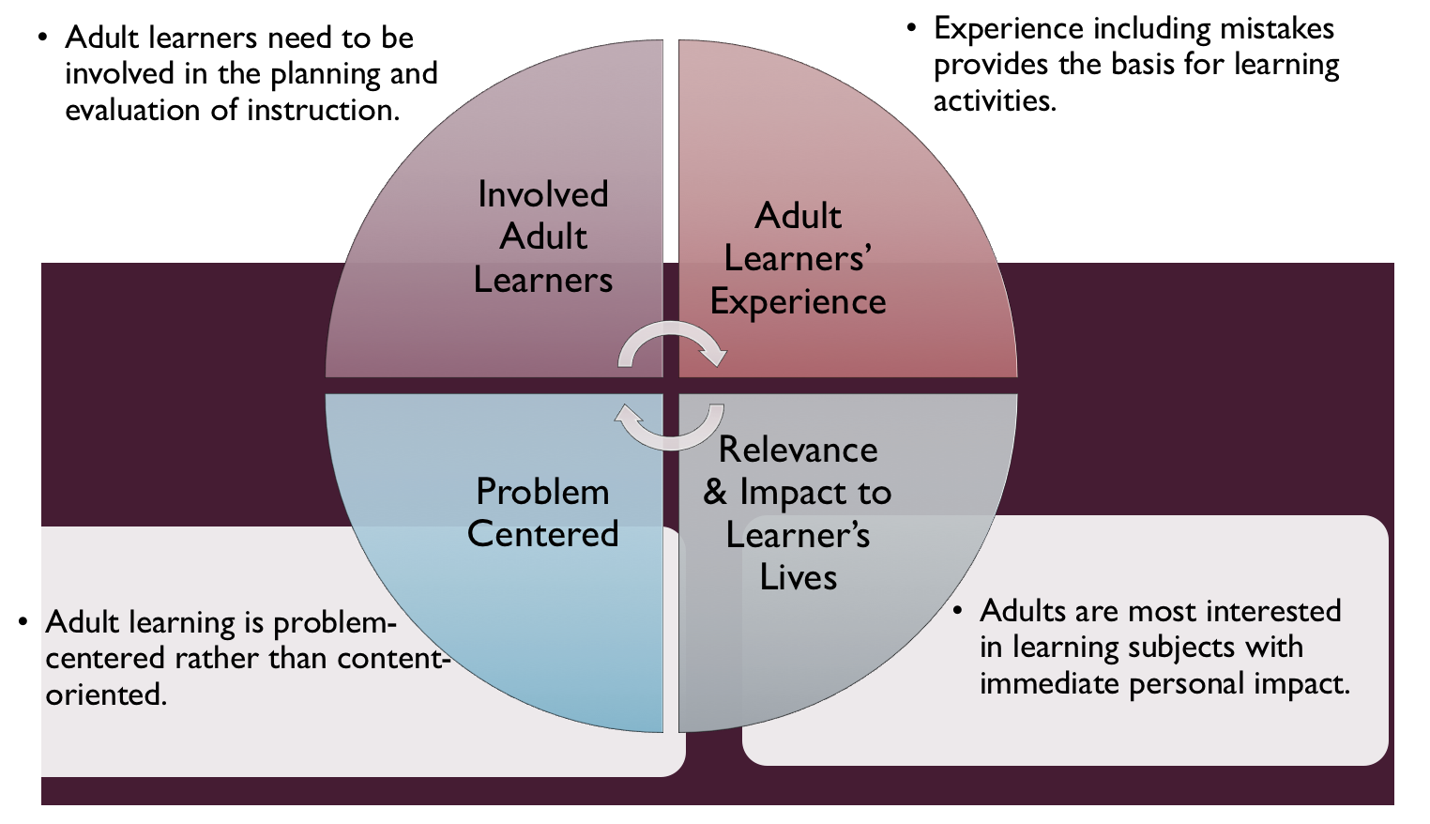
Figure credit: C. J. Carmichael adapted from M. S. Knowles and R.E. Mayer
Additionally, adult learners:
- Are experts of their lived experience.
- Come with their own motivations and goals.
- Need a safe and trusting learning environment.
- Know or will come up with 85% of the information you are planning to share.
- Remember 30% of what they hear and see, 50% of a demonstration, 70% of what they simulate, and 90% when they do the real thing.
Facilitated dialogue allows the classroom to become a conversation. Such discussion offers a way for students to explore supposedly settled questions and develop a fuller appreciation for the complexity of our knowledge. Model and encourage participants to ask open-ended questions that don’t seek yes/no answers or have right wrong answers. This will help create a safe and trustworthy learning environment that helps participants reflect on information and make it personally relevant. The ground rules for engagement from the Intro Session in the GB Learning Library - Core Preparation can be re-introduced if discussions lead to difficult and emotional conversations.
Review (time will vary; minimally 2 to 3 hours)
Go to the online GB Learning Library - Advanced Preparation and review the resources available in the section Group Gardens and New York State Seed to Supper including:
- Session Slides and Facilitator Notes
- FAQs
- Facilitator Guide
- Participant Guide
- Knowledge Check
- Print Materials for Before Session Pre-Work and Hands-on Activities
Gather materials and supplies (1 plus hours)

Gather other materials for Hands-on Activities. The GB Learning Library Activity Directions documents include a supply list for each activity.
Communicate with participants before session (1 hour)
Ideally at least 2 weeks in advance of this session provide participants with the Participant Guide found in the GB Learning Library. This document details what participants must do before the session. Review the document to determine if you need to supply any material in advance and to confirm the links are still good. Time to complete this pre-work will vary depending on the participant’s background and interest. We estimate most participants should allocate 3 to 5 hours.
Program Evaluation/Feedback (1 hour)
See section below.
Session Flow and Delivery
Total time for session is 1 hour - 55 minutes of task time & 5 minutes for a break.
As participants settle in, ask them to complete a review activity that you’ve prepared or selected from the review bank OR go over pre-work with others around them.
Session Tasks
Task 1: Opening and Introduction (5 minutes)
Welcome everyone, review housekeeping, ground rules, learning objectives, and class flow.
Task 2: Reconnect (5 minutes)
Ask participants pair up to discuss the question under THINK in their Participant Guide.
Task 3: Community Gardens Presentation - Why Engage Group Gardens? Discussion (15 minutes)
Listen to recorded presentation.
Use or adapt to suit your teaching style and needs the Session Slides and Facilitator notes found in GB Learning Library. Or create a presenter can create own presentation to meet learning objectives on page 1 of this document.
Task 4: Insensitive Statements Hands-on Activity (10 minutes)
Follow activity directions document found in GB Learning Library.
15 Minute BREAK
Task 5: New York State Seed to Supper (10 minutes)
Review the contents of the program, roles and responsibilities and relevant research from New York State.
Task 6: Conclusion (5 minutes)

Ask participants to reflect on key take home points from today and any lingering questions.
Direct participants’ attention to the items listed under After Session in their Participant Guide.
Task 7: Program Evaluation/Feedback (5 minutes)
Provide participants with an avenue to give feedback and data for your program evaluation including reporting. See section below on Program Evaluation/Feedback.
Task 8: Participant Evaluation/Knowledge Check (part of participant’s After Session work)
Provide an avenue for participants to assess what they know. See section below on Participant Evaluation/Knowledge Check.
After Session
Total time for follow-up will vary; minimally 2 hours.
Communicate with participants after session (1 hour)
Follow-up on unanswered content questions that emerged during session as needed as well as provide feedback on the knowledge check.
Consider Program Evaluation/Feedback (1 hour)
Summarize the feedback and data you received from participants for your program reporting and or future planning needs. See section below on Program Evaluation/Feedback.
Session Materials and Supplies
General Materials List
Facilitator notes Markers Index cards Pens
Highlighters Flip chart paper Name tags Feedback Forms
Post-it® notes Masking tape Computer/Internet/Projector
Materials by Task
Before Session Tasks
- Materials found in GB Learning Library:
  - Advanced Topic, Group Gardens and Seed to Supper session
  - Evaluation Toolkit
Task 1 - Opening and Introduction
- Participant Guide
- Session Slides and Facilitator Notes
Task 2 - Reconnect
- Participant Guide
- Flip chart paper and markers for group discussion notes
Task 3 - Community Gardens Presentation - Why Engage Group Gardens? Discussion:
- Participant Guide
- Flip chart paper and markers for group discussion notes
Task 3 – Insensitive Statements Hands-on Activity
- Activity Directions and found in GB Learning Library.

Task 4 - Vegetable Matching Activity Hands-on Activity
- Activity Directions and found in GB Learning Library.
- A list approx. 10 vegetables with two different names for each
- Printouts of pictures of vegetables, two printouts/vegetable (one with one name, one with the other)
- Chalkboard/poster board
Task 5 – New York State Seed to Supper
- Participant Guide
- Flip chart paper and markers for group discussion notes
Task 6 - Conclusions
Task 7 – Program Evaluation/Feedback
- Your evaluation/feedback materials
Task 8 – Participant Evaluation/Knowledge Check
- Materials for participants to assess what they know around this topic such as Knowledge Check from GB Learning Library
For After Session
- Feedback from participants
- Reporting forms
- Knowledge Check Key from GB Learning Library

Optional Activities
Frequently Asked Questions (FAQs)
With the input of county and campus-based experts, we have compiled a list of top FAQs for each topic areas and placed it with the other session resources in the GB Learning Library. Though not an exhaustive list, it should provide an opportunity for discussion and exploration of resources related to the topic. Integrate the FAQs in a way that makes sense for your local program. The FAQs could be used to prompt discussions within your group or they could be adapted into a scavenger hunt where individuals sift through reliable resources to find correct answers. Feel free to add or subtract questions and resources in the answers to meet your program's needs and address emerging issues.
Participant Evaluation/Knowledge Check
Adult learners enjoy getting feedback on what they have learned. In the GB Learning Library, you will find the Knowledge Check handouts for each session. You may ask participants to answer the questions at home on their own or in small groups discussions. The Knowledge Check KEY can be used to allow participants to self-check or for the educator to grade and provide feedback. You may wish to identify more engaging ways to self‐test what they have learned as it motivates and empowers them to be more accountable for their learning.
Program Evaluation/Feedback
Time for creating and implementing a program evaluation plan will vary; minimally 1 hour.
Ideally, evaluation begins before the program starts. Though for many educators, the idea of measuring the effects of your program is so daunting it never begins. With this in mind, we provide an Evaluation Toolkit in the GB Learning Library. Our aim is to offer tools you can use, even while you’re on the run. Check it out as you consider these key questions:
- Who is this evaluation for?
- What do you want to know, and why?
- What’s do‐able, really?
Other key resources will be your local county program plan of work which likely aligns with CCE Programmatic Plans: http://www2.cce.cornell.edu/plans/Pages/FY-2016-CCE-Programmatic-Plans.aspx
Find on CCE staff website under the Organizational Development and Planning Unit a Program Reporting module: http://staff.cce.cornell.edu/orgdev/Pages/reporting.aspx
References
Edmunds, Brooke. Hadekel, Christine, & Monette, Pamela (2017) The Seed to Supper Program in Linn and Benton County: Impact on gardening behavior, consumption of vegetables & knowledge of community resources. Journal of Extension. 55(3).
Ehrenhalt, Jey (2019, Spring). Liberated Roots. Teaching Tolerance, Issue 58, 19-22. https://www.tolerance.org/sites/default/files/2018-01/Teaching-Tolerance-magazine-58.pdf
Francis, Mark. Urban Open Space. Washington: Island Press, 2003
McMillan, Tracy (2014) The New Face of Hunger. National Geographic. https://www.nationalgeographic.com/foodfeatures/hunger/
Kansas State University Research and Extension. (2012, January 12). Different Types of Community Gardens .Retrieved from http://youtu.be/OeHgrIIPF9M.
Kansas State University Research and Extension. (2012, January 18). Community Gardens: Typical Costs .Retrieved from https://youtu.be/2zrooEAeIVc.
Texas State University. (2015, June 12). Maintaining a Community Garden .Retrieved from https://youtu.be/VXXG4pXglVM.
National Gardening Association (2014) Garden to Table: A Five Year Look into Food Gardening in America. https://garden.org/special/pdf/2014-NGA-Garden-to-Table.pdf
Program Policy Education and Action for Fighting Poverty and Economic Hardship in Upstate New York. Retrieved from http://povertyaction.cals.cornell.edu/
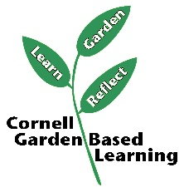
Date Published/Updated: 1/28/2020
Ashley Miller Helmholdt

Facilitator’s Notes

List quotes and behavior change you noticed, especially those that may be included in your necessary reporting, success story, or for future program improvement:
List Participant Commitments that you will need to follow up on:
Changes and Adaptations to Session:

