Soil Amendments and Fertilizers
Participant Guide
A soil amendment refers to a material added to the soil to improve its physical, biological or chemical properties. There are many different types of soil amendments, each fulfilling a different goal. While some may add nutrients, others may improve soil structure. While some may act quickly others will act more slowly over a sustained time period. It is important to understand what different soil amendments do and how to apply them.

By actively participating in Soil Amendments and Fertilizers, you will:
- Practice reading a soil test report to gather information about the soil nutrient status of a site.
- Explain management practices that help individuals enhance soil to optimize plant success.
- Identify when and how to use compost and other soil amendments.
- Practice using Cornell’s Cover Crop Guide and become familiar with cover crop management practices.
- Recognize that soils can be impacted by lead and other contaminants and it is important to consider the quality of any material that you add to your garden in order to avoid contaminants and other undesirable materials.
- Read and understand fertilizer labels to be able to identify appropriate fertilizers to meet plant needs and personal goals.

Before Session
DO:
- Look online or go to your local garden center and look at fertilizers for lawns, gardens and landscapes. Take a photo or write down at least one label, bring that with you to class. Or, if you are online, you can print the label to bring to class or load the label on your device during class.
EXPLORE:
- NY Cover Crop Guide and Cover Crop Decision Tool, take 10-15 minutes to explore and try using the cover crop tool. http://covercrops.cals.cornell.edu
- Cornell Garden-Based Learning Healthy Soil Page, take 5-10 minutes to explore http://gardening.cals.cornell.edu/garden-guidance/healthysoil.
  - Read Getting the Most out of Your Vegetable Garden Soil Test Report (pdf) https://blogs.cornell.edu/gblblog/files/2016/07/Veggie-Info-Sheet-2016-1jsq90e.pdf
  - Browse other sections under ‘For Nutrient Testing with Cornell Recommendations’ focusing on what you find most interesting or relevant.
READ:
- Soil Amendments and Fertilizers (23 pgs) handout provided

Opening and Introduction
- Facilitator reviews housekeeping, ground rules, learning objectives, and class flow.
Reconnect
- Partner up to discuss: Why should we care about soil? What are some ways we can learn about our soil?

Soil Amendments and Fertilizers Presentation
- Listen to presentation.

Station-Based Hands-on Activities
- Participants divide up into smaller groups and rotate around to stations to engage in hands-on activities related to soil amendments and fertilizers.

Conclusions
- Facilitator leads group reflection on key take home points and any lingering questions.

Program Feedback
- Share your insight to help us improve the program, report results, & plan for the future.

Knowledge Check
- Assess what you now know. Be motivated and empowered to share your knowledge with your peers and to learn more.

After Session
REFLECT:
- What happened?
- What was my response to what happened? How do I make sense of it?
- How does it relate to other things I know?
- What can I conclude?
- What might I do differently next time?

WATCH:
- Benefits of No-Till Farming, (~1.5 minutes) https://www.youtube.com/watch?v=Rpl09XP_f-w
- Dangers of Compaction, (~4.5 minutes). This video is geared towards farmers, but is useful for gardening too. https://www.youtube.com/watch?v=GTUVRieYoZ8

LEARN MORE:
- Metals in Urban Garden Soils, https://ecommons.cornell.edu/handle/1813/48147
- Comprehensive Assessment of Soil Health http://www.css.cornell.edu/extension/soil-health/manual.pdf
- The Garden Ecology Project https://blogs.cornell.edu/gep/gardeners/
- University of Delaware http://extension.udel.edu/factsheets/delaware-gardeners-guide-to-lawn-and-landscape-fertilizers/
- Soil Science Simplified, 4th Edition by Helmut Kohnke and D.P. Franzmeier

Campus Links:
- Cornell Soil Health, https://soilhealth.cals.cornell.edu/
- Healthy Soils, Healthy Communities, http://blogs.cornell.edu/healthysoils/
- Cornell Nutrient Analysis Laboratory, https://cnal.cals.cornell.edu/
- Cornell Soil Health, https://soilhealth.cals.cornell.edu/

Looking for Cornell people and resources? Don’t google, try the Cornell web search: http://www.cornell.edu/search/index.cfm

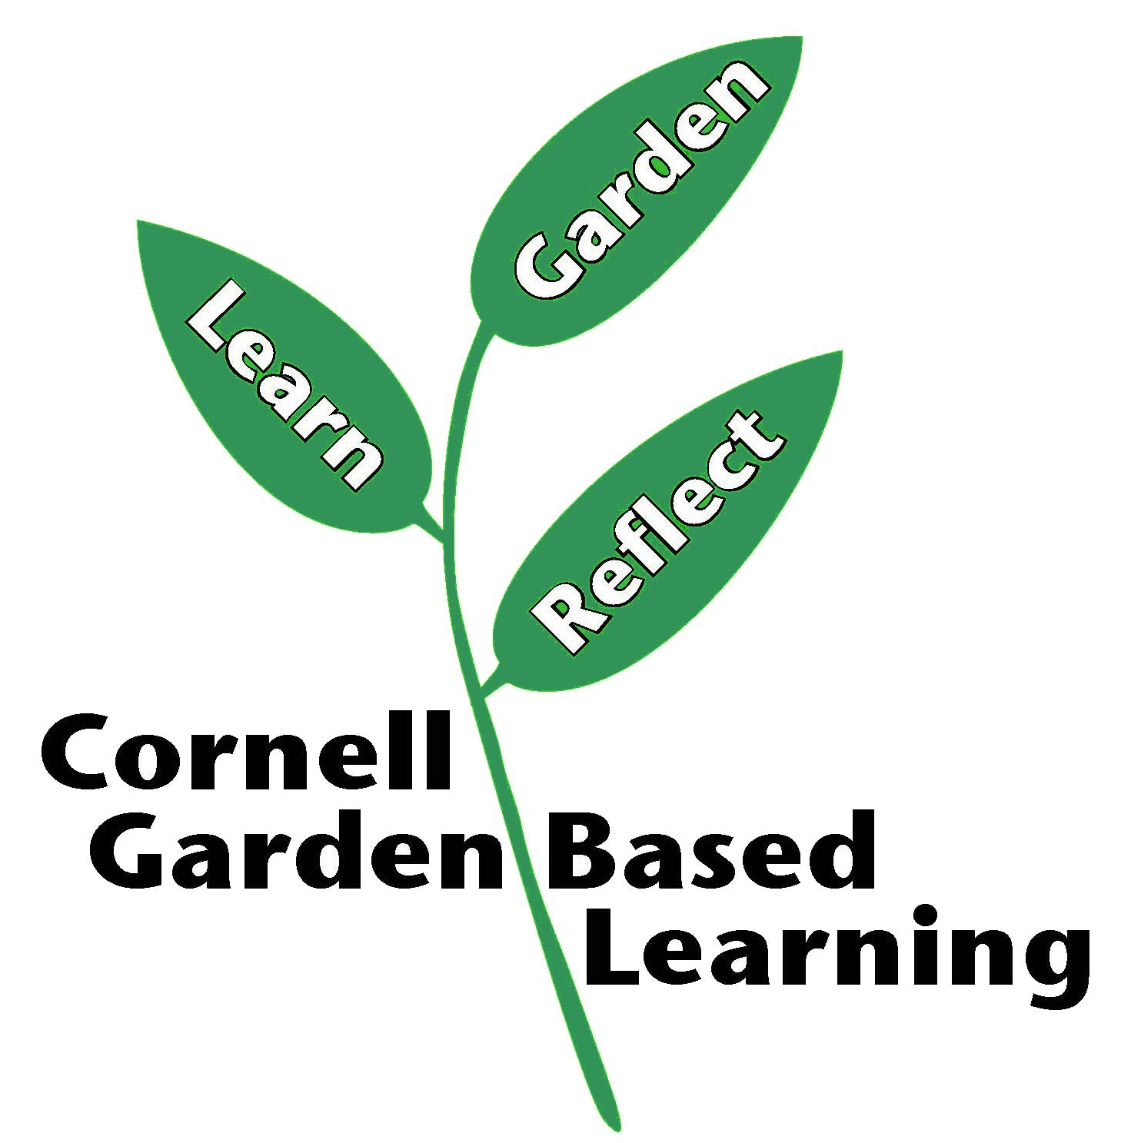
Date Published/Updated: April 2019
Revised May 2020 AMH

