WHO:  Participants | Individuals preparing for Master Gardener Volunteer role.
WHY:  The Situation | A soil amendment refers to a material added to the soil to improve its physical, biological or chemical properties. There are many different types of soil amendments, each fulfilling a different goal. While some may add nutrients, others may improve soil structure. While some may act quickly others will act more slowly over a sustained time period. It is important to understand what different soil amendments do and how to apply them.
WHEN:  Timing | 2.5 hours/135 minutes of session time & 15 minutes for a break.
WHERE:  Space | Classroom setting with seats and tables arranged in a circle or in clusters conducive to discussion and participation.
Learning Objectives* | Learning Strategy
Practice reading a soil test report to gather information about the soil nutrient status of a site. | Getting the Most out of Your Vegetable Garden Soil Test Report pre-work reading; Understanding A Soil Test Activity
Explain management practices that help individuals enhance soil to optimize plant success. | Session presentation; Benefits of No-Till Farming and Dangers of Compaction post-work videos
Identify when and how to use compost and other soil amendments. | Session presentation; Soil Amendments and Fertilizers pre-work reading
Practice using Cornell’s Cover Crop Guide and become familiar with cover crop management practices. | Cover Crop Scavenger Hunt Activity; Session presentation
Recognize that soils can be impacted by lead and other contaminants and it is important to consider the quality of any material that you add to your garden in order to avoid contaminants and other undesirable materials. | Soil Contamination Discussion Activity
Read and understand fertilizer labels to be able to identify appropriate fertilizers to meet plant needs and personal goals. | Reading and Understanding Fertilizers Activity; Session presentation
*These learning objectives match those in Participant Guide & Presentation.
Before Session
Total time for preparation will vary; minimally 8 hours.
Consider adult learning theory and strategies for implementation
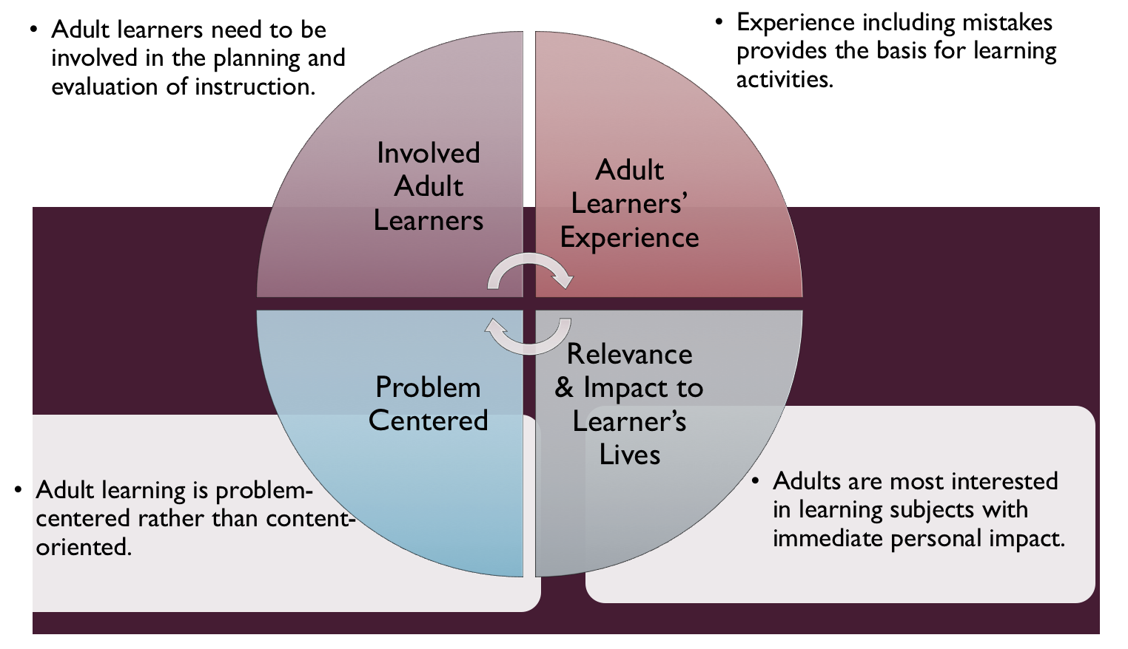
Figure credit: C. J. Carmichael adapted from M. S. Knowles and R.E. Mayer
Additionally, adult learners:
- Are experts of their lived experience.
- Come with their own motivations and goals.
- Need a safe and trusting learning environment.
- Know or will come up with 85% of the information you are planning to share.
- Remember 30% of what they hear and see, 50% of a demonstration, 70% of what they simulate, and 90% when they do the real thing.
Facilitated dialogue allows the classroom to become a conversation. Such discussion offers a way for students to explore supposedly settled questions and develop a fuller appreciation for the complexity of our knowledge. Model and encourage participants to ask open-ended questions that don’t seek yes/no answers or have right/wrong answers. This will help create a safe and trustworthy learning environment that helps participants reflect on information and make it personally relevant. The Ground Rules for Engagement from the Toolkit section in the GB Learning Library - Core Preparation can be re-introduced if discussions lead to difficult and emotional conversations.
Review (time will vary; minimally 4 to 6 hours)
Go to the online GB Learning Library - Core Preparation and review the resources available in the section Soil Amendments and Fertilizers, including:
- Session Slides and Facilitator Notes
- FAQs
- Facilitator Guide
- Participant Guide
- Knowledge Check
- Print Materials for Before Session Pre-Work and Hands-on Activities
- Note: There is a stand-alone Soil Contaminant Discussion activity in this session. Please note that the topic of soil contaminants can be integrated into any mention of soil testing. Though we focus on soil testing for pH, organic matter and nutrients, soil testing for contaminants is another important topic.
Gather materials and supplies (2 plus hours)
- Write cover crops on index cards for station-based activity, Cover Crop Scavenger Hunt. See activity handout.
Communicate with participants before session (1 hour)
Ideally at least 2 weeks in advance of this session provide participants with the Participant Guide found in the GB Learning Library - Core Preparation. This document details what participants must do before the session. Review the document to determine if you need to supply any material in advance and to confirm the links are still good. Time to complete this pre-work will vary depending on the participant’s background and interest. We estimate most participants should allocate 3 to 5 hours.
Program Evaluation/Feedback (1 hour)
See section below.
Session Flow and Delivery
Total time for session is 2.5 hours - 135 minutes of task time & 15 minutes for a break.
Session Tasks
Task 1: Opening and Introduction (5 minutes)
Welcome everyone, review housekeeping, ground rules, learning objectives, and class flow.
Task 2: Reconnect (5 minutes)
Ask participants to discuss:
- Why should we care about soil?
- What are some ways we can learn about our soil?
Task 3: Soil Amendments and Fertilizers presentation (50 Minutes)
See session presentation and follow facilitator’s notes.
15 Minute BREAK
Task 4: Station-Based Hands-on Activities (60 minutes)
Break into 4 groups and have each group spend 15 minutes per activity.
Follow the activity directions documents found in the GB Learning Library.
1) Reading and Understanding Soil Tests
2) Reading and Understanding Fertilizer Labels
3) Cover Crop Scavenger Hunt
4) Soil Contaminant Discussion
Task 5: Conclusion (10 minutes)

Ask participants to reflect on key take home points from today and any lingering questions.
Direct participants’ attention to the items listed under After Session in their Participant Guide.
Task 6: Program Evaluation/Feedback (5 minutes)
Provide participants with an avenue to give feedback and data for your program evaluation and reporting. See section below on Program Evaluation/Feedback.
Task 7: Participant Evaluation/Knowledge Check (part of participant’s After Session work)
Provide an avenue for participants to assess what they know. See section below on Participant Evaluation/Knowledge Check.
After Session
Total time for follow-up will vary; minimally 2 hours.
Communicate with participants after session (1 hour)
Follow-up on unanswered content questions that emerged during the session and provide feedback on the knowledge check.
Consider Program Evaluation/Feedback (1 hour)
Summarize the feedback and data you received from participants for your program reporting and or future planning needs. See section below on Program Evaluation/Feedback.
Session Materials and Supplies
General Materials List
Facilitator notes, Markers, Index cards, Pens, Highlighters, Flip chart paper, Name tags Feedback Forms, Post-it® notes, Masking tape, Computer/Internet/Projector
Materials by Task
Before Session Tasks
- Materials found in GB Learning Library:
  - Module 5: Management Strategies Section 5.2 Soil Amendments and Fertilizers
  - Evaluation Toolkit
Task 1 - Opening and Introduction
- Participant Guide
- Session Slides and Facilitator Notes
Task 2 - Reconnect
- Participant Guide
- Flip chart paper and markers for group discussion notes
Task 3 – Soil Amendments and Fertilizers presentation
- Session Slides and Facilitator Notes
Task 4 - Station-Based Hands-on Activities
Activity Directions documents for each of these are found in the GB Learning Library. Materials are listed in each document and summarized here:
- Reading and Understanding a Soil Test Activity
  - Sample Soil Analysis Report Form D-1 NY Report for each participant
  - Activity handout for each participant
  - A variety of sample soil test results (optional)
- Reading and Understanding Fertilizer Labels
  - A fertilizer label photo for each participant (participants should bring one with them as part of their pre-work).
  - A few extra fertilizer labels to have on hand.
  - Activity handout for each participant
- Cover Crop Scavenger Hunt
  - Laptop, tablet or smartphone with internet access for each pair or small group
  - Activity handout for each participant
  - Index cards (write one cover crop on each index card, each pair or small group will need one index card)
    - Annual Ryegrass
    - Field Peas
    - Oats
    - Arugula
    - Fall Mustard
    - Feel free to add additional cover crops from the database
- Soil Contaminant Discussion Activity
  - Sources and Impacts of Contaminants in Soils handout for each participant
  - What Gardeners Can Do: 10 Best Practices for Healthy Gardening handout for each participant
  - Activity handout for each participant
Task 5 – Conclusion
- Participant Guide
- Flip chart paper and markers for group discussion notes
Task 6 – Program Evaluation/Feedback
- Your evaluation/feedback materials
Task 7 – Participant Evaluation/Knowledge Check
- Materials for participants to assess what they know around this topic such as Knowledge Check from GB Learning Library
For After Session
- Feedback from participants
- Reporting forms
- Knowledge Check Key from GB Learning Library

Optional Activities
Frequently Asked Questions (FAQs)
With the input of county and campus-based experts, we have compiled a list of top FAQs for each topic areas and placed it with the other session resources in GB Learning Library. Though not an exhaustive list, it should provide an opportunity for discussion and exploration of resources related to the topic. Integrate the FAQs in a way that makes sense for your local program. The FAQs could be used to prompt discussions within your group or they could be adapted into a scavenger hunt where individuals sift through reliable resources to find correct answers. Feel free to add or subtract questions and resources in the answers to meet your program's needs and address emerging issues.
Participant Evaluation/Knowledge Check

Adult learners enjoy getting feedback on what they have learned. In the GB Learning Library, you will find the Knowledge Check handouts for each session. You may ask participants to answer the questions at home on their own or in small groups discussions. The Knowledge Check KEY can be used for participants to self-check or for the educator to grade and provide feedback. You may wish to identify more engaging ways for participants to self‐test what they have learned as it motivates and empowers them to be more accountable for their learning.
Program Evaluation/Feedback
Time for creating and implementing a program evaluation plan will vary; minimally 1 hour.
Ideally, evaluation begins before the program starts. Though for many educators, the idea of measuring the effects of your program is so daunting it never begins. With this in mind, we provide an Evaluation Toolkit in the GB Learning Library. Our aim is to offer tools you can use, even while you’re on the run. Check it out as you consider these key questions:
- Who is this evaluation for?
- What do you want to know, and why?
- What’s do‐able, really?
Other key resources will be your local county program plan of work which likely aligns with CCE Programmatic Plans: http://www2.cce.cornell.edu/plans/Pages/FY-2016-CCE-Programmatic-Plans.aspx
Find on CCE staff website under the Organizational Development and Planning Unit a Program Reporting module: http://staff.cce.cornell.edu/orgdev/Pages/reporting.aspx
References
For Adult Learning Theory references see those listed in GB Learning Library in Module 6: Facilitating Learning Section 6.1 Adult Learning and Community Engagement.

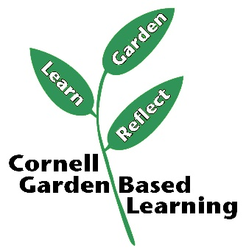
Date Published/Updated: March 2019

Facilitator’s Notes

List quotes and behavior change you noticed, especially those that may be included in your necessary reporting, success story, or for future program improvement:
List Participant Commitments that you will need to follow up on:
Changes and Adaptations to Session:

