Organic Waste Management: Composting
Participant Guide
There are a wide range of waste producers in New York State including individuals, agriculture, industry, and government. These different types of waste producers need access to information and solutions for managing their waste, reducing waste at the source, minimizing energy use and costs, and managing the risk and environmental inequities resulting from waste generation and disposal practices. Improved waste management and waste reduction efforts will result in an enhanced and protected environment, including soil, air, and water, and reduced risk for individuals and families. (Sourced from CCE Statewide Plan of Work)
By actively participating in Organic Waste Management: Composting, you will:
- Understand that composting is managed decomposition and that there is a link between compost and soil health.
- Articulate the proper management of compost including acceptable inputs and the balance of browns and greens.
- Demonstrate the proper technique of lasagna layering.
- Assess various composting systems (i.e. wire bin, tumblers, worm bin) and be able to assist the public in selecting the type that best suits them.
- Understand the process of how composting works, be familiar with the factors that facilitate or slow the process.
- Determine if compost is finished (mature) and be versed in how to harvest and use the compost.
- Recognize the current statistics regarding food waste and steps that can be taken individually and statewide to minimize the food waste stream.
- Identify common composting troubleshooting and problems and become familiar with composting FAQs.
Before Session
READ:
- Compost Resources from the CCE Tompkins County Compost Education program: http://ccetompkins.org/gardening/composting/compost-resources
  - Lasagna Composting (1 page)
  - Is It Done Yet? (2 pages)
WATCH:
- Videos from the CCE Tompkins County Compost Education program:
http://ccetompkins.org/gardening/composting/compost-resources
  - Lasagna Layering (8 ½ minutes)
- Videos from Cornell University’s vermicompost research page: http://cwmi.css.cornell.edu/vermicompost.htm
  - Vermicompost and Pythium Suppression (3 minutes)
DO:
- Daily for 1 week record the weight of your household’s kitchen food waste that would be appropriate to add to a home compost pile. Bring to class a slip of paper with:
  - your total household’s kitchen food waste weight for the week
  - your guess of the average household’s kitchen food waste weight for your class participants
  - your first name
THINK:
- List organic materials you generate in the kitchen or yard that could be used in a home composting system. Label each as either 'browns' or 'greens' or unknown.
- Consider what additional efforts you could take to reduce waste and divert organic materials from our landfills.
- What questions do you hear from others about composting? And do you have questions?
Opening and Introduction
- Facilitator reviews housekeeping, ground rules, learning objectives, and class flow.
- Hand in your slip of paper from the DO activity above.
Reconnect
- Partner up to discuss the question listed under the pre-work THINK prompt.
Home Composting Lecture
- Engage in presentation.
Addressing Food Waste in our Kitchen Discussion
- Facilitator leads group discussion and sharing of results the DO activity above.
Station-Based Hands-on Activities
- Participants divide up into smaller groups and rotate around to stations to engage in hands-on activities about home composting.
Compost Troubleshooting Hands-on Activity
- Participants divide into pairs or smaller groups for activity then return for whole group discussion.
Conclusions
- Facilitator leads group reflection on key take home points and any lingering questions.
Program Feedback
- Share your insight to help us improve the program, report results, & plan for the future.
Knowledge Check
- Assess what you now know. Be motive and empower to share with your peers and learn more.
After Session
REFLECT:
- What happened?
- What was my response to what happen? How do I make sense of it?
- How does it relate to other things I know?
- What can I conclude?
- What might I do differently next time?
LEARN MORE:
- Cornell Waste Management Institute (CWMI) has put most of its resources in Cornell eCommons: https://ecommons.cornell.edu/

Use the search tool to find resources in the CWMI eCommon’s:
  - Composting at Home – the Green and Brown Alternative http://hdl.handle.net/1813/29111
  - Home Composting Slide Show http://hdl.handle.net/1813/44789
  - School Composting https://hdl.handle.net/1813/52083
  - Composting: Biology in the curriculum http://hdl.handle.net/1813/45757
  - School Composting, Let’s Start Composting curriculum http://hdl.handle.net/1813/45757
  - Master Composter Curriculum http://hdl.handle.net/1813/12933
- Compost Resources from CCE Tompkins County Master Composter program: http://ccetompkins.org/gardening/composting
- EPA’s Food: Too Good to Waste https://www.epa.gov/sustainable-management-food/food-too-good-waste-implementation-guide-and-toolkit
- Further with Food https://furtherwithfood.org
- New York State Food Recovery Campaign https://www.facebook.com/NYSFoodRecoveryCampaign/
Campus Links:
- Cornell Waste Management Institute (CWMI) http://cwmi.css.cornell.edu
- Cornell University’s vermicompost research http://cwmi.css.cornell.edu/vermicompost.htm
Looking for Cornell people and resources? Don’t Google; try the Cornell web search: http://www.cornell.edu/search/index.cfm.

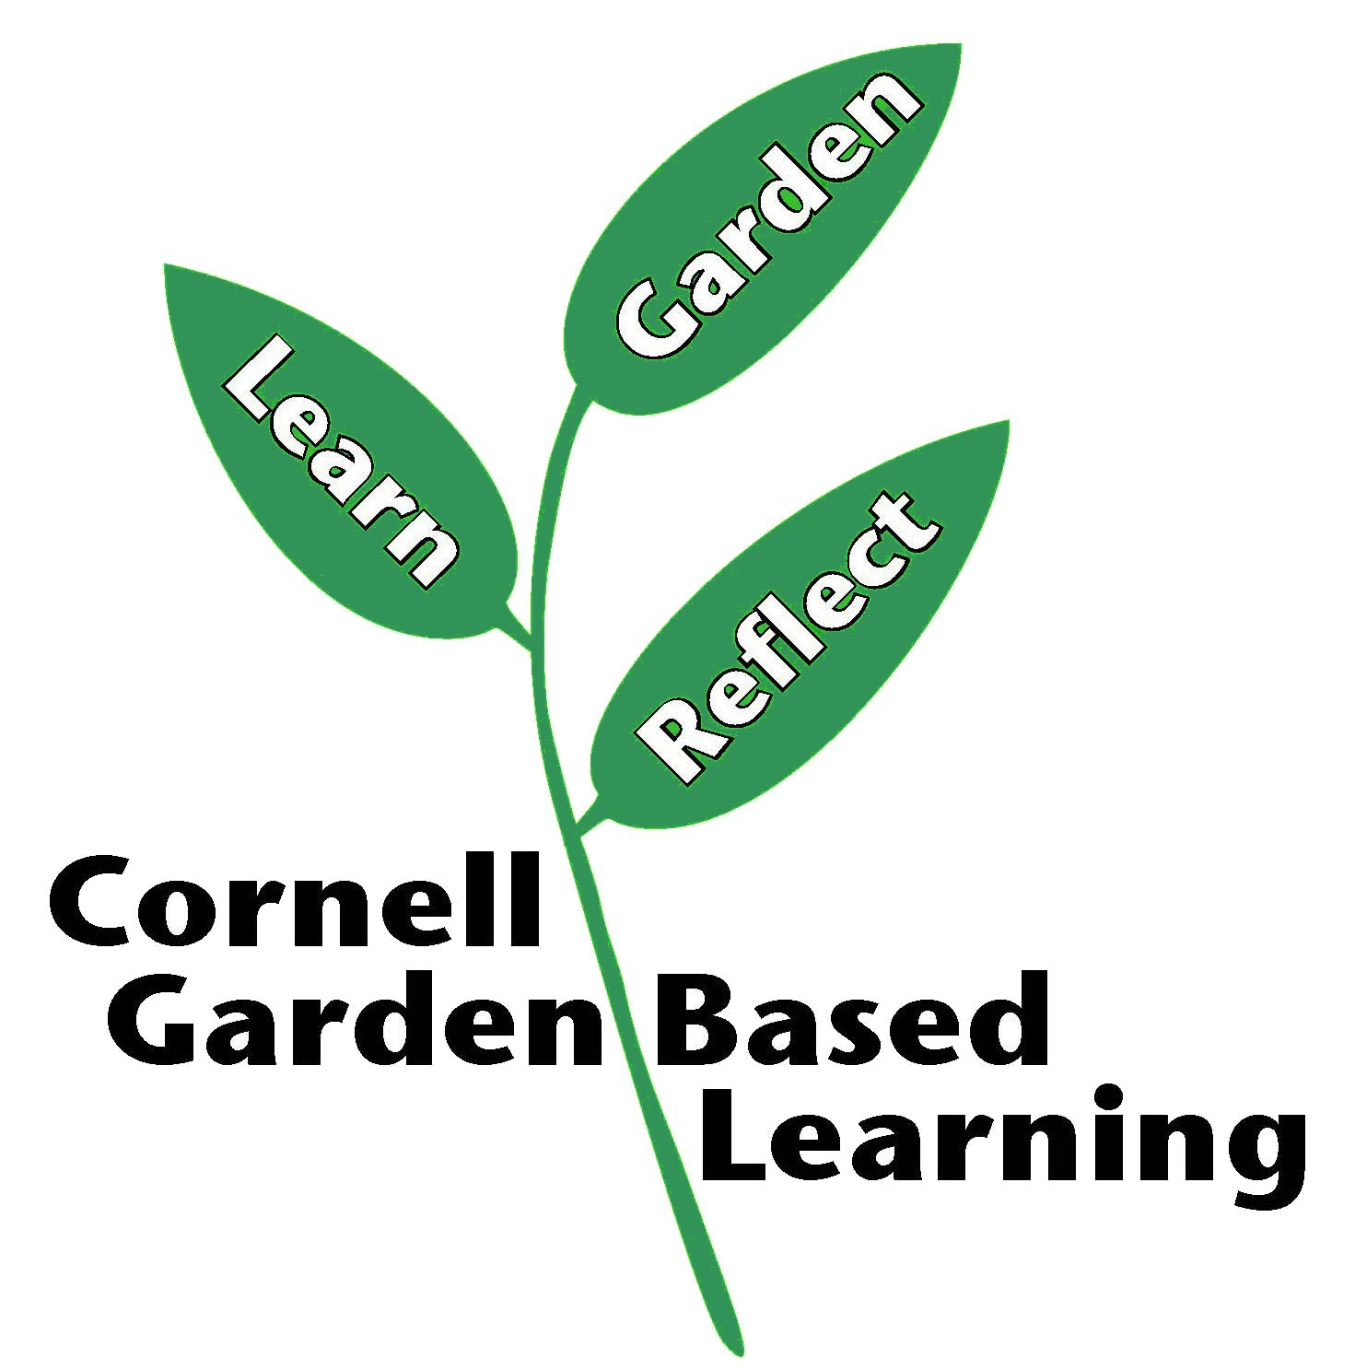
Date Published/Updated: April 2019

