Invasive Species for Gardeners
Participant Guide
Invasive species threaten the function and integrity of ecosystems, native species, and managed landscapes. To support environmental stewardship, gardeners need to be aware of the top terrestrial invasive species threatening their region, where to report potential sightings, and the sound garden management practices that may minimize wider distribution.
By actively participating in Invasive Species for Gardeners, you will:
- Consider definitions of what’s ‘non-native’ and what’s ‘invasive’, and discuss some of the controversy around these definitions.
- Recognize the impacts invasive species have on our ecosystems & human quality of life.
- Understand the invasion curve and what actions are appropriate at each stage of invasion.
- Learn the profile of an invasive weed or pest, and the red flags for invasiveness.
- Discuss the regional nature of invasiveness, and what that might mean in the face of climate change.
- Become familiar with resources that will assist in identification characteristics, lifecycles, signs, and symptoms for current top invasive species in your region.
- Explore the prohibited and regulated species regulations in New York and how to report suspect invasions to state and local agencies.
- Consider and discuss the invasive species in our landscapes and management strategies.
Before Session
READ:
- Upstate Hemlock Trees under Attack from Woolly Invader, an online article from the Rochester NY’s Democrat and Chronicle. Found online at: https://www.democratandchronicle.com/story/news/2017/09/18/upstate-hemlock-trees-under-attack-woolly-invader/677642001/
WATCH:
- Video Invasive Species: The Basics (6 minutes): https://www.youtube.com/watch?v=yIgysZ5Hho8
DO:
- Choose one of the following invasive species to research. Make and bring to class a short list of 1) identifying characteristics of your chosen invasive species; 2) information on what ecological problems it is causing; 3) management strategies gardeners use to minimize its spread.
Slender False Brome: https://www.dec.ny.gov/animals/108686.html
Jumping Worms: https://blogs.cornell.edu/cerp/files/2017/11/JumpingWoms_FactSheet-11_15_17-2026fwt.pdf
Porcelain Berry: http://www.docs.dcnr.pa.gov/cs/groups/public/documents/document/dcnr_010236.pdf
THINK:
- Consider what makes one non-native (like tulips) fine, and another one (like knotweed) 'invasive'? What is the difference between an invasive species, a weed, and an aggressive native species?
Opening and Introduction
- Facilitator reviews housekeeping, ground rules, learning objectives, and class flow.
Reconnect
- Partner up to discuss the question listed under the pre-work THINK prompt.
Invasive Species in NY Lecture
- Listen to presentation.
Blockbuster Survey Hands-on Activity Discussion
- Engage in small group activity and whole group discussion. Having use of tablets, laptops, or smartphones is needed for this activity.
Minute Paper on Reporting and Prioritizing Invasive Species Activity
- Engage in small group activity and whole group discussion.
Conclusions
- Facilitator leads group reflection on key take home points and any lingering questions.
Program Feedback
- Share your insight to help us improve the program, report results, & plan for the future.
Knowledge Check
- Assess what you now know. Be motived and empowered to share with your peers and learn more.
After Session
REFLECT:
- What happened?
- What was my response to what happened? How do I make sense of it?
- How does it relate to other things I know?
- What can I conclude?
- What might I do differently next time?

LEARN MORE:
- Plant Wise Brochure: http://www.dec.ny.gov/docs/lands_forests_pdf/plantwise.pdf
- Prohibited and regulated species in New York: http://www.dec.ny.gov/animals/99141.html
- New York Invasive Species Information: http://www.nyis.info/index.php
- New York Invasive Species Awareness Week: https://stoptheinvasionny.com/
- DEC terrestrial invasive website: http://www.dec.ny.gov/animals/95383.html
- IMap invasives website: http://www.imapinvasives.org/
- Partnerships for Regional Invasive Species Management (PRISM): https://www.dec.ny.gov/animals/47433.html
- Hemlock Woolly Adelgid:
  - NYS Hemlock Initiative: https://blogs.cornell.edu/nyshemlockinitiative/
  - A Film About the Loss of an Ecosystem (23-minute documentary): https://www.youtube.com/watch?v=AupnMjYaI0Q&feature=youtu.be
  - Hemlock Woolly Adelgid Fact Sheet: http://www.dec.ny.gov/docs/lands_forests_pdf/hwafactsheet.pdf
- Emerald Ash Borer
  - Emerald Ash Borer in New York: http://www.dec.ny.gov/animals/7253.html
  - Brochure: http://www.dec.ny.gov/docs/lands_forests_pdf/eabearlydetect.pdf
- Oak Wilt Fact Sheet, http://www.dec.ny.gov/docs/lands_forests_pdf/oakwiltfs.pdf
- Bugwood resource for images of and information on invasive species: http://bugwood.org
- Washington Post Article “Dirty Dozen: https://www.washingtonpost.com/news/energy-environment/wp/2015/02/23/like-most-invasive-species-pythons-are-in-the-u-s-to-stay/?utm_term=.ec15178d2afc

Biocontrol: More Than Cane Toads and Mongooses: https://www.popsci.com/blog-network/our-modern-plagues/biocontrol-more-cane-toads-and-mongooses
- Doug Tallamy’s talk “Are Alien Plants Bad?”: https://vod.video.cornell.edu/media/Are+%22Alien%22+Plants+%22Bad%22F+-+Dr.+Doug+Tallamy/1_qi915ub2

Campus Links:

Cornell University New York Invasive Species Research Institute: http://www.nyisri.org/

Looking for Cornell people and resources? Don’t Google; try the Cornell web search: http://www.cornell.edu/search/index.cfm
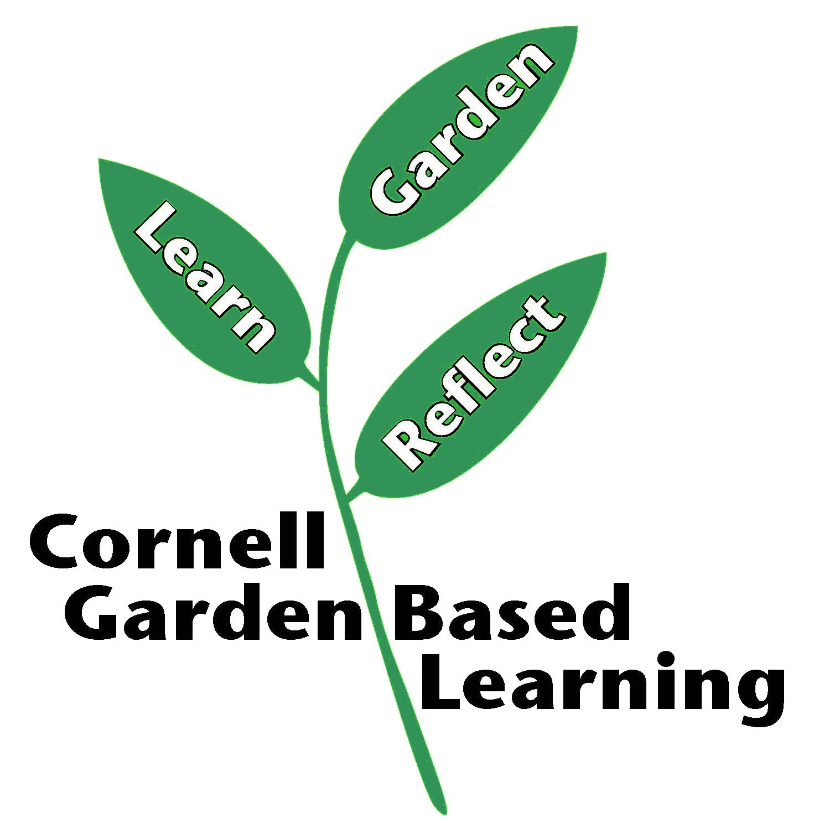
Date Published/Updated: April 2019

