Gardening in a Warming World
Participant Guide
Cornell Cooperative Extension (CCE) is committed to educating stakeholders about climate change and helping citizens implement the strategies that are needed to adapt to and mitigate impacts. Gardeners everywhere are seeing the impacts of the changing climate on their gardens. Gardening means dealing directly with drought conditions, flooding and water-logging; unseasonable cold and freezing conditions; increases in new pests; changes in plant diseases; variability in heat and hardiness zones; and extreme weather events. This Gardening in a Warming World session aims to prepare volunteers as they are increasingly called upon for information in the face of this new gardening challenge.

By actively participating in Gardening in a Warming World, you will:
- Understand systems thinking as it applies to your garden system
- Be familiar with the basics of climate change
- List current and future possible impacts of climate change on New York State
- Identify ways to manage gardens to mitigate and adapt to climate impacts
- Have tools to be a peer educator around Gardening in a Warming World

Before Session
READ:
- Gardening in a Warming World: A Climate Smart Gardening Course Book. This 40-page document is divided into 4 units that describe the key concepts. Find at: http://climatechange.cornell.edu/gardening/

THINK:
- What changes have you noticed in your garden? What changes are challenging your garden success? How are they challenging? Any enhancing your gardening success?
- Reflect on how your personal observations are consistent or inconsistent with insights others have collected about climate change impacts through scientific monitoring, research and modeling as well as those from fellow gardeners.

Opening and Introduction
- Facilitator reviews agenda, housekeeping and ground rules, learning outcomes.
- Participants individually reflect on their garden and a few volunteers share with group.

Systems Thinking for Sustainable Gardening Discussion Activity
- Facilitator shares definitions for “systems” and “systems thinker” then leads group brainstorms around how systems thinking could increase pest management success.

Knowing Your Garden Systems Discussion Activity
- Facilitator leads group in identifying approaches to documenting garden observations.
- Participants individually review “Knowing your Garden System” handout.
- In a pair or small group discuss Do in Advance questions from Think section bullet 1.

Climate Change Basics Lecture
- Listen to presentation
- Review how you might use the worksheet “Reliable Resources Matrix.”

Climate Smart Garden Audit Discussion Activity
- Participants in pairs complete “Climate-smart gardening put into action” then return to whole group to highlight.

Conclusions
- Facilitator leads group reflection on key take home points and any lingering questions.

Program Feedback
- Share your insight to help us improve the program, report results, & plan for the future.

Knowledge Check
- Assess what you now know. Be motivated and empowered to share your knowledge with your peers and to learn more.

After Session
REFLECT:
- What happened?
- What was my response to what happened? How do I make sense of it?
- How does it relate to other things I know?
- What can I conclude?
- What might I do differently next time?

LEARN MORE:
- Gardening in a Warming World curriculum http://climatechange.cornell.edu/gardening
- Cornell Botanic Gardens Climate Change Garden video https://vimeo.com/103466340
- Use search terms climate change to find a number of Cornell SIPS Horticulture videos related to the topic. https://www.youtube.com/user/CornellHorticulture/featured

Campus Links:
Cornell Institute for Climate Smart Solutions: http://climatechange.cornell.edu/

Looking for Cornell people and resources? Don’t Google, try the Cornell web search: http://www.cornell.edu/search/index.cfm

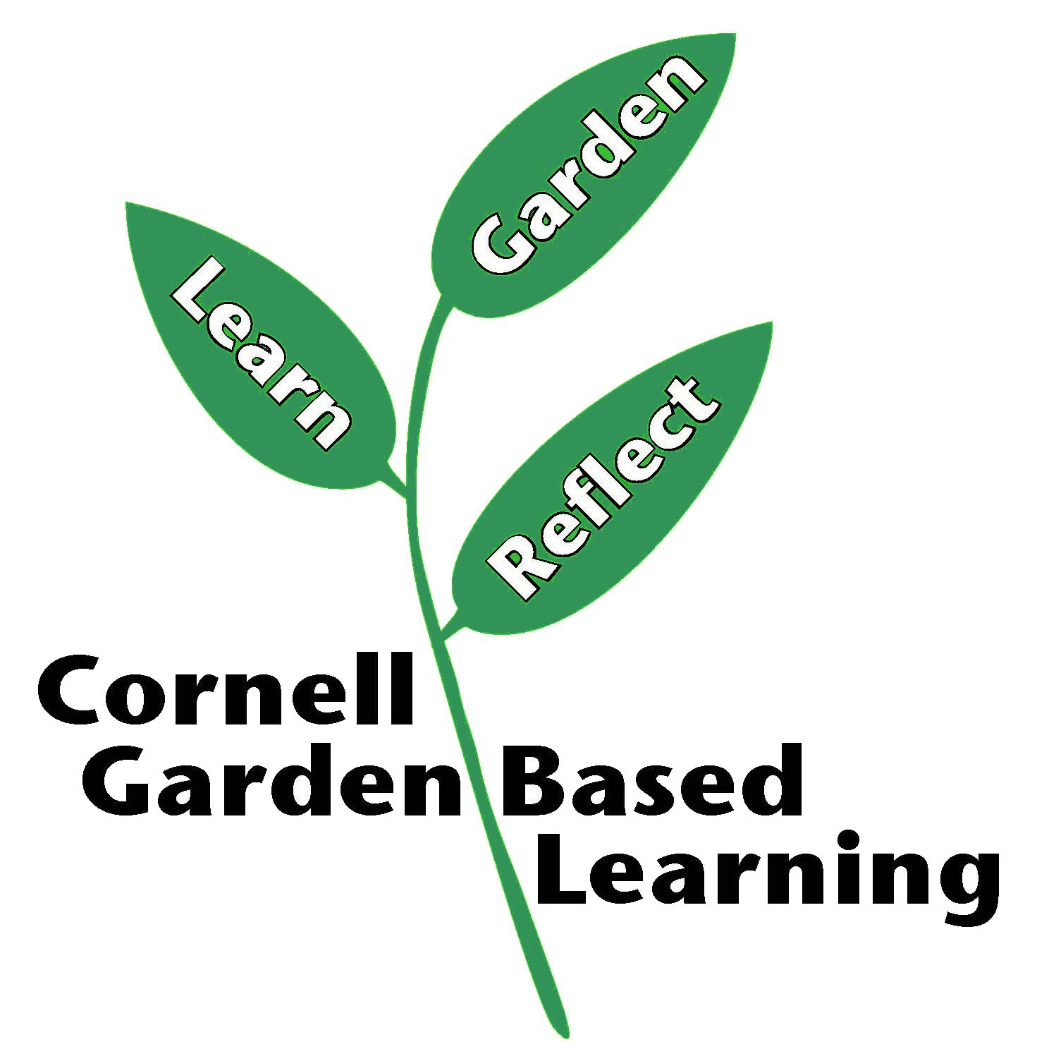
Date Published/Updated: April 2019

