WHO:  Participants | Individuals preparing for Master Gardener Volunteer role.
WHY:  The Situation | Improved waste management and waste reduction efforts will result in an enhanced and protected environment, including soil, air, and water, and reduced risk for individuals and families.  There are a wide range of waste producers in New York State including individuals, agriculture, industry, and government. These different types of waste producers need access to information and solutions for managing their waste, reducing waste at the source, minimizing energy use and costs, and managing the risk and environmental inequities resulting from waste generation and disposal practices. (Sourced from CCE Statewide Plan of Work)
WHEN:  Timing | 2.5 hours. 135 minutes of session time & 15 minutes for a break.
WHERE:  Space | Classroom setting with seats and tables arranged in a circle or in clusters conducive to discussion and participation.
Learning Objectives* |  | Learning Strategy (name specific approach to be used)
Understand that composting is managed decomposition and that there is a link between compost and soil health. |  | Composting presentation; pre-work
Articulate the proper management of compost including acceptable inputs and the balance of browns and greens. |  | Composting presentation; pre-work
Demonstrate the proper technique of lasagna layering. |  | Lasagna Bin Composting Activity; Lasagna Composting factsheet
Assess various composting systems (i.e. wire bin, tumblers, worm bin) and be able to assist the public in selecting the type that best suits them. |  | Composting presentation; Vermicompost video and webpage
Understand the process of how composting works, be familiar with the factors that facilitate or slow the process. |  | Composting presentation; pre-work
Determine if compost is finished (mature) and be versed in how to harvest and use the compost. |  | Compost Maturity Activity; “Is it Done Yet” factsheet
Recognize the current statistics regarding food waste and steps that can be taken individually and statewide to minimize the food waste stream. |  | Weighing and keeping track of one’s kitchen scraps for one week; post-work journal activity
Identify common composting troubleshooting and problems and become familiar with composting FAQs. |  | Compost troubleshooting activity and discussion
*These learning objectives match those in Participant Guide & Presentation.
Before Session
Total time for preparation will vary; minimally 8 hours.
Consider adult learning theory and strategies for implementation
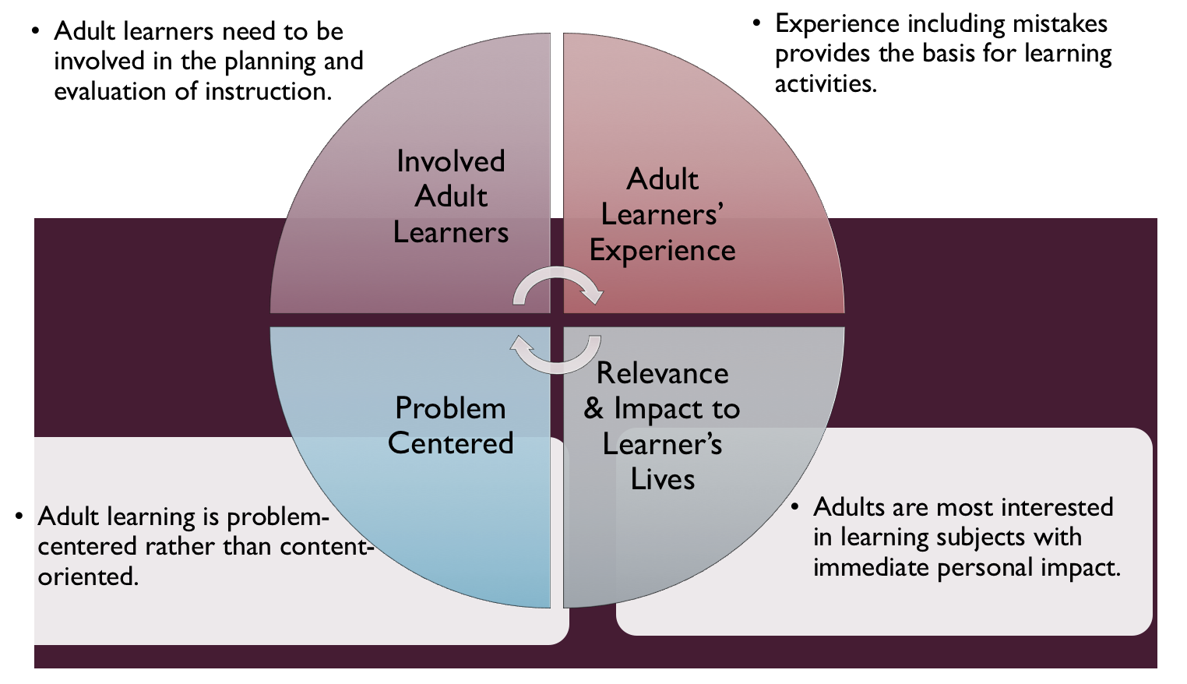
Figure credit: C. J. Carmichael adapted from M. S. Knowles and R.E. Mayer
Additionally, adult learners:
- Are experts of their lived experience.
- Come with their own motivations and goals.
- Need a safe and trusting learning environment.
- Know or will come up with 85% of the information you are planning to share.
- Remember 30% of what they hear and see, 50% of a demonstration, 70% of what they simulate, and 90% when they do the real thing.
Facilitated dialogue allows the classroom to become a conversation. Such discussion offers a way for students to explore supposedly settled questions and develop a fuller appreciation for the complexity of our knowledge. Model and encourage participants to ask open-ended questions that don’t seek yes/no answers or have right wrong answers. This will help create a safe and trustworthy learning environment that helps participants reflect on information and make it personally relevant. The ground rules for engagement from the Intro Session in the GB Learning Library - Core Preparation can be re-introduced if discussions lead to difficult and emotional conversations.
Review (time will vary; minimally 4 to 6 hours)
Go to the online GB Learning Library - Core Preparation and review the resources available in this section Organic Waste Management: Composting including:
- Session Slides and Facilitator Notes
- FAQs (plus additional Q & A sheets)
- Facilitator Guide
- Participant Guide
- Knowledge Check
- Print Materials for Hands-on Activities
Gather materials and supplies (2 plus hours)
Gather other materials for Hands-on Activities. The GB Learning Library Activity Directions documents include a supply list for each activity and the build a compost bin has the most supplies that may take some time to gather.
Communicate with participants before session (1 hour)
Ideally at least 2 weeks in advance of this session provide participants with the Participant Guide found in the GB Learning Library - Core Preparation. This document details what participants must do before the session. Review the document to determine if you need to supply any material in advance and to confirm the links are still good. Time to complete this pre-work will vary depending on the participant’s background and interest. We estimate most participants should allocate 3 to 5 hours.
Program Evaluation/Feedback (1 hour)
See section below.
Session Flow and Delivery
Total time for session is 2.5 hours - 135 minutes of task time & 15 minutes for a break.
As participants settle in collect their documentation from the before session work related to the “Addressing Food Waste in our Kitchen Activity.” From the information shared calculate the total weight for the group and the person who guessed the closest to the total weight to share in Task 4.
Session Tasks
Task 1: Opening and Introduction (5 minutes)
Welcome everyone, review housekeeping, ground rules, learning objectives, and class flow.
Task 2: Reconnect (10 minutes)
Ask participants to pair up and discuss the question under THINK in their Participant Guide.
Task 3: Home Composting Lecture (45 minutes)
Listen to the recorded presentation.
Use the Session Slides and Facilitator notes found in GB Learning Library; feel free to adapt the resources to suit your teaching style and needs. Alternatively, a presenter can create their own presentation to meet the learning objectives on page 1 of this document.
Task 4: Addressing Food Waste in our Kitchen Hands-on Activity Discussion (15 minutes)
Follow activity directions document found in GB Learning Library. Participants begin activity as part of the before session work.
15 Minute BREAK
Task 5: Station-Based Hands-on Activities (45 minutes)
Follow the activity directions documents found in GB Learning Library.
1) Create a Lasagna Compost Bin
2) Compost Maturity
Divide participants into 2 groups and have groups rotate around on your timed 20 minute intervals. If 2 groups are still too large, consider 4 groups with 2 locations for each activity.
Task 6: Compost Troubleshooting Hands-on Activity (15 minutes)
Follow activity directions document found in GB Learning Library.
Task 7: Conclusion (10 minutes)

Ask participants to reflect on key take home points from today and any lingering questions.
Direct participants’ attention to the items listed under After Session in their Participant Guide.
Task 8: Program Evaluation/Feedback (5 minutes)
Provide participants with an avenue to give feedback and data for your program evaluation including reporting. See section below on Program Evaluation/Feedback.
Task 9: Participant Evaluation/Knowledge Check (part of participant’s After Session work)
Provide an avenue for participants to assess what they know. See section below on Participant Evaluation/Knowledge Check.
After Session
Total time for follow-up will vary; minimally 2 hours.
Communicate with participants after session (1 hour)
Follow-up on unanswered content questions that emerged during session as needed as well as provide feedback on the knowledge check.
Consider Program Evaluation/Feedback (1 hour)
Summarize the feedback and data you received from participants for your program reporting and or future planning needs. See section below on Program Evaluation/Feedback.
Session Materials and Supplies
General Materials List
Facilitator notes Markers Index cards Pens
Highlighters Flip chart paper Name tags Feedback Forms
Post-it® notes Masking tape Computer/Internet/Projector
Materials by Task
Before Session Tasks
- Materials found in GB Learning Library:
  - Module 5: Management Strategies Section 5.1 Organic Waste: Composting
  - Evaluation Toolkit
Task 1 - Opening and Introduction
- Participant Guide
- Session Slides and Facilitator Notes
Task 2 - Reconnect
- Participant Guide
- Flip chart paper and markers for group discussion notes
Task 3 – Home Composting Lecture
- Session Slides and Facilitator Notes
Task 4 – Addressing Food Waste in our Kitchen Hands-on Activity Discussion
- Activity Direction document for found in GB Learning Library. Participants begin activity as part of the before session work and provide additional information at start of session that needs to be tabulated before this task.
Task 5 - Station-Based Hands-on Activities
Activity Directions documents for each of these are found in GB Learning Library. Materials are listed in each document and summarized here:
- Create a Lasagna Compost Bin (alternatively use paper materials to simulate)
  - Mini-demo bins
  - Welded Wire Fencing
  - Sample compost materials
- Compost Maturity
  - Fact sheet: “Is it done Yet?”
Task 6 – Compost Troubleshooting Hands-on Activity
- Activity Direction and matching cards documents can be found in GB Learning Library.
Task 7 – Conclusion
- Participant Guide
- Flip chart paper and markers for group discussion notes
Task 8 – Program Evaluation/Feedback
- Your evaluation/feedback materials
Task 9 – Participant Evaluation/Knowledge Check
- Materials for participants to assess what they know around this topic such as Knowledge Check from GB Learning Library
For After Session
- Feedback from participants
- Reporting forms
- Knowledge Check Key from GB Learning Library

Optional Activities
Frequently Asked Questions (FAQs)
With the input of county and campus-based experts, we have compiled a list of top FAQs for each topic areas and place it with the other session resources in GB Learning Library. Though not an exhaustive list, it should provide an opportunity for discussion and exploration of resources related to the topic. Integrate the FAQs in a way that makes sense for your local program. The FAQs could be used to prompt discussions within your group or they could be adapted into a scavenger hunt where individuals sift through reliable resources to find correct answers. Feel free to add or subtract questions and resources in the answers to meet your program's needs and address emerging issue.
You might consider taking a tour of a local compost operation.
Does someone in your staff or community have a vermicompost (worm) bin? Bring it to the session as an example of another composting option to consider.
Participant Evaluation/Knowledge Check
Adult learners enjoy getting feedback on what they have learned. In the GB Learning Library, you will find the Knowledge Check handouts for each session. You may ask participants to answer the questions at home on their own or in small groups discussions. The Knowledge Check KEY can be used to allow participants to self-check or for the educator to grade and provide feedback. You may wish to identify more engaging ways to self‐test what they have learned as it motivates and empowers them to be more accountable for their learning.
Program Evaluation/Feedback
Time for creating and implementing a program evaluation plan will vary; minimally 1 hour.
Ideally, evaluation begins before the program starts. However, for many educators the idea of measuring the effects of your program is so daunting it never begins. With this in mind, we provide an Evaluation Toolkit in the GB Learning Library. Our aim is to offer tools you can use, even while you’re on the run. Check it out as you consider these key questions:
- Who is this evaluation for?
- What do you want to know, and why?
- What’s do‐able, really?
Other key resources will be your local county program plan of work which likely aligns with CCE Programmatic Plans: http://www2.cce.cornell.edu/plans/Pages/FY-2016-CCE-Programmatic-Plans.aspx
Find on CCE staff website under the Organizational Development and Planning Unit a Program Reporting module: http://staff.cce.cornell.edu/orgdev/Pages/reporting.aspx
References
For Adult Learning Theory references see those listed in GB Learning Library in Module 6: Facilitating Learning Section 6.1 Adult Learning and Community Engagement.
Cornell Soil and Waste Management Institute. Online at http://www.cwmi.css.cornell.edu/.
CCE Tompkins County Compost Education Program. Online at www.ccetompkins.org/gardening/composting.
Tomaselli, J., Morrill, A., Stengle, J., Christian-Reuter, A., Valenti, D., Lester, D., Albam, A., Crawford, D., Shayler, H. 2017. Towards Sustainability Foundation Project. Why Compost: Communicating the Positive Effect of Organic Material on Soil Health and Water and Nutrient Management in Sustainable Home Gardens.
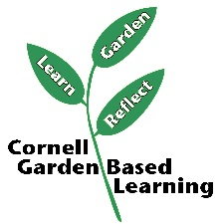
Date Published/Updated: April 2019

Facilitator’s Notes

List quotes and behavior change you noticed, especially those that may be included in your necessary reporting, success story, or for future program improvement:
List Participant Commitments that you will need to follow up on:
Changes and Adaptations to Session:

