WHO:  Participants | Individuals preparing for Master Gardener Volunteer role.
WHY:  The Situation | Invasive species threaten the function and integrity of ecosystems, native species, and managed landscapes. To support environmental stewardship, gardeners need to be aware of the top terrestrial invasive species threatening their region, where to report potential sightings, and the sound garden management practices that may minimize wider distribution.
WHEN:  Timing | 2.5 hours. 135 minutes of session time & 15 minutes for a break.
WHERE:  Space | Classroom setting with seats and tables arranged in a circle or in clusters conducive to discussion and participation.
Learning Objectives* |  | Learning Strategy (name specific approach to be used)
Consider definitions of what’s ‘non-native’ and what’s ‘invasive’, and discuss some of the controversy around these definitions. |  | Session presentation and class discussions
Recognize the impacts invasive species have on our ecosystems and human quality of life. |  | Invasive Species: The Basics video; Activity Blockbuster Survey
Understand the invasion curve and what actions are appropriate at each stage of invasion. |  | Session presentation
Learn the profile of an invasive weed or pest, and the red flags for invasiveness. |  | Read newspaper article; Activity Blockbuster Survey
Discuss the regional nature of invasiveness, and what that might mean in the face of climate change. |  | Session presentation
Become familiar with resources that will assist in identification characteristics, lifecycles, signs and symptoms for current top invasive species in your region. |  | Post session Learn More content
Explore the prohibited and regulated species regulations in New York and how to report suspect invasions to state and local agencies. |  | Session presentation; Activity Minute Paper
Consider and discuss the invasive species in our landscapes, and management strategies. |  | Before Session DO research; Activity Blockbuster Survey
*These learning objectives match those in Participant Guide & Presentation.
Before Session
Total time for preparation will vary; minimally 8 hours.
Consider adult learning theory and strategies for implementation
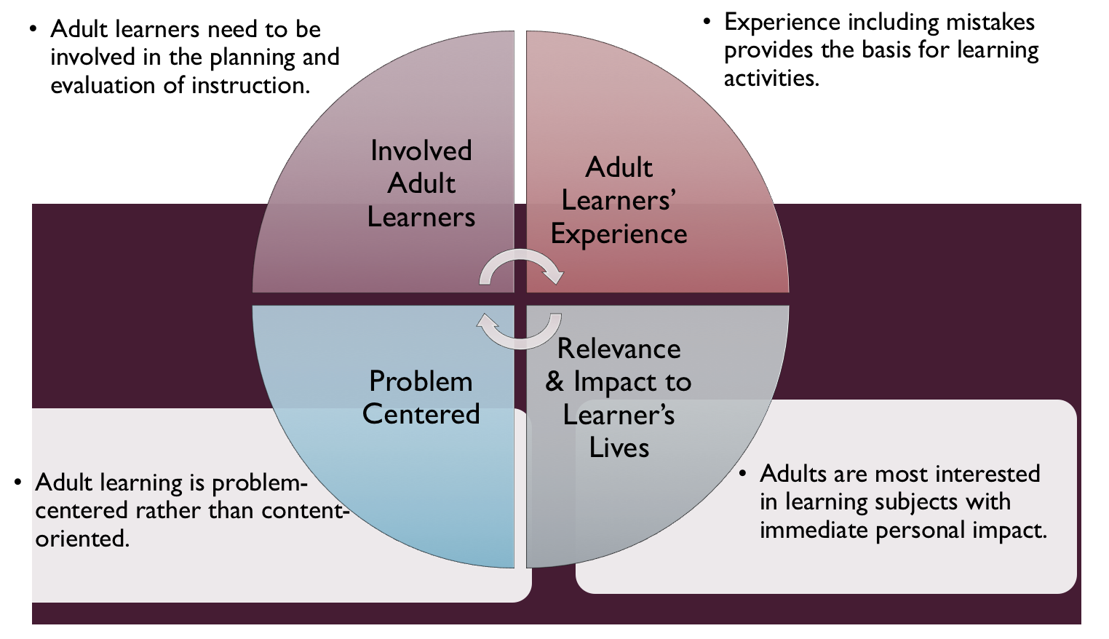
Figure credit: C. J. Carmichael adapted from M. S. Knowles and R.E. Mayer
Additionally, adult learners:
- Are experts of their lived experience.
- Come with their own motivations and goals.
- Need a safe and trusting learning environment.
- Know or will come up with 85% of the information you are planning to share.
- Remember 30% of what they hear and see, 50% of a demonstration, 70% of what they simulate, and 90% when they do the real thing.
Facilitated dialogue allows the classroom to become a conversation. Such discussion offers a way for students to explore supposedly settled questions and develop a fuller appreciation for the complexity of our knowledge. Model and encourage participants to ask open-ended questions that don’t seek yes/no answers or have right/wrong answers. This will help create a safe and trustworthy learning environment that helps participants reflect on information and make it personally relevant. The ground rules for engagement from the Intro Session in the Learning Library - Core Preparation can be re-introduced if discussions lead to difficult and emotional conversations.
Consider your local PRISM (partnerships for regional invasive species management)
Do they have an expert to facilitate or look over the session and adapt to fit your local area? PRISM contact list: http://nyis.info/prisms-and-partners/
Review (time will vary; minimally 4 to 6 hours)
Go to the online Learning Library - Core Preparation and review the resources available in the section Invasive Species for Gardeners:
- Session Slides and Facilitator Notes
- FAQs
- Facilitator Guide
- Participant Guide
- Knowledge Check
- Hands-on Activities Directions
Gather materials and supplies (2 plus hours)
The Learning Library Activity Directions documents include a supply list for each activity. Activity materials are minimal, though internet access in the class setting is needed and in advance write out index cards for blockbuster survey activity and the minute paper prompts on a flip chart.
Communicate with participants before session (1 hour)
Ideally at least 2 weeks in advance of this session provide participants with the Participant Guide found in the Learning Library - Core Preparation. This document details what participants must do before the session. Review the document to determine if you need to supply any material in advance and to confirm the links are still good. Time to complete this pre-work will vary depending on the participant’s background and interest. We estimate most participants should allocate 3 to 5 hours.
Program Evaluation/Feedback (1 hour)
See section below.
Session Flow and Delivery
Total time for session is 2.5 hours - 135 minutes of task time & 15 minutes for a break.
As participants settle in, ask them to complete a review activity that you’ve prepared or selected from the review bank OR go over pre-work with others around them.

Session Tasks
Task 1: Opening and Introduction (5 minutes)
Welcome everyone, review housekeeping, ground rules, learning objectives, and class flow.
Task 2: Reconnect (10 minutes)
Ask participants pair up to discuss the question under THINK in their Participant Guide.
Task 3: Invasive Species in NY Lecture (60 minutes)
Listen to the recorded presentation.
Use the Session Slides and Facilitator notes found in the Learning Library; feel free to adapt the resources to suit your teaching style and needs. Alternatively, a presenter can create their own presentation to meet the learning objectives on page 1 of this document.
Task 4: Blockbuster Survey Hands-on Activity Discussion (30 minutes)
Follow activity directions document found in Learning Library. Participants having use of tablets, laptops, smartphones, or print resources is needed for this activity.
Task 5: Minute Paper on Reporting and Prioritizing Invasive Species Activity (15 minutes)
Follow the activity directions documents found in Learning Library.
15 Minute BREAK
Task 6: Conclusion (10 minutes)
Ask participants to reflect on key take home points from today and any lingering questions.
Direct participants’ attention to the items listed under After Session in their Participant Guide.
Task 7: Program Evaluation/Feedback (5 minutes)
Provide participants with an avenue to give feedback and data for your program evaluation including reporting. See section below on Program Evaluation/Feedback.
Task 8: Participant Evaluation/Knowledge Check (part of participant’s After Session work)
Provide an avenue for participants to assess what they know. See section below on Participant Evaluation/Knowledge Check.
After Session
Total time for follow-up will vary; minimally 2 hours.
Communicate with participants after session (1 hour)
Follow-up on unanswered content questions that emerged during session as needed as well as provide feedback on the knowledge check.

Consider Program Evaluation/Feedback (1 hour)
Summarize the feedback and data you received from participants for your program reporting and or future planning needs. See section below on Program Evaluation/Feedback.
Session Materials and Supplies
General Materials List
Facilitator notes Markers Index cards Pens, Highlighters, Flip chart paper Name tags Feedback Forms, Post-it® notes, Masking tape Computer/Internet/Projector
Materials by Task
Before Session Tasks
- Materials found in CCE MGV Learning Library:
  - Module 5: Management Strategies Section 5.3 Invasive Species for Gardeners
  - Evaluation Toolkit
Task 1 - Opening and Introduction
- Participant Guide
- Session Slides and Facilitator Notes
Task 2 - Reconnect
- Participant Guide
- Flip chart paper and markers for group discussion notes
Task 3 – Invasive Species in NY Lecture
- Activity Directions and Factsheet document found in Learning Library.
Task 4 – Blockbuster Survey Hands-on Activity Discussion Activity
- Direction document found in Learning Library. Participants having use of tablets, laptops, smartphones, or print resources is needed for this activity.
Task 5 - Minute Paper on Reporting and Prioritizing Invasive Species Activity
- Direction document found in Learning Library. No significant supplies.
Task 6 – Conclusion
- Participant Guide
- Flip chart paper and markers for group discussion notes
Task 7 – Program Evaluation/Feedback
- Your evaluation/feedback materials
Task 8 – Participant Evaluation/Knowledge Check
- Materials for participants to assess what they know around this topic such as Knowledge Check from Learning Library
For After Session
- Feedback from participants
- Reporting forms
- Knowledge Check Key from Learning Library

Optional Activities
Frequently Asked Questions (FAQs)
With the input of county and campus-based experts, we have compiled a list of top FAQs for each topic areas and place it with the other session resources in Learning Library. Though not an exhaustive list, it should provide an opportunity for discussion and exploration of resources related to the topic. Integrate the FAQs in a way that makes sense for your local program. The FAQs could be used to prompt discussions within your group or they could be adapted into a scavenger hunt where individuals sift through reliable resources to find correct answers. Feel free to add or subtract questions and resources in the answers to meet your program's needs and address emerging issue.
Participant Evaluation/Knowledge Check
Adult learners enjoy getting feedback on what they have learned. In the Learning Library, you will find the Knowledge Check handouts for each session. You may ask participants to answer the questions at home on their own or in small groups discussions. The Knowledge Check KEY can be used to allow participants to self-check or for the educator to grade and provide feedback. You may wish to identify more engaging ways to self‐test what they have learned as it motivates and empowers them to be more accountable for their learning.
Program Evaluation/Feedback
Time for creating and implementing a program evaluation plan will vary; minimally 1 hour.
Ideally, evaluation begins before the program starts. However, for many educators the idea of measuring the effects of your program is so daunting it never begins. With this in mind, we provide an Evaluation Toolkit in the Learning Library. Our aim is to offer tools you can use, even while you’re on the run. Check it out as you consider these key questions:
- Who is this evaluation for?
- What do you want to know, and why?
- What’s do‐able, really?
Other key resources will be your local county program plan of work which likely aligns with CCE Programmatic Plans: http://www2.cce.cornell.edu/plans/Pages/FY-2016-CCE-Programmatic-Plans.aspx
Find on CCE staff website under the Organizational Development and Planning Unit a Program Reporting module: http://staff.cce.cornell.edu/orgdev/Pages/reporting.aspx
References
For Adult Learning Theory references see those listed in Learning Library in Module 6: Facilitating Learning Section 6.1 Adult Learning and Community Engagement.
Cornell University New York Invasive Species Research Institute http://www.nyisri.org/
Prohibited and regulated species in New York. http://www.dec.ny.gov/animals/99141.html
DEC terrestrial invasive species website. Online at: http://www.dec.ny.gov/animals/95383.html
NYS Hemlock Initiative. Online at: https://blogs.cornell.edu/nyshemlockinitiative/
Emerald Ash Borer in New York. Online at: http://www.dec.ny.gov/animals/7253.html
New York State PRISM organizations. Online at: http://www.dec.ny.gov/animals/47433.html

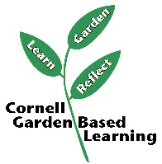
Date Published/Updated: April 2019

Facilitator’s Notes

List quotes and behavior change you noticed, especially those that may be included in your necessary reporting, success story, or for future program improvement:
List Participant Commitments that you will need to follow up on:
Changes and Adaptations to Session:

