WHO:  Participants | Individuals preparing for Master Gardener Volunteer role.
WHY:  The Situation | Climate data for the last 50 years show dramatic changes in temperature and precipitation at the global, national, regional, and state levels. In New York and elsewhere, global climate change is believed responsible for more erratic weather patterns, warmer temperatures, heavier rainfall, lower snow levels, and altered season length with intensifying impact on humans, wildlife, the economy, and the environment. Cornell Cooperative Extension (CCE) is committed to educating stakeholders about this intensifying challenge and helping citizens implement the strategies that are needed to adapt to and mitigate climate change. (CCE Statewide Plan of Work)
WHEN:  Timing | 2.5 hours/135 minutes of session time & 15 minutes for a break.
WHERE:  Space | Classroom setting with seats and tables arranged in a circle or in clusters conducive to discussion and participation.
Learning Objectives* | Learning Strategy (name specific approach to be used)
Understand systems thinking as it applies to your garden system. | Content from Unit 1 & 2 of course book will be presented, facilitator will lead group discussions, and individuals will engage in pre-work activities.
Be familiar with the basics of climate change. | Content from Unit 3 course book will be presented.
List current and future possible impacts of climate change on NYS. | Content from Unit 3 course book will be presented, and facilitator will lead group discussions.
Identify ways to manage gardens to mitigate and adapt to climate impacts. | Content from Unit 4 course book will be presented; small groups will complete worksheet and discuss Garden Audit.
Have tools to be a peer educator around Gardening in a Warming World. | Be provided with curriculum materials and facilitator will lead group discussions to identify additional needs to support preparedness.
*These learning objectives match those in Participant Guide & Presentation.

Before Session
Total time for preparation will vary; minimally 8 hours.
Consider adult learning theory and strategies for implementation
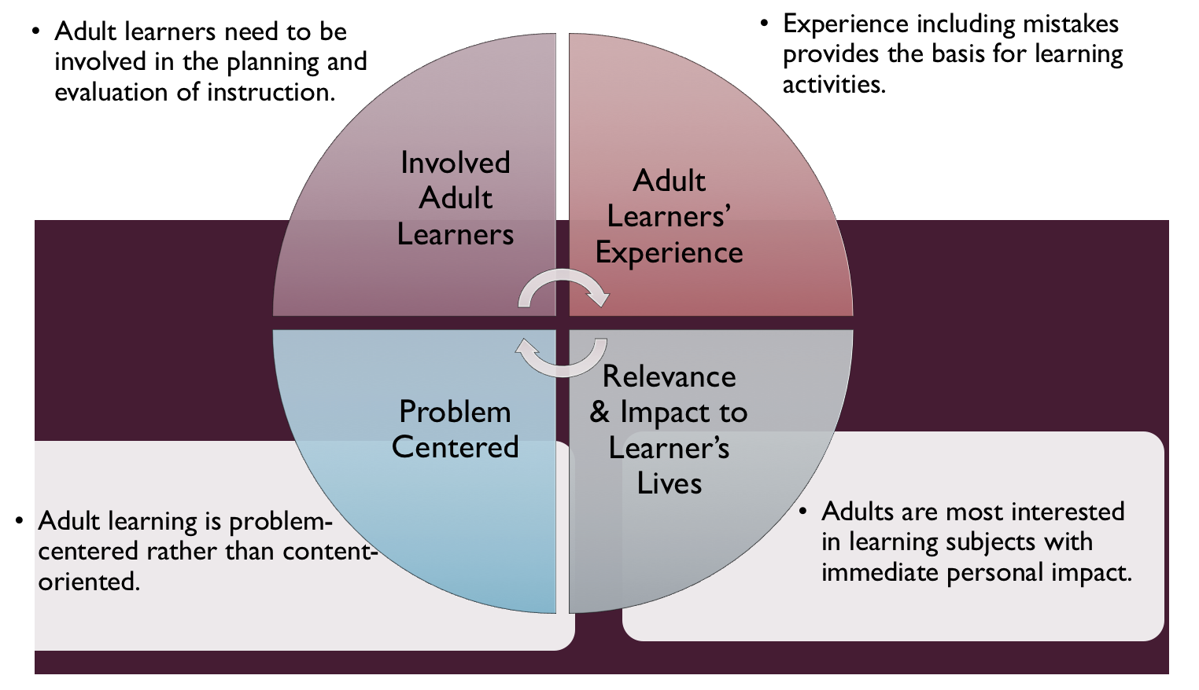
Figure credit: C. J. Carmichael adapted from M. S. Knowles and R.E. Mayer
Additionally, adult learners:
- Are experts of their lived experience.
- Come with their own motivations and goals.
- Need a safe and trusting learning environment.
- Know or will come up with 85% of the information you are planning to share.
- Remember 30% of what they hear and see, 50% of a demonstration, 70% of what they simulate, and 90% when they do the real thing.
It’s important to acknowledge that dialogue around climate change can lead to difficult and emotional conversations. Facilitated dialogue allows the classroom to become a conversation. Such discussion offers a way for students to explore supposedly settled questions and develop a fuller appreciation for the complexity of our knowledge. Model and encourage participants to ask open-ended questions that don’t seek yes/no answers or have right/wrong answers. This will help create a safe and trustworthy learning environment that helps participants reflect on information and make it personally relevant. The ground rules for engagement from the Intro Session in the GB Learning Library - Core Preparation can be re-introduced if discussions lead to difficult and emotional conversations.
Review (time will vary; minimally 6 hours)
Go to the online GB Learning Library - Core Preparation and review the resources available in the section Gardening in a Warming World including:
- FAQs
- Facilitator Guide
- Participant Guide
- Knowledge Check
This unit also has these resources which are also available to the public via http://climatechange.cornell.edu/gardening
- Climate Smart Gardening Course Book
- Facilitator’s Handouts from Notebook
- Companion Presentation
- Presenter Notes for Companion Presentation
Gather materials and supplies (1 hours)
Make copies for all participants of the 9 pages - Facilitator’s Handouts from Notebook.
Communicate with participants before session (1 hour)
Ideally at least 2 weeks in advance of this session provide participants with the Participant Guide found in the GB Learning Library - Core Preparation. This document details what participants must do before the session. Review the document to determine if you need to supply any material in advance and to confirm the links are still good. Time to complete this pre-work will vary depending on the participant’s background and interest. We estimate most participants should allocate 5 hours.
Program Evaluation/Feedback (1 hour)
See section below.
Session Flow and Delivery
Total time for session is 2.5 hours - 135 minutes of task time & 15 minutes for a break.
Session Tasks
Task 1: Opening and Introduction (20 minutes)
Welcome everyone, review housekeeping, ground rules, learning objectives, and class flow.
Engage participants in the ice breaker activity in the Presentation Notes where they sketch or describe their gardening space. Provide time for very brief introductions. Welcome everyone, review housekeeping, ground rules, learning objectives, and class flow.
Task 2: Benefits of Systems Thinking for Sustainable Gardening Discussion (10 minutes)
Consider definitions of “systems” and “systems thinker”; refer to “System Thinker” handout from appendix in Facilitator’s Notebook and reflect on how systems thinking could lead to great success in pest management.
Task 3: Knowing Your Garden Systems Discussion (20 minutes)
Identify ways people are observing and documenting their gardens. Return to ice breaker activity where they sketched or described their gardening space. Share handout “Knowing your Garden System” from appendix in Facilitator’s Notebook and give participants 5 or more minutes to review and add some more detail to their initial descriptions or sketch using the handout to prompt them to consider specific aspects of their space. They can continue the activity later, as we are just trying to get them thinking about their specific space and what they know about it. Lead group into next unit by briefly facilitating whole group discussion that allows them to voice observations around: What changes have you noticed in your garden?
Task 4: Climate Change Basics Lecture (25 minutes)
Present the basics around weather, climate, using weather and climate data in gardening, greenhouse effect as well as indicators of a warming world and impact of a changing climate. Refer to these handouts from appendix in Facilitator’s Notebook; “What is the Greenhouse Effect?”, “What Happens in New York State When the Climate Changes?” and “Reliable Resources Matrix.”
15 Minute BREAK
Task 5: Climate-Smart Garden Audit Discussion Activity (45 minutes)
Define mitigation and adaptation; participants complete and reflect on worksheet “Climate-smart gardening put into action” from appendix in Facilitator’s Notebook. Outline the elements of a climate smart garden audit from Gardening In a Warming World Course Book and engage in a small group activity described in the Facilitator’s Notebook under Unit 4 in the activities appendix.
Task 6: Conclusion (10 minutes)
Ask participants to reflect on key take home points from today and any lingering questions.
Direct participants’ attention to the items listed under After Session in their Participant Guide. Reflect on talking with others about Gardening in a Warming World. Encourage participants to review these sections from the Facilitators Notebook and you may make copies of them to distribute:

Section 5: Creating a Study Circle for Gardening in a Warming World (1 page)

Section 6: How to Talk About Gardening in Warming World with Others (5 pages)
Task 7: Program Evaluation/Feedback (5 minutes)
Provide participants with an avenue to give feedback and data for your program evaluation and reporting. See section below on Program Evaluation/Feedback.
Task 8: Participant Evaluation/Knowledge Check (part of participant’s After Session work)
Provide an avenue for participants to assess what they know. See section below on Participant Evaluation/Knowledge Check.
After Session
Total time for follow-up will vary; minimally 2 hours.
Communicate with participants after session (1 hour)
Follow-up on unanswered content questions that emerged during the session and provide feedback on the knowledge check.
Consider Program Evaluation/Feedback (1 hour)
Summarize the feedback and data you received from participants for your program reporting and or future planning needs. See section below on Program Evaluation/Feedback.
Session Materials and Supplies
General Materials List
Facilitator notes Markers Index cards Pens/Highlighters Flip chart paper Name tags Feedback Forms Post-it® notes Masking tape Computer/Internet/Projector
Materials by Task
Before Session Tasks
- Materials found in GB Learning Library:
  - Module 5: Management Strategies/Issues Section 5.4 Gardening in a Warming World
  - Evaluation Toolkit
Task 1 - Opening and Introduction
- Participant Guide
- Session Slides and Facilitator Notes
- Blank sheet of copy paper for each participant for ice breaker activity in the Presentation Notes.
Task 2 - Benefits of Systems Thinking for Sustainable Gardening Discussion Activity
- Being a System Thinker handout from appendix in Facilitator’s Notebook.
- Flip chart paper and markers for group discussion notes.
Task 3 – - Knowing Your Garden Systems Discussion Activity
- Knowing your Garden System handout from appendix in Facilitator’s Notebook.
- Participant’s description or sketches from ice breaker.
- Flip chart paper and markers for group discussion notes.
Task 4 - Climate Change Basics Lecture
- What is the Greenhouse Effect? handout from appendix in Facilitator’s Notebook.
- What Happens in New York State When the Climate Changes? handout from appendix in Facilitator’s Notebook.
- Reliable Resources Matrix handout from appendix in Facilitator’s Notebook.
- Flip chart paper and markers for group discussion notes.
Task 5 - Climate-Smart Garden Audit Discussion Activity
- Climate-smart gardening put into action handout in Facilitator’s Notebook.
- Flip chart paper and markers for groups or have them use own notebook paper.
- For reference participants may want to have their electronic or print copy of Unit 4 in Gardening in a Warming World: A Climate Smart Gardening Course Book.
Task 6 – Conclusion
- Participant Guide
- Flip chart paper and markers for group discussion notes
- (Optional) Copies of these sections from the Facilitators Notebook:
  - Section 5: Creating a Study Circle for Gardening in a Warming World
  - Section 6: How to Talk About Gardening in Warming World with Others
Task 7 – Program Evaluation/Feedback
- Your evaluation/feedback materials
Task 8 – Participant Evaluation/Knowledge Check
- Materials for participants to assess what they know around this topic such as Knowledge Check from GB Learning Library
For After Session
- Feedback from participants
- Reporting forms
- Knowledge Check Key from GB Learning Library

Optional Activities
Frequently Asked Questions (FAQs)
With the input of county and campus-based experts, we have compiled a list of top FAQs for each topic areas and placed it with the other session resources in the GB Learning Library. Though not an exhaustive list, it should provide an opportunity for discussion and exploration of resources related to the topic. Integrate the FAQs in a way that makes sense for your local program. Feel free to add or subtract questions and resources in the answers to meet your program's needs and address emerging issues.
Additional activity ideas can be found in the Gardening in a Warming World Facilitator’s Notebook (http://climatechange.cornell.edu/gardening) look at:
- Section 5: Creating a Study Circle for Gardening in a Warming World
- Section 6: How to Talk About Gardening in a Warming World with Others
- Appendix B - Activities
Inspire Understanding with Discussion are questions that encourage reflection on the Unit content; activities range in titles and are included for both individuals and groups.
- Unit 1- Inspire understanding with discussion, Garden Clinic, Ball of Yarn Interconnections, Mind Map
- Unit 2- Inspire Understanding with Discussion, Garden Journaling Exercise, Cataloging Your Garden Site, A Close Look: Cultivating Plant Observation Skills, Creating a Garden Calendar, Are the Bloom Dates Changing and More?, Create Your Own Garden Landscape Maps, Where’s the Pattern? Mapping Exercise
- Unit 3- Inspire Understanding with Discussion, Identify Reliable Sources About Climate Change Reliable Resources Matrix, Hot Globe, How Do You Feel?, Role Play
- Unit 4- Inspire Understanding with Discussion, Right Plant Right Place
Participant Evaluation/Knowledge Check
Adult learners enjoy getting feedback on what they have learned. In the GB Learning Library, you will find the Knowledge Check handouts for each session. You may ask participants to answer the questions at home on their own or in small group discussions. The Knowledge Check KEY can be used for participants to self-check or for the educator to grade and provide feedback. You may wish to identify more engaging ways for participants to self‐test what they have learned as it motivates and empowers them to be more accountable for their learning.
Program Evaluation/Feedback
Time for creating and implementing a program evaluation plan will vary; minimally 1 hour.
Ideally, evaluation begins before the program starts. Though for many educators, the idea of measuring the effects of your program is so daunting it never begins. With this in mind, we provide an Evaluation Toolkit in the GB Learning Library. Our aim is to offer tools you can use, even while you’re on the run. Check it out as you consider these key questions:
- Who is this evaluation for?
- What do you want to know, and why?
- What’s do‐able, really?
Other key resources will be your local county program plan of work which likely aligns with CCE Programmatic Plans: http://www2.cce.cornell.edu/plans/Pages/FY-2016-CCE-Programmatic-Plans.aspx
Find on CCE staff website under the Organizational Development and Planning Unit a Program Reporting module: http://staff.cce.cornell.edu/orgdev/Pages/reporting.aspx
References
For Adult Learning Theory references see those listed in GB Learning Library in Module 6: Facilitating Learning Section 6.1 Adult Learning and Community Engagement.
The Gardening in a Warming World curriculum materials have extension references and numerous resources in each unit. There is highly politicized condemnation of climate change science; it is important that we use reliable, research-based information in both learning ourselves and educating others.
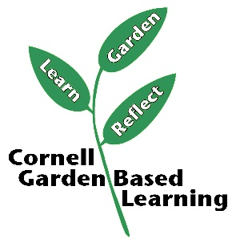
Date Published/Updated: April 2019

Facilitator’s Notes

List quotes and behavior change you noticed, especially those that may be included in your necessary reporting, success story, or for future program improvement:
List Participant Commitments that you will need to follow up on:
Changes and Adaptations to Session:

