Vegetable Gardening Part 2
Knowledge Check
In the GBL Learning Library - Core Preparation Sessions
this is Section 2.1b in Module 2: Food Gardening

1. Why is it best to avoid planting crops from the same family in the same place 2 years in a row? How many years should you wait?

2. Provide an example of succession planting. Why might it be valuable strategy in promoting soil health?

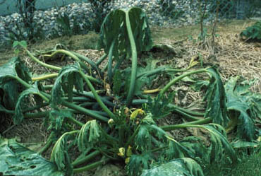
3. My squash plant looks terrible, what is wrong with it (picture to the right)?

4. What is one season extension technique?

Published: April 2019
Author: Fiona Doherty
Reviewer: Laurie VanNostrand, Michelle Podolec, Donna Alese Cooke

