Vegetable Gardening 1
Participant Guide

Community and home food gardening are active and affordable ways to improve food security status and be an ecological steward. Vegetables and fruits can be grown in containers, raised beds, or directly into the ground. CCE staff and volunteers are often well-positioned to promote knowledge and skills gains related to growing food in these settings. It is a priority of CCE to work with vulnerable populations to educate families and influence policies that will allow youth, families, and communities to make sound nutritional decisions with constrained resources. (Adapted from the CCE Statewide Plan of Work)

By actively participating in Vegetable Gardening 1, you will:
- Recognize common vegetable families.
- Identify common garden pests and diseases.
- Examine methods to start vegetable seeds indoors and outdoors.
- Describe best management practices for water, weed, pest prevention, and nutrient management for maintaining vegetable and herb crops.

Before Session
READ:
- Excerpt Chapters from Seed to Supper course book (26 pages provided).
- Factsheet Indoor Vegetable Seed Starting (2 pages provided).
DO:
- Any seed packets at home? Bring them in. Empty ones are fine.
EXPLORE:
- Take about 20 minutes to explore the Cornell Food Gardening Resources - This is an excellent site as it provides advice on growing 58 different vegetables as well as many herbs. All of it is written for New York growing conditions. It also provides more detailed information on saving seeds, container gardening and variety recommendations. This is a site you will want to keep bookmarked on your computer. You might click on a few links that catch your interest and read a little more or watch a couple videos. www.gardening.cornell.edu/vegetables and http://www.gardening.cornell.edu/homegardening/scene0391.html

Opening and Introduction
- Facilitator reviews housekeeping, ground rules, learning objectives, and class flow.
We Are Family Vegetable Crops Hands-on Activity Part A
- Facilitator leads participants through individual reflection and adding to charts.

Vegetable Garden 10 Things to Know Lecture
- Listen to presentation.

Seed Packet Sorting Hands-on Activity
- Facilitator leads participants through small group activity and discussion.

Vegetable Gardening Pests Lecture
- Listen to presentation.

Conclusions
- Facilitator leads group reflection on key take home points and any lingering questions.

Program Feedback
- Share your insight to help us improve the program, report results, & plan for the future.

Knowledge Check
- Assess what you now know. Be motived and empowered to share with your peers and learn more.

After Session
REFLECT:
- What happened?
- What was my response to what happen? How do I make sense of it?
- How does it relate to other things I know?
- What can I conclude?
- What might I do differently next time?

LEARN MORE:
There are a large number of resources about vegetable gardening at Cornell University and beyond, here are a few. This is arranged by NYS Seed to Supper Course Book chapter topics:

Chapter 1- Planning Your Garden
- Vegetable Varieties for Gardeners- http://vegvariety.cce.cornell.edu/main/login.php
- Cornell Garden-Based Learning Citizen Science projects related to growing vegetables http://gardening.cals.cornell.edu/citizen-science/
- Vegetable Growing Guides http://www.gardening.cornell.edu/homegardening/scene0391.html
- Fact Sheets on Food Gardening resource page http://gardening.cornell.edu/vegetables/

Chapter 2- Getting Started with Healthy Soil
- Cover crop guide for New York Vegetable Growers http://covercrop.org
- Cover Crops for Urban Gardens (Garden Ecology project) https://blogs.cornell.edu/gep/gardeners
- Healthy Soils, Healthy Communities; http://blogs.cornell.edu/healthysoils
- Soil Contaminants and Best Practices for Healthy Gardens, Cornell Waste Management Institute http://cwmi.css.cornell.edu/soilquality.htm#research
- Fact Sheets on Food Gardening resource page http://gardening.cornell.edu/vegetables/
- Fact Sheets on soil testing resource page http://gardening.cornell.edu/soil

Chapter 3- Planting Your Garden
- Fact Sheets on Food Gardening resource page http://gardening.cornell.edu/vegetables/
- Eliot Coleman’s Four Season Farm books, http://fourseasonfarm.com/read-our-books
- Vegetable Gardening for Dummies by Charlie Nardozzi, 2009
- How to Grow More Vegetables by John Jeavons, 2012 8th edition
- The Vegetable Gardener’s Bible by Edward C. Smith, 2009

Chapter 4- Caring for Your Growing Garden
- Save the rain: http://savetherain.us/green-programs/green-infrastructure/rain-barrels/ and http://cceonondaga.org/resources/how-to-build-a-rain-barrel
- Rain Barrels, Fact Sheet 218; Cornell Cooperative Extension Rockland County; http://rocklandcce.org/resources/rain-barrels
- Plant Rotation in the Garden Based on Plant Families https://extension.psu.edu/plant-rotation-in-the-garden-based-on-plant-families
- Vegetable Resources, New York State Integrated Pest Management website, Cornell, CALS; https://nysipm.cornell.edu/agriculture/vegetables/resources/
- Troubleshooting, Cornell Garden- Based Learning, http://gardening.cals.cornell.edu/garden-guidance/troubleshooting/
- Late Blight Information; New York State Integrated Pest Management website, Cornell, CALS; https://nysipm.cornell.edu/agriculture/vegetables/pest-alerts-vegetables/late-blight/
- Cornell University Insect Diagnostic Laboratory; http://idl.entomology.cornell.edu
- Pests, Cornell Vegetable Program, CALS; https://cvp.cce.cornell.edu/pests.php#topbo
- Weed Control for the Home Vegetable Garden, Bellinder, Robin R.; Kline, Roger A. and Warholic, Donald T. Cornell University Cooperative Extension, https://ecommons.cornell.edu/handle/1813/3618
- Weeds and Your Garden, New York State Integrated Pest Management, Cornell, CALS https://ecommons.cornell.edu/bitstream/handle/1813/43859/weeds-in-garden-bro-NYSIPM.pdf;sequence=1
- Cornell Publications Wildlife Damage Management Fact Sheets; http://wildlifecontrol.info/publications/cornell-publications

Chapter 5 - Harvesting and Using Your Bounty
- Resources in GBL Learning Library Advance Topic Seed Saving
- The National Center for Home Food Preservation; The University of Georgia; https://nchfp.uga.edu/
- So Easy to Preserve, The University of Georgia, https://setp.uga.edu
- Handy Reference for Drying Vegetables and Herbs; Prepared by Katherine T. Humphrey and Judy L. Price, Cornell Cooperative Extension Home Food Preservation Experts, 2002; https://cpb-us-e1.wpmucdn.com/blogs.cornell.edu/dist/b/2712/files/2009/04/2011_handy_ref_dry_veg.pdf
- Handy Reference for Canning Fruits. Ruth Klippstein, Division of Nutritional Sciences, Cornell University. http://ccetompkins.org/resources/handy-reference-for-canning-fruits
- Handy Reference for Canning Vegetables; Ruth Klippstein, Division of Nutritional Sciences, Cornell University. http://ccetompkins.org/resources/handy-reference-for-canning-vegetables
- Freezing Fruits and Vegetables; Mary Lou Tenney, Division of Nutritional Sciences, Cornell University. http://ccetompkins.org/resources/freezing-fruits-vegetables
- Storage Guidelines for Fruits and Vegetables, Cornell Cooperative Extension of Chemung County; http://chemung.cce.cornell.edu/resources/storage-guidelines-for-fruits-vegetables

Campus Links:
- Cornell Garden-Based Learning Food Gardening web page: www.gardening.cornell.edu/vegetables
- Cornell Garden-Based Learning Citizen Science projects related to growing vegetables http://gardening.cals.cornell.edu/citizen-science/
- Cornell Commercial Vegetables: https://www.vegetables.cornell.edu/

Looking for Cornell people and resources? Don’t Google; try the Cornell web search: http://www.cornell.edu/search/index.cfm

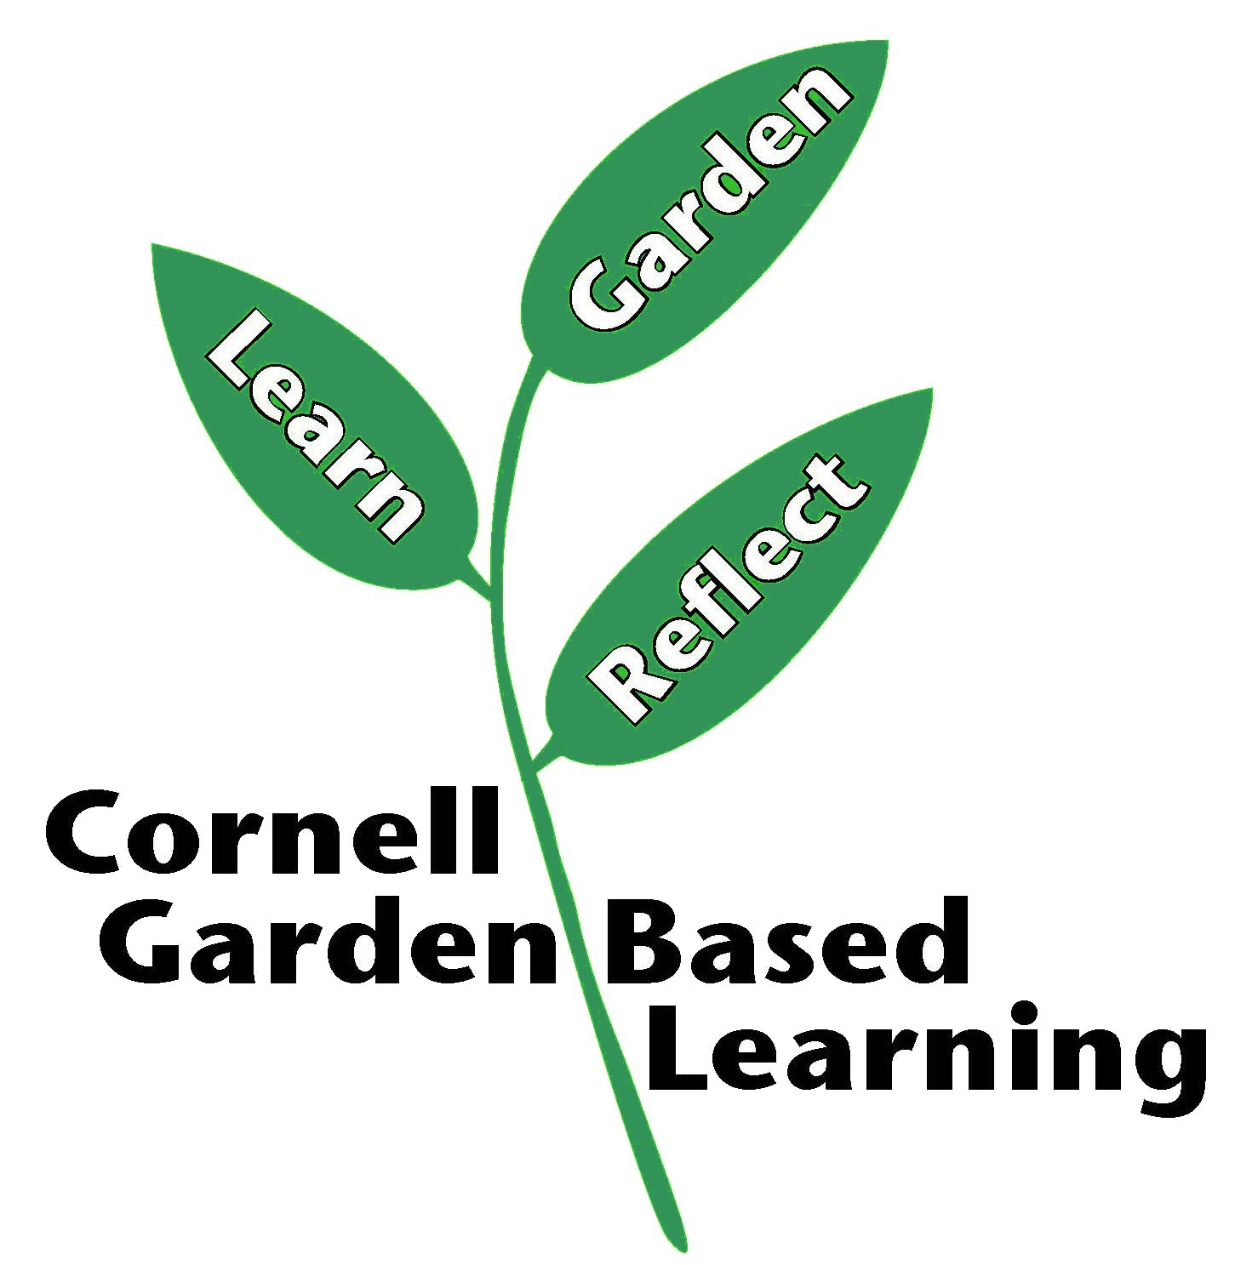
Date Published/Updated: April 2019

