WHO:  Participants | Individuals preparing for Master Gardener Volunteer role.
WHY:  The Situation | Community and home gardening are active and affordable ways to improve food security status. CCE staff and volunteers are often well-positioned to promote knowledge and skills gains related to growing food in these settings. It is a priority of CCE to work with vulnerable populations to educate families and influence policies that will allow youth, families and communities to make sound nutritional decisions with constrained resources. (Adapted from the CCE Statewide Plan of Work.)
WHEN:  Timing | 2.5 hours. 135 minutes of session time & 15 minutes for a break.
WHERE:  Space | Classroom setting with seats and tables arranged in a circle or in clusters conducive to discussion and participation.
Learning Objectives* |  | Learning Strategy (name specific approach to be used)
Recognize common vegetable families. |  | Hands-on Activities: We Are Family Vegetable Crops (Part A) & Seed Sorting Activity
Identify common garden pests and diseases. |  | Presentation: Vegetable Gardening Pests
Examine methods to start vegetable seeds indoors and outdoors. |  | Presentation: Vegetable Garden 10 Things to Know; Read Fact sheet Indoor Vegetable Seed Starting
Describe best management practices for watering, pest prevention, and nutrient management for maintaining vegetable and herb crops. |  | Presentation: Top Ten Things to Know for a Successful Vegetable Garden Presentation; Hands-on Activity: We Are Family Vegetable Crops (Part A); Read Excerpt Chapters from Seed to Supper Course Book and supplemental fact sheets
*These learning objectives match those in Participant Guide & Presentation.
Before Session
Total time for preparation will vary; minimally 8 hours.

Consider adult learning theory and strategies for implementation

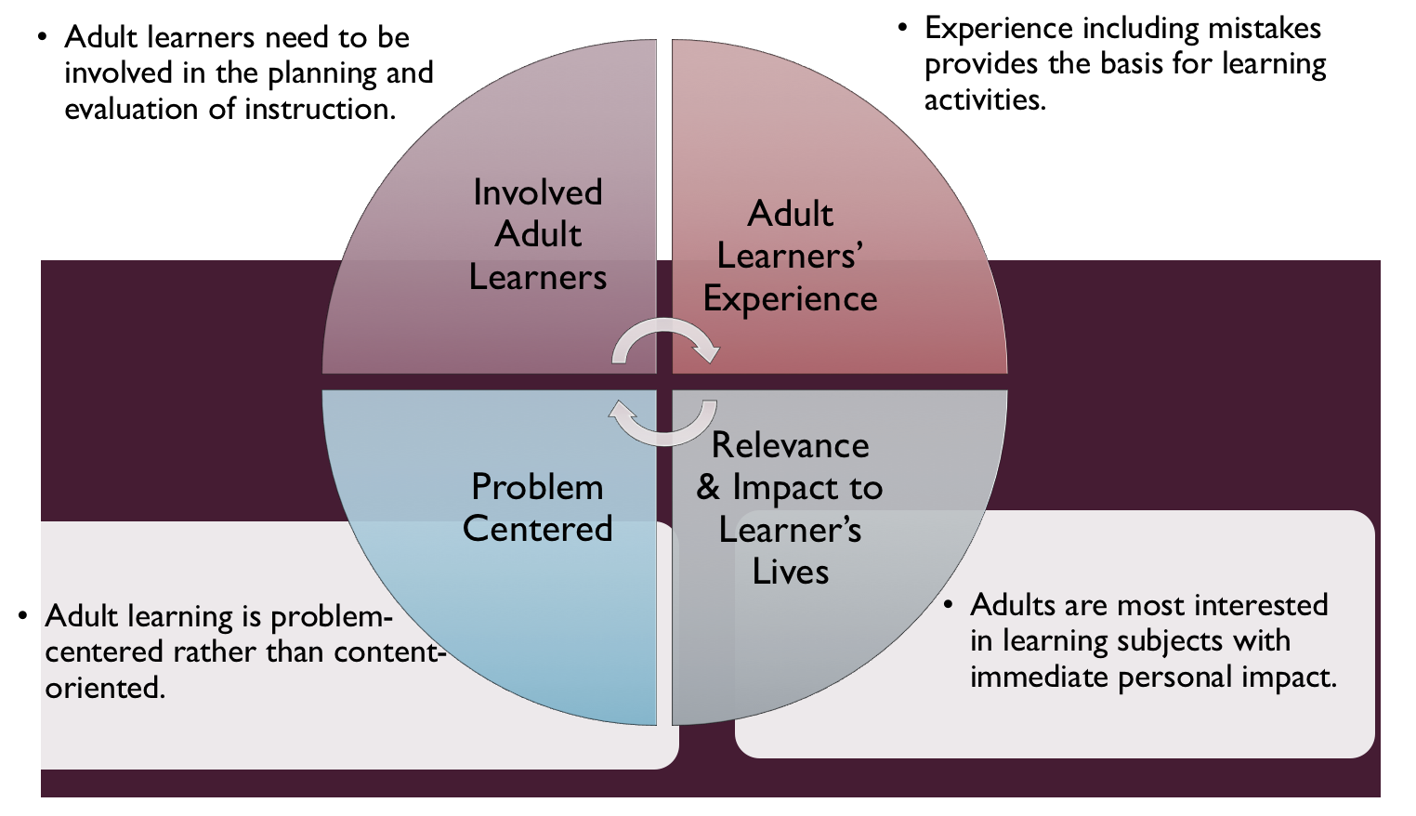
Figure credit: C. J. Carmichael adapted from M. S. Knowles and R.E. Mayer
Additionally, adult learners:
- Are experts of their lived experience.
- Come with their own motivations and goals.
- Need a safe and trusting learning environment.
- Know or will come up with 85% of the information you are planning to share.
- Remember 30% of what they hear and see, 50% of a demonstration, 70% of what they simulate, and 90% when they do the real thing.

Facilitated dialogue allows the classroom to become a conversation. Such discussion offers a way for students to explore supposedly settled questions and develop a fuller appreciation for the complexity of our knowledge. Model and encourage participants to ask open-ended questions that don’t seek yes/no answers or have right/wrong answers. This will help create a safe and trustworthy learning environment that helps participants reflect on information and make it personally relevant. The Ground Rules for Engagement from the Toolkit section in the GBL Learning Library - Core Preparation can be re-introduced if discussions lead to difficult and emotional conversations.

Review (time will vary; minimally 4 to 6 hours)
Go to the online GBL Learning Library - Core Preparation and review the resources available in the section Vegetable Gardening (Part 1 of 2) including:
- Session Slides and Facilitator Notes
- Participant Guide
- Knowledge Check
- Print Materials for Before Session Pre-Work and Hands-on Activities
- FAQs
- Videos - Vegetable Gardening Presentation (note there is no concrete overlap with the Session Slides and Facilitator Notes).

Gather materials and supplies (2 plus hours)
The biggest challenge might be gathering seed packets for a hands-on activity. The document KEY Common Vegetable Crops Plant Families is used in both activities but no need to print for all participants (just a couple copies will do). Find Activity Directions and Key document in GBL Learning Library.

Communicate with participants before session (1 hour)
Ideally at least 2 weeks in advance of this session provide participants with the Participant Guide found in the GBL Learning Library - Core Preparation. This document details what participants must do before the session. Review the document to determine if you need to supply any material in advance and to confirm the links are still good. Time to complete this pre-work will vary depending on the participant’s background and interest. We estimate most participants should allocate 3 to 5 hours.

Ask participants if they have seed packets they might bring in (empty is fine).

Program Evaluation/Feedback (1 hour)
See section below.

Session Flow and Delivery
Total time for session is 2.5 hours - 135 minutes of task time & 15 minutes for a break.

As participants settle in, ask them to complete a review activity that you’ve prepared or selected from the review bank OR go over pre-work with others around them.

Session Tasks
Task 1: Opening and Introduction (5 minutes)
Welcome everyone, review housekeeping, ground rules, learning objectives, and class flow.

Task 2: We Are Family Vegetable Crops Hands-on Activity Part A (15 minutes)
Follow the activity direction for Part A. Document found in GBL Learning Library.

Task 3: Vegetable Garden 10 Things to Know (45 minutes)
Use the Session Slides and Facilitator notes found in Learning Library; feel free to adapt the resources to suit your teaching style and needs. Alternatively, a presenter can create their own presentation to meet the learning objectives on page 1 of this document. Or use the recorded presentation either having participants view outside class or during class. Note that there is no concrete overlap with the Session Slides and Facilitator Notes.

15 Minute BREAK

Task 4: Seed Packet Sorting Hands-on Activity (20 minutes)
Follow the activity direction document found in GBL Learning Library.

Task 5: Vegetable Gardening Pests Lecture (40 minutes)
Use the Session Slides and Facilitator notes found in GBL Learning Library; feel free to adapt the resources to suit your teaching style and needs. Alternatively, a presenter can create their own presentation to meet the learning objectives on page 1 of this document. Or use the recorded presentation either having participants view outside class or during class. Note that there is no concrete overlap with the Session Slides and Facilitator Notes.

Task 6: Conclusion (5 minutes)
Ask participants to reflect on key take home points from today and any lingering questions.
Direct participants’ attention to the items listed under After Session in their Participant Guide.

Task 7: Program Evaluation/Feedback (5 minutes)
Provide participants with an avenue to give feedback and data for your program evaluation including reporting. See section below on Program Evaluation/Feedback.

Task 8: Participant Evaluation/Knowledge Check (part of participant’s After Session work)
Provide an avenue for participants to assess what they know. See section below on Participant Evaluation/Knowledge Check.

Collect the seed packets, flip chart sheets, and family traits sheets to use again in the Vegetable Gardening 2 session hands-on activities.

After Session
Total time for follow-up will vary; minimally 2 hours.

Communicate with participants after session (1 hour)
Follow-up on unanswered content questions that emerged during session as needed as well as provide feedback on the knowledge check and after session activity.

Consider Program Evaluation/Feedback (1 hour)
Summarize the feedback and data you received from participants for your program reporting and or future planning needs. See section below on Program Evaluation/Feedback.

Session Materials and Supplies
General Materials List
Facilitator notes Markers Index cards Pens
Highlighters Flip chart paper Name tags Feedback Forms
Post-it® notes Masking tape Computer/Internet/Projector

Materials by Task
Before Session Tasks
- Materials found in GBL Learning Library:
  - Section 2.1a in Module 2: Vegetable Gardening 1
  - Vegetable Gardening Videos www.youtube.com/playlist?list=PLHPXm2Es8aQC2vyn2lV1ij3bAHtPk2kg2&disable_polymer=true
- Evaluation Toolkit
Task 1 - Opening and Introduction
- Participant Guide
- Session Slides and Facilitator Notes
Task 2 - We Are Family Vegetable Crops Hands-on Activity Part A
- Activity Directions document and handout are in GBL Learning Library
- Flip chart paper and markers with plant family name them
Task 3 – Vegetable Garden 10 Things to Know Lecture
- Session Slides and Facilitator Notes or Recordings though note that there is no concrete overlap between recordings slides.
Task 4 - Seed Packet Sorting Hands-on Activity
- Seed packets – lots!
- Activity Directions document and handout are in GBL Learning Library
Task 5 – Vegetable Gardening Pests Lecture
- Session Slides and Facilitator Notes or Recordings though note that there is no concrete overlap between recordings slides.
Task 6 – Conclusion
- Participant Guide
- Flip chart paper and markers for group discussion notes
Task 7 – Program Evaluation/Feedback
- Your evaluation/feedback materials
Task 8 – Participant Evaluation/Knowledge Check
- Materials for participants to assess what they know around this topic such as Knowledge Check from GBL Learning Library
For After Session
- Feedback from participants
- Reporting forms
- Knowledge Check Key from GBL Learning Library

Optional Activities
Frequently Asked Questions (FAQs)
With the input of county and campus-based experts, we have compiled a list of top FAQs for each topic areas and place it with the other session resources in GBL Learning Library. Though not an exhaustive list, it should provide an opportunity for discussion and exploration
of resources related to the topic. Integrate the FAQs in a way that makes sense for your local program. The FAQs could be used to prompt discussions within your group or they could be adapted into a scavenger hunt where individuals sift through reliable resources to find correct answers. Feel free to add or subtract questions and resources in the answers to meet your program's needs and address emerging issue.

Participant Evaluation/Knowledge Check
Adult learners enjoy getting feedback on what they have learned. We provide in GBL Learning Library the Knowledge Check handouts for each session. You may ask participants to answer the question at home on their own or in small groups discussions. The Knowledge Check KEY can be used to allow participants to self-check or for the educator to grade and provide feedback. You may wish to identify more engaging ways to self‐test what they have learned as it motivates and empowers them to take more active control of their learning.

Program Evaluation/Feedback
Time for creating and implementing a program evaluation plan will vary; minimally 1 hour.

Ideally, evaluation begins before the program starts. However, for many educators the idea of measuring the effects of your program is so daunting it never begins. With this in mind, we provide an Evaluation Toolkit in the GBL Learning Library. Our aim is to offer tools you can use, even while you’re on the run. Check it out as you consider these key questions:
- Who is this evaluation for?
- What do you want to know, and why?
- What’s do‐able, really?

Other key resources will be your local county program plan of work which likely aligns with CCE Programmatic Plans: http://www2.cce.cornell.edu/plans/Pages/FY-2016-CCE-Programmatic-Plans.aspx.

Find on CCE staff website under the Organizational Development and Planning Unit a Program Reporting module: http://staff.cce.cornell.edu/orgdev/Pages/reporting.aspx.

References
See GBL Learning Library Introduction Module for Adult Learning Theory references.

See GBL Learning Library Problem Solving Module for Integrated Pest Management references.
- New York State Integrated Pest Management, Cornell University CALS;Defining IPM;
https://nysipm.cornell.edu/about/defining-ipm/
There are a large number of resources about vegetable gardening at Cornell University and beyond, this may not include all. This is arranged by NYS Seed to Supper Course Book chapter topics:

Chapter 1- Planning Your Garden
- Vegetable Varieties for Gardeners- http://vegvariety.cce.cornell.edu/main/login.php
- Cornell Garden-Based Learning Citizen Science projects related to growing vegetables http://gardening.cals.cornell.edu/citizen-science/
- Vegetable Growing Guides http://www.gardening.cornell.edu/homegardening/scene0391.html
- Fact Sheets on Food Gardening resource page http://gardening.cornell.edu/vegetables/

Chapter 2- Getting Started with Healthy Soil
- Cover crop guide for New York Vegetable Growers http://covercrop.org
- Cover Crops for Urban Gardens (Garden Ecology project) https://blogs.cornell.edu/gep/gardeners
- Healthy Soils, Healthy Communities; http://blogs.cornell.edu/healthysoils
- Soil Contaminants and Best Practices for Healthy Gardens, Cornell Waste Management Institute http://cwmi.css.cornell.edu/soilquality.htm#research
- Fact Sheets on Food Gardening resource page http://gardening.cornell.edu/vegetables/
- Fact Sheets on soil testing resource page http://gardening.cornell.edu/soil

Chapter 3- Planting Your Garden
- Fact Sheets on Food Gardening resource page http://gardening.cornell.edu/vegetables/
- Eliot Coleman’s Four Season Farm books, http://fourseasonfarm.com/read-our-books
- Vegetable Gardening for Dummies by Charlie Nardozzi, 2009
- How to Grow More Vegetables by John Jeavons, 2012 8th edition
- The Vegetable Gardener’s Bible by Edward C. Smith, 2009

Chapter 4- Caring for Your Growing Garden
- Save the rain: http://savetherain.us/green-programs/green-infrastructure/rain-barrels/ and http://cceonondaga.org/resources/how-to-build-a-rain-barrel
- Rain Barrels, Fact Sheet 218; Cornell Cooperative Extension Rockland County; http://rocklandcce.org/resources/rain-barrels
- Plant Rotation in the Garden Based on Plant Families https://extension.psu.edu/plant-rotation-in-the-garden-based-on-plant-families
- Vegetable Resources, New York State Integrated Pest Management website, Cornell, CALS; https://nysipm.cornell.edu/agriculture/vegetables/resources/
- Troubleshooting, Cornell Garden- Based Learning, http://gardening.cals.cornell.edu/garden-guidance/troubleshooting/
- Late Blight Information; New York State Integrated Pest Management website, Cornell, CALS; https://nysipm.cornell.edu/agriculture/vegetables/pest-alerts-vegetables/late-blight/
- Cornell University Insect Diagnostic Laboratory; http://idl.entomology.cornell.edu
- Pests, Cornell Vegetable Program, CALS; https://cvp.cce.cornell.edu/pests.php#topbo
- Weed Control for the Home Vegetable Garden, Bellinder, Robin R.; Kline, Roger A. and Warholic, Donald T. Cornell University Cooperative Extension, https://ecommons.cornell.edu/handle/1813/3618
- Weeds and Your Garden, New York State Integrated Pest Management, Cornell, CALS https://ecommons.cornell.edu/bitstream/handle/1813/43859/weeds-in-garden-bro-NYSIPM.pdf;sequence=1
- Cornell Publications Wildlife Damage Management Fact Sheets; http://wildlifecontrol.info/publications/cornell-publications

Chapter 5 - Harvesting and Using Your Bounty
- Resources in GBL Learning Library Advance Topic Seed Saving
- The National Center for Home Food Preservation; The University of Georgia; https://nchfp.uga.edu/
- So Easy to Preserve, The University of Georgia, https://setp.uga.edu
- Handy Reference for Drying Vegetables and Herbs; Prepared by Katherine T. Humphrey and Judy L. Price, Cornell Cooperative Extension Home Food Preservation Experts, 2002; https://cpb-us-e1.wpmucdn.com/blogs.cornell.edu/dist/b/2712/files/2009/04/2011_handy_ref_dry_veg.pdf
- Handy Reference for Canning Fruits. Ruth Klippstein, Division of Nutritional Sciences, Cornell University. http://ccetompkins.org/resources/handy-reference-for-canning-fruits
- Handy Reference for Canning Vegetables; Ruth Klippstein, Division of Nutritional Sciences, Cornell University. http://ccetompkins.org/resources/handy-reference-for-canning-vegetables
- Freezing Fruits and Vegetables; Mary Lou Tenney, Division of Nutritional Sciences, Cornell University. http://ccetompkins.org/resources/freezing-fruits-vegetables
- Storage Guidelines for Fruits and Vegetables, Cornell Cooperative Extension of Chemung County; http://chemung.cce.cornell.edu/resources/storage-guidelines-for-fruits-vegetables

•Cornell Commercial Vegetables, https://www.vegetables.cornell.edu/

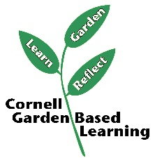
Date Published/Updated: April 2019
Facilitator’s Notes

List quotes and behavior change you noticed, especially those that may be included in your necessary reporting, success story, or for future program improvement:
List Participant Commitments that you will need to follow up on:
Changes and Adaptations to Session:

