Fruit Gardening
Participant Guide

Community and home gardening are active and affordable ways to improve food security status. CCE staff and volunteers are often well-positioned to promote knowledge and skills gains related to growing food in these settings. It is a priority of CCE to work with vulnerable populations to educate families and influence policies that will allow youth, families and communities to make sound nutritional decisions with constrained resources. (Adapted from the CCE Statewide Plan of Work)

By actively participating in Fruit Gardening, you will:
- Describe the critical components of a suitable site for growing fruit and planning for minimizing pests.
- Identify keys to success in a garden setting for:
  - Trees (apples, pears, peaches, cherry, plum)
  - Woody vines (grapes & kiwi)
  - Bushes/shrubs (elderberries, currants, gooseberries, blueberries)
  - Herbaceous perennials (raspberries & blackberries)
  - Ground cover (strawberries)
- Become familiar with pruning strategies for fruit crops.
Before Session
READ:
- Cornell Guide to Growing Fruit at Home (pdf - 111 pages) - Read the ‘Before You Begin’ section (pg. 1-13) plus the ‘Keys to Success’ sidebars for each crop. Review the crop section to become familiar with the content. While you may choose to read thoroughly about a crop that interests you, there is no need to read every bit or memorize the content in this resource. Simply bookmark for future reference. https://ecommons.cornell.edu/handle/1813/67
DO:
- After you read the above guide, choose one fruit crop from the Activity Calendar for Fruit Crops Hands on Activity and follow the directions to list all key aspects to growing it in the planting year and subsequent years; this includes keys to success, best management practices, as well as any questions you have about it. Note there is an accompanying worksheet and key for this activity.
- Take this a step further and fill out the whole Activity Calendar for Fruit Crops worksheet for all crops listed.
THINK:
- If you selected a familiar crop above, consider if what you read about it matches up to your experience with it? If you have chosen one that you have never grown, consider why you are interested in it and what do you think might be the biggest challenges growing it? The biggest reward?
Opening and Introduction
- Facilitator reviews housekeeping, ground rules, learning objectives, and class flow.
Reconnect
- Partner up to discuss the question listed under the pre-work THINK prompt.
Growing Fruit in the Home Garden Lecture
- Listen to presentation.
- Complete Activities Calendar for Fruit Crops.
Conclusions
- Facilitator leads group reflection on key take home points and any lingering questions.
Program Feedback
- Share your insight to help us improve the program, report results, & plan for the future.
Knowledge Check
- Assess what you now know. Be motived and empowered to share with your peers and learn more.
After Session
REFLECT:
- What happened?
- What was my response to what happen? How do I make sense of it?
- How does it relate to other things I know?
- What can I conclude?
- What might I do differently next time?

LEARN MORE:
- Regional Pest Alert article on Spotted Wing Drosophila (SWD) http://fruit.cornell.edu/spottedwing/
- Watch the following short videos to gain knowledge about pruning different types of fruit crops. (~15 minutes total)
  - Raspberries: https://goodgardeningvideos.org/videos/how-to-prune-raspberry-canes/ (~3 ½ minutes)
  - Apples: https://goodgardeningvideos.org/videos/how-to-prune-an-apple-tree/ (~3 minutes)
  - Blueberries: https://goodgardeningvideos.org/videos/how-to-prune-a-young-blueberry-bush/ (~5 minutes)
  - Grapes: https://goodgardeningvideos.org/videos/how-to-care-for-young-grape-vines/ (~4 minutes)
Campus Links:
- Commercial fruit growers: http://fruit.cornell.edu/
- Minor fruit production: https://blogs.cornell.edu/berries/productions/specialty-fruit-production/
- Berry diagnostic tool: https://blogs.cornell.edu/berrytool/
- NYS IPM: https://nysipm.cornell.edu/agriculture/fruits/
Looking for Cornell people and resources? Don’t Google; try the Cornell web search: http://www.cornell.edu/search/index.cfm

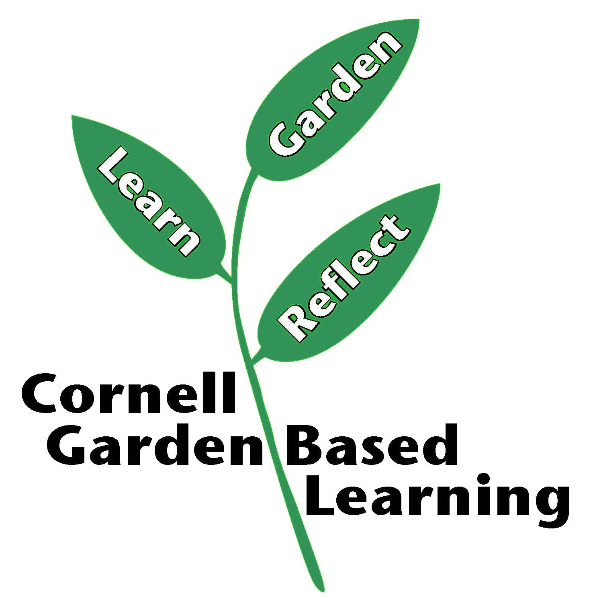
Date Published/Updated: April 2019

