Nutrition, Food Safety and Food Security Participant Guide
Food security refers to sustained access at all times, in socially acceptable ways, to food adequate in quantity and quality to maintain a healthy life. Community and home gardening are active and affordable ways to improve food security status for individuals and families. CCE staff and volunteers are often well-positioned to promote knowledge and skills gains related to growing food in these settings, post-harvest food safety, and nutrition. It is a priority of CCE to work with vulnerable populations to educate families and influence policies that will allow youth, families and communities to make sound nutritional decisions with constrained resources. (Adapted from the CCE Statewide Plan of Work)
By actively participating in Nutrition, Food Safety and Food Security, you will:
- Recognize Eat Smart New York’s (ESNY) nutrition education activities and how garden programs link to their main messages.
- Identify the ways in which MGVs can partner with ESNY.
- Understand safe handling, preparation, and preservation of food including important practices in preventing foodborne illnesses and avoiding cross contamination.
- Examine aspects of food security including the availability and access to food, sufficiency of food, social and cultural acceptability of food, and nutritional quality and safety of food.
- Become familiar with the latest statistics and impacts of food insecurity in New York State and articulate the importance of gardening as a way to foster food security.
Before Session
READ:
- Chapter 6 from Seed to Supper (27-page excerpt provided). No need to read details on every crop, just pick a couple favorites.
- Take 15 minutes to read some of the information on the Hunger in America website, especially the details about New York numbers and who goes hungry. http://www.feedingamerica.org/hunger-in-america/
WATCH:
- “Caring for Your Garden and the Power of Food in Our Lives” video (2 minutes). Scroll down to chapter #4, watch this video and consider the reflection questions: http://gardening.cals.cornell.edu/program-tools/planning-organizing/effective-community-engagement/
THINK:
- Do you know if community and home gardening are enhancing food security status of individuals and families in your community or county? If yes, how?
- What do you already know about organizations in your community and county? Who are involved in food resources and nutrition education?
- Do you think there is an organization that would be particularly interested in partnering with Master Gardener Volunteers to promote knowledge and skills gains related to growing food to improve food security status? Why might they be interested?
Opening and Introduction
- Facilitator reviews housekeeping, ground rules, learning objectives, and class flow.
Introduction to Eat Smart New York (ESNY) Lecture
- Listen to presentation.
Reconnect
- Partner up and discuss to the question listed above under THINK.
Food Preservation and Food Security Lecture
- Listen to presentation.
Food Safety Hands-on Activity
- Facilitator leads participants through group activity and discussion.
Food Preservation Scavenger Hunt Hands-on Activity
- Facilitator leads participants through group activity and discussion.
Conclusions
- Facilitator leads group reflection on key take home points and any lingering questions.
- Consider how nutrition, food safety, and food security relate to gardening? How will the information shared shape your work as a garden-based learning volunteer?
Program Feedback
- Share your insight to help us improve the program, report results, and plan for the future.
Knowledge Check
- Assess what you now know. Be motived and empowered to share with your peers and learn more.
After Session
REFLECT:
- What happened?
- What was my response to what happen? How do I make sense of it?
- How does it relate to other things I know?
- What can I conclude?
- What might I do differently next time?

LEARN MORE:
Eat Smart NY: http://eatsmartnewyork.org/
CCE Saratoga Food Preservation website: http://ccesaratoga.org/nutrition-food/food-preservation
Program Policy Education and Action for Fighting Poverty and Economic Hardship in Upstate New York: http://povertyaction.cals.cornell.edu/
Benefits of Garden-Based Learning: http://gardening.cals.cornell.edu/program-tools/benefits-and-research/
HUNGER 101 Foodbank of the Southern Tier: https://www.foodbankst.org/hunger-ed-101
USDA Center for Nutrition Policy and Promotion: https://www.cnpp.usda.gov/
Choose my plate popular topics: https://www.choosemyplate.gov/popular-topics
SNAP-Ed: https://snaped.fns.usda.gov/state-snap-ed-contacts/new-york
The New Face of Hunger: http://www.nationalgeographic.com/foodfeatures/hunger/
Confronting Poverty: https://confrontingpoverty.org/
So Easy to Preserve, 6th Edition – University of Georgia: https://setp.uga.edu/
Wild Harvest Table: http://ccesaratoga.org/nutrition-food/wild-game
Food safety: https://www.foodsafety.gov/keep/basics/index.html
Get connected. Get answers. http://211nys.org/find-services
Handy Reference for Drying Vegetables and Herbs: https://cpb-us-e1.wpmucdn.com/blogs.cornell.edu/dist/b/2712/files/2009/04/2011_handy_ref_dry_veg.pdf
Handy Reference for Canning Fruits: http://ccetompkins.org/resources/handy-reference-for-canning-fruits
Handy Reference for Canning Vegetables: http://ccetompkins.org/resources/handy-reference-for-canning-vegetables
Freezing Fruits and Vegetables; Mary Lou Tenney, Division of Nutritional Sciences, Cornell University: http://ccetompkins.org/resources/freezing-fruits-vegetables
Storage Guidelines for Fruits and Vegetables, Cornell Cooperative Extension of Chemung, County: http://chemung.cce.cornell.edu/resources/storage-guidelines-for-fruits-vegetables
Campus Links:
Nutrition, Food Safety and Security, and Obesity Prevention: http://cce.cornell.edu/program/nutrition

Looking for Cornell people and resources? Don’t Google; try the Cornell web search: http://www.cornell.edu/search/index.cfm

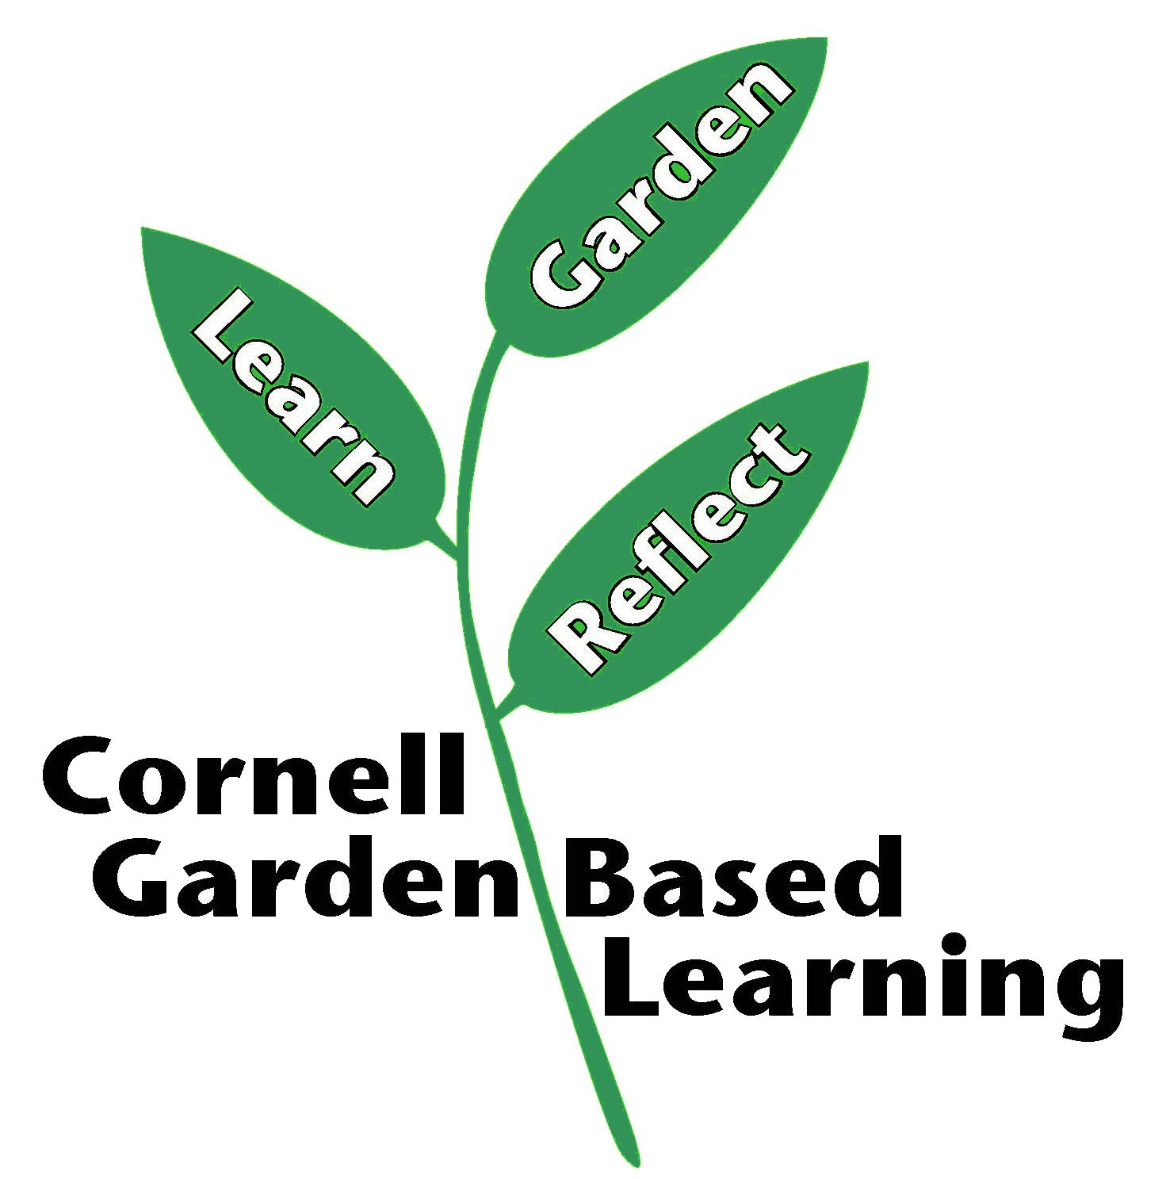
Date Published/Updated: April 2019

