WHO:  Participants | Individuals preparing for Master Gardener Volunteer role.
WHY:  The Situation | Food security refers to sustained access at all times, in socially acceptable ways, to food adequate in quantity and quality to maintain a healthy life. Community and home gardening are active and affordable ways to improve food security status. CCE staff and volunteers are often well-positioned to promote knowledge and skills gains related to growing food in these settings, post-harvest food safety, and nutrition. It is a priority of CCE to work with vulnerable populations to educate families and influence policies that will allow youth, families and communities to make sound nutritional decisions with constrained resources. (Adapted from the CCE Statewide Plan of Work.)
WHEN:  Timing | 2.5 hours. 135 minutes of session time & 15 minutes for a break.
WHERE:  Space | Classroom setting with seats and tables arranged in a circle or in clusters conducive to discussion and participation.
Learning Objectives* |  | Learning Strategy
Recognize Eat Smart New York’s (ESNY) nutrition education activities and how garden programs link to their main messages. |  | Presentation content
Identify the ways in which MGVs can partner with ESNY. |  | Discussion question
Understand safe handling, preparation and preservation of food including important practices in preventing foodborne illnesses and avoiding cross contamination. |  | Presentation content; Hands-on Activities (Food Safety and Food Preservation Scavenger Hunt)
Examine aspects of food security including the availability and access to food, sufficiency of food, social and cultural acceptability of food, and nutritional quality and safety of food. |  | Presentation content
Become familiar with the latest statistics and impacts of food insecurity in New York State and articulate the importance of gardening as a way to foster food security. |  | Feeding America Hunger in New York:  https://www.feedingamerica.org/hunger-in-america/new-york
*These learning objectives match those in Participant Guide & Presentation.

Before Session

Total time for preparation will vary; minimally 8 hours.

Consider adult learning theory and strategies for implementation

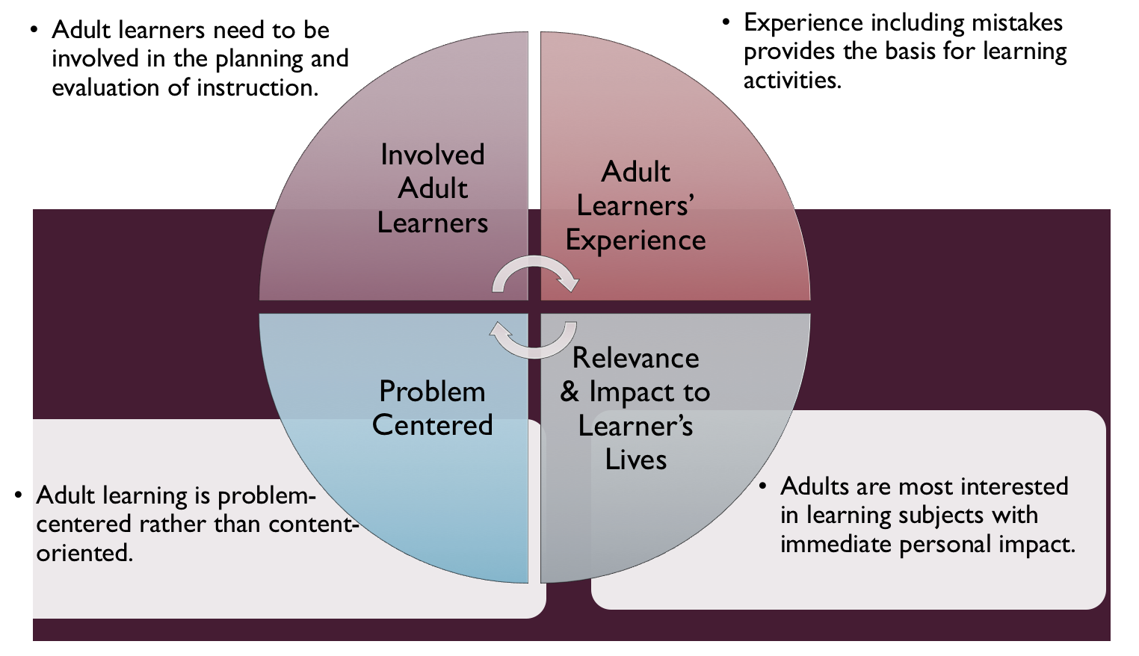
Figure credit: C. J. Carmichael adapted from M. S. Knowles and R.E. Mayer
Additionally, adult learners:
- Are experts of their lived experience.
- Come with their own motivations and goals.
- Need a safe and trusting learning environment.
- Know or will come up with 85% of the information you are planning to share.
- Remember 30% of what they hear and see, 50% of a demonstration, 70% of what they simulate, and 90% when they do the real thing.

Facilitated dialogue allows the classroom to become a conversation. Such discussion offers a way for students to explore supposedly settled questions and develop a fuller appreciation for the complexity of our knowledge. Model and encourage participants to ask open-ended questions that don’t seek yes/no answers or have right/wrong answers. This will help create a safe and trustworthy learning environment that helps participants reflect on information and make it personally relevant. The Ground Rules for Engagement from the Toolkit section in the GBL Learning Library - Core Preparation can be re-introduced if discussions lead to difficult and emotional conversations.

Consider strategies for implementation
Identify the network of educators in your county region who might cover nutrition, food preservation or ESNY (Eat Smart New York). Find out more about their program plans and if there is opportunity to work across program areas. If so how? Providing this training for Master Gardener Volunteers? Educational materials?
- SNAP-Ed: in New York - Eat Smart New York https://s3.amazonaws.com/assets.cce.cornell.edu/attachments/3020/SNAP-Ed-Informational-handout-final.pdf?1412260794
- ESNY Eat Better for Less https://s3.amazonaws.com/assets.cce.cornell.edu/attachments/3018/Eat-Smart-New-York-Eat-Better-for-Less-.pdf?1412260774
- USDA Snap Ed Materials and Curricula https://snaped.fns.usda.gov/snap-ed-library

Review (time will vary; minimally 4 to 6 hours)
Go to the online GBL Learning Library - Core Preparation and review the resources available in the section Nutrition, Food Safety After Harvest, and Food Security including:
- Session Slides and Facilitator Notes
- Participant Guide
- Knowledge Check
- Print Materials for Before Session Pre-Work, and Hands-on Activities
- FAQs

Gather materials and supplies (2 plus hour)
Mainly making copies of handouts for activities from GBL Learning Library.

Communicate with participants before session (1 hour)
Ideally at least 2 weeks in advance of this session provide participants with the Participant Guide found in the GBL Learning Library - Core Preparation. This document details what participants must do before the session. Review the document to determine if you need to supply any material in advance and to confirm the links are still good. Time to complete this pre-work will vary depending on the participant’s background and interest. We estimate most participants should allocate 3 to 5 hours.

The scavenger hunt activity requires searching the internet on mobile devices. If not available in classroom location, provide participant with the activity to do in advance and ask them to bring in results to discuss.

Program Evaluation/Feedback (1 hour)
See section below.

Session Flow and Delivery
Total time for session is 2.5 hours - 135 minutes of task time & 15 minutes for a break.
As participants settle in, ask them to complete a review activity that you’ve prepared or selected from the review bank OR go over pre-work with others around them.
Session Tasks
Task 1: Opening and Introduction (5 minutes)
Welcome everyone, review housekeeping, ground rules, learning objectives, and class flow.
Task 2: Introduction to Eat Smart New York (ESNY) Lecture (30 minutes)
Use or adapt to suit your teaching style and needs the Session Slides and Facilitator notes found in GBL Learning Library. Alternatively, create your own presentation to meet learning objectives on page 1 of this document.
Task 3: Reconnect (10 minutes)
Ask participants to pair up to discuss the question under THINK in their Participant Guide. If time permits, ask volunteers to share with full groups a highlight from their conversation.
Task 4: Food Preservation and Food Security Lecture (30 minutes)
Use or adapt to suit your teaching style and needs the Session Slides and Facilitator notes found in GBL Learning Library. Alternatively, create your own presentation to meet learning objectives on page 1 of this document.
15 Minute BREAK
Task 5: Food Safety Hands-on Activity (15 minutes)
Follow the activity directions found in GBL Learning Library.
Task 6: Food Preservation Scavenger Hunt Hands-on Activity (30 minutes)
Follow the activity directions found in GBL Learning Library.
Task 7: Conclusion (10 minutes)
Consider how nutrition, food safety, and food security relate to gardening? How will the information shared shape your work as garden-based learning volunteer?
Ask participants to reflect on key take home points from today and any lingering questions.
Direct participants’ attention to the items listed under After Session in their Participant Guide.
Task 8: Program Evaluation/Feedback (5 minutes)
Provide participants with an avenue to give feedback and data for your program evaluation including reporting. See section below on Program Evaluation/Feedback.
Task 9: Participant Evaluation/Knowledge Check (part of participant’s After Session work)
Provide an avenue for participants to assess what they know. See section below on Participant Evaluation/Knowledge Check.
After Session
Total time for follow-up will vary; minimally 2 hours.
Communicate with participants after session (1 hour)
Follow-up on unanswered content questions that emerged during session as needed as well as provide feedback on the knowledge check and their Worksheet Site Assessment Activity.
Consider Program Evaluation/Feedback (1 hour)
Summarize the feedback and data you received from participants for your program reporting and/or future planning needs. See section below on Program Evaluation/Feedback.
Session Materials and Supplies
General Materials List
Facilitator notes Markers Index cards Pens
Highlighters Flip chart paper Name tags Feedback Forms
Post-it® notes Masking tape Computer/Internet/Projector
Materials by Task
Before Session Tasks
- Materials found in GBL Learning Library:
  - Module 2: Food Gardening Section 2.3 Nutrition, Food Safety After Harvest, and Food Security
  - Evaluation Toolkit
Task 1 - Opening and Introduction
- Participant Guide
Task 2 – Introduction to Eat Smart New York (ESNY) Lecture
- Session Slides and Facilitator Notes
Task 3 – Reconnect
- Participant Guide
Task 4 – CCE Food Preservation Food Security Lecture
- Session Slides and Facilitator Notes
Task 5 - Food Safety Activity
- Activity directions and worksheet are found in GBL Learning Library
Task 6 - Food Preservation Scavenger Hunt
- Activity directions and worksheet are found in GBL Learning Library
Task 4 – Conclusion
- Participant Guide
- Flip chart paper and markers for group discussion notes
Task 5 – Program Evaluation/Feedback
- Your evaluation/feedback materials
Task 6 – Participant Evaluation/Knowledge Check
- Materials for participants to assess what they know around this topic such as Knowledge Check from GBL Learning Library
For After Session
- Feedback from participants
- Reporting forms
- Knowledge Check Key from GBL Learning Library

Optional Activities
Frequently Asked Questions (FAQs)
With the input of county and campus-based experts, we have compiled a list of top FAQs for each topic areas and place it with the other session resources in GBL Learning Library. Though not an exhaustive list, it should provide an opportunity for discussion and exploration of resources related to the topic. Integrate the FAQs in a way that makes sense for your local program. The FAQs could be used to prompt discussions within your group or they could be adapted into a scavenger hunt where individuals sift through reliable resources to find correct answers. Feel free to add or subtract questions and resources in the answers to meet your program's needs and address emerging issue.
Participant Evaluation/Knowledge Check
Adult learners enjoy getting feedback on what they have learned. We provide in GBL Learning Library the Knowledge Check handouts for each session. You may ask participants to answer the question at home on their own or in small groups discussions. The Knowledge Check KEY can be used to allow participants to self-check or for the educator to grade and provide feedback. You may wish to identify more engaging ways to self‐test what they have learned as it motivates and empowers them to take more active control of their learning.
Program Evaluation/Feedback
Time for creating and implementing a program evaluation plan will vary; minimally 1 hour.
Ideally, evaluation begins before the program starts. However, for many educators the idea of measuring the effects of your program is so daunting it never begins. With this in mind, we provide an Evaluation Toolkit in the GBL Learning Library. Our aim is to offer tools you can use, even while you’re on the run. Check it out as you consider these key questions:
- Who is this evaluation for?
- What do you want to know, and why?
- What’s do‐able, really?
Other key resources will be your local county program plan of work which likely aligns with CCE Programmatic Plans: http://www2.cce.cornell.edu/plans/Pages/FY-2016-CCE-Programmatic-Plans.aspx
Find on CCE staff website under the Organizational Development and Planning Unit a Program Reporting module: http://staff.cce.cornell.edu/orgdev/Pages/reporting.aspx
References
HUNGER 101 Foodbank of the Southern Tier. Online at https://www.foodbankst.org/hunger-ed-101.
The New Face of Hunger (National Geographic). Online at http://www.nationalgeographic.com/foodfeatures/hunger.
Confronting Poverty. Online at https://confrontingpoverty.org/.
Program Policy Education and Action for Fighting Poverty and Economic Hardship in Upstate New York. Online at http://povertyaction.cals.cornell.edu/.
Seed to Supper Garden Program Fosters Healing. Online at
https://www.oregonfoodbank.org/seed-to-supper-garden-program-fosters-healing-video/.
SNAP-Ed: in New York - Eat Smart New York. Online at https://s3.amazonaws.com/assets.cce.cornell.edu/attachments/3020/SNAP-Ed-Informational-handout-final.pdf?1412260794.
ESNY Eat Better for Less. Online at https://s3.amazonaws.com/assets.cce.cornell.edu/attachments/3018/Eat-Smart-New-York-Eat-Better-for-Less-.pdf?1412260774.
USDA Snap Ed Materials and Curricula. Online at https://snaped.fns.usda.gov/snap-ed-library.

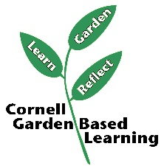
Date Published/Updated: April 2019

Facilitator’s Notes

List quotes and behavior change you noticed, especially those that may be included in your necessary reporting, success story, or for future program improvement:
List Participant Commitments that you will need to follow up on:
Changes and Adaptations to Session:

