Right Plant, Right Place
Participant Guide

It is not possible to grow plants and gardens well without the support, water and nutrients provided by the soil. Ignoring the soil or assuming that all soils are alike can lead to disappointments or poor choices of management practices. Remember that the soil should be teaming with life and constantly changing. We can have more productive gardens and successful landscape plantings by understanding our soil and site characteristics and by utilizing systems thinking as applied to soil and site management practices.

Key Term: Systems thinking is an approach that aims to understand the complexity of the world in terms of relationships, connectedness and context.

By actively participating in Right Plant, Right Place, you will:
- Describe the basic relationship of soil and other environmental factors to plant growth and development.
- Understand the characteristics and basic properties of soil such as texture, pH, and organic matter and their impact on nutrient availability.
- Recognize that there is a right plant for the right soil and the right soil for the right plant.
- Become familiar with the concept of systems thinking and explain how developing habits of systems thinking when practicing management tactics in homes, lawns, gardens, and landscapes can support environmental stewardship and a sustainable community.
- Apply the criteria for basic site assessment.

Before Session

READ:
- Introduction to Soils (pdf) (32-page handout provided)
WATCH:
- UW- Extension Master Gardener Program Level 1 Soils video: Soil Properties Important for Gardening (18 minutes) https://www.youtube.com/watch?v=LP39i_dZsLE&list=PLrktjgTJbkvVtin6QshFaZc0KECcRxrXX&index=2

DO:
- One to several days before class do the Jar Test Activity (pdf) (2-page handout provided). Bring your jar with you to class; OR take a photo of the jar and take key measurements of the settled layers.
- Bring a small amount of soil (up to ½ cup) with you to class for Soil pH Activity. Watch the first 2 minutes of this video for guidance in collecting a soil sample: http://soilhealth.cals.cornell.edu/testing-services/collecting-samples/.
THINK:
- What do you know about your soil?
- How has your thinking about your soil changes in the time you have been gardening?
- What do you do to your soil? Why?

Opening and Introduction
- Facilitator reviews housekeeping, ground rules, learning objectives, and class flow.
Right Plant, Right Place Lecture
- Listen to presentation.
Station-Based Hands-on Activities
- Participants divide up into smaller groups and rotate around to stations to engage in hands-on activities about soil and systems thinking.
Conclusions
- Facilitator leads group reflection on key take home points and any lingering questions.
Program Feedback
- Share your insight to help us improve the program, report results, & plan for the future.
Knowledge Check
- Assess what you now know. Be motived and empowered to share with your peers and learn more.
After Session

REFLECT:
- What happened?
- What was my response to what happen? How do I make sense of it?
- How does it relate to other things I know?
- What can I conclude?
- What might I do differently next time?
DO:
- Complete Worksheet Site Assessment (pdf) (2-page handout provided)

LEARN MORE:
- Cornell’s Intro to Soil Lecture Channel https://www.youtube.com/watch?v=S9jBc19Ylvc&list=PLs7Y2nGwfz4HPoRAaB64c-MdF1kK-P-Wy&index=1&t=0s
- UW- Extension Master Gardener Program Level 1 Soils video, What is Soil (11 minutes) https://www.youtube.com/watch?v=smPMb1xa9zw&index=1&list=PLrktjgTJbkvVtin6QshFaZc0KECcRxrXX
- USDA Soil Texture Calculator, https://www.nrcs.usda.gov/wps/portal/nrcs/detail/soils/survey/?cid=nrcs142p2_054167
- USDA Web Soil Survey, https://websoilsurvey.sc.egov.usda.gov/App/HomePage.htm
- Soil Science Simplified, 4th Edition by Helmut Kohnke and D.P. Franzmeier

Campus Links:
- Cornell Healthy Soil www.gardening.cornell.edu/soil

Looking for Cornell people and resources? Don’t Google; try the Cornell web search: http://www.cornell.edu/search/index.cfm

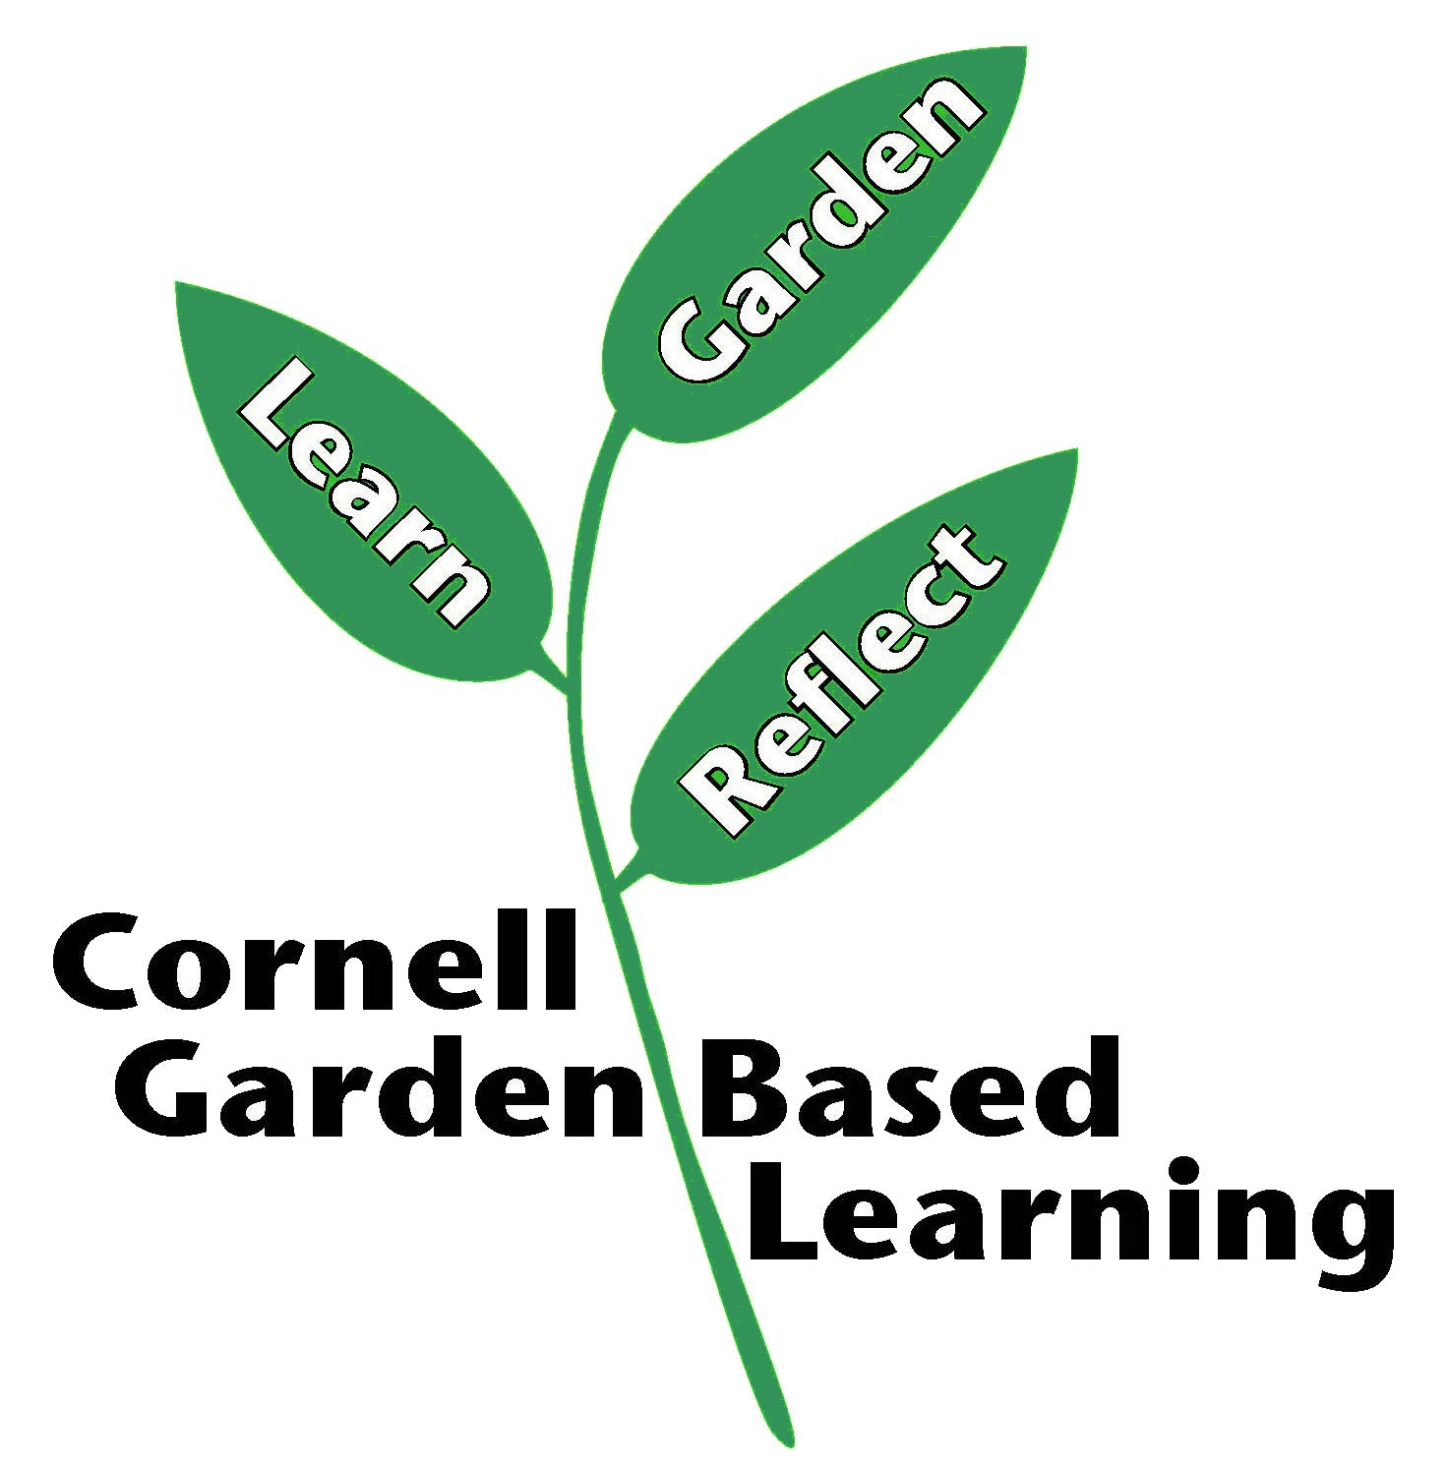
Date Published/Updated: April 2019

