WHO:  Participants | Individuals preparing for Master Gardener Volunteer role.
WHY:  The Situation | New York residents rely on a wide variety of natural resources including forested mountains; aquatic environments (wetlands, marshes, estuaries, streams and lakes); and an accompanying diversity of plant and animal species, for recreation, tourism, and raw products. Citizens need current information on residential land management tactics that support environmental stewardship as well as guidance in planning for and initiating steps to enhance homes, lawns, gardens, and landscapes that support environmental stewardship and a sustainable community. (Sourced from CCE Statewide Plan of Work)
WHEN:  Timing | 2.5 hours. 135 minutes of session time & 15 minutes for a break.
WHERE:  Space | Classroom setting with seats and tables arranged in a circle or in clusters conducive to discussion and participation.
Learning Objectives* |  | Learning Strategy
Describe the basic relationship of soil and other environmental factors to plant growth and development. |  | In pairs or small groups, participants will discuss the relationship between soil, environmental factors, and plant growth.
Understand the characteristics and basic properties of soil such as texture, pH and organic matter and their impact on nutrient availability. |  | Perform a pH test, a jar test, and a soil texture test. Read the Introduction to Soils chapter.
Recognize that there is a right plant for the right soil and the right soil for the right plant. |  | Listen to and discuss portions of the Right Plant, Right Place presentation. Read the Introduction to Soils chapter.
Become familiar with the concept of systems thinking and explain how developing habits of systems thinking when practicing management tactics in homes, lawns, gardens and landscapes can support environmental stewardship and a sustainable community. |  | Systems Thinking activity and discussion.
Apply the criteria for basic site assessment. |  | Post-session Site Assessment activity
*These learning objectives match those in Participant Guide & Presentation.
Before Session

Total time for preparation will vary; minimally 8 hours.

Consider adult learning theory and strategies for implementation

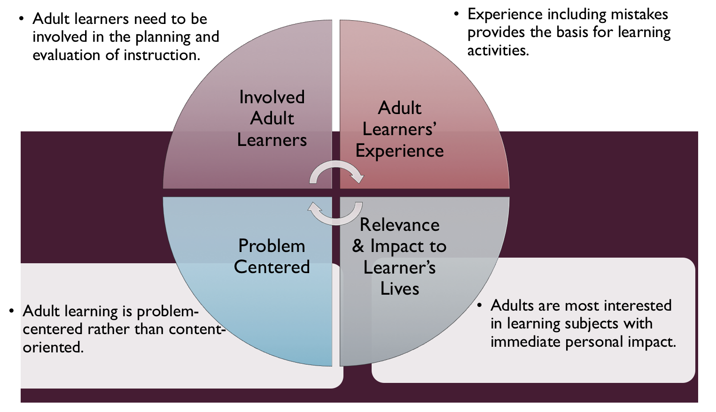
Figure credit: C. J. Carmichael adapted from M. S. Knowles and R.E. Mayer
Additionally, adult learners:
- Are experts of their lived experience.
- Come with their own motivations and goals.
- Need a safe and trusting learning environment.
- Know or will come up with 85% of the information you are planning to share.
- Remember 30% of what they hear and see, 50% of a demonstration, 70% of what they simulate, and 90% when they do the real thing.

Facilitated dialogue allows the classroom to become a conversation. Such discussion offers a way for students to explore supposedly settled questions and develop a fuller appreciation for the complexity of our knowledge. Model and encourage participants to ask open-ended questions that don’t seek yes/no answers or have right/wrong answers. This will help create a safe and trustworthy learning environment that helps participants reflect on information and make it personally relevant. The Ground Rules for Engagement from the Toolkit section in the MGV Learning Library - Core Preparation can be re-introduced if discussions lead to difficult and emotional conversations.

Review (time will vary; minimally 4 to 6 hours)
Go to the online MGV Learning Library - Core Preparation and review the resources available in the section Right Plant, Right Place including:
- Session Slides and Facilitator Notes
- FAQs
- Participant Guide
- Knowledge Check
- Print Materials for Before Session Pre-Work, Hands-on Activities, After Session Work
- Optional Activities and Resources

Gather materials and supplies (2 plus hours)
Make sure you have pH test kits with good reagents. Order Cornell kits from: https://cnal.cals.cornell.edu/ph-kits/.
Set up a few of your own jars as demos for the Jar Test Activity; this needs to be started at least a few days in advance of the class time.
Gather other materials for Hands-on Activities. The MGV Learning Library Activity Directions documents include a supply list for each activity.

Communicate with participants before session (1 hour)
Ideally at least 2 weeks in advance of this session provide participants with the Participant Guide found in the MGV Learning Library - Core Preparation. This document details what participants must do before the session. Review the document to determine if you need to supply any material in advance and to confirm the links are still good. Time to complete this pre-work will vary depending on the participant’s background and interest. We estimate most participants should allocate 3 to 5 hours. They need to bring a garden soil sample to class for Soil pH Activity and try the Jar Test Activity at home.

Program Evaluation/Feedback (1 hour)
See section below.

Session Flow and Delivery

Total time for session is 2.5 hours - 135 minutes of task time & 15 minutes for a break.

As participants settle in, ask them to complete a review activity that you’ve prepared or selected from the review bank OR go over pre-work with others around them.
Session Tasks
Task 1: Opening and Introduction (5 minutes)
Welcome everyone, review housekeeping, ground rules, learning objectives, and class flow.

Task 2: Right Plant, Right Place Lecture (40 minutes)
Use the Session Slides and Facilitator notes found in MGV Learning Library; feel free to adapt the resources to suit your teaching style and needs. Alternatively, a presenter can create their own presentation to meet the learning objectives on page 1 of this document.

15 Minute BREAK

Task 3: Station-Based Hands-on Activities (80 minutes)
Follow the activity directions documents found in MGV Learning Library.
1) Soil pH
2) Jar Test
3) Soil Texture
4) Being a Systems Thinker
You may choose to divide participants into 4 groups and have groups rotate around on your timed 20 minute intervals.

Task 4: Conclusion (5 minutes)
Ask participants to reflect on key take home points from today and any lingering questions.
Direct participants’ attention to the items listed under After Session in their Participant Guide.

Task 5: Program Evaluation/Feedback (5 minutes)
Provide participants with an avenue to give feedback and data for your program evaluation including reporting. See section below on Program Evaluation/Feedback.

Task 6: Participant Evaluation/Knowledge Check (part of participant’s After Session work)
Provide an avenue for participants to assess what they know. See section below on Participant Evaluation/Knowledge Check.

Provide participants with Worksheet Site Assessment Activity document from Library.

After Session

Total time for follow-up will vary; minimally 2 hours.

Communicate with participants after session (1 hour)
Follow-up on unanswered content questions that emerged during session as needed as well as provide feedback on the knowledge check and their Worksheet Site Assessment Activity.

Consider Program Evaluation/Feedback (1 hour)
Summarize the feedback and data you received from participants for your program reporting and or future planning needs. See section below on Program Evaluation/Feedback.

Session Materials and Supplies
General Materials List
Facilitator notes Markers Index cards Pens
Highlighters Flip chart paper Name tags Feedback Forms
Post-it® notes Masking tape Computer/Internet/Projector

Materials by Task
Before Session Tasks
- Materials found in MGV Learning Library:
  - Module 1: The Fundamentals Section 1.2 Right Plant, Right Place
  - Evaluation Toolkit
Task 1 - Opening and Introduction
- Participant Guide
- Session Slides and Facilitator Notes
Task 2 – Right Plant, Right Place Lecture
- Session Slides and Facilitator Notes
Task 3 - Station-Based Hands-on Activities
Activity Directions documents and handouts for each of these are found in CCE MGV Learning Library. Materials are listed in each document and summarized here:
- Soil pH
  - Soil pH kits (see before session above for ordering Cornell soil pH kits)
  - Pipets
  - Copies of soil pH ranges
  - Paper towels and a bowl of water to clean kit wells
- Jar Test
  - Water
  - 2 cups of soil
  - Wet paper towels or wash rag
  - Quart-sized jar with lid
  - 1 teaspoon of liquid dish soap
  - Rulers
- Soil Texture
  - Garden Soil Samples
  - Newspaper to lay on the table
  - Paper towels for clean up
- Being a Systems Thinker
  - Handout Being a Systems Thinker in MGV Learning Library
  - Scrap paper and writing utensils
Task 4 – Conclusion
- Participant Guide
- Flip chart paper and markers for group discussion notes
Task 5 – Program Evaluation/Feedback
- Your evaluation/feedback materials
Task 6 – Participant Evaluation/Knowledge Check
- Materials for participants to assess what they know around this topic such as Knowledge Check from MGV Learning Library
For After Session
- Feedback from participants
- Reporting forms
- Knowledge Check Key from Learning Library
- Provide participants Worksheet Site Assessment Activity

Optional Activities

Directions to the following activities can be found in the online MGV Learning Library - Core Preparation in the section Right Plant, Right Place:
- Sit Spot in Class or Sit Spot at Home
- Worksheet Existing Plant Landscape Values
- Garden and Landscape Area

Frequently Asked Questions (FAQs)
With the input of county and campus-based experts, we have compiled a list of top FAQs for each topic areas and place it with the other session resources in MGV Learning Library. Though not an exhaustive list, it should provide an opportunity for discussion and exploration of resources related to the topic. Integrate the FAQs in a way that makes sense for your local program. The FAQs could be used to prompt discussions within your group or they could be adapted into a scavenger hunt where individuals sift through reliable resources to find correct answers. Feel free to add or subtract questions and resources in the answers to meet your program's needs and address emerging issues.

Participant Evaluation/Knowledge Check

Adult learners enjoy getting feedback on what they have learned. We provide in MGV Learning Library the Knowledge Check handouts for each session. You may ask participants to answer the question at home on their own or in small group discussions. The Knowledge Check KEY can be used to allow participants to self-check or for the educator to grade and provide feedback. You may wish to identify more engaging ways to self‐test what they have learned as it motivates and empowers them to take more active control of their learning.

Program Evaluation/Feedback

Time for creating and implementing a program evaluation plan will vary; minimally 1 hour.

Ideally, evaluation begins before the program starts. However, for many educators the idea of measuring the effects of your program is so daunting it never begins. With this in mind, we provide an Evaluation Toolkit in the MGV Learning Library. Our aim is to offer tools you can use, even while you’re on the run. Check it out as you consider these key questions:
- Who is this evaluation for?
- What do you want to know, and why?
- What’s do‐able, really?

Other key resources will be your local county program plan of work which likely aligns with CCE Programmatic Plans: http://www2.cce.cornell.edu/plans/Pages/FY-2016-CCE-Programmatic-Plans.aspx.

Find on CCE staff website under the Organizational Development and Planning Unit a Program Reporting module: http://staff.cce.cornell.edu/orgdev/Pages/reporting.aspx.

References

Booth-Sweeney, Linda. 12 Habits of Mind. Accessed May 12, 2016 from http://www.lindaboothsweeney.net/thinking/habits.
Gardening in a Warming World: A Climate Smart Gardening Course Book. 2018. Online at
http://climatechange.cornell.edu/gardening/.

Habits of a System Thinker from Systems Thinking in Schools. Online at watersfoundation.org.

Landscape for Life Instructor’s Manual: Lesson 2: The Role of Soil in Sustainable Gardens. 2014. 22-26 pp. Online at www.landscapeforlife.org.

Mazza, Charles P. 2013. Site Assessment for Better Gardens and Landscapes.

Russell-Anelli, Jonathan; Gruttadaurio, Joan. 2004. Soils and Fertilizers.

University of Wisconsin Extension Master Gardener Program Level 1: Soil Properties Important for Gardening (video). Online at https://www.youtube.com/watch?v=LP39i_dZsLE&list=PLrktjgTJbkvVtin6QshFaZc0KECcRxrXX&index=2.

University of Wisconsin Extension Master Gardener Program Level 1: What is Soil (video). Online at
https://www.youtube.com/watch?v=smPMb1xa9zw&index=1&list=PLrktjgTJbkvVtin6QshFaZc0KECcRxrXX.

USDA Natural Resources Conservation Service: Soils. Online at
https://www.nrcs.usda.gov/wps/portal/nrcs/site/soils/home/.

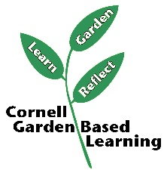
Date Published/Updated: 2019

Facilitator’s Notes

List quotes and behavior change you noticed, especially those that may be included in your necessary reporting, success story, or for future program improvement:
List Participant Commitments that you will need to follow up on:
Changes and Adaptations to Session:

