Basic Plant Pathology
Participant Guide

A plant disease is a dynamic process during which a plant, a pathogen (living or nonliving), and the environment interact over a period of time and interfere with a plant’s functions. Plant pathology is the study of plant diseases. Becoming familiar with plant diseases is an important skill for any gardener. Accurate, early detection is critical for plant health. (Adapted from Penn State Extension Master Gardener Manual, pg. 184 https://extension.psu.edu/master-gardener-manual)

By actively participating in Basic Plant Pathology, you will:
- Explain the difference between biotic and abiotic diseases.
- Review the five types of biotic disease organisms and their life cycles (fungi, bacteria, viruses, nematodes and phytoplasmas).
- Recognize the disease pyramid/triangle.
- Be familiar with the five basic steps to diagnosing plant problems (determine if problem exists, look for patterns, determine time of development, ask questions, and synthesize the information). Use the approach to determine if example plant problems are caused by abiotic or biotic factors.
- Recognize the importance of accurate, early detection of introduced and invasive pathogens.

Before Session
READ:
- Plant Diagnostics: What is “Wrong” With My Plant? (pdf) (2 pages handout provided)
- Basic Plant Pathology General Information (pdf) (7 page handout provided)

WATCH:
- Common Diseases in the Garden by Barb Neal. YouTube video ~ 22 minutes. https://youtu.be/CcgZAZPt_iA?list=PLHPXm2Es8aQDjvBs5r3ZXEA4DRBUqiT58

DO:
- Take 30 minutes to explore and get acquainted with the following plant pathology resources:
  - Cornell’s Plant Disease Diagnostic Clinic http://plantclinic.cornell.edu/
    - Scroll down to the Resources section at the bottom of the page
    - Explore the Factsheets tab at the top of the page
  - Cornell Vegetable MD Online Plant Pathology Web Page: http://vegetablemdonline.ppath.cornell.edu/Home.htm

  - Cornell Berry Diagnostic Tool: https://blogs.cornell.edu/berrytool/

THINK:
- What plant diseases have you experienced in your garden endeavors? What type of disease was it: fungi, bacteria, viruses, nematodes, or phytoplasma related? How did you know?
- What are the key steps to consider when addressing plant disease questions?

Opening and Introduction
- Facilitator reviews housekeeping, ground rules, learning objectives, and class flow.

Reconnect
- Partner up to discuss the question listed under the pre-work THINK prompt.

Basic Plant Pathology Lecture
- Listen to presentation.

Diagnosing Plant Problems Sorting Exercises
- Facilitator leads participants through group activity.

Diagnosing Plant Problems Scenarios
- Facilitator leads participants through group activity.

Conclusions
- Facilitator leads group reflection on key take home points and any lingering questions.

Program Feedback
- Share your insight to help us improve the program, report results, & plan for the future.

Knowledge Check
- Assess what you now know. Be motived and empowered to share with your peers and learn more.

After Session
REFLECT:
- What happened?
- What was my response to what happen? How do I make sense of it?
- How does it relate to other things I know?
- What can I conclude?
- What might I do differently next time?

DO:
- Take 15 minutes to revisit the following plant pathology resources:
  - Cornell’s Plant Disease Diagnostic Clinic http://plantclinic.cornell.edu/
    - Scroll down to the Resources section at the bottom of the page
    - Explore the Factsheets tab at the top of the page
  - Cornell Vegetable MD Online Plant Pathology Web Page: http://vegetablemdonline.ppath.cornell.edu/Home.htm
  - Cornell Berry Diagnostic Tool: https://blogs.cornell.edu/berrytool/

LEARN MORE:
- MGV Level 1: Plant Pathology from the University of Wisconsin. YouTube video series - 9 parts lasting about 2 ¼ hours total. https://www.youtube.com/playlist?list=PLrktjgTJbkvXEFLcYK98KLzK8Oq5YRrye
- MGV Level 1: Diagnosing Plant Problems video ~ 55 minutes https://www.youtube.com/watch?v=u1C4gAMxQnM&list=PLrktjgTJbkvU5J7_m_VgjK5uxu_wYJGG8&index=2&t=0s
- MGV Level 1: Diagnosing Plant Problems, Finding an Answer: The Hats of Plant Diagnostics. 7 short podcasts to listen to, about 40 minutes total. http://blogs.ces.uwex.edu/mgvlevel1/integrated-pest-management/diagnosing-plant-problems/
- Fantastic Fungi: The Forbidden Fruit - YouTube video ~2.5 minutes https://www.youtube.com/watch?v=EDkR2HIlEbc
- Wow! Fungi plant growth - The Private Life of Plants with David Attenborough - BBC wildlife. YouTube video ~1.5 minutes https://www.youtube.com/watch?v=puDkLFcCZyI
- Become a Certified First Detector http://firstdetector.org/detector-modules
- Training videos here: http://firstdetector.org/taxonomic-training
- Northeast Plant Diagnostic Network: www.NEPDN.org
- Ohio State Yard & Garden Fact Sheets: http://www.ag.ohio-state.edu/~ohioline/lines/hygs.html
- Purdue University: http://www.ppdl.purdue.edu/ppdl/Reference_links.html#Gardening_Landscapes
- Missouri Extension Service: http://muextension.missouri.edu/xplor/agguides/hort/index.htm

Campus Links:
- Cornell Plant Disease Diagnostic Clinic: http://plantclinic.cornell.edu/
- Cornell Vegetable MD Online Plant Pathology Web Page: http://vegetablemdonline.ppath.cornell.edu/Home.htm
- Cornell Berry Diagnostic Tool: https://blogs.cornell.edu/berrytool/
- NYS Integrated Pest Management: https://nysipm.cornell.edu/

Looking for Cornell people and resources? Don’t Google; try the Cornell web search: http://www.cornell.edu/search/index.cfm

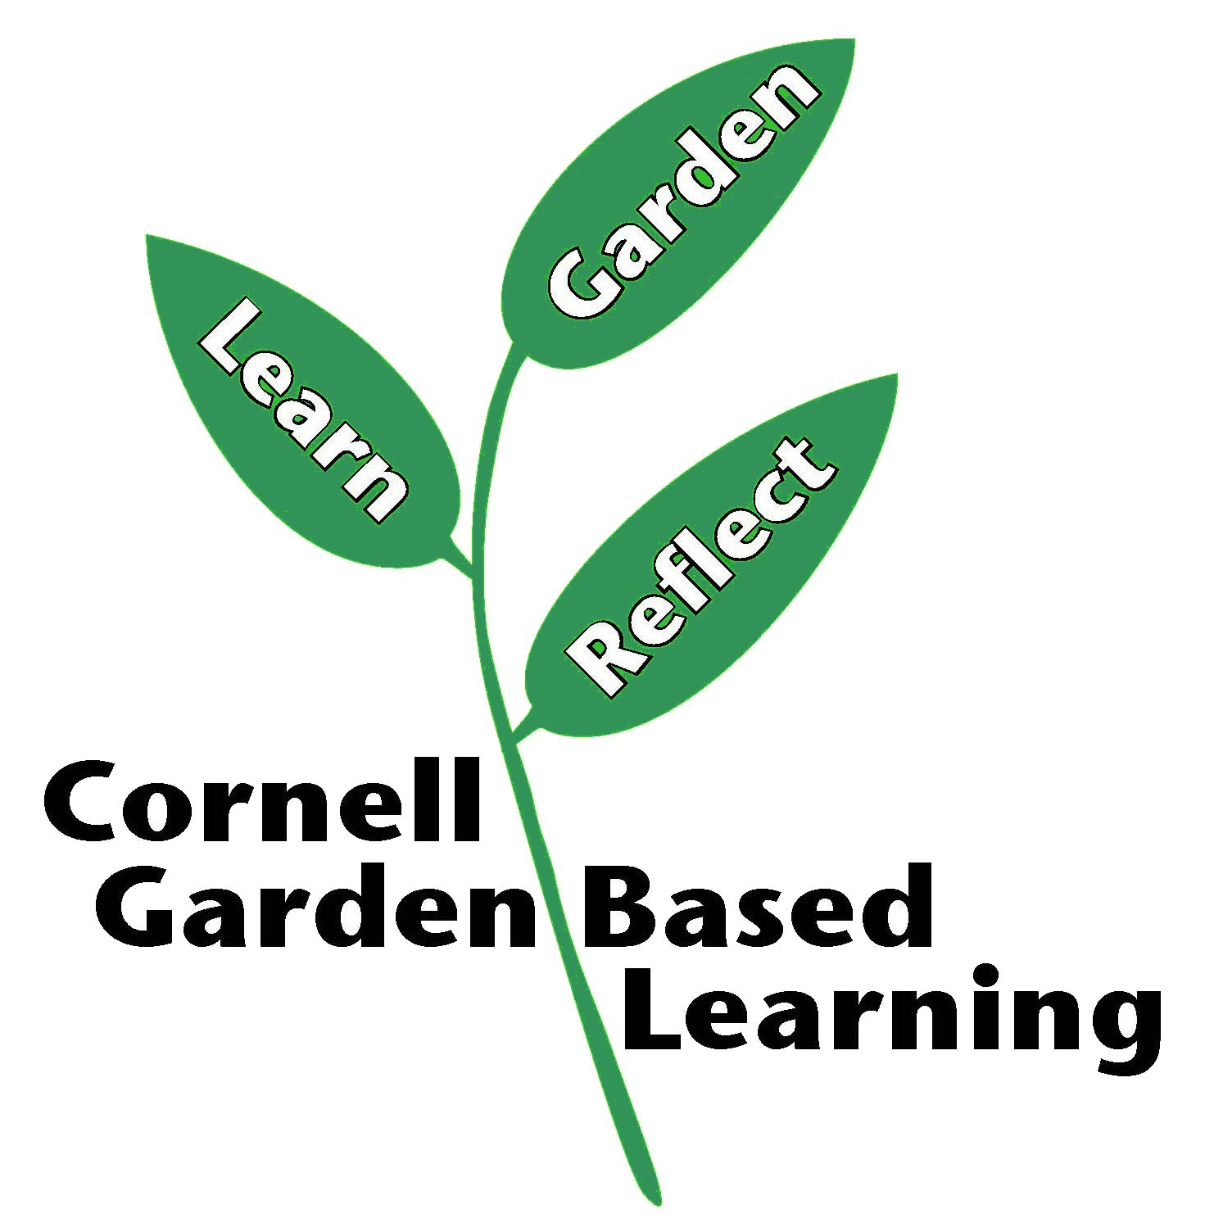
Date Published/Updated: April 2019

