WHO:  Participants | Individuals preparing for Master Gardener Volunteer role.
WHY:  The Situation | CCE is focused on developing capacity among citizens, leaders, and local officials so they are better prepared to address challenges and opportunities, improve quality of life, and build strong and vibrant communities. CCE works toward the long-term sustainability and well-being of communities through collaborations and partnerships and promotes active and representative participation toward enabling all community members to shape their collective future.  One key strategy is to increase the number of residents practicing management tactics in homes, lawns, gardens and landscapes that support environmental stewardship and a sustainable community. Accurate and early detection of plant diseases is an important piece to the well-being of both landscapes and communities. (Sourced from CCE Statewide Plan of Work)
WHEN:  Timing | 2.5 hours. 135 minutes of session time & 15 minutes for a break.
WHERE:  Space | Classroom setting with seats and tables arranged in a circle or in clusters conducive to discussion and participation.
Learning Objectives* |  | Learning Strategy
Explain the difference between biotic and abiotic diseases. |  | Basic Plant Pathology presentation
Review the five types of biotic disease organisms and their life cycles (fungi, bacteria, viruses, nematodes and phytoplasmas). |  | Basic Plant Pathology presentation
Recognize the disease pyramid/triangle. |  | Basic Plant Pathology presentation
Be familiar with the five basic steps to diagnosing plant problems (determine if problem exists, look for patterns, determine time of development, ask questions, and synthesize the information). Use the approach to determine if example plant problems are caused by abiotic or biotic factors. |  | Diagnosing Plant Problems Exercises
Recognize the importance of accurate, early detection of introduced and invasive pathogens. |  | Diagnosing Plant Problems Exercises
*These learning objectives match those in Participant Guide & Presentation.

Before Session

Total time for preparation will vary; minimally 8 hours.

Consider adult learning theory and strategies for implementation

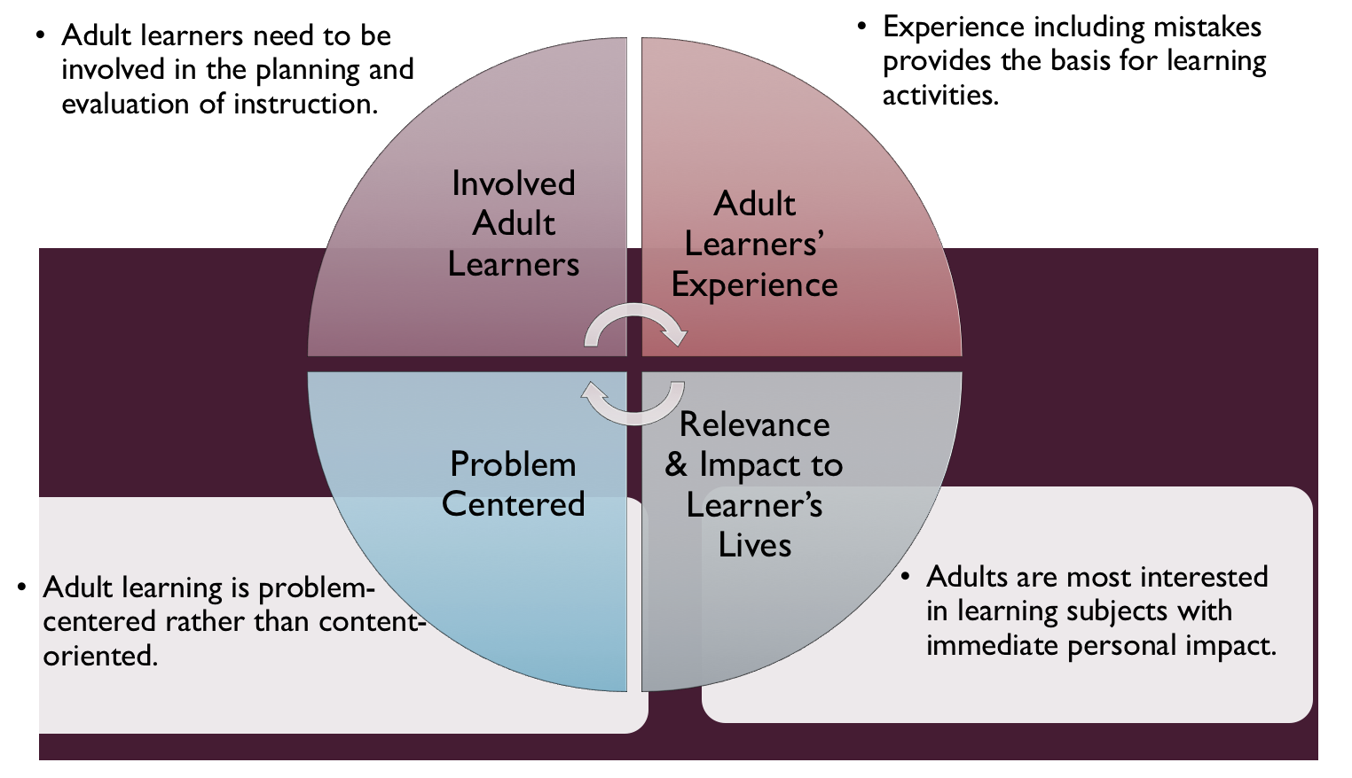
Figure credit: C. J. Carmichael adapted from M. S. Knowles and R.E. Mayer
Additionally, adult learners:
- Are experts of their lived experience.
- Come with their own motivations and goals.
- Need a safe and trusting learning environment.
- Know or will come up with 85% of the information you are planning to share.
- Remember 30% of what they hear and see, 50% of a demonstration, 70% of what they simulate, and 90% when they do the real thing.

Facilitated dialogue allows the classroom to become a conversation. Such discussion offers a way for students to explore supposedly settled questions and develop a fuller appreciation for the complexity of our knowledge. Model and encourage participants to ask open-ended questions that don’t seek yes/no answers or have right/wrong answers. This will help create a safe and trustworthy learning environment that helps participants reflect on information and make it personally relevant. The Ground Rules for Engagement from the Toolkit section in the GBL Learning Library - Core Preparation can be re-introduced if discussions lead to difficult and emotional conversations.

Review (time will vary; minimally 4 to 6 hours)
Go to the online GBL Learning Library - Core Preparation and review the resources available in the section Basic Plant Pathology including:
- Session Slides and Facilitator Notes
- FAQs
- Participant Guide
- Knowledge Check
- Print Materials for Before Session Pre-Work and Hands-on Activities

Gather materials and supplies (2 plus hours)
Print materials and assemble envelopes for Hands-on Activities to practice diagnosing plant problems. The GBL Learning Library has the Activity Directions documents as well as photos and scenarios that correspond to the activities. You may wish to use different photos or create your own scenarios; these are provided as a place to start.

Communicate with participants before session (1 hour)
Ideally at least 2 weeks in advance of this session provide participants with the Participant Guide found in the GBL Learning Library - Core Preparation. This document details what participants must do before the session. Review the document to determine if you need to supply any material in advance and to confirm the links are still good. Time to complete this pre-work will vary depending on the participant’s background and interest. We estimate most participants should allocate 3 to 5 hours.

Program Evaluation/Feedback (1 hour)
See section below.

Session Flow and Delivery

Total time for session is 2.5 hours - 135 minutes of task time & 15 minutes for a break.

As participants settle in, ask them to complete a review activity that you’ve prepared or selected from the review bank OR go over pre-work with others around them.

Session Tasks
Task 1: Opening and Introduction (5 minutes)
Welcome everyone, review housekeeping, ground rules, learning objectives, and class flow.

Task 2: Reconnect (5 minutes)
Ask participants to pair up to discuss the question under THINK in their Participant Guide.

Task 3: Basic Plant Pathology Lecture (55 minutes)
Listen to the recorded presentation.
Use the Session Slides and Facilitator notes found in GBL Learning Library; feel free to adapt the resources to suit your teaching style and needs. Alternatively, a presenter can create their own presentation to meet the learning objectives on page 1 of this document.

15 Minute BREAK

Task 4: Diagnosing Plant Problems Sorting Exercises (25 minutes)
Follow the activity direction document found in GBL Learning Library.

Task 5: Diagnosing Plant Problems Scenarios (35 minutes)
Follow the activity direction document found in GBL Learning Library.

Scenario 1: A well-informed community member with a lot of information.
The issue is Hollyhock Rust; more information can be found at: http://plantclinic.cornell.edu/factsheets/hollyhockrust.pdf

Scenario 2: Not enough information is provided by the community member.

Scenario 3: A commercial agriculture focus.
Pass along to appropriate commercial horticulture expert at your local CCE. The grower is dealing with Corn Smut: http://plantclinic.cornell.edu/factsheets/cornsmut.pdf.

Scenario 4: A suspected regulatory issue.
Oak Wilt; report promptly to DEC (Department of Environmental Conservation).

Scenario 5: Someone who insists it is something that it isn’t.
The person insists it is early blight but it is likely frost injury.

Task 6: Conclusion (5 minutes)
Ask participants to reflect on key take home points from today and any lingering questions.
Direct participants’ attention to the items listed under After Session in their Participant Guide.

Task 7: Program Evaluation/Feedback (5 minutes)
Provide participants with an avenue to give feedback and data for your program evaluation including reporting. See section below on Program Evaluation/Feedback.

Task 8: Participant Evaluation/Knowledge Check (part of participant’s After Session work)
Provide an avenue for participants to assess what they know. See section below on Participant Evaluation/Knowledge Check.

After Session

Total time for follow-up will vary; minimally 2 hours.

Communicate with participants after session (1 hour)
Follow-up on unanswered content questions that emerged during session as needed as well as provide feedback on the knowledge check.

Consider Program Evaluation/Feedback (1 hour)
Summarize the feedback and data you received from participants for your program reporting and or future planning needs. See section below on Program Evaluation/Feedback.

Session Materials and Supplies
General Materials List
Facilitator notes Markers Index cards Pens
Highlighters Flip chart paper Name tags Feedback Forms
Post-it® notes Masking tape Computer/Internet/Projector

Materials by Task
Before Session Tasks
- Materials found in GBL Learning Library:
  - Module 1: The Fundamentals Section 1.4 Basic Plant Pathology
  - Evaluation Toolkit
Task 1 - Opening and Introduction
- Participant Guide
- Session Slides and Facilitator Notes
Task 2 - Reconnect
- Participant Guide
- Flip chart paper and markers for group discussion notes
Task 3 - Basic Plant Pathology Lecture
- Session slides and facilitator notes.
Task 4 - Diagnosing Plant Problems Sorting Exercises
- Activity Directions document and photos for this are in GBL Learning Library.
- You will need to create 3 photo filled envelopes for each of your small groups.
Task 5 - Diagnosing Plant Problems Scenarios
- Activity Directions document and scenarios for this are in GBL Learning Library.
Task 6 – Conclusion
- Participant Guide
- Flip chart paper and markers for group discussion notes
Task 7 – Program Evaluation/Feedback
- Your evaluation/feedback materials
Task 8 – Participant Evaluation/Knowledge Check
- Materials for participants to assess what they know around this topic such as Knowledge Check from GBL Learning Library
For After Session
- Feedback from participants
- Reporting forms
- Knowledge Check Key from GBL Learning Library

Optional Activities

Frequently Asked Questions (FAQs)
With the input of county and campus-based experts, we have compiled a list of top FAQs for each topic areas and place it with the other session resources in GBL Learning Library. Though not an exhaustive list, it should provide an opportunity for discussion and exploration of resources related to the topic. Integrate the FAQs in a way that makes sense for your local program. The FAQs could be used to prompt discussions within your group or they could be adapted into a scavenger hunt where individuals sift through reliable resources to find correct answers. Feel free to add or subtract questions and resources in the answers to meet your program's needs and address emerging issue.

Participant Evaluation/Knowledge Check

Adult learners enjoy getting feedback on what they have learned. We provide in GBL Learning Library the Knowledge Check handouts for each session. You may ask participants to answer the question at home on their own or in small groups discussions. The Knowledge Check KEY can be used to allow participants to self-check or for the educator to grade and provide feedback. You may wish to identify more engaging ways to self‐test what they have learned as it motivates and empowers them to take more active control of their learning.

Program Evaluation/Feedback

Time for creating and implementing a program evaluation plan will vary; minimally 1 hour.

Ideally, evaluation begins before the program starts. However, for many educators the idea of measuring the effects of your program is so daunting it never begins. With this in mind, we provide an Evaluation Toolkit in the GBL Learning Library. Our aim is to offer tools you can use, even while you’re on the run. Check it out as you consider these key questions:

- Who is this evaluation for?
- What do you want to know, and why?
- What’s do‐able, really?

Other key resources will be your local county program plan of work which likely aligns with CCE Programmatic Plans: http://www2.cce.cornell.edu/plans/Pages/FY-2016-CCE-Programmatic-Plans.aspx.

Find on CCE staff website under the Organizational Development and Planning Unit a Program Reporting module: http://staff.cce.cornell.edu/orgdev/Pages/reporting.aspx.

References

Diagnosing Plant Problems: A systemic approach to diagnosing plant damage. Revised by Karen L. Snover-Clift. 2010. Accessed from http://plantclinic.cornell.edu/mgresourses/MGT-Diag.PlantProblems-HO-Watertown.pdf or Plant Diagnostic Lab Master Gardener Page at http://plantclinic.cornell.edu/mastergardner.html.

Penn State Extension Master Gardener Manual. 184 pp. Online at https://extension.psu.edu/master-gardener-manual.

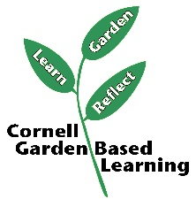

Date Published/Updated: April 2019

Facilitator’s Notes

List quotes and behavior change you noticed, especially those that may be included in your necessary reporting, success story, or for future program improvement:
List Participant Commitments that you will need to follow up on:
Changes and Adaptations to Session:

