Plant Biology for Gardeners
Participant Guide

Plant biology is the study of plant life. As a gardener, it is important to understand how plants grow and function. We could not survive without plants and we depend on them for food, fossil fuels, lumber, fibers, medicines, paper, latex, resin, cork, spices, fragrances, and dyes. After gaining an understanding of plant structure and function, participants will be able to translate these skills into more complex gardening topics. (Sourced from University of Maryland Master Gardener Handbook, pg. 27 https://extension.umd.edu/mg/maryland-master-gardener-handbook).

By actively participating in Plant Biology for Gardeners, you will:
- Recognize the parts of a plant and their functions.
- Discover the ways plants are classified into family groups and the value of scientific names.
- Become familiar with the environmental factors that affect plant germination, growth, and phenology (spacing, nutrients, light, day length, water, and temperature).
- Examine the three basic processes for plant growth and development: photosynthesis, respiration, and transpiration.
- Consider how plant characteristics are used in classification, identification, and dichotomous keys.

Before Session
READ:
- Cornell’s Botany Language Basics (6-page handout provided)
- Latin 101 by Dora Galitzki in Garden Design magazine from October 2000. (2-page handout provided)
- Most common plant families guide - Review to become familiar with the content on this more than 50 page document. Choose a few families of interest to read thoroughly. There is no need to memorize content that you can look up in this resource. http://www.sci.sdsu.edu/plants/plantsystematics/Identifying_50_major_plant_families.pdf

WATCH:
- MGV Level 1: Introduction to Plants videos from the University of Wisconsin. (Collectively ~ 50 minutes) https://www.youtube.com/playlist?list=PLrktjgTJbkvVjl-0QrbIM4Ox0AyLaK68C

THINK:
- What captivates you the most about the lives of plants?
- Why is a scientific name important? Why might it be important for gardeners to know how to research and identify a plant’s scientific name? What more do you want to know about plants in general or about a specific family, species, or cultivar?

Opening and Introduction
- Facilitator reviews housekeeping, ground rules, learning objectives, and class flow.
Reconnect
- Partner up to discuss the question listed under the pre-work THINK prompt.
Cultivating Plant Observation Skills Activity
- Facilitator leads participants through group activity.
Station-Based Hands-on Activities Part 1
- Participants divide up into smaller groups and rotate around to stations to engage in hands-on activities about plant parts and characteristics.
- Station-Based Hands-on Activities Part 2
- Participants divide up into smaller groups and rotate around to stations to engage in hands-on activities about plant parts and characteristics.
Conclusions
- Facilitator leads group reflection on key take home points and any lingering questions.
Program Feedback
- Share your insight to help us improve the program, report results, & plan for the future.
Knowledge Check
- Assess what you now know. Be motived and empowered to share with your peers and learn more.
After Session
REFLECT:
- What happened?
- What was my response to what happen? How do I make sense of it?
- How does it relate to other things I know?
- What can I conclude?
- What might I do differently next time?

PRACTICE:
- Using identification keys takes practice. There are many print publications for plant identification; below are a few online tools. If you are new to using identification keys, try starting with a plant that you already know the identification for and attempt to work through one of these keys or a key from another source.
  - Cornell’s Woody Plant Database http://woodyplants.cals.cornell.edu/home
  - Cornell’s Turfgrass and Landscape Weed ID http://turfweeds.cals.cornell.edu/
  - Cornell’s online Guide to Viburnums http://www.hort.cornell.edu/vlb/key/index.html
  - The Plant List, a working list of all known species http://www.theplantlist.org/

LEARN MORE:
- Cornell “The Science and Politics of the GMO” MOOC course, https://www.edx.org/course/science-politics-gmo-cornellx-gmo101x#
- The Patterns Method of Plant Identification An Easier Way to Identify Plants by Thomas J. Elpel, author of Botany in a Day. http://www.wildflowers-and-weeds.com/Plant_Identification/index.html
- Botany for Gardeners, Third edition, 2010 by Brian Capon.
- Oregon State University Basic Botany for Master Gardeners, an online very short course https://pace.oregonstate.edu/catalog/master-gardener-series-basic-botany
- Botany Primer from National Phenology Network https://www.usanpn.org/files/shared/files/USA-NPN_Botany-Primer.pdf
- Inner life of plants – slow life video clips of photosynthesis, cell creation, phototropism, growth and development…http://plantsinmotion.bio.indiana.edu/usbg/index.htm
- Photosynthesis: Fun in the Sun. Though way more than you might need to know, this is well done and helps us appreciate the marvelous system that is the basis for life on earth. (~14 minutes). https://www.youtube.com/watch?v=FfLLHQDgpjI
- The First Flower – Nova (~53 minutes) https://www.youtube.com/watch?v=f7ztefVrFnU
- Twig Identification PowerPoint. This lecture will show you how to use the Virginia Tech Twig ID websites. (YouTube video) https://www.youtube.com/watch?v=WZeDrn8SRaQ&feature=youtu.be
- The Love Life of Plants https://www.youtube.com/watch?time_continue=170&v=tUZTdtnO3Xw

Campus Links:
- Cornell’s Plant Biology section: https://plantbio.cals.cornell.edu/
- Cornell’s Plant Breeding and Genetics section: https://plbrgen.cals.cornell.edu/
- Cornell’s Horticulture section: https://hort.cals.cornell.edu/

Looking for Cornell people and resources? Don’t Google; try the Cornell web search: http://www.cornell.edu/search/index.cfm

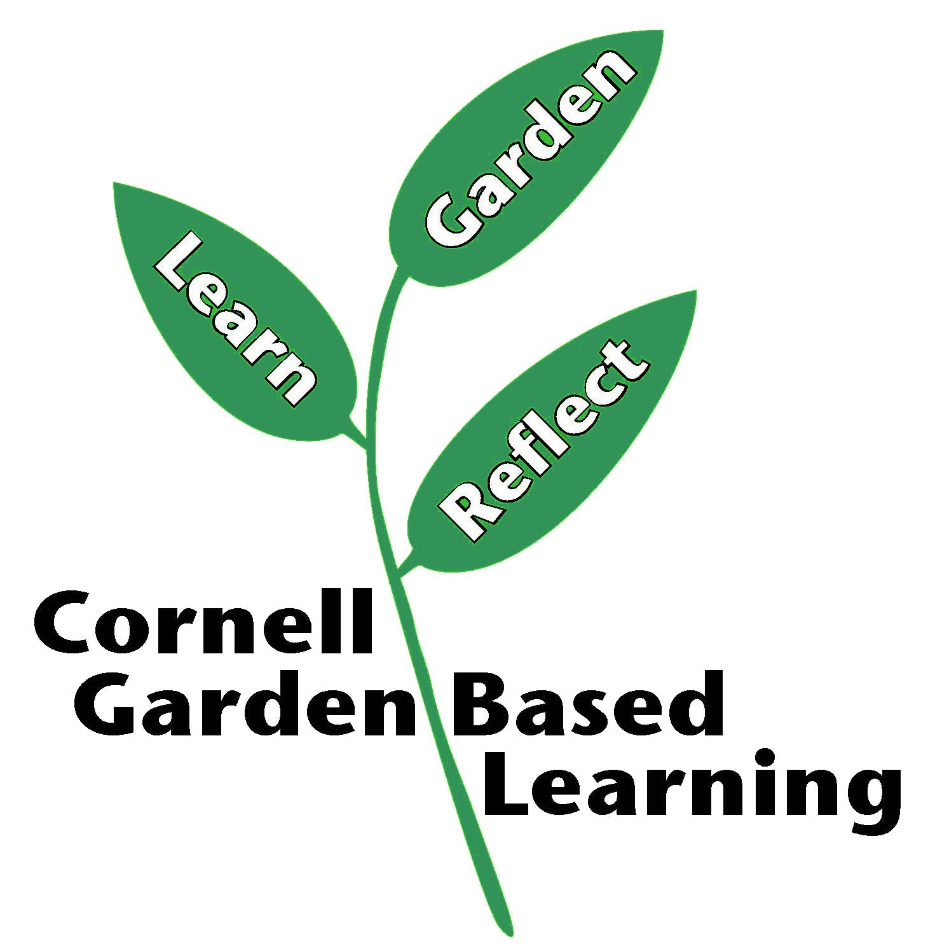
Date Published: April 2019

