WHO:  Participants | Individuals preparing for Master Gardener Volunteer role.
WHY:  The Situation | Plant biology is the study of plant life. As a gardener, it is important to understand how plants grow and function. We could not survive without plants and we depend on them for food, fossil fuels, lumber, fibers, medicines, paper, latex, resin, cork, spices, fragrances and dyes. After gaining an understanding of plant structure and function, participants will be able to translate these skills into more complex gardening topics. (Sourced from University of Maryland Master Gardener Handbook, pg. 27)  https://extension.umd.edu/mg/maryland-master-gardener-handbook
WHEN:  Timing | 2.5 hours. 135 minutes of session time & 15 minutes for a break.
WHERE:  Space | Classroom setting with seats and tables arranged in a circle or in clusters conducive to discussion and participation.
Learning Objectives* | Learning Strategy
Recognize the parts of a plant and their functions. | Station-Based Activities; Botany Language Basics for Identification of Flower Plants reading; Pre-work videos from the University of Wisconsin
Discover the ways plants are classified into family groups and the value of scientific names. | Field ID of the 50 most common plant families reading; Latin 101 reading; Botany Language Basics for Identification of Flower Plants reading; Pre-work videos from the University of Wisconsin
Become familiar with the environmental factors that affect plant germination, growth and phenology (spacing, nutrients, light, day length, water, temperature) | Pre-work videos from the University of Wisconsin
Examine the three basic processes for plant growth & development, photosynthesis, respiration & transpiration | Pre-work videos from the University of Wisconsin
Consider how plant characteristics are used in classification, identification and dichotomous keys. | Station-Based Activities; Field ID of the 50 most common plant families reading; Pre-work videos from the University of Wisconsin
*These learning objectives match those in Participant Guide & Presentation.

Before Session

Total time for preparation will vary; minimally 8 hours.

Consider adult learning theory and strategies for implementation

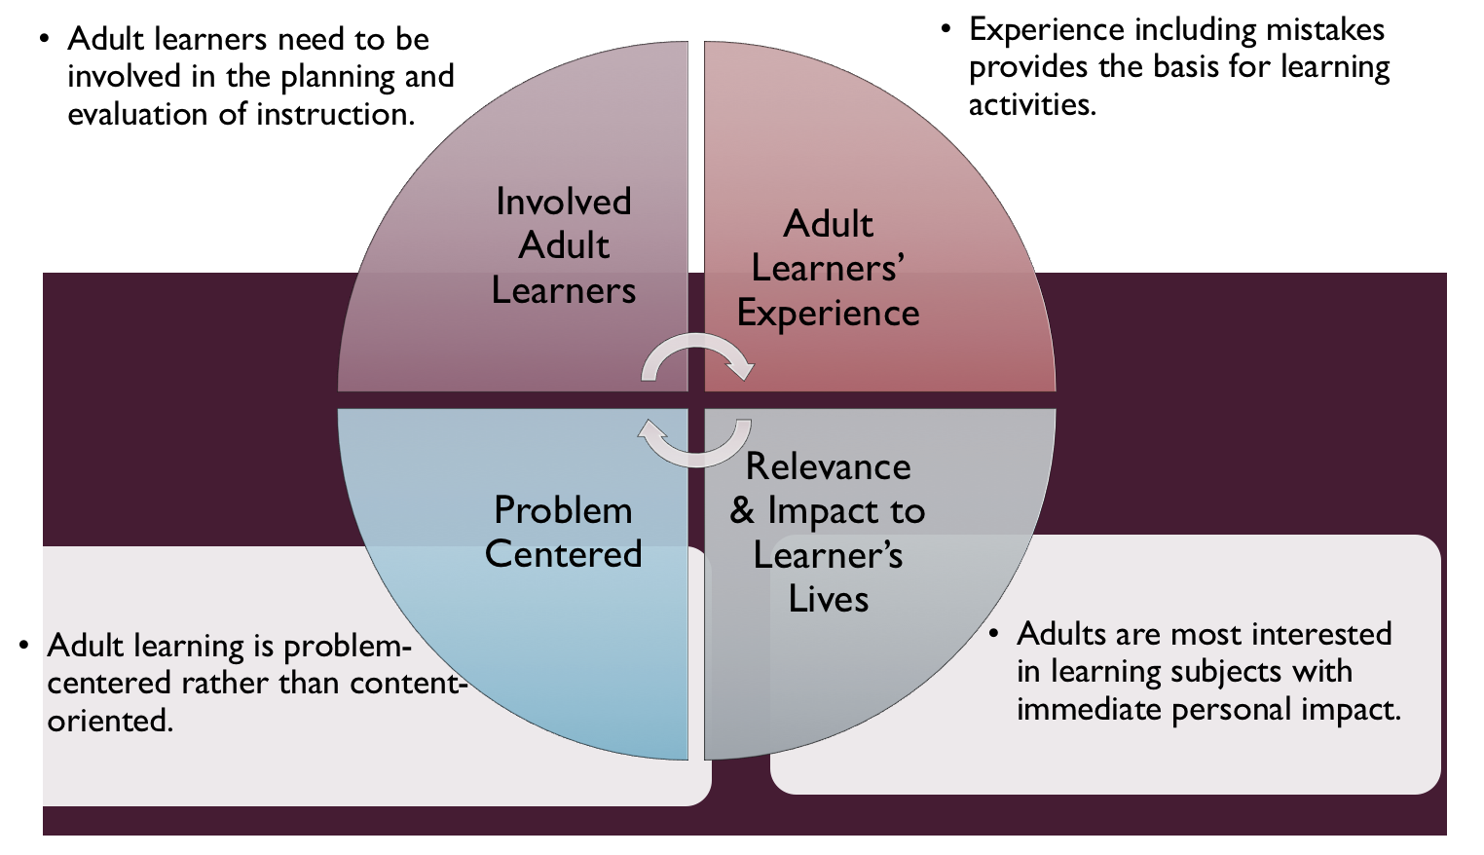
Figure credit: C. J. Carmichael adapted from M. S. Knowles and R.E. Mayer
Additionally, adult learners:
- Are experts of their lived experience.
- Come with their own motivations and goals.
- Need a safe and trusting learning environment.
- Know or will come up with 85% of the information you are planning to share.
- Remember 30% of what they hear and see, 50% of a demonstration, 70% of what they simulate, and 90% when they do the real thing.

Facilitated dialogue allows the classroom to become a conversation. Such discussion offers a way for students to explore supposedly settled questions and develop a fuller appreciation for the complexity of our knowledge. Model and encourage participants to ask open-ended questions that don’t seek yes/no answers or have right/wrong answers. This will help create a safe and trustworthy learning environment that helps participants reflect on information and make it personally relevant. The Ground Rules for Engagement from the Toolkit section in the MGV Learning Library - Core Preparation can be re-introduced if discussions lead to difficult and emotional conversations.

Review (time will vary; minimally 4 to 6 hours)
Go to the online MGV Learning Library - Core Preparation and review the resources available in the section Plant Biology for Gardeners including:
- Session Slides and Facilitator Notes
- FAQs
- Participant Guide
- Knowledge Check
- Print Materials for Before Session Pre-Work and Hands-on Activities

Gather materials and supplies (2 plus hours)
Soak monocot and dicot seeds for the Activity Monocots and Dicots. Consider how many days the seeds need to germinate under your conditions; you may want to vary soaking times to have the same seeds at different stages of germination.
Gather other materials for Hands-on Activities. The MGV Learning Library Activity Directions documents include a supply list for each activity, there are a lot of them! You might also ask participants to bring some in with them such as flowers.

Communicate with participants before session (1 hour)
Ideally at least 2 weeks in advance of this session provide participants with the Participant Guide found in the MGV Learning Library - Core Preparation. This document details what participants must do before the session. Review the document to determine if you need to supply any material in advance and to confirm the links are still good. Time to complete this pre-work will vary depending on the participant’s background and interest. We estimate most participants should allocate 3 to 5 hours.

Program Evaluation/Feedback (1 hour)
See section below.

Session Flow and Delivery

Total time for session is 2.5 hours - 135 minutes of task time & 15 minutes for a break.

As participants settle in, ask them to complete a review activity that you’ve prepared or selected from the review bank OR go over pre-work with others around them.

Session Tasks
Task 1: Opening and Introduction (5 minutes)
Welcome everyone, review housekeeping, ground rules, learning objectives, and class flow.

Task 2: Reconnect (10 minutes)
Ask participants to pair up and discuss the question under THINK in their Participant Guide.

Task 3: Cultivating Plant Observation Skills Activity (25 minutes)
Follow activity directions document found in MGV Learning Library.

Task 4: Station-Based Hands-on Activities Part 1 (40 minutes)
Follow the activity directions documents found in MGV Learning Library.
1) Herbaceous plants
2) Woody plants
3) Monocots and dicots
4) Flower parts
You may choose to divide participants into 4 groups and have groups rotate around on your timed 20 minutes intervals. Aim to have each group complete 2 activities before the break.

15 Minute BREAK

Task 5: Station-Based Hands-on Activities Part 2 (40 minutes)
Continue as described in Task 4 with the aim to have each group complete their 2 final activities after break.

Task 6: Conclusion (10 minutes)

Ask participants to reflect on key take home points from today and any lingering questions.
Direct participants’ attention to the items listed under After Session in their Participant Guide.

Task 7: Program Evaluation/Feedback (5 minutes)
Provide participants with an avenue to give feedback and data for your program evaluation including reporting. See section below on Program Evaluation/Feedback.

Task 8: Participant Evaluation/Knowledge Check (part of participant’s After Session work)
Provide an avenue for participants to assess what they know. See section below on Participant Evaluation/Knowledge Check.

After Session

Total time for follow-up will vary; minimally 2 hours.

Communicate with participants after session (1 hour)
Follow-up on unanswered content questions that emerged during session as needed as well as provide feedback on the knowledge check.

Consider Program Evaluation/Feedback (1 hour)
Summarize the feedback and data you received from participants for your program reporting and or future planning needs. See section below on Program Evaluation/Feedback.

Session Materials and Supplies
General Materials List
Facilitator notes Markers Index cards Pens
Highlighters Flip chart paper Name tags Feedback Forms
Post-it® notes Masking tape Computer/Internet/Projector

Materials by Task
Before Session Tasks
- Materials found in MGV Learning Library:
  - Module 1: The Fundamentals Section 1.1 Plant Biology for Gardeners
  - Evaluation Toolkit
Task 1 - Opening and Introduction
- Participant Guide
- Session Slides and Facilitator Notes
Task 2 - Reconnect
- Participant Guide
- Flip chart paper and markers for group discussion notes
Task 3 - Cultivating Plant Observation Skills Activity
- Activity Directions and Factsheet document found in MGV Learning Library.
- Materials listed in the above document and summarized here:
  - One vascular plant sample per participant or ask participants to bring sample
  - Paper bags for each sample
  - Paper and pencils for sketching or ask participants to bring
  - Resources that provide terminology for plant characteristics
Task 4 and 5 - Station-Based Hands-on Activities Part 1 and Part 2
Activity Directions documents for each of these are found in MGV Learning Library. Materials are listed in each document and summarized here:
- Herbaceous plants
  - Several herbaceous plant samples with intact leaves, stems and roots
  - Plant part labels in activity directions
  - Herbaceous plant ID book or online herbaceous plant ID database
- Woody plants
  - A variety of woody plant samples including leaves & stems (use from Task 3)
  - Print Manual of Woody Plants Excerpt from MGV Learning Library
- Monocots and Dicots
  - Bean and corn seedlings; soaked corn and bean seeds
  - Microscope
  - Hand lenses
  - Documents in the Materials to Print for Activity in MGV Learning Library
  - Activity Directions and Worksheet and KEY from MGV Learning Library
- Flower Parts
  - Hand lenses
  - Three types of flowers for learners to observe and dissect
  - Images in the Materials to Print for Activity in MGV Learning Library
Task 6 – Conclusion
- Participant Guide
- Flip chart paper and markers for group discussion notes
Task 7 – Program Evaluation/Feedback
- Your evaluation/feedback materials
Task 8 – Participant Evaluation/Knowledge Check
- Materials for participants to assess what they know around this topic such as Knowledge Check from MGV Learning Library
For After Session
- Feedback from participants
- Reporting forms
- Knowledge Check Key from MGV Learning Library

Optional Activities

Frequently Asked Questions (FAQs)
With the input of county and campus-based experts, we have compiled a list of top FAQs for each topic areas and place it with the other session resources in MGV Learning Library. Though not an exhaustive list, it should provide an opportunity for discussion and exploration of resources related to the topic. Integrate the FAQs in a way that makes sense for your local program. The FAQs could be used to prompt discussions within your group or they could be adapted into a scavenger hunt where individuals sift through reliable resources to find correct answers. Feel free to add or subtract questions and resources in the answers to meet your program's needs and address emerging issues.

Participant Evaluation/Knowledge Check

Adult learners enjoy getting feedback on what they have learned. We provide in MGV Learning Library the Knowledge Check handouts for each session. You may ask participants to answer the question at home on their own or in small groups discussions. The Knowledge Check KEY can be used to allow participants to self-check or for the educator to grade and provide feedback. You may wish to identify more engaging ways to self‐test what they have learned as it motivates and empowers them to take more active control of their learning.

Program Evaluation/Feedback

Time for creating and implementing a program evaluation plan will vary; minimally 1 hour.
Ideally, evaluation begins before the program starts. However, for many educators the idea of measuring the effects of your program is so daunting it never begins. With this in mind, we provide an Evaluation Toolkit in the MGV Learning Library. Our aim is to offer tools you can use, even while you’re on the run. Check it out as you consider these key questions:
- Who is this evaluation for?
- What do you want to know, and why?
- What’s do‐able, really?

Other key resources will be your local county program plan of work which likely aligns with CCE Programmatic Plans: http://www2.cce.cornell.edu/plans/Pages/FY-2016-CCE-Programmatic-Plans.aspx

Find on CCE staff website under the Organizational Development and Planning Unit a Program Reporting module: http://staff.cce.cornell.edu/orgdev/Pages/reporting.aspx

References

Southern Tier MGV Work Team, CCE Tioga (Barb Neal), Tompkins (Chrys Gardener and Pat Curran), Chemung (Jingjing Yin), and Broome (Linda Svoboda) which developed and piloted these activities in their 2016 regional preparation of volunteers.

Dirr, Michael A. 1998. Manual of Woody Landscape Plants: Their Identification, Ornamental Characteristics, Culture, Propagation and Uses. xiv-xxviii pp.

Young, Paul. 1982. The Botany Coloring Book. 83 & 98 pp.

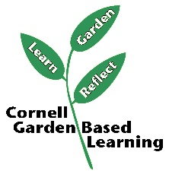

Date Published: April 2019

Facilitator’s Notes

List quotes and behavior change you noticed, especially those that may be included in your necessary reporting, success story, or for future program improvement:
List Participant Commitments that you will need to follow up on:
Changes and Adaptations to Session:

