Beneficial Insects
Participant Guide

Wild pollinators and managed bees are critically important to the health of New York’s environment, as well as the strength of the state’s agricultural economy. Many of the state’s leading crops, such as applies, berries, pumpkins and several other fruits, rely heavily on insect pollination. New York State is also home to more than 450 wild pollinator species, a native population that is important not only to the pollination of commercial crops, but to biodiversity in our environment. (Sourced from DEC New York State Pollinator Protection Plan, 2016)

By actively participating in Beneficial Insects, you will:
- Become familiar with beneficial insects, how to attract them to the garden, and their value in the ecosystem and cultivated landscapes.
- Learn about insect morphology and identify key morphological characteristics of insects:
  - Three major body parts: head, thorax, abdomen
  - Six legs
  - Exoskeleton
  - Antennae
- Explain the two common life cycle types of insects - complete and incomplete metamorphosis.
- Become familiar with the characteristics of five orders of common garden insects:
  - Coleoptera (beetles)
  - Diptera (true flies)
  - Lepidoptera (butterflies and moths)
  - Hymenoptera (bees, wasps, and ants)
  - Hemiptera (true bugs, hoppers, aphids)
- Recognize the evidence insects leave behind on plants.

Before Session
READ:
- Basic Entomology for Identification factsheet (pdf) (2 pages handout provided)
- Insect Injury to Plants reprint (pdf) (2 pages handout provided)
- Beneficial Insects - Nature’s Pest Control factsheet (pdf) (4 pages) Find it in this list of Cornell Insect Diagnostic Lab Factsheets: http://idl.entomology.cornell.edu/factsheets

WATCH:
- Entomology 101 Video Series

DO:
- Explore the online resource BugGuide: http://bugguide.net/node/view/73
  - Find one insect you weren't previously aware of and become familiar with it.
    - What are its key morphological characteristics? Does it have complete or incomplete metamorphosis? Which insect order is it in?
THINK:
- Are you already familiar with beneficial insects? Make a list of those.
- What are some questions you have about beneficial insects?

Opening and Introduction
- Facilitator reviews housekeeping, ground rules, learning objectives, and class flow.

Reconnect
- Partner up to discuss the question listed under the pre-work THINK prompt.

Entomology 101 Lecture
- Listen to presentation.

Beneficial Insects Lecture
- Listen to presentation.

Insect Orders Hands-on Activity
- Facilitator leads participants through group activity and discussion.

Conclusions
- Facilitator leads group reflection on key take home points and any lingering questions.

Program Feedback
- Share your insight to help us improve the program, report results, & plan for the future.

Knowledge Check
- Assess what you now know. Be motived and empowered to share with your peers and learn more.

After Session

REFLECT:
- What happened?
- What was my response to what happen? How do I make sense of it?
- How does it relate to other things I know?
- What can I conclude?
- What might I do differently next time?

DO:
- BugFinder Activity (pdf) (2-page handout provided)
- Explore Cornell Insect Diagnostic Lab Factsheets: http://idl.entomology.cornell.edu/factsheets

LEARN MORE:
- Putnam County Cornell Cooperative Extension’s Create a Pollinator Paradise web resource: http://putnam.cce.cornell.edu/gardening/create-a-pollinator-paradise
- The Power of Pollinators: Bee Biology and Identification video ~37 minutes
- https://vod.video.cornell.edu/media/Bee+Biology/1_us110ww9
- Cornell Entomologist’s Naturalist Outreach YouTube videos including one on arthropod predators and insect phylogeny: https://www.youtube.com/user/naturalistoutreach
- 2018 All Bugs Good and Bad Webinar Series: Bees, Wasps, and Hornets, Oh My!: https://www.youtube.com/watch?v=C4YqzCTlPyc&feature=youtu.be
- 2018 All Bugs Good and Bad Webinar Series: Attracting Pollinators to Our Landscape https://www.youtube.com/watch?v=9GKrbTFWkFA&feature=youtu.be
- MGV Level 1: Entomology from the University of Wisconsin. YouTube video series 5 parts - 60 minutes: https://www.youtube.com/playlist?list=PLrktjgTJbkvVpnZhmjxvA21PxyWVa0Kdx
- Insect Structure, Function, and Metamorphosis - YouTube video ~20 minutes https://www.youtube.com/watch?v=tM53SsmJY6I
- Managing Insects: Friend of Foe? YouTube video - ~18 minutes https://www.youtube.com/watch?v=_3k2Mqty1QU
- Dr. Entom YouTube video series on insects - 7 YouTube videos, 5 to 11 minutes each https://www.youtube.com/channel/UCZnWmkcky0RrayAjXVEmLzw
- Cicada Metamorphosis Timelapse YouTube video ~3 minutes https://www.youtube.com/watch?v=mArDqy8RkxM
- Introduction to Scale Insects: YouTube video ~2.5 minutes https://www.youtube.com/watch?v=ZEzNVN-xGlA
- BugGuide: http://bugguide.net/node/view/15740
- Insects: Their Natural History and Diversity: With a Photographic Guide to Insects of Eastern North America by Stephen A. Marshall, http://www.fireflybooks.com/index.php/catalogue/adult-books/nature-and-science/insects/product/11548-insects-their-natural-history-and-diversity-with-a-photographic-guide-to-insects-of-eastern-north-america
- A Field Guide to Insects: America North of Mexico by Donald J. Borror and Richard E. White, https://www.amazon.com/Field-Guide-Insects-America-Mexico/dp/0395911702/ref=pd_lpo_sbs_14_t_0?_encoding=UTF8&psc=1&refRID=9H4T1J328GXWBNAX321X
- Garden Insects of North America: The Ultimate Guide to Backyard Bugs by Whitney Cranshaw, https://www.amazon.com/Garden-Insects-North-America-Princeton/dp/0691095612
- Insects that Feed on Trees and Shrubs by Warren T. Johnson and Howard H. Lyon, http://www.cornellpress.cornell.edu/book/?GCOI=80140100626460
- PCT Field Guide for the Management of Urban Spiders By Stoy A. Hedges and Richard S. Vetter; Dan Moreland, Editor https://store.pctonline.com/en/pct-field-guide-for-the-management-of-urban-spiders-2nd-ed
- Common Spiders of North America by R. A. Bradley (Author), S. Buchanan (Illustrator)
- Some Commonly Encountered Pennsylvania Spiders from PENN State https://ento.psu.edu/extension/factsheets/pdf/commonly-encountered-pa-spiders

Campus Links:
- Cornell of Entomology Outreach: https://entomology.cals.cornell.edu/extension/
- Cornell Insect Diagnostic Lab: http://idl.entomology.cornell.edu/
- NYS Integrated Pest Management: https://nysipm.cornell.edu/
- Pollinator Network at Cornell: https://pollinator.cals.cornell.edu/
- Cornell’s Biological Control: A Guide to Natural Enemies in North America: https://biocontrol.entomology.cornell.edu/index.php

Looking for Cornell people and resources? Don’t Google; try the Cornell web search: http://www.cornell.edu/search/index.cfm

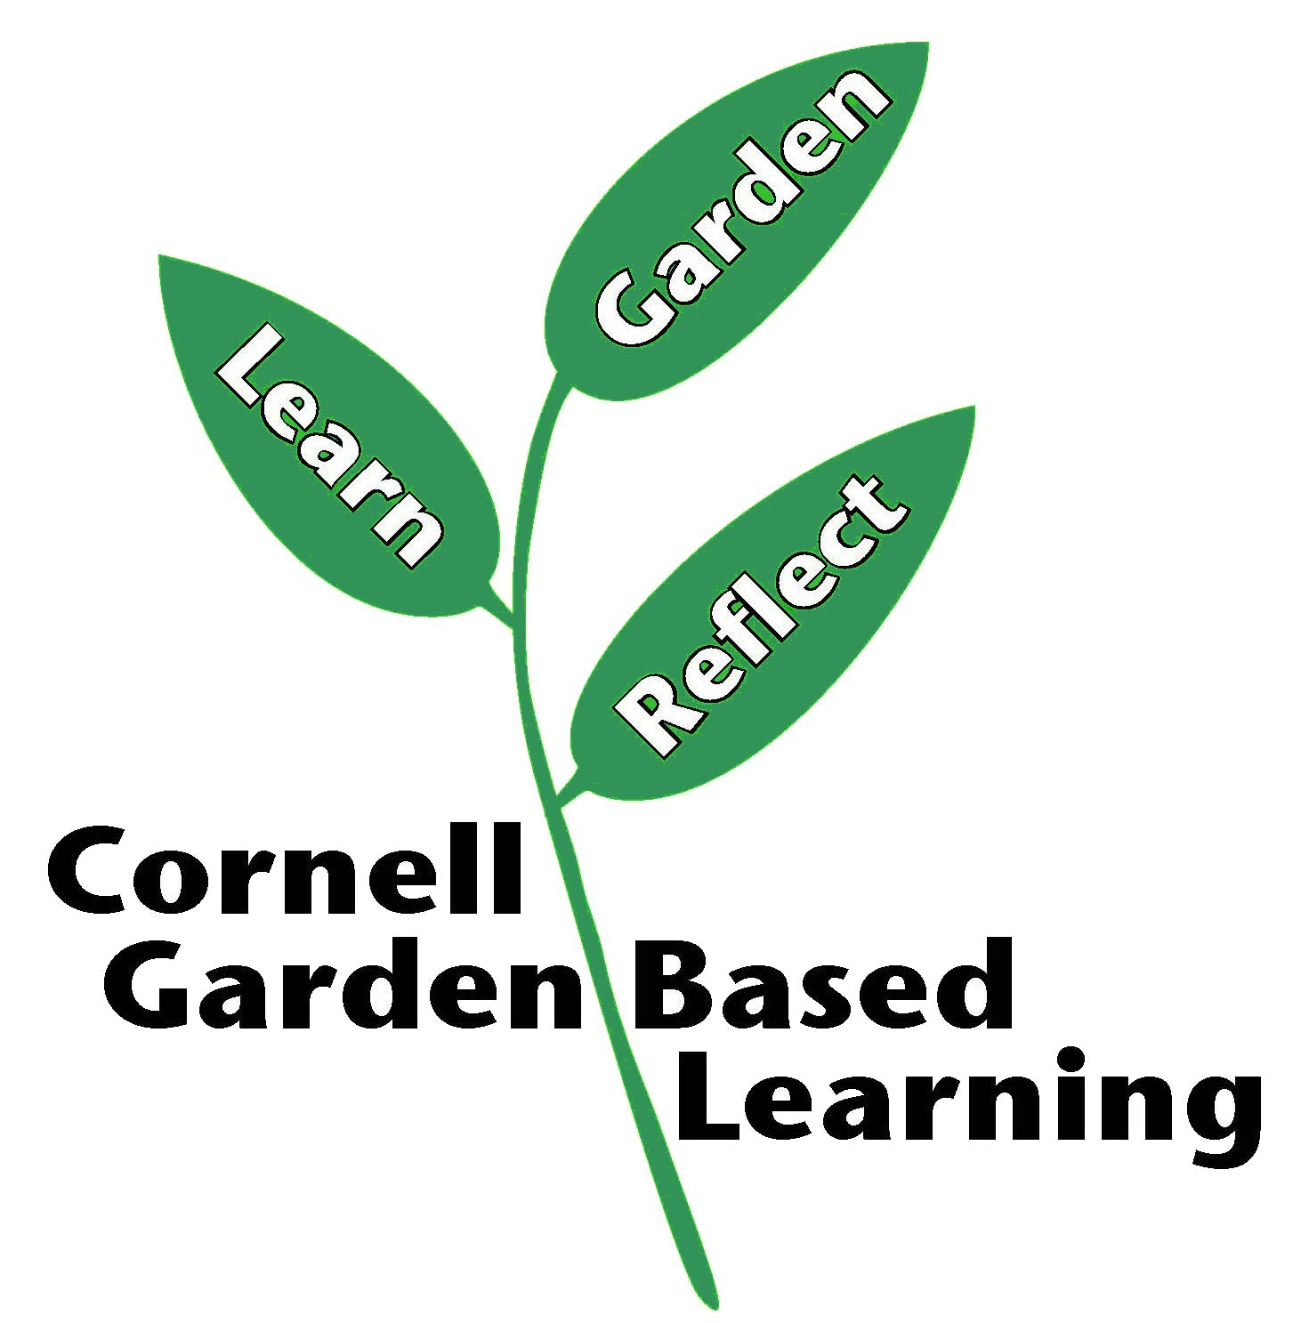
Date Published/Updated: April 2019

