WHO:  Participants | Individuals preparing for Master Gardener Volunteer role.
WHY:  The Situation | Biodiversity and natural resource protection is highlighted as one of the CCE Statewide Plan of Work’s main focus areas.  Wild pollinators and managed bees are critically important to the health of New York’s environment, as well as the strength of the state’s agricultural economy. Many of the state’s leading crops, such as apples, berries, pumpkins and several other fruits rely heavily on insect pollination. New York State is also home to more than 450 wild pollinator species, a native population that is important not only to the pollination of commercial crops, but to biodiversity in our environment. (Sourced from DEC NYS Pollinator Protection Plan, 2016)
WHEN:  Timing | 2.5 hours. 135 minutes of session time & 15 minutes for a break.
WHERE:  Space | Classroom setting with seats and tables arranged in a circle or in clusters conducive to discussion and participation.
Learning Objectives* |  | Learning Strategy
Become familiar with beneficial insects, how to attract them to the garden and their value in the ecosystem and cultivated landscapes. |  | Beneficial Insects presentation; Beneficial Insects reading and BugGuide
Learn about insect morphology and identify key morphological characteristics of insects:  - Three major parts: head, thorax, abdomen  - Six legs  - Exoskeleton  - Antennae |  | Entomology 101 presentation; Basic Entomology for Identification reading
Explain the two common life cycle types of insects - complete and incomplete metamorphosis |  | Entomology 101 presentation
Become familiar with the characteristics of five orders of common garden insects:  - Coleoptera (beetles)  - Diptera (true flies)  - Lepidoptera (butterflies and moths)  - Hymenoptera (bees, wasps and ants)  - Hemiptera (true bugs, hoppers, aphids) |  | Entomology 101 presentation
Recognize the evidence insects leave behind on plants. |  | Beneficial Insects presentation; Insects and Injury pre-work reading
*These learning objectives match those in Participant Guide & Presentation.

Before Session
Total time for preparation will vary; minimally 8 hours.

Consider adult learning theory and strategies for implementation

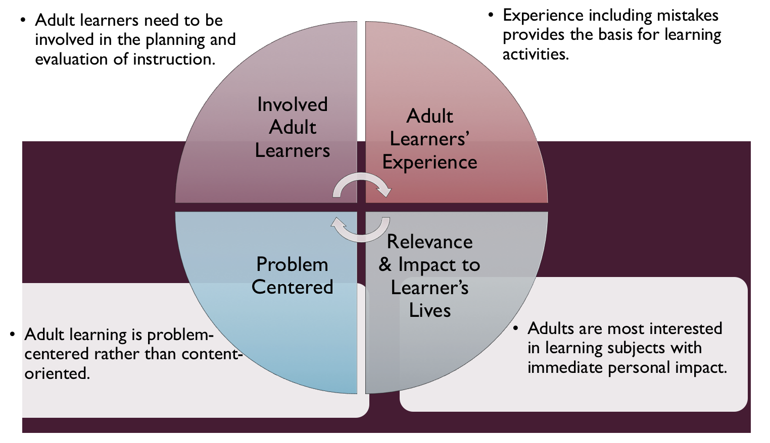
Figure credit: C. J. Carmichael adapted from M. S. Knowles and R.E. Mayer
Additionally, adult learners:
- Are experts of their lived experience.
- Come with their own motivations and goals.
- Need a safe and trusting learning environment.
- Know or will come up with 85% of the information you are planning to share.
- Remember 30% of what they hear and see, 50% of a demonstration, 70% of what they simulate, and 90% when they do the real thing.
Facilitated dialogue allows the classroom to become a conversation. Such discussion offers a way for students to explore supposedly settled questions and develop a fuller appreciation for the complexity of our knowledge. Model and encourage participants to ask open-ended questions that don’t seek yes/no answers or have right/wrong answers. This will help create a safe and trustworthy learning environment that helps participants reflect on information and make it personally relevant. The Ground Rules for Engagement from the Toolkit section in the GBL Learning Library - Core Preparation can be re-introduced if discussions lead to difficult and emotional conversations.

Review (time will vary; minimally 4 to 6 hours)
Go to the online GBL Learning Library - Core Preparation and review the resources available in the section Beneficial Insects including:
- Session Slides and Facilitator Notes or Recordings
- FAQs
- Participant Guide
- Knowledge Check
- Print Materials for Before Session Pre-Work, Hands-on Activity, and Optional Activity

Gather materials and supplies (2 plus hours)
Print supply materials for Insect Order activity. The GBL Learning Library has the Activity Directions document as well as flash cards and handout. You may wish to use different photos these are provided as a place to start.

Communicate with participants before session (1 hour)
Ideally at least 2 weeks in advance of this session provide participants with the Participant Guide found in the GBL Learning Library - Core Preparation. This document details what participants must do before the session. Review the document to determine if you need to supply any material in advance and to confirm the links are still good. Time to complete this pre-work will vary depending on the participant’s background and interest. We estimate most participants should allocate 3 to 5 hours.

Program Evaluation/Feedback (1 hour)
See section below.
Session Flow and Delivery
Total time for session is 2.5 hours - 135 minutes of task time & 15 minutes for a break.

As participants settle in, ask them to complete a review activity that you’ve prepared or selected from the review bank OR go over pre-work with others around them.

Session Tasks
Task 1: Opening and Introduction (5 minutes)
Welcome everyone, review housekeeping, ground rules, learning objectives, and class flow.

Task 2: Reconnect (10 minutes)
Ask participants to pair up to discuss the question under THINK in their Participant Guide.

Task 3: Entomology 101 Lecture (40 minutes)
Listen to the recorded presentation.
Use the Session Slides and Facilitator notes found in GBL Learning Library; feel free to adapt the resources to suit your teaching style and needs. Alternatively, a presenter can create their own presentation to meet the learning objectives on page 1 of this document.

15 Minute BREAK

Task 4: Beneficial Insects Lecture (40 minutes)
Listen to the recorded presentation.
Use the Session Slides and Facilitator notes found in GBL Learning Library; feel free to adapt the resources to suit your teaching style and needs. Alternatively, a presenter can create their own presentation to meet the learning objectives on page 1 of this document.

Task 5: Insect Orders Hands-on Activity (25 minutes)
Follow the activity direction document found in GBL Learning Library.

Task 6: Conclusion (10 minutes)
Ask participants to reflect on key take home points from today and any lingering questions.
Direct participants’ attention to the items listed under After Session in their Participant Guide.

Task 7: Program Evaluation/Feedback (5 minutes)
Provide participants with an avenue to give feedback and data for your program evaluation including reporting. See section below on Program Evaluation/Feedback.

Task 8: Participant Evaluation/Knowledge Check (part of participant’s After Session work)
Provide an avenue for participants to assess what they know. See section below on Participant Evaluation/Knowledge Check.

After Session
Total time for follow-up will vary; minimally 2 hours.

Communicate with participants after session (1 hour)
Follow-up on unanswered content questions that emerged during session as needed as well as provide feedback on the knowledge check and after session activity.

Consider Program Evaluation/Feedback (1 hour)
Summarize the feedback and data you received from participants for your program reporting and or future planning needs. See section below on Program Evaluation/Feedback.

Session Materials and Supplies
General Materials List
Facilitator notes Markers Index cards Pens
Highlighters Flip chart paper Name tags Feedback Forms
Post-it® notes Masking tape Computer/Internet/Projector

Materials by Task
Before Session Tasks
- Materials found in GBL Learning Library:
  - Module 1: The Fundamentals Section 1.3 Beneficial Insects
  - Evaluation Toolkit
Task 1 - Opening and Introduction
- Participant Guide
- Session Slides and Facilitator Notes
Task 2 - Reconnect
- Participant Guide
- Flip chart paper and markers for group discussion notes
Task 3 – Entomology 101 Lecture
- Session Slides and Facilitator Notes or Recordings
Task 4 - Beneficial Insects Lecture
- Session Slides and Facilitator Notes or Recordings
Task 5 - Insect Orders Hands-on Activity
- Activity Directions document, flash cards and handout are in GBL Learning Library
Task 6 – Conclusion
- Participant Guide
- Flip chart paper and markers for group discussion notes
Task 7 – Program Evaluation/Feedback
- Your evaluation/feedback materials
Task 8 – Participant Evaluation/Knowledge Check
- Materials for participants to assess what they know around this topic such as Knowledge Check from GBL Learning Library
For After Session
- Feedback from participants
- Reporting forms
- Knowledge Check Key from GBL Learning Library
- Optional activity directions for BugGuide are in GBL Learning Library

Optional Activities
Frequently Asked Questions (FAQs)
With the input of county and campus-based experts, we have compiled a list of top FAQs for each topic areas and place it with the other session resources in GBL Learning Library. Though not an exhaustive list, it should provide an opportunity for discussion and exploration of resources related to the topic. Integrate the FAQs in a way that makes sense for your local program. The FAQs could be used to prompt discussions within your group or they could be adapted into a scavenger hunt where individuals sift through reliable resources to find correct answers. Feel free to add or subtract questions and resources in the answers to meet your program's needs and address emerging issues.

Participant Evaluation/Knowledge Check
Adult learners enjoy getting feedback on what they have learned. We provide in GBL Learning Library the Knowledge Check handouts for each session. You may ask participants to answer the question at home on their own or in small groups discussions. The Knowledge Check KEY can be used to allow participants to self-check or for the educator to grade and provide feedback. You may wish to identify more engaging ways to self‐test what they have learned as it motivates and empowers them to take more active control of their learning.

Program Evaluation/Feedback
Time for creating and implementing a program evaluation plan will vary; minimally 1 hour.
Ideally, evaluation begins before the program starts. However, for many educators the idea of measuring the effects of your program is so daunting it never begins. With this in mind, we provide an Evaluation Toolkit in the GBL Learning Library. Our aim is to offer tools you can use, even while you’re on the run. Check it out as you consider these key questions:
- Who is this evaluation for?
- What do you want to know, and why?
- What’s do‐able, really?

Other key resources will be your local county program plan of work which likely aligns with CCE Programmatic Plans: http://www2.cce.cornell.edu/plans/Pages/FY-2016-CCE-Programmatic-Plans.aspx.

Find on CCE staff website under the Organizational Development and Planning Unit a Program Reporting module: http://staff.cce.cornell.edu/orgdev/Pages/reporting.aspx.

References
Jason Dombroskie, Manager for the Cornell University Insect Collection and the Coordinator of the Insect Diagnostic Lab, and his personal photo library.

Malinoski, Mary K. Introduction to Insects. Revised for NYS by Carolyn Klass, 20-21 pp.
Earth Partnership for Schools, University of Wisconsin (Insect Order Handout).

Southern Tier MGV Work Team: CCE Tioga (Barb Neal), Tompkins (Chrys Gardener and Pat Curran), Chemung (Jingjing Yin), and Broome (Linda Svoboda), who developed and piloted these activities in their 2016 regional preparation of volunteers.

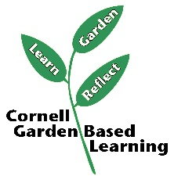

Date Published/Updated: April 2019

Facilitator’s Notes

List quotes and behavior change you noticed, especially those that may be included in your necessary reporting, success story, or for future program improvement:
List Participant Commitments that you will need to follow up on:
Changes and Adaptations to Session:

