Community Engagement and Action Projects
Participant Guide

Garden-based education can serve as a catalyst for addressing food security and hunger; climate change; sustainable energy; childhood obesity and nutrition; food safety; and youth, family and community development. The widespread appeal of gardening provides opportunities to use gardens to connect with diverse audiences. Cornell Cooperative Extension is part of the USDA’s National Institute of Food and Agriculture Cooperative Extension System, consequently CCE Master Gardener Volunteers are uniquely linked to Cornell University and positioned to provide best practices for creating successful gardening experiences grounded in research-based knowledge.

By actively participating in this Community Engagement and Action Projects session, you will:
- Reflect on your identity.
- Acknowledge that community engagement is essential to identifying collaborative solutions.
- Identify the steps you will take to complete an action project.

Before Session

READ:
- Fact Sheet Qualities of an Active Contributor to a Peer Learning Network (2 pg handout provided)
- Learning Styles as a Myth (1 web page) https://ctl.yale.edu/LearningStylesMyth
- Page 1 of Action Project Planning Worksheet (12 pg handout provided)
WATCH:
- The six short videos (~ 30 minutes total) on the Cornell Garden-Based Learning's 'Effective Community Engagement' web page. Consider the reflective questions under each video and prepare to discuss some of these in class. http://gardening.cals.cornell.edu/program-tools/planning-organizing/effective-community-engagement
- The very short “ins and outs of public events” videos (~ 15 minutes total) from Colorado State MGV Program, https://spark.adobe.com/page/6h23TrCM8wMr5/
- Constructing Learning Objectives posted on TechSmith’s SCREENCAST.COM Service (~ 5 minute video) http://www.screencast.com/t/31O8Yjxu
DO:
- Worksheet Your Identity Pie Chart (1 pg handout provided)
THINK:
- How might elements of your identity impact your role as a peer educator? And your contributions to a peer learning network?
- What inspires you to learn and reach beyond your garden gate to connect with individuals and families in your community?
- What do you think you bring to the CCE Master Gardener Volunteer experience? Consider broadly your experiences, knowledge, skills, attitude, and passions.
Opening and Introduction
- Facilitator reviews housekeeping, ground rules, learning objectives, and class flow.
Reconnect
- Form listening pairs for discussion of the questions listed under the THINK prompt above. Then the whole group creates a wall of post-it notes listing their experiences, knowledge, skills, attitude, and passions.
Effective Community Engagement Discussion Hands-on Activity
- Engage in small group activity and whole group discussion.
Action Project Discussion
- Facilitator introduce Action Projects using the Action Project Planning Worksheet.
Garden-Based Learning Outreach Scenarios Hands-on Activity
- Engage in small group activity and whole group discussion.
Conclusions
- Facilitator leads group activity to find out where people are from and leads reflection on key take home points and any lingering questions.
Program Feedback
- Share your insight to help us improve the program, report results, & plan for the future.
Knowledge Check
- Assess what you now know. Be motivated and empowered to share your knowledge with your peers and to learn more.
After Session
REFLECT:
- What happened?
- What was my response to what happen? How do I make sense of it?
- How does it relate to other things I know?
- What can I conclude?
- What might I do differently next time?

LEARN MORE:
- Building Community: A Tool Kit for Youth & Adults in charting Assets and Creating Change http://www.theinnovationcenter.org/files/BuildingCommunity_ToolKit.pdf
- Community Tool Box University of Kansas (https://ctb.ku.edu/en ) specifically at: https://ctb.ku.edu/en/table-of-contents/assessment/assessing-community-needs-and-resources/windshield-walking-surveys/main
- Community Development Society (https://www.comm-dev.org/) Community Capitals Asset Identification Worksheet http://srdc.msstate.edu/fop/levelthree/trainarc/socialcapital/communitycapitalstodevelopassets-emeryfeyflora2006.pdf
- ABCD Model for Writing Objectives https://ccconlineed.instructure.com/courses/837/pages/abcd-model-for-writing-objectives

Campus Links:
- Cornell Cooperative Extension http://cce.cornell.edu/
- Cornell Garden-Based Learning http://gardening.cals.cornell.edu/
- Cornell University Library, Portal for Cornell Cooperative Extension
http://guides.library.cornell.edu/cce_portal

Looking for Cornell people and resources? Don’t google, try the Cornell web search: http://www.cornell.edu/search/index.cfm

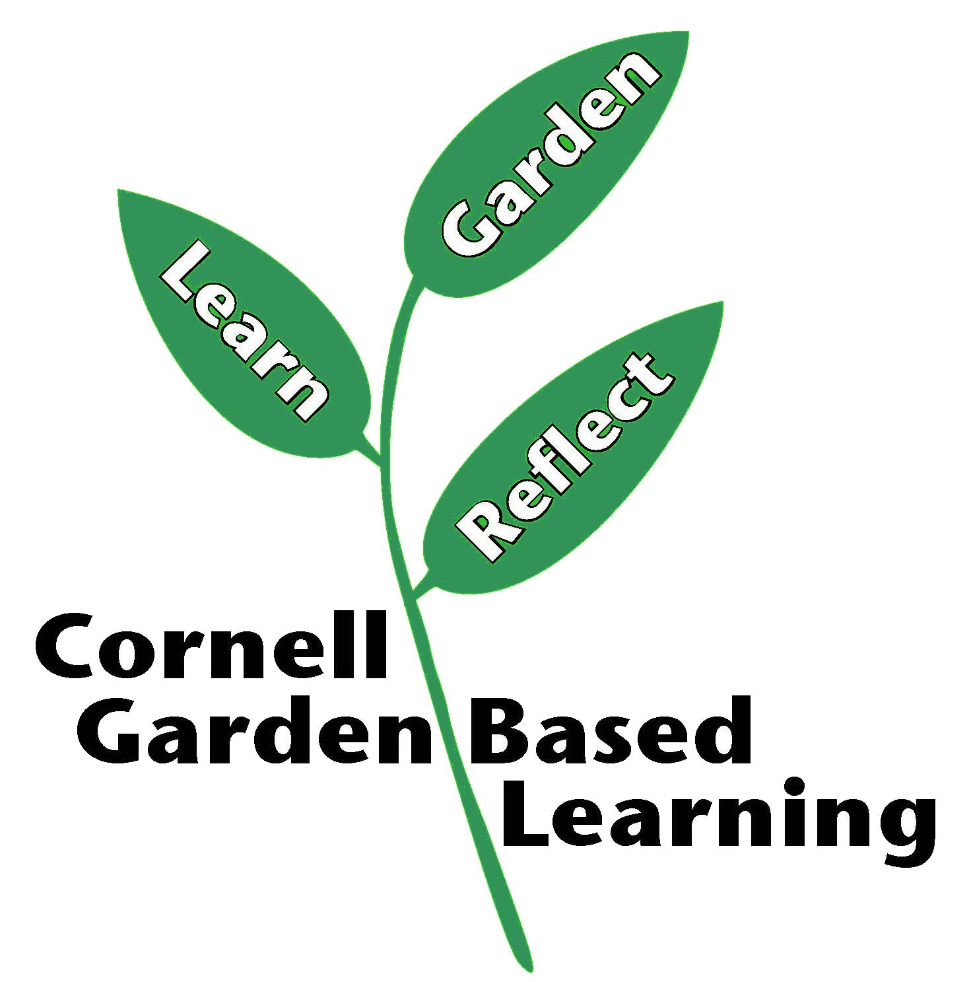
Date Published: April 2019

