WHO:  Participants | Individuals preparing for Master Gardener Volunteer role.
WHY:  The Situation | Garden-based education can serve as a catalyst for addressing food security and hunger; climate change; sustainable energy; childhood obesity and nutrition; food safety; and youth, family and community development. The widespread appeal of gardening provides opportunities to use gardens to connect with diverse audiences. Cornell Cooperative Extension is part of the USDA’s National Institute of Food and Agriculture Cooperative Extension System, consequently CCE Master Gardener Volunteers are uniquely linked to Cornell University and positioned to provide best practices for creating successful gardening experiences grounded in research-based knowledge.
WHEN:  Timing | 2.5 hours/135 minutes of session time & 15 minutes for a break.
WHERE:  Space | Classroom setting with seats and tables arranged in a circle or in clusters conducive to discussion and participation.
Learning Objectives* | Learning Strategy (name specific approach to be used)
Reflect on your identity. | Worksheet Your Identity Pie Chart; Reading Fact sheet Qualities of an Active Contributor to a Peer Learning Network; THINK prompt in Pre-work and Reconnect Task
Acknowledge that community engagement is essential to identifying collaborative solutions. | Hands-on Activity Effective Community Engagement Discussion with Videos
Identify the steps you will take to complete an action project. | Action Projects Discussion; Review Action Project Planning Worksheet and Example Action Projects; Hands-on Activities Garden-Based Learning Outreach Scenarios.
*These learning objectives match those in Participant Guide & Presentation.
Before Session

Total time for preparation will vary; minimally 6 hours.

Consider adult learning theory and strategies for implementation

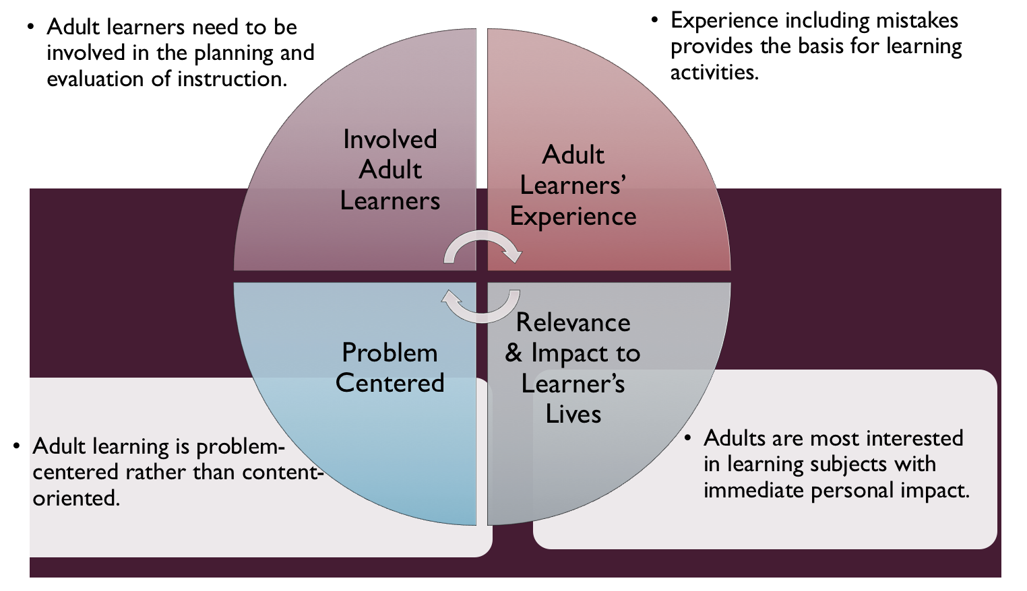
Figure credit: C. J. Carmichael adapted from M. S. Knowles and R.E. Mayer

Additionally, adult learners:
- Are experts of their lived experience.
- Come with their own motivations and goals.
- Need a safe and trusting learning environment.
- Know or will come up with 85% of the information you are planning to share.
- Remember 30% of what they hear and see, 50% of a demonstration, 70% of what they simulate, and 90% when they do the real thing.

Facilitated dialogue allows the classroom to become a conversation. Such discussion offers a way for students to explore supposedly settled questions and develop a fuller appreciation for the complexity of our knowledge. Model and encourage participants to ask open-ended questions that don’t seek yes/no answers or have right/wrong answers. This will help create a safe and trustworthy learning environment that helps participants reflect on information and make it personally relevant. See task 1 below regarding the conversation around Our Ground Rules for Engagement.

Review (time will vary; minimally 4 hours)
Go to the online Learning Library - Core Preparation and review the resources available in the section Adult Learning and Peer Learning Networks including:
- Session Slides and Facilitator Notes
- Facilitator Guide
- Participant Guide
- Knowledge Check
- Print Materials for Before Session Pre-Work and Hands-on Activities
- Action Project Planning Worksheet - dates for benchmarks need to be set

Gather materials and supplies (1 hour)
There is a small amount of materials to print and organize including Action Project Planning Worksheet. For one Hands-on Activity a tablet or laptop for each of the groups to watch about 3-minute Internet video is needed.

Communicate with participants before session (1 plus hour)
Ideally at least 2 weeks in advance of this session provide participants with the Participant Guide found in the Learning Library - Core Preparation. This document details what participants must do before the session. Review the document to determine the additional materials you need to provide in advance and to confirm the links are still good. Time to complete this pre-work will vary depending on the participant’s background and interest. We estimate most participants should allocate 5 hours. For one activity a tablet or laptop for each of the groups to watch about 3-minute Internet video is needed so encourage participants who might have one to bring it.

Program Evaluation/Feedback (1 hour)
See section below.

Session Flow and Delivery
Total time for session is 2.5 hours (135 minutes of task time & 15 minutes for a break).

Session Tasks
Task 1: Opening and Introduction (5 minutes)
Welcome everyone, review housekeeping, ground rules, learning objectives, and class flow.

Task 2: Reconnect (25 minutes)
Show Listening Pairs slide. Throughout the preparation sessions we will have repeated opportunities to pair up. To make the most of these opportunities, we will aim to:
- Listen without interruption
- Take turns
- Communicate interest, encouragement and confidence in people
- Be pleased with people and their efforts to think and try new things

Ask participants to pair up and discuss the question under THINK in their Participant Guide. Each person task 3 to 5 minutes to share with partner for a total of about 6 to 10 minutes.

After they have time to chat with a partner provide each participant with 8 to 10 post-it notes. Instruct them to take a few minutes to record the knowledge, skill, attitude, experience, or passion they are bringing to the CCE MGV program on post-it notes. Encourage them to try to come up with at least 5 things and put each on a separate note. You may wish to keep the notes anonymous or have them include their name and last initial on their notes.

Post finished notes directly on the wall or a large poster paper on the wall or easel. As the notes go up urge participants to take the lead on grouping related ones. There is no right or wrong grouping and they can work together to arrange and rearrange as they like and as more are added. End by asking if anyone wishes to share any observations about themes that emerge based on the items they see on the wall.

Consider revisiting this activity at the end of the session and/or throughout the remaining sessions. As participants gain more understanding of the work, they may realize they are tapping into far more than just their gardening experiences.

In regional trainings with a lot of counties and people, consider having people do this activity within their county groups.

Task 3: Effective Community Engagement Discussion Hands-on Activity (30 minutes)
Follow activity directions document found in the Learning Library. Wrap up activity with poem by Margaret Wheatley called Turning to One Another.

- minute BREAK
Task 4: Action Projects Discussion (30 minutes)
Introduce participants to Action Projects using the Action Project Planning Worksheet, Session Slides and Facilitator notes all found in Learning Library; adapt the resources to suit your teaching style and needs.

Task 5: Garden-Based Learning Outreach Scenarios Hands-on Activity (30 minutes)
Follow activity directions document found in the Learning Library.

Task 6: Conclusion (10 minutes)

Conclude by asking participants to reflect on key take home points from today and any lingering questions. Direct participants’ attention to the items listed under After Session in their Participant Guide.

Task 7: Program Evaluation/Feedback (5 minutes)
Provide participants with an avenue to give feedback and data for your program evaluation and reporting. See section below on Program Evaluation/Feedback.

Task 8: Participant Evaluation/Knowledge Check (part of participant’s After Session work)
Provide an avenue for participants to assess what they know. See section below on Participant Evaluation/Knowledge Check.

After Session

Total time for follow-up will vary; minimally 2 hours.

Communicate with participants after session (1 hour)
Follow-up on unanswered content questions that emerged during the session and provide feedback on the knowledge check.

Consider Program Evaluation/Feedback (1 hour)
Summarize the feedback and data you received from participants for your program reporting and or future planning needs. See section below on Program Evaluation/Feedback.

Session Materials and Supplies

General Materials List
Facilitator notes, Markers, Index cards, Pens
Highlighters, Flip chart paper, Name tags, Feedback Forms
Post-it® notes, Masking tape, Computer/Internet/Projector

Materials by Task
Before Session Tasks
- Materials found in Learning Library:
  - Module 0: Section 2 Community Engagement and Action Projects
  - Evaluation Toolkit
Task 1 - Opening and Introduction
- Participant Guide
- Session Slides and Facilitator Notes
Task 2 - Reconnect
- Participant Guide
- Post-it® notes, Flip chart paper
Task 3 – Effective Community Engagement Discussion Hands-on Activity
- Activity Directions are found in Learning Library. A tablet or laptop for each of the groups to watch about 3-minute video.
Task 4 – Action Project Discussion
- Action Project Planning Worksheet
- Session Slides and Facilitator Notes
Task 5 – Garden-Based Learning Outreach Scenarios Hands-on Activity
- Activity Directions are found in Learning Library.
Task 6 – Conclusion
- Participant Guide
- Flip chart paper and markers for group discussion notes
Task 7 – Program Evaluation/Feedback
- Your evaluation/feedback materials
Task 8 – Participant Evaluation/Knowledge Check
- Materials for participants to assess what they know around this topic such as Knowledge Check from Learning Library
For After Session
- Feedback from participants
- Reporting forms
- Knowledge Check Key from Learning Library

Optional Activities

Additional “getting to know your community” activities:

Scavenger hunt in important locations and institutions in the community.

“Windshield or Walking Survey” to systematically observe and get a sense of various communities. More in Community Tool Box University of Kansas https://ctb.ku.edu/en specifically at: https://ctb.ku.edu/en/table-of-contents/assessment/assessing-community-needs-and-resources/windshield-walking-surveys/main

Community Capitals Asset Identification Worksheet http://srdc.msstate.edu/fop/levelthree/trainarc/socialcapital/communitycapitalstodevelopassets-emeryfeyflora2006.pdf Community Development Society https://www.comm-dev.org/

Participant Evaluation/Knowledge Check

Adult learners enjoy getting feedback on what they have learned. In the Learning Library, you will find the Knowledge Check handouts for each session. You may ask participants to answer the questions at home on their own or in small groups discussions. The Knowledge Check KEY can be used for participants to self-check or for the educator to grade and provide feedback. You may wish to identify more engaging ways for participants to self‐test what they have learned as it motivates and empowers them to be more accountable for their learning.

Program Evaluation/Feedback
Time for creating and implementing a program evaluation plan will vary; minimally 1 hour.

Ideally, evaluation begins before the program starts. Though for many educators, the idea of measuring the effects of your program is so daunting it never begins. With this in mind, we provide an Evaluation Toolkit in the Learning Library. Our aim is to offer tools you can use, even while you’re on the run. Check it out as you consider these key questions:
- Who is this evaluation for?
- What do you want to know, and why?
- What’s do‐able, really?

Other key resources will be your local county program plan of work which likely aligns with CCE Programmatic Plans: http://www2.cce.cornell.edu/plans/Pages/FY-2016-CCE-Programmatic-Plans.aspx

Find on CCE staff website under the Organizational Development and Planning Unit a Program Reporting module: http://staff.cce.cornell.edu/orgdev/Pages/reporting.aspx

References

- David A. Kolb on experiential learning. David A. Kolb’s model of experiential learning can be found in many discussions of the theory and practice of adult education, informal education and lifelong learning. David A. Kolb is Professor of Organizational Behavior in the Weatheread School of Management.
- NYS Seed to Supper Facilitators Preparation Course (2018).
- Cornell Garden-Based Learning Effective Community Engagement http://gardening.cals.cornell.edu/program-tools/planning-organizing/effective-community-engagement/
- ABCD Model for Writing Objectives https://ccconlineed.instructure.com/courses/837/pages/abcd-model-for-writing-objectives

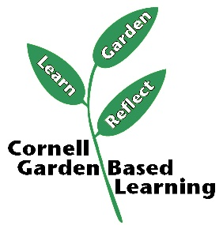
Date Published: April 2019

Facilitator’s Notes

List quotes and behavior change you noticed, especially those that may be included in your necessary reporting, success story, or for future program improvement:
List Participant Commitments that you will need to follow up on:
Changes and Adaptations to Session:

