Adult Learning and Peer Learning Networks
Participant Guide

Cooperative Extension supports communities by developing the capacity of our citizens, so they are prepared to better address challenges and opportunities, improve quality of life, and build strong and vibrant networks. We ground our public issues education and trainings in evidence and research-based knowledge. We work toward the long-term sustainability and well-being of communities through collaborations and partnerships that enhance active and representative participation toward enabling all community members to shape our collective future. We embrace partnerships based on mutual respect and trust as they provide a foundation for innovative strategies and informed decision making to create positive and lasting change. The widespread appeal of gardening provides opportunities to use gardens to connect with diverse audience and make garden-based education a catalyst for addressing food security and hunger; climate change; sustainable energy; childhood obesity and nutrition; food safety; and youth, family and community development.

By actively participating in Adult Learning and Peer Learning Networks, you will:
- Appreciate the importance of establishing ground rules in a learning environment.
- Consider the value of garden-based learning.
- Understand the basic principles of adult learning.
- Recognize the value of an effective peer learning network in the exchange of information among local knowledge and research-based sources.
- Articulate the criteria for evaluating information to identify reliable sources.

Before Session

READ:
- Fact Sheet Our Ground Rules for Engagement (1 pg handout provided)
- Fact Sheet Peer Learning Networks Support the CCE Mission (3 pgs handout provided)
- Fact Sheet Evaluating Sources (2 pgs handout provided)
- Browse the content available on these Cornell University LibGuides:
Evaluating Information:
http://guides.library.cornell.edu/c.php?g=543699&p=4433818
HORT 1175: Storying the Foodshed: Evaluating Credibility:
http://guides.library.cornell.edu/c.php?g=32487&p=204540
Critically Analyzing Information Sources: Critical Appraisal and Analysis:
http://guides.library.cornell.edu/criticallyanalyzing
A Guide to Finding Visual Resources:
http://guides.library.cornell.edu/findimages
WATCH:
- Adult Learning in Under 3 minutes from An Introduction into Adult Learning Concepts by Alan Caddell MA Ed. https://www.youtube.com/watch?v=8lvkJhXnEZk
- The C.R.A.P. Test in action: Websites from Portland State University Library (5 minute video) https://www.youtube.com/watch?v=lhwB4zQD4XA
DO:
- Worksheet Your Garden Lifeline (2 pgs handout provided)
- Worksheet Facilitating Adult Learning (4 pgs handout provided)
THINK:
- What does successful gardening look like to you? How might you sketch or describe in words the journey, pathway or what this achievement looks like?

Opening and Introduction
- Facilitator leads a brief discussion of ground rules and shares about housekeeping, learning objectives, and class flow.
Connect
- Mingle to introduce and discuss the question listed under the THINK prompt above.
The Basic Principles of Adult Learning Lecture
- Engage in presentation.
Extension Peer Learning Networks Lecture
- Engage in presentation.
Garden-Based Learning Outreach Facilitation Hands-on Activity
- Engage in small group activity and whole group discussion.
Conclusions
- Facilitator leads group activity to find out where people are from plus leads reflection on key take home points and any lingering questions.
Program Feedback
- Share your insight to help us improve the program, report results, & plan for the future.
Knowledge Check
- Assess what you now know. Be motivated and empowered to share your knowledge with your peers and to learn more.
After Session

REFLECT:
- What happened?
- What was my response to what happen? How do I make sense of it?
- How does it relate to other things I know?
- What can I conclude?
- What might I do differently next time?

LEARN MORE:
- Facilitating Learning with the Adult Brain in Mind: A Conceptual and Practical Guide by Kathleen Taylor, Catherine Marienau (March 2016) http://www.wiley.com/WileyCDA/WileyTitle/productCd-1118711459.html
- Unlocking the Magic of Facilitation: 11 Key Concepts You Didn't Know You Didn't Know by Sam Killermann and Meg Bolger
- David Kolb's experiential learning http://www2.le.ac.uk/departments/gradschool/training/eresources/teaching/theories/kolb
- Learning Styles as a Myth https://ctl.yale.edu/LearningStylesMyth
- Diffusion of Innovations – a book in its 5th edition by Everett M. Rogers
- Baram-Tsabari et al. (2015) Bridging science education and science communication research. Research in Science Teaching http://onlinelibrary.wiley.com/doi/10.1002/tea.21202/full
- Fiske and Dupree. (2014). Gaining trust as well as respect in communicating to motivated audiences about science topics. Proceedings of the National Academy of Sciences, 111 (Supplement 4). http://www.pnas.org/content/111/Supplement_4/13593.full.pdf

Campus Links:
- Cornell Cooperative Extension http://cce.cornell.edu/
- Cornell Garden-Based Learning http://gardening.cals.cornell.edu/
- Cornell University Library, Portal for Cornell Cooperative Extension
http://guides.library.cornell.edu/cce_portal
- Cornell University Library, Research Guides http://guides.library.cornell.edu/libguides/home
- Cornell Center for Teaching Innovation https://teaching.cornell.edu/

Looking for Cornell people and resources? Don’t google, try the Cornell web search: http://www.cornell.edu/search/index.cfm

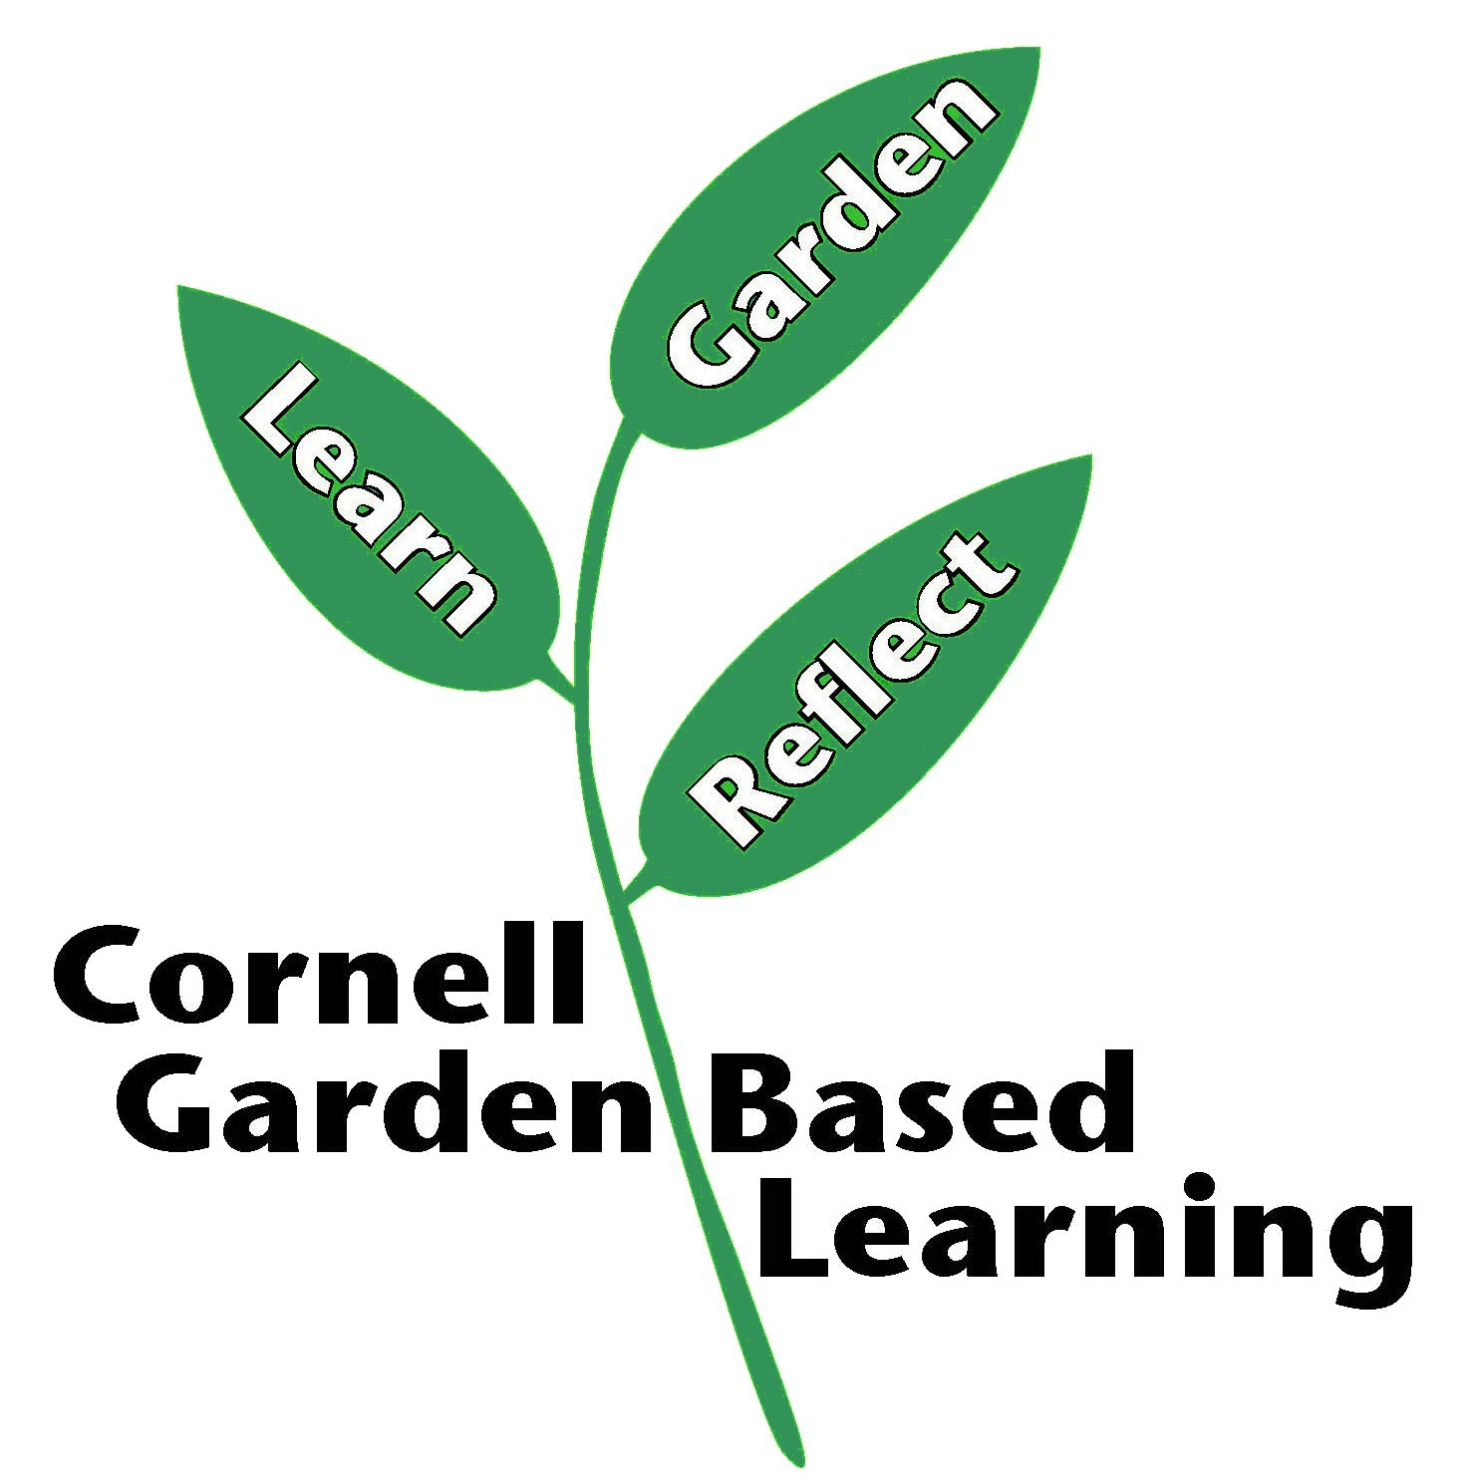
Date Published/Updated: April 2019

