WHO:  Participants | Individuals preparing for Master Gardener Volunteer role.
WHY:  The Situation | Cooperative Extension supports communities by developing the capacity of our citizens, so they are prepared to better address challenges and opportunities, improve quality of life, and build strong and vibrant networks. We ground our public issues education and trainings in evidence and research-based knowledge. We work toward the long-term sustainability and well-being of communities through collaborations and partnerships that enhance active and representative participation toward enabling all community members to shape our collective future. We embrace partnerships based on mutual respect and trust as they provide a foundation for innovative strategies and informed decision making to create positive and lasting change. The widespread appeal of gardening provides opportunities to use gardens to connect with diverse audiences and make garden-based education a catalyst for addressing food security and hunger; climate change; sustainable energy; childhood obesity and nutrition; food safety; and youth, family and community development. (adapted from CCE Statewide Plan of Work - 2018)
WHEN:  Timing | 2.5 hours/135 minutes of session time & 15 minutes for a break.
WHERE:  Space | Classroom setting with seats and tables arranged in a circle or in clusters conducive to discussion and participation.
Learning Objectives* |  | Learning Strategy (name specific approach to be used)
Appreciate the importance of establishing ground rules in a learning environment. |  | Read and Discuss – Factsheet Our Ground Rules for Engagement.
Consider the value of garden-based learning. |  | Worksheet Activity – Your Garden Lifeline; Think and Connect activity What Does Successful Gardening Look Like?
Understand the basic principles of adult learning. |  | Worksheet Activity - Facilitating Adult Learning; Lecture - Basic Principles of Adult Learning; Hands-on Activities - Garden-Based Learning Scenarios.
Recognize the value of an effective peer learning network in the exchange of information among local knowledge and research-based sources. |  | Reading - Peer Learning Networks Support the Cornell Cooperative Extension Mission; Lecture – Peer Learning Networks
Articulate the criteria for evaluating information to identify reliable sources. |  | Reading - Fact Sheet Evaluating Sources; Lecture – Peer Learning Networks
*These learning objectives match those in Participant Guide & Presentation.

Before Session

Total time for preparation will vary; minimally 6 hours.

Consider adult learning theory and strategies for implementation

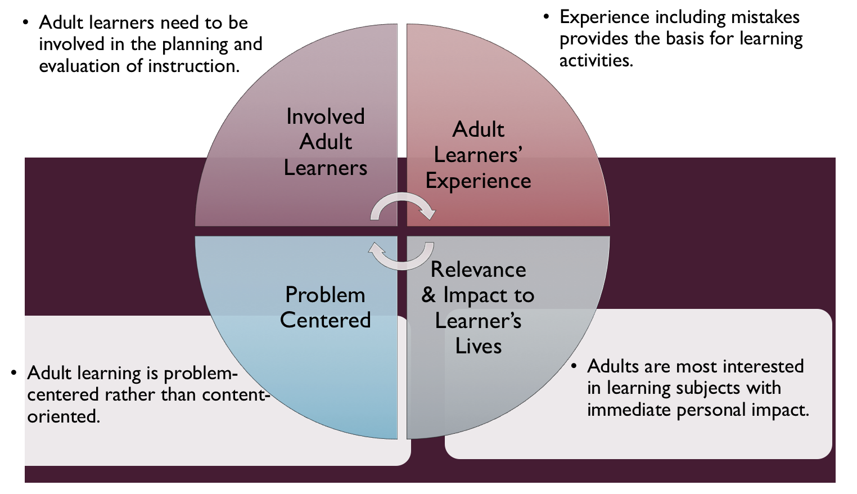
Figure credit: C. J. Carmichael adapted from M. S. Knowles and R.E. Mayer

Additionally, adult learners:
- Are experts of their lived experience.
- Come with their own motivations and goals.
- Need a safe and trusting learning environment.
- Know or will come up with 85% of the information you are planning to share.
- Remember 30% of what they hear and see, 50% of a demonstration, 70% of what they simulate, and 90% when they do the real thing.

Facilitated dialogue allows the classroom to become a conversation. Such discussion offers a way for students to explore supposedly settled questions and develop a fuller appreciation for the complexity of our knowledge. Model and encourage participants to ask open-ended questions that don’t seek yes/no answers or have right/wrong answers. This will help create a safe and trustworthy learning environment that helps participants reflect on information and make it personally relevant. See task 1 below regarding the conversation around Our Ground Rules for Engagement.

Review (time will vary; minimally 4 hours)
Go to the online Learning Library - Core Preparation and review the resources available in the section Adult Learning and Peer Learning Networks including:
- Session Slides and Facilitator Notes
- FAQs
- Facilitator Guide
- Participant Guide
- Knowledge Check
- Print Materials for Before Session Pre-Work and Hands-on Activities

Gather materials and supplies (1 hour)
There is a small amount of materials to print and organize for Hands-on Activities.

Communicate with participants before session (1 plus hour)
Ideally at least 2 weeks in advance of this session provide participants with the Participant Guide found in the Learning Library - Core Preparation. This document details what participants must do before the session. Review the document to determine the additional materials you need to provide in advance and to confirm the links are still good. Time to complete this pre-work will vary depending on the participant’s background and interest. We estimate most participants should allocate 5 hours.

Program Evaluation/Feedback (1 hour)
See section below.

Session Flow and Delivery

Total time for session is 2.5 hours (135 minutes of task time & 15 minutes for a break).

Session Tasks
Task 1: Opening and Introduction (15 minutes)
Welcome everyone and begin with a brief discussion of ground rules. (Assure all that time for more introductions will come.) If you have not done so in advance of class provide hard copies of fact sheet Our Ground Rules for Engagement. Allow time for participants to read, share comments or questions, and any additions they would like the group to consider. State the intention is for the group to hold our ground rules for engagement in mind throughout all sessions together and beyond. Encourage all to keep the sheet accessible and not to hesitate to share comments and questions if they arise at a later time.
Finish welcoming everyone by share housekeeping points, learning objectives, and class flow for the day.

Task 2: Connect (15 minutes)
Share with participants that our Extension network supports others in gathering knowledge and information to achieve gardening success. This journey begins by recognizing that success can vary from person to person and seeking to understand what a person wishes to achieve and why.
Ask participants to mingle about the room and take just a minute to introduce themselves to 1 to 3 people they do not know with their name and a personal reflection that emerged for them when they considered the question under THINK in their Participant Guide: What does successful gardening look like to you? If time allows bring whole group together and ask a few volunteers to share as someone records reflections on large sheet. You might leave the sheet posted during the session and future sessions for participants to continue to add responses.

Task 3: The Basic Principles of Adult Learning Lecture (30 minutes)
Use either the recorded video or the Session Slides and Facilitator notes all found in Learning Library; adapt the resources to suit your teaching style and needs. Alternatively, a presenter can create their own presentation to meet the learning objectives on page 1 of this document. The video recording is just 15 minutes long though there is instruction to stop the recording and reflect at several points.

15 Minute BREAK

Task 4: Extension Peer Learning Networks Lecture (25 minutes)
Session Slides and Facilitator notes all found in Learning Library; adapt the resources to suit your teaching style and needs. Alternatively, a presenter can create their own presentation to meet the learning objectives on page 1 of this document.

Task 5: Garden-Based Learning Facilitation Scenarios Hands-on Activity (30 minutes)
Follow activity directions document found in the Learning Library.

Task 6: Conclusion (15 minutes)

Consider this quick activity for participants to learn more about each other and where everyone is from in your county or region (could facilitate ride sharing to future sessions).
Orient people to an imaginary map on the floor of your county or region ask people to stand on the imaginary map where they currently live. Don’t fuss too much; let participants sort themselves out to get a rough idea who is where and who is near whom. You might bring in a printed map of your region or county or project onto screen.

Further conclude by asking participants to reflect on key take home points from today and any lingering questions. Direct participants’ attention to the items listed under After Session in their Participant Guide.

Task 7: Program Evaluation/Feedback (5 minutes)
Provide participants with an avenue to give feedback and data for your program evaluation and reporting. See section below on Program Evaluation/Feedback.

Task 8: Participant Evaluation/Knowledge Check (part of participant’s After Session work)
Provide an avenue for participants to assess what they know. See section below on Participant Evaluation/Knowledge Check.

After Session
Total time for follow-up will vary; minimally 2 hours.

Communicate with participants after session (1 hour)
Follow-up on unanswered content questions that emerged during the session and provide feedback on the knowledge check.

Consider Program Evaluation/Feedback (1 hour)
Summarize the feedback and data you received from participants for your program reporting and or future planning needs. See section below on Program Evaluation/Feedback.

Session Materials and Supplies
General Materials List
Facilitator notes Markers Index cards Pens
Highlighters Flip chart paper Name tags Feedback Forms
Post-it® notes Masking tape Computer/Internet/Projector

Materials by Task
Before Session Tasks
- Materials found in Learning Library:
  - Module 0: Section 1 Adult Learning and Peer Learning Networks
  - Evaluation Toolkit
Task 1 - Opening and Introduction
- Participant Guide
- Fact Sheet Our Ground Rules for Engagement
- Session Slides and Facilitator Notes
Task 2 - Connect
- Participant Guide
Task 3 – The Basic Principles of Adult Learning Lecture
- Session Slides and Facilitator Notes (alternatively 15-minute video)
Task 4 – Peer Learning Networks Lecture
- Session Slides and Facilitator Notes
- Fact Sheet Evaluating Sources
Task 5 - Garden-Based Learning Facilitation Scenarios Hands-on Activity
- Activity Directions are found in Learning Library. Each small group facilitation scenarios with the roles for each cut into separate strips.
Task 6 – Conclusion
- You might bring in a printed map of your region or county or project onto screen
- Participant Guide
- Flip chart paper and markers for group discussion notes
Task 7 – Program Evaluation/Feedback
- Your evaluation/feedback materials
Task 8 – Participant Evaluation/Knowledge Check
- Materials for participants to assess what they know around this topic such as Knowledge Check from Learning Library
For After Session
- Feedback from participants
- Reporting forms
- Knowledge Check Key from Learning Library

Optional Activities

Frequently Asked Questions (FAQs)
With the input of county and campus-based experts, we have compiled a list of top FAQs for each topic areas and placed it with the other session resources in Learning Library. Feel free to add or subtract questions and resources in the answers to meet your program's needs and address emerging issues.

Participant Evaluation/Knowledge Check

Adult learners enjoy getting feedback on what they have learned. In the Learning Library, you will find the Knowledge Check handouts for each session. You may ask participants to answer the questions at home on their own or in small groups discussions. The Knowledge Check KEY can be used for participants to self-check or for the educator to grade and provide feedback. You may wish to identify more engaging ways for participants to self‐test what they have learned as it motivates and empowers them to be more accountable for their learning.

Program Evaluation/Feedback
Time for creating and implementing a program evaluation plan will vary; minimally 1 hour.

Ideally, evaluation begins before the program starts. Though for many educators, the idea of measuring the effects of your program is so daunting it never begins. With this in mind, we provide an Evaluation Toolkit in the Learning Library. Our aim is to offer tools you can use, even while you’re on the run. Check it out as you consider these key questions:
- Who is this evaluation for?
- What do you want to know, and why?
- What’s do‐able, really?

Other key resources will be your local county program plan of work which likely aligns with CCE Programmatic Plans: http://www2.cce.cornell.edu/plans/Pages/FY-2016-CCE-Programmatic-Plans.aspx

Find on CCE staff website under the Organizational Development and Planning Unit a Program Reporting module: http://staff.cce.cornell.edu/orgdev/Pages/reporting.aspx

References

Adult Learning and Facilitation
- David A. Kolb on experiential learning. David A. Kolb’s model of experiential learning can be found in many discussions of the theory and practice of adult education, informal education and lifelong learning. David A. Kolb is Professor of Organizational Behavior in the Weatheread School of Management.
- Knowles, Malcolm. and Associates (1984). Andragogy in action: Applying modern principles of adult learning. San Francisco: Jossey-Bass.
- Dan Spalding’s How to Teach Adults, Chapter 1: Foundations of Teaching.
- NYS Seed to Supper Facilitator Preparation Course (2018).
- Sigman-Grant, M. Facilitated Dialogue Basics A Self Study Guide. 2004
- The National Center on Universal Design for Learning, http://www.udlcenter.org/aboutudl/take_a_tour_udl

Peer Learning Networks and Source Evaluation
- M. Rogers, Everett & Singhal, Arvind & M. Quinlan, Margaret. (2009). Diffusion of Innovations. 418-434.
- Cross, Rob & Parker, Andrew & Prusak, Laurence & Borgatti, Stephen. (2001). Knowing What We Know: Supporting Knowledge Creation and Sharing in Social Networks. Organizational Dynamics. 30. 100-120. 10.1016/S0090-2616(01)00046-8.
- Baram-Tsabari et al. (2015) Bridging science education and science communication research. Journal of Research in Science Teaching.
- Fiske and Dupree. (2014). Gaining trust as well as respect in communicating to motivated audiences about science topics. Proceedings of the National Academy of Sciences, 111(Supplement 4), 13583-13584. doi: 10.1073/pnas.1317505111
- Evaluating Information- Applying the CRAAP Test, https://www.csuchico.edu/lins/handouts/eval_websites.pdf
- The CRAP Test in Action (5 minute video) https://www.youtube.com/watch?v=lhwB4zQD4XA
- Evaluating resources LibGuides from Cornell http://guides.library.cornell.edu/c.php?g=543699&p=4433818 http://guides.library.cornell.edu/c.php?g=32487&p=204540

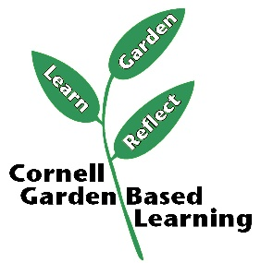
Date Published/Updated: April 2019

Facilitator’s Notes

List quotes and behavior change you noticed, especially those that may be included in your necessary reporting, success story, or for future program improvement:
List Participant Commitments that you will need to follow up on:
Changes and Adaptations to Session:

