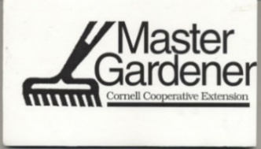

Schoharie Master Gardener General Meeting

February 15, 2022

Facilitator: Jessica Holmes

- Introduced Rebecca, the new Agriculture and Horticulture intern from SUNY Cobleskill, did introductions of the group
- Chris Cash is doing a series of workshops for free at Landis Arboretum, one on seed propagation
- Spoke about the plant sale, SUNY Cobleskill will not be doing a large sale, only small sporadic sales. They will not be an option to get plants from. Jessica and Becca are working on a plan B or to determine if we will be canceling. We will need to come up with a plan for 2023 on a new way to conduct the plant sale.
- Schoharie County Seed Swap is February 26th, 10am-Noon. Margo, Susan, Scott, Liz, Bernie and Becca will be at the seed swap. Handouts and display boards will be up for the public. The building will be open at 8:30am to start setting up.
- Becca also did a short presentation on Kitchen Gardens which will be uploaded on Moodle.
- March 8th-6pm we will have Dean from Maple Hollow farm to present on Beginner Beekeeping

