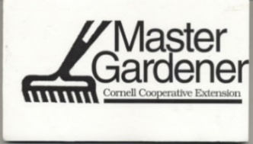

Otsego Master Gardener General Meeting
Zoom

March 9, 2022

Facilitator: Jessica Holmes
Notetaker: Jessica Holmes
Guest Speaker: Susan Williams

Attendees: Madelyn Sanchez, Carol Phelps, Kim L’Heureux, Peter Coleman, Pati Grady, Mary Ellen Calta, Mary-Ellen Crawford, Francine Stayter, Diane Dirig, Kathy Koch, Darleen Fournier, Chris Burrington, Susan Jones, Susanna Membrino, Becca Leone, Ellen Alex, Kelly Rourke, Betsy

Notes:
- We are able to meet in person, in the office moving forward. Masks will be optional at this point. Hybrid will be available as well.
- Master Gardener Appeal order, please email Madelyn or Jessica to place the order by March 22nd.
- We officially have a new Executive Director, Liz Callahan from Cooperstown. She will be starting April 12th.
- I forgot to mention in the meeting but will add to these notes that we also have a new Agriculture Implementation Specialist in the Cooperstown office. Her name is Helen Powers-Light. Please make her feel welcome as you see her around the office.
- Soil review March 30th 10 in the office and hybrid, please bring in soil to test and look at.
- If everyone can submit their Master Gardener Volunteer hours by March 31st from October through March, I will give everyone a summary of their hours.
- February meeting minutes were approved by Kim, second Chris
- All committees reported
- Seed swap and Cathedral in Bloom were successful
- More details in the recording here: https://vod.video.cornell.edu/media/Otsego+Master+Gardener+Meeting/1_en7xwnbm

